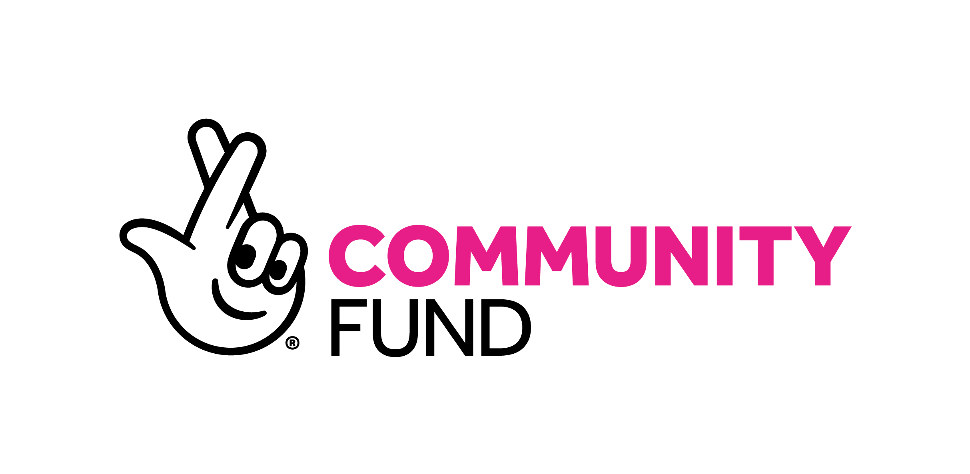

Communities making the difference
Our impact in 2024-25

The National Lottery Community Fund

Foreword
As communities continue to face what may feel like the toughest of times, they are also proving something both simple and profound: that connection, care and collective action remain among the most powerful resources we have.

Conversations about the state of the country often focus on what is breaking down - pressure on public services, declining trust, rising isolation, deepening inequality, growing tensions and uncertainty about the future. These challenges are real and they matter.

But every day, in villages, towns and cities across the UK, we see another story.

We see people choosing to come together rather than turn away. We see community organisations creating welcoming spaces where support is offered without judgement. We see volunteers helping neighbours through difficult times. We see young people stepping into leadership, communities improving the places around them and people quietly rebuilding connection, trust and hope.

This work rarely makes headlines. Yet, increasingly, we are learning that it is not peripheral to the health of society - it is foundational to it.

This is why our strategy is called ‘It Starts with Community’. Whether the issue is health, opportunity, stronger communities, the environment or wellbeing, we increasingly see that lasting change happens when communities have the relationships, confidence, power and support to shape their own futures.

Strong communities are part of the essential infrastructure of a healthy country. They shape wellbeing, resilience, belonging and opportunity. They help people feel safer, healthier and more connected to one another. They create the conditions in which people feel able to contribute, participate and believe they have some influence over the future of the places where they live.

This report tells the story of what communities across the UK are making possible with support from The National Lottery Community Fund.

In the year covered by this report, over half of our funding went to communities facing the greatest poverty, disadvantage and discrimination. Across the UK, we funded an idea every eight minutes.

Thanks to National Lottery players, the 13,100 projects we funded that ended in 2024-25 directly reached nearly 7 million people. Millions more benefitted indirectly through families, relationships and wider communities. Volunteers contributed more than one million volunteering days.

These numbers are significant. But what matters most is what sits behind them.

A youth club that stays open. A trusted adult who listens. A community garden that helps neighbours connect. A warm space where someone feels less alone. Parents gaining confidence. Refugees finding belonging. Communities improving local green spaces. Volunteers giving their time because they care about the places they live in and the people around them.

Across thousands of grants, we see communities acting as places of support, participation and resilience under increasing pressure. We also see community organisations acting as part of the social infrastructure that helps prevent isolation, distrust and disconnection from deepening.

This work matters more than ever.

Over the past year, communities continued to face rising living costs, strained public services and mounting pressures on mental health and wellbeing. We also witnessed moments of tension, division and violence that reminded us how fragile trust and belonging can sometimes feel.

At the same time, this report shows that communities are not passive in the face of these pressures. People continue to care deeply about one another and the places where they live. Across the UK, communities are still creating connection, support and hope - often quietly and often against the odds.

But this report also raises important questions.

What more must we do to learn about what helps communities thrive? What and who is still missing from the impact we are seeing? How do we strengthen trust, participation and belonging in places where people feel disconnected from power and opportunity? How do we not only support young people, but also make sure they have the power to shape their communities’ futures? How do we ensure environmental action feels relevant, inclusive and rooted in everyday life? And how do we connect community-led action to the larger systems and institutions that shape people’s lives?

Increasingly, we are learning that while local action matters enormously, communities cannot carry these pressures alone. The scale of the challenges facing society - from health inequalities to social fragmentation and climate change - requires stronger long-term investment in the social infrastructure that helps communities thrive.

That means our role as a funder must continue to evolve.

We remain committed to supporting the smallest grassroots ideas through to large local and national partnerships. But we also need to learn alongside communities, share insights more openly, support long-term change and act more boldly where evidence and community experience tell us it is needed.

This report reflects that shift. It is not only a report about what has been funded. It is also an attempt to better understand what communities across the UK are teaching us about resilience, participation, prevention, belonging and change.

As we move into the next phase of It Starts with Community, we want to build on the lessons from this report. That means continuing to support grassroots action and trusted local organisations, while also acting more boldly where communities tell us greater change is needed.

Over the coming years, we aim to deepen our work on long-term challenges. This includes social connection and stronger communities, healthier lives, opportunities for children and young people, and positive action for nature and the environment. We will strengthen how we learn alongside communities and how we use that insight to shape greater national action and investment - and to back bigger, bolder ideas capable of delivering lasting change.

Our strategy is grounded in a simple belief: communities are where change happens.

Not as a last resort when other systems fail, but as a foundation for a healthier, fairer and more hopeful future.

When communities thrive, we all do.

David Knott
CEO

It starts with community
This report shows that in every project and every idea we fund, from the smallest to the largest, there is potential for a better future for our communities.

Much of the impact of our funding can seem ordinary on the surface. Although this work rarely makes headlines, it creates building blocks enable communities to connect, build relationships and act on what matters to them.

Evidence shows that strong, connected, trusting communities transform lives, often in quiet but lasting ways. They create the conditions for people to live healthier lives, feel safer and more confident and believe they have power, agency and control over what happens in their community and their future. Our role is to make that possible and lasting.

We fund what matters most to communities. We focus our funding where need is greatest, while remaining open and accessible to communities across the UK. We aim to fund in ways that reduce burden, increase confidence and give organisations the time and flexibility they need to do their best work.

This report demonstrates that community-led action helps brings people together at the most challenging times, how that support for children and young people at an early stage sets them up for a better life, and how investing in healthier communities can help prevent future problems. It shows how communities are taking positive action for nature and the environment.

When we launched our strategy, It Starts with Community, in 2023, we made three clear choices that changed the way we worked. We focused our work on four key missions, doubled the amount of money available for National Lottery Awards for All at the grassroots level and committed to putting equity at the forefront of our work.

This is your Fund. It starts with community. And it starts with people choosing, every day, to create more good days for one another.

The year in numbers
From 1 April 2024 to 31 March 2025, we awarded £790.9 million through 13,100 grants to 12,500 community organisations, supporting community-led action in towns, cities and rural areas alike.

We funded projects through National Lottery good cause monies and the government’s dormant assets scheme, and delivered third-party funding to support people across the UK.

National Lottery:
- 12,648 Grants
- £757.2 million

Dormant Accounts:
- 165 Grants
- £25.9 million

Third Party:
- 287 Grants
- £7.9 million

Funding directly supported up to 6.8 million people, with a further
14.4 million benefiting indirectly through families, networks and communities. That’s up to 21 million people who were touched by our funding – around 30% of the UK population. Each grant directly supported an average of 746 people.

Our funding reached every nation and region of the UK. Crucially, it reached where need was greatest: 47% of our grants and 51% of our funding went to communities in the 30% most deprived areas. This puts us on track to meet our strategy commitment to ensure that, by 2027, at least half of all our grants go to communities facing the greatest poverty, disadvantage and discrimination.

Across our funding, 78% provided targeted support to diverse groups, maximising impact across communities. The remaining 22% of the projects we funded were open to all, complementing targeted projects and reaching those who might otherwise be missed.

People projects focused on:
- People with long term illness or disability - 33%
- Families - 27%
- Carers - 17%
- Men and Boys - 13%
- People experienced harm, abuse or discrimination - 11%
- People involved with the justice system - 4%
- Peoples educationally or economically disadvantaged - 31%
- Babies, children or young people - 24%
- People with multiple complex needs 15%
- Migrants, asylum seekers and refugees - 12%
- People experiencing homelessness - 7%
- Faith Communities - 4%
- Older People - 28%
- Women and Girls - 18%
- Unemployed people - 14%
- Communities experiencing racial inequality - 12%
- LGBTQ+ people - 6%
- People at end of life and their families - 3%

Note: Projects could focus on more than one group; percentages therefore add to more than 100%.

Two-thirds of funded projects involved volunteers. In total, this amounts to 127,878 volunteers over the lifetime of these projects.

On average, each grant engaged 14 volunteers, each of whom donated eight working days to their project. This totals 6.8 million hours or over 1 million working days. That represents an extraordinary collective contribution - volunteers generously giving their time, energy and commitment to strengthen their communities.

We funded over £760 million for our missions, broken down as follows:
- Communities come together - £310.1 million
- Children and young people - £208.3 million
- Healthier lives - £175.6 million
- Environmental sustainability - £69.2 million
Together, these figures represent a shared achievement. These numbers represent real people and real lives that have been changed. By working with thousands of local leaders and organisations, we have ensured our funding has a life-changing impact every day across the UK.

One Fund, 13,100 grants, £790.9 million

Scotland
- £75.6 million
- 2184 grants

England
- £529.9 million
- 9158 grants

Northern Ireland
- £38.7 million
- 728 grants

Wales
- £55.9 million
- 980 grants

UK
- £90.9 million
- 50 grants

Bringing our strategy to life

Our missions
We engaged with more than 18,000 people and organisations about what would make the most difference to them to inform the development of our four community-led missions. They guide our funding, learning and efforts to influence change. They connect everyday action to long-term change, supporting communities in shaping their own futures.

Our missions support communities to:
- come together
- help children and young people thrive
- enable people to live healthier lives
- be environmentally sustainable.

90% of grants ending in 2025 contributed to at least one of our missions, with the percentage of grants aligned with each mission as follows:

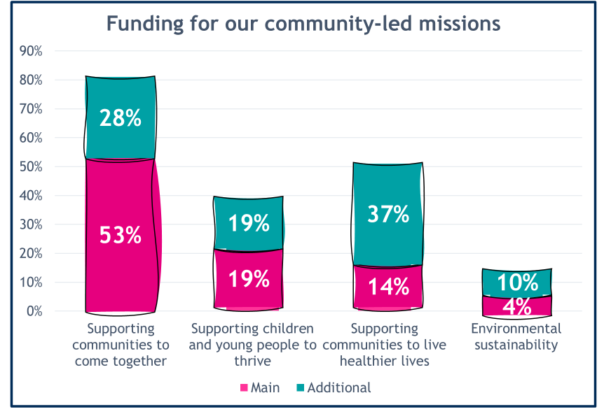

More than 80% of grant holders supported communities to come together, strengthening bonds and building new connections. Often, helping communities come together enables other missions. This is at the heart of our work:
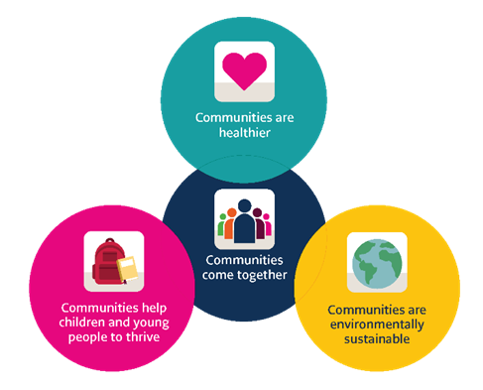

Our missions are broad and span many areas of society. To help understand our impact, we developed our missions framework, which helps communities tell us what matters most in their work. We have identified 18 outcomes and asked grant holders which of the outcomes linked to their main mission their activity contributed to.

Wellbeing, connection and belonging

The outcomes that help communities function well every day were the most commonly selected – the building blocks of community. They focus on wellbeing, connection, belonging and people feeling able to shape their own communities. These outcomes matter to people everywhere and form the foundation of much of our impact. Increasingly, we are learning that these outcomes are not secondary benefits. Trust, connection, belonging and participation are foundational conditions for stronger communities, healthier lives and long-term resilience.

They are most closely linked to our mission to support communities to come together. This mission underpins all our work, so these outcomes are relevant across our other missions, too.

The six most common outcomes were:
- Improved people’s wellbeing, physical or mental health (79%)
- Improved connections and relationships (72%)
- Delivered activities or events, online or in person (60%)
- Gave people a sense of safety, belonging or trust (53%)
- Provided or improved places for people to come together (53%)
- Enabled people to make a positive difference in their community (42%)

How it all fits together

Our funding works best when outcomes build on one another. Strong foundations, such as wellbeing, connection, belonging and trust, are built through safe places to meet and shared activities. These foundations are grounded in people feeling able and encouraged to get involved in their local community.

With these foundations in place, more targeted support can have a deeper, longer-lasting impact. This support includes working with children and young people, addressing health inequalities and supporting environmental action.

Together, this everyday, community-led work helps create lasting change - for people, for communities and the places they call home.

Communities come together
Over the past few years, the number of people who say community matters to them has declined. The continuing narrative is about division and disconnection in society.

Nearly three-quarters of people feel they have little or no influence over decisions affecting their local area. One in four people experiences loneliness. A sizeable minority say they don’t feel a sense of belonging to the area where they live. We recognise these challenges, but we also see how much worse they could have been without the projects we fund.

Supporting society’s foundations, bringing people together to build connections, create trust and belonging, and the power to shape change, is vitally important. It’s why 81% of grant holders said their project contributed to bringing communities together. It’s the golden thread that runs through everything we do and will do.

In many places, across thousands of grants, we see community organisations acting as part of the social infrastructure that helps prevent isolation, tension and disconnection from worsening. This work can often appear ordinary, yet its long-term importance is profound.

We call these the ‘building blocks’ of a strong community. Our model is shown below.
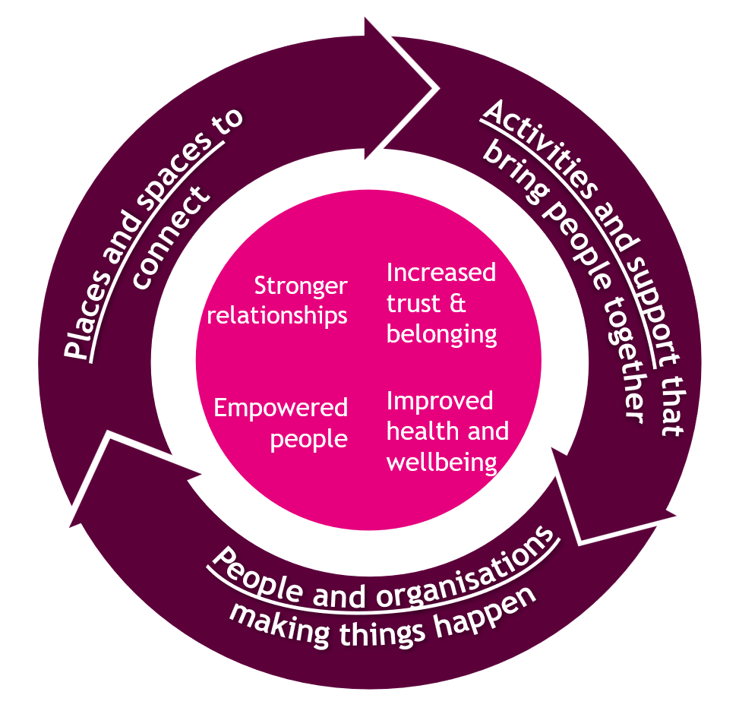

The impact of our funding
Communities come together:
- In 2024-25 we awarded £310.1 million to support this mission.
- Grants ending in 2024-25 directly benefited over 3.2 million people across the UK.

Seven in ten (72%) of our grant holders told us that the funding helped improve connections and relationships in their communities.

It often starts with a physical, or even an online, space - providing welcoming, inclusive places for people to gather, find support, form friendships, break down barriers and feel they belong.

The UK faces a loneliness epidemic. Supporting communities to tackle it must be at the forefront of our work. This is what our grant holders are doing. From village halls and community centres to local parks and warm hubs, more than half (53%) of our grants have provided or improved spaces where people can come together in their communities.

Almost four in five (79%) of these grant holders worked to make their spaces inclusive for all, ensuring they were physically accessible, safe and inviting for people from all backgrounds.

Community connections are also forged through events and activities. A total of 60% of our grants funded community events, ranging from one-off celebrations to regular activities. These are often run by volunteers, given steeply rising costs for the organisations we support.

When people feel safe, valued and able to trust those around them, they are far more likely to connect with and contribute to their community. Over half (53%) of our grants helped beneficiaries feel a greater sense of safety, belonging and trust.

The Pals Programme

Graeme Aston, 62, can’t speak highly enough about the support he received from the Pals Programme, Stockton-on-Tees. It provides wellbeing activities for men from all communities, bringing them together and providing mutual support.

Graeme said: “As the head of English at a big school in Hartlepool, I was under a lot of pressure to get results and I was working 78 hours a week just trying to keep afloat. We then had two diagnoses of cancer in the family, and I have a disabled son needing significant support.

“I had a breakdown and ended up being off work for eight months. A friend, Tim, was telling me ‘mate, you need to come along to the choir’ so I went along and met Mike, the founder.

“Mike could see I was nervous and he said quietly in my ear ‘look around the room, half the blokes in here are going through stuff’. It made me feel less alone. Then we started to sing. It was just a group of blokes singing Keep the Home Fires Burning in a pub, but it was incredible.”

With funding from The National Lottery, The Pals Programme expanded its support for men in the area experiencing challenges. Using fun days out, cooking classes, local walks and more, the group provided more spaces for potentially life-changing conversations to take place.

Graeme continued: “I started going every week and very quickly became involved in the different activities. It’s so easy to get wrapped up in your own misery and the drudgery of everyday life, but the choir pulled me out of that. Doing things like gardening, something completely outside my normal world, and meeting these men with whom I probably would never have crossed paths, was incredibly valuable. We have such different lives, yet we are all husbands, fathers, workers and share a love of our community and a common set of values.”

What helps communities connect?
Connected communities don’t happen by accident. When inclusive spaces disappear, trusted relationships fade, opportunities to get involved are lost, and people drift apart. However, the projects we fund show how to prevent this. Welcoming spaces, community events, strong local relationships and opportunities for people to take action on what matters to them all help build trust, belonging and confidence. These small things can make a real difference, especially for people who feel isolated or have a limited social circle.

Working locally makes a big impact. Positive activities that give people a shared goal or interest create common ground and foster connection. Building connections between people and their neighbourhoods promotes a sense of belonging. In a period when many people feel disconnected from decision-making and from each other, these opportunities to participate, contribute and build relationships matter deeply. They help strengthen the social capital and trust that communities rely on during difficult times.

Learning how best to bring people together, break down barriers and make communities welcoming for everyone, whether they have lived there for years or are new to the area, can be challenging. However, it’s vital that local people from all backgrounds and all walks of life have the power to shape the places they use and the decisions that affect them, so shared spaces continue to meet the community’s needs.

We believe in shifting power and control so people can lead change on the issues that matter to them in their neighbourhoods, focusing on those who have least influence. Around 42% of our grants help people make a positive difference in their communities. We will go further by making long-term investments, such as the Community Wealth Fund in England, prioritising areas of greater need. This will support people in collaborating to strengthen the places they call home. This will help neighbourhoods and community spaces stay alive, busy and full of good days.

Communities help children and young people thrive
Every child and young person deserves to feel safe, supported and able to look to the future with confidence. Our funding helps make this possible. It gives babies the best start in life, supports children and young people in developing social and emotional skills and creates opportunities for them to be heard, build resilience and flourish.

Our funding responds to real challenges facing children and young people today. In late 2025, almost a million young people were not in education, employment or training (NEET), against a backdrop of emotional and wellbeing issues. According to The Children’s Society, 9% of children and young people aged 10 to 17 in 2025 reported low overall wellbeing.

As children become teenagers and young adults, the role of community remains important. Across the UK, widening inequalities and growing pressure on wellbeing continue to shape young people’s lives.

The impact of our funding
Children and young people thrive
- In 2024-25 we awarded £208.3 million to support this mission.
- Grants ending in 2024-25 directly benefited over 1.1 million children and young people across the UK.

The projects we fund support children and young people at many levels, from individual family support sessions and local youth clubs to programmes that reach entire neighbourhoods.

Helping children and young people to thrive starts from their earliest days. Across our funding, 7% of our grants specifically supported babies and young children to have a good start in life. Most of this (92%) was through direct support for families in the first days, months and years.

This direct support helped children build social and emotional skills (69%) and improve their speech and communication (43%). It also gave parents a chance to get support together (56%). Nearly half of this funding (42%) helped families most in need by providing essentials such as food or basic household items. Other support included help with healthy eating and nutrition, as well as advice on health and healthcare.

Our £215 million investment in A Better Start is an example of this. It’s a 10-year programme that supported families and toddlers in five locations across England.

To thrive, children and young people must develop the confidence to navigate life as they grow. One in five of our grants (20%) helped them develop essential social and emotional skills, including coping with stress, understanding their emotions, being kind to others, working as a team and bouncing back from difficulties.

Growing into adulthood can be hard, especially for those facing disadvantage. Around 11% of our grants supported young people at this stage of their lives, with help including training, access to further education and support to find work and live independently.

Home-Start Wrexham

Sam and Stephen live in Wrexham with their four-year-old twin boys, who both have additional needs, and their two-year-old son. They appreciate what a difference it makes to have someone on their side.

When they arrived at Home-Start Wrexham, Sam was barely coping. However, things began to change with encouragement and practical help from Home-Start Director, Pam Hoyle.

Sam explained: “I would not have survived without the Home-Start team. When people say they are drowning, I was already under water. I was barely holding on. Pam saved me.

“The amount the boys have learnt within months of working with Pam is incredible. I thought the boys would always be in nappies and that they were never going to talk. Pam said to me, ‘just because they can’t speak, doesn’t mean that they are not capable’. She was the first person who actually said that to me and I felt like crying.”

Over time, the boys made progress that Sam once thought was impossible. Small milestones - learning new skills, gaining confidence, becoming more independent - brought hope back into everyday life. Support didn’t change everything at once, but it made each day feel more manageable.

Home-Start Wrexham helps local families facing pressure and struggling to access the help they need. With National Lottery funding, the charity works alongside families to strengthen relationships, build confidence and help children to thrive.

Pam said: “Many families are feeling overwhelmed, not only by everyday family life but [also] by how hard it can be to find the right services at the right time. Home-Start helps by bridging gaps and offering support when families feel lost or alone, one day at a time.”

What helps children and young people to thrive?
The projects we fund use a range of approaches to help children and young people grow and thrive. These include access to trusted adults, safe and welcoming spaces, and opportunities to participate, learn and belong.

Young people are more likely to thrive when they have adults they can rely on - people who listen to them, guide them and support them through challenges. Community groups often provide these relationships, particularly for young people who may not find them elsewhere.

Safe spaces matter, whether youth clubs, community centres or informal activities where young people feel welcome, valued and free to be themselves. These places help build confidence, friendships and a sense of belonging.

But there is no ‘one size fits all’ approach, as young people need choice to pursue their interests and passions. Sport, the arts, volunteering and work experience all play an essential role in helping them build skills, try new things and feel part of something bigger.

Young people tell us they want to be heard and trusted. They thrive not only when they receive support, but when they have power to change things. This enables them to shape decisions and access meaningful opportunities to contribute to their communities and future. Many of the projects we fund enable them to take responsibility, make decisions and shape their communities, such as Young Start in Scotland. We take this approach in how we operate too, co-designing with young people and giving them a seat at the table on our board and committees. It helps them build confidence and prepares them for adulthood.

Mental wellbeing is a key concern. We fund projects that provide both early assistance and urgent support, helping young people cope with stress, build resilience and develop healthy relationships. We are still learning how best to support young people to navigate the challenges posed by social media, the opportunities to build their future careers, and the importance of trusted adults in their lives.

Together, all these projects we fund across the UK help young people feel supported, confident and hopeful – giving them more good days as they grow into adulthood.

Communities are healthier

Communities play a vital role in helping people live healthier lives. Our funding helps people take practical steps towards better health, and creates welcoming spaces that foster connection and support everyday wellbeing. The projects we fund seek to tackle inequalities that drive poor health outcomes. Often, preventative action makes the biggest difference. This is where community activity can help reduce future demand for health services.

Across the UK, health inequalities remain wide and deeply rooted. Life expectancy varies sharply between regions. Outcomes are often worse in parts of Scotland, the North of England and Wales. Some communities face even greater barriers due to poverty, discrimination or historic disadvantage.

Those we seek to support represent immense untapped potential. Very few people (<1%) have a voice in decisions about local health services, but by supporting community-led action, we can help change this. Support for health works best when it is shaped with communities, not imposed on them.

We need to identify, understand and remove the barriers that prevent people from leading healthier lives, so we can improve everyone’s outcomes. It is only by tackling health inequity, alongside health inequality, that we can make a real difference.

The impact of our funding
Healthier lives:
- In 2024-25 we awarded £175.6 million to support this mission.
- Grants ending in 2024-25 directly benefited over 1.2 million people across the UK.

Our grant holders help people in their communities take meaningful steps towards better physical, mental and emotional health - from community gardens supporting mental health to crisis outreach work in homes.

In total, 79% of our grants contributed to improved wellbeing, physical health or mental health. Of these grants, 78% of projects contributed to reducing depression, anxiety and stress. Around 75% addressed loneliness, 57% helped strengthen emotional resilience, and 48% supported healthy lifestyles, including healthy eating and exercise.

There is a clear connection between this mission and our mission to support communities to come together, as building healthier communities needs community infrastructure. So, 11% of our grants provided or improved places that support health and wellbeing, while 15% delivered activities or events.

In total, 8% of our grants improved community health and wellbeing services. Examples include creating new services, expanding existing ones or making them easier to access. Around 44% of these grants involved co-designing services with local people and 51% supported community empowerment by seeking feedback from residents.

Group Recovery Aftercare Community Enterprise (GRACE)

Robert Smith has devoted his life to helping others find stability, dignity, and hope. But it’s been a hard-won journey following his own challenges.

He founded the charity Group Recovery Aftercare Community Enterprise (GRACE) in 2012 after recovering from years of addiction, poor mental health, and homelessness, and a childhood in which he experienced instability, poverty, and trauma from a young age.

Despite these setbacks 61-year old Robert managed to build a successful career in the building trade. But everything came tumbling down when he was made redundant and lost the money to drink and gambling, eventually ending up homeless.

Robert said: “Just when I thought I had reached rock bottom, something else would happen and I would sink even further. I tried to block everything out in any way I could, hoping it would make me feel better, but it only made things worse.”

At his lowest ebb, Robert was ready to take his life, but he was saved by a phone call. He said: “I was stood at the edge of the canal, ready to step over, and my phone rang. It was a pastor who my friend had put me in touch with.”

The pastor told Robert to go to his local addiction services and this time Robert listened.

As he began to recover, Robert started organising meetings. He found that once people finished formal recovery programmes, there was little community support to help them rebuild their lives or develop new skills.

So, he founded GRACE in East Dunbartonshire to create a positive environment focused on learning, connection and self-worth.

With support from National Lottery funding, GRACE has grown to offer activities such as art, digital classes, yoga, and health walks, alongside peer support.

Robert said: “I feel blessed every day. I am in the fortunate position that I see people’s lives being changed right in front of me. People come in and they are on their knees, emotionally broken, and then suddenly they are facilitating classes and sharing their positive experiences with new people coming in.”

Robert’s inspiring commitment to his community has been recognised with a British Empire Medal. But his greatest achievement, he says, is witnessing people discover a healthier, more hopeful path.

What helps communities to be healthier?
Poor health is rarely just about individual choices. It is shaped by deeper issues and inequalities that build up over time, limiting people’s chances long before illness begins.

Our funding recognises this, with around one in ten of our grants directly helping to reduce health inequalities by tackling the root causes of poor health. These include low income, insecure work, poor access to services and social exclusion. Many projects support people facing additional barriers, such as long-term disability, racial inequality and other forms of disadvantage.

Grant holders improve health by working in ways that reflect real life. Their support is practical, welcoming and shaped by local people. This might include help with everyday needs, opportunities to build healthier habits or safe spaces where people feel supported and valued. Over time, this support builds trust, connection and confidence, enabling them to take positive steps for their physical, mental and emotional health.

Good health depends on more than medical care alone. Alongside treatment and support for essentials such as food and housing, people benefit from connecting with others and having a sense of purpose. Community-based support is often easier to access and more personal and responsive than clinical services alone. This aligns with the NHS’s shift towards community care to prevent and manage people’s health issues. It will help address the root causes of poor health, not just the symptoms.

Community organisations play a vital role in prevention by stepping in early to offer support before people reach crisis point. It’s the right thing to do, and it helps prevent emergencies and reduces pressure on already stretched health services. Along with our health sector partners, we are learning how best to measure the impact of more community-based care. We’re also looking at the national rollout of digital technologies, such as artificial intelligence, to improve people’s health. Healthier communities are built not only through clinical services. Increasingly, we know that relationships, trust, and local support networks help people stay well before crises emerge.

By strengthening communities and addressing the root causes of inequality and inequity, our funding helps people stay healthier for longer – creating more good days, now and in the future.

Communities are environmentally sustainable

With so many immediate pressures facing communities, environmental issues are sometimes ignored. But environmental sustainability is vital to everyone and every community. Environmental issues affect our health, wellbeing and quality of life, both now and in the future.

The climate emergency is an urgent challenge facing society. While many environmental issues are global and require global solutions, communities can also make a real difference locally. Our funding supports this by helping communities improve their environmental impact, connect people with nature and respond to climate change in ways that matter to everyday life.

The UK is one of the most nature-depleted countries in Europe. Access to green space is deeply unequal, with millions of people living in areas with little or no access to nature. At the same time, awareness is high - most people expect environmental changes to affect their lives in the coming years.

The impact of our funding
Environmental sustainability:
- In 2024-25 we awarded £69.2 million to support this mission.
- Grants ending in 2024-25 directly benefited over 500,000 people across the UK.

The projects we funded in 2024-25 helped people take local action for the environment, feel more ownership of the challenges they face and connect more deeply with nature.

Improving access to nature strengthens local communities’ connection to the environment and promotes wellbeing. Around 14% of our grants improved access to nature. This included community gardens, allotments, parks, urban spaces, nature reserves and wildlife areas or woodlands, beaches, rivers and the wider countryside.

In total, 8% of our grants enabled people to improve their community’s impact on the environment. Activities included:
- educating people about growing their own food
- supporting renewable energy projects such as solar panels and heat pumps
- advising on ‘green’ transport options
- organising hands-on clean-ups
- supervising community gardens
- caring for green spaces
- and encouraging reuse and upcycling with ‘repair cafes’.

A total of 5% of our grants supported community organisations to have an improved environmental impact. For example, by cutting their carbon footprint through greater energy efficiency, using more renewable energy, reducing their water use, tackling pollution and improving their green spaces.

As well as specific sustainability projects, we are aware of the environmental impact of all our funding. We want to help restore nature and support communities to adapt and thrive in a changing world.

Across our funding, 80% of our grassroots grant holders and 89% of our larger grants seek to reduce their negative environmental impact. This includes minimising resource use, improving energy efficiency, switching to renewable energy sources, measuring environmental impact and improving green spaces. There is more we can learn about the scale of action being taken and how we can support grant holders to go further.

Funded organisations are beginning to operate more sustainably, while benefiting local communities in other ways. However, we still need to learn more about the best ways to measure and improve our environmental impact across all our funding.

Incredible Edible Lambeth

Victoria moved to Lambeth with her baby daughter over 25 years ago. Like many new mothers, she missed working and started to feel isolated. Despite living on a housing estate of thousands of people, she didn’t know her neighbours, barely saw people in the street and didn’t feel part of a community.

Many will understand how isolated she felt. Her feelings only began to improve when she first stepped outside her comfort zone. Her story shows how getting involved in your local area can spread positivity, impacting not just one life, but an entire community.

Victoria started volunteering with a group of women who were renovating a local park. They transformed the space, growing fruit and vegetables in the greenhouse and distributing seedlings to other local groups. Victoria unearthed a passion for growing food. When local community gardening groups like hers joined together to push for change, she found herself in the middle of the action. She has been part of Incredible Edible Lambeth ever since.

Victoria explained: “Food growing is a really brilliant way for people to take small actions that make a huge difference to where they live. I think of growers as an army of activists who are making a difference – our role at Incredible Edible Lambeth is to join them together.

“Most community gardens are run by one or two volunteers who have really big ambitions to support climate action and improve access to food. They show the small, simple actions that people can do to support benefits like improving mental and physical health, building community, and making accessible and friendly sites.”

With support from National Lottery funding, the Growing from the Root project worked with organisations to run events in community gardens throughout the borough.

“One estate did a planting day with a bouncy castle and food, and another estate did a seed giveaway so loads of people came to get stuff for their own gardens. The events were a great way of bringing in extra resources and connecting people,” added Victoria.

The events also gave people permission to access their outdoor community spaces, broke down barriers by being welcoming, and helped them feel ownership of these communal areas.

Victoria said: “On a lot of these estates, there is very poor access to nature, so these events gave residents the opportunity to interact with green space, other people, food and activities. It was very joyful.”

What helps communities to be environmentally sustainable?

So far, only a small proportion of our grants have focused specifically on supporting communities to become environmentally sustainable. We must learn and do more in the years ahead. Increasing funding in this area is a key focus as we strive to meet the commitments set out in our strategy and corporate plan.

Our grant holders are already taking important steps. They are reducing energy use, cutting emissions, managing waste and protecting local green areas through practical action and community involvement. Many projects invite people to get involved directly through planting, growing, cleaning up or improving shared spaces. These activities bring people together, build pride and strengthen connection to place.

Environmental action works best when people can see and feel the benefits, whether it’s improved wellbeing, lower energy bills or places families want to use, such as safe play areas or attractive green spaces. These connections to their everyday lives means they are more likely to care for these places.

We know environmental activities don’t always feel inclusive. Many grant holders are changing this by linking nature to different cultures, traditions and lived experiences, helping more people feel welcome in outdoor spaces and environmental groups. Diverse leadership is also important, so people can see themselves in the work.

Local environmental action has the best chance of success if it starts small and is easy to get involved in. Focusing on early, visible improvements can be important, as they are linked to beliefs and values. Moreover, focusing on people’s sense of community can be more effective than concentrating on the broader climate emergency.

Our grant holders support this approach. From community gardens to local green spaces, their work improves wellbeing, tackles inequality and brings people together. When communities connect with nature, they become healthier, more resilient and better equipped to face the future. We are still learning what community resilience and adaptation require amid long-term environmental change. Communities may increasingly need support to prepare for and respond to climate change and its practical impacts on daily lives.

This is how environmental action creates more good days – for people, for communities and for generations to come.

Supporting community organisations

Our funding would achieve nothing without the dedication, insight and deep local knowledge of the individuals who lead and work within the organisations we fund. They are at the heart of our work. They know when to act boldly, when to be patient and when to keep going, even when progress is not straightforward.

More than delivery partners, they are changemakers rooted in their communities, responsive to real lives and committed to long-term change. Many of these organisations also act as trusted institutions. They foster relationships, create a sense of belonging, and help communities respond to pressure and change over time.

As a funder, we unlock that potential by investing in people, partnerships and learning. This diagram shows how our funding helps organisations achieve change and strengthen communities.

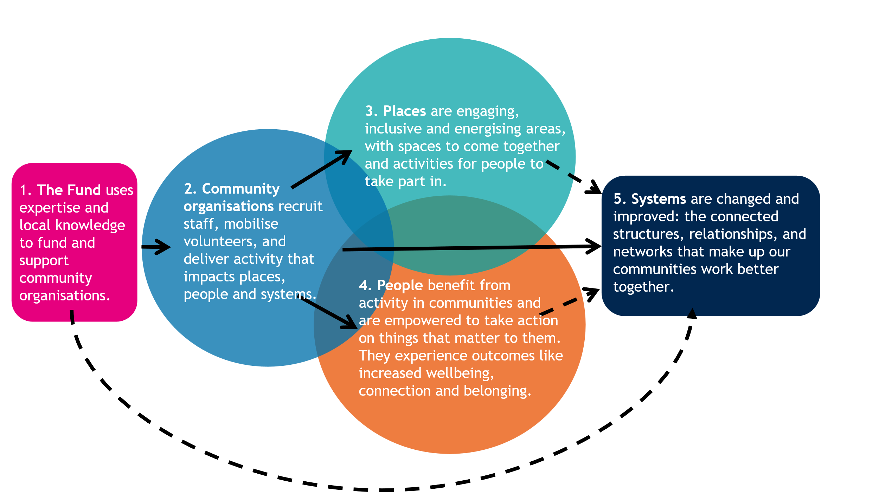

Investing in people
Behind every funded project are committed employees and volunteers whose skills, relationships and local knowledge turn funding into meaningful impact.

In total, 68% of grant holders had paid employees to deliver their projects. The remaining 32% relied on volunteers or used our funding for other needs, such as activity or equipment costs.

Of the projects with paid employees, 18,973 Full Time Equivalent (FTE) roles provided at least 29.7 million hours (or 4.2 million working days) of support to beneficiaries. On average, our funding directly supported just over half of these (9,802 FTE), with the rest funded by other sources.

This investment in people also strengthened leadership, built organisational resilience and ensured continuity for communities who rely on trusted local organisations.

Volunteers are a vital part of community-led action. Two-thirds of funded projects involved volunteers, totalling 127,878 volunteers across the projects’ lifetime.

On average, each grant engaged 14 volunteers. Each volunteer contributed eight working days to their project, totalling 6.8 million hours or over 1 million working days – an extraordinary collective contribution.

Volunteers give generously of their time, energy and commitment to strengthen their communities. They extend local organisations’ reach, cultural insight and trust. Our funding helped organisations support their volunteers, making it easier for people to stay involved and become leaders in their communities.

R:evolve Recycle
The lives of Ifeoma Evangeline and Duncan Sharp looked very different on paper but volunteering brought them together.

Ifeoma arrived in Scotland from Nigeria carrying the weight of separation from her family, unsure of where she belonged. Duncan had decades of experience, but needed a new challenge. The 79-year-old’s career in the Royal Navy had been spent underwater defusing bombs and leading teams in environments that most people would never dare enter.

And yet, one afternoon, they found themselves side by side in a sewing workshop, sorting donated clothes.

This is the power of community projects like National Lottery-funded R:evolve Recycle in South Lanarkshire. Its sessions bring people together to teach them about the environmental impact of fast fashion and how to reduce waste sent to landfill.

Ifeoma started volunteering with the project during a challenging time. After moving to Scotland, she felt unsure and struggled to find work. Passing by the project one day, she saw a sign asking for volunteers and decided to step inside.

Ifeoma explained: “It was a two-way thing. I was helping but at the same time getting experience. Being involved in the group really helped me build my confidence, language skills and ability to understand the Scottish accent better and eventually led to securing my job in customer service.”

Participation in the project gave Ifeoma connection, purpose and new skills, and the chance to meet people like Duncan.

Sewing and making were always part of Duncan’s life. His mother taught him to sew as a boy. In the Navy, he became the go-to person for fixing uniforms and sewing badges.

During COVID, Duncan noticed a local online project making face masks from reclaimed fabric. When he went to collect some masks, a conversation turned into an invitation to get involved.

What began as a casual contribution became regular volunteering. He learned to use a sewing machine, then branched into embroidery, needlework, crochet and macramé.

By investing their time in the project, they found a new purpose and opportunities to contribute positively to their community and meet new people.

Partnership working
Collaboration is central to effective community change. Across our funding, 49% of our grant holders worked in partnership with others to deliver their projects.

On average, each project involved eight formal partners, totalling 33,933 across all our grants. These partners included community groups, charities, local authorities, public services, private companies and faith organisations. Working with diverse partners strengthens projects. It helps them reach more people and stay focused on what communities need, thereby amplifying the collective impact of our funding.

Grant holders told us that collaboration with others made their work stronger, more ambitious and more effective. Most (92%) said it increased the scale of their impact. Others said partnerships enabled them to reach new or different communities, support more people and improve the quality of their services. However, there were cost implications: half found that partnerships increased cost efficiency, but others experienced additional costs. We want to improve our understanding of the full cost impact and whether this is lasting.

Learning and legacy
Our grant holders are learning organisations. They gather insight, listen to communities and use evidence to strengthen their work.

In total, 70% of funded projects conducted evaluation or research, with most of these grant holders (92%) using internal rather than external evaluation (8%) to understand and improve their work. Many (67%) use evaluation to support funding applications, while even more (91%) use it to improve their projects for the future. Some use this evidence to help other organisations or influence local or national policy, driving change beyond their own projects.

After our funding ended, 80% of projects continued. Half of these secured additional funding, while the rest sustained their work by other means, including self-funding, greater reliance on volunteers, reducing the scale of their work or collaboration with others.

Turbo-charging grassroots funding
In 2023, we doubled the maximum length and value of National Lottery Awards for All grants – our grassroots funding – from one to two years and £10,000 to £20,000. These projects are critical in creating the connections and bonds that strengthen society.

We wanted to give community organisations more flexibility in when they spend their funding. We also wanted to increase the resources available to sustain their work. These grants may be small in size, but they are big in impact.

We commissioned an independent organisation to interview grant holders and evaluate the difference this change made. Grant holders said the changes had benefited their organisation, project delivery, people and communities. It wasn’t just about doing more of the same. The changes enabled those we funded to work differently, more effectively and with more impact.

Grant holders said the change helped their organisations feel more secure. They could use their time and money more efficiently. Some recruited new staff, increased job stability and invested in staff development. They were able to focus on longer-term delivery rather than short-term fundraising. They could plan for the future and invest strategically, spending grant money more cost-effectively.

Grant holders were also able to improve project delivery. They managed rising costs to maintain or expand service hours. Some improved accessibility by providing specialist equipment, facilities or translation services. Others tailored projects for specific groups, with the flexibility to test, learn and adapt services to their community’s needs.

Most importantly, grant holders improved the support they provided to people and communities. Improved organisational stability meant they built long-term trust with the people they were supporting. They increased their reach, with 70% of grant holders supporting more people than before the changes. Others increased the number of sessions and activities offered. Some worked in partnership and accessed additional funding, leading to better relationships and more meaningful outcomes.

“Getting the funding is giving us the stability as an organisation… So, we can give people that confidence that the organisation will be there to support people for longer.” (Grant holder, England)

Together, these changes strengthened grant holders’ capacity, confidence and credibility. It enabled them to deliver more innovative and inclusive services and focus on longer-term, community-led impact.

Belfast City of Sanctuary
Israel’s story highlights the power of connecting with your community and the life-changing difference that can make.

After arriving in Northern Ireland from Nigeria in 2006, Israel Eguaogie felt overwhelmed. He and his family felt isolated by racism. Israel says: “I felt excluded in so many ways.”

However, Israel’s life changed when he connected with the Belfast City of Sanctuary. They helped him and his family access support, navigate services and begin to feel part of the community.

“City of Sanctuary gave me answers when I had none,” said Israel. “They told me, ‘We are here to support you’ and they meant it. They took us to the places we needed to go to get help, taking time out of their days because they genuinely cared. They even attended my wife’s graduation. Before long, we felt truly embedded in the community.”

Israel felt grateful for the support and wanted to give back. He joined the organisation in 2016, helping it grow into what it is today. Belfast City of Sanctuary creates a welcoming place for refugees, asylum seekers and newcomers in Belfast and across Northern Ireland, helping them integrate into the community.
With National Lottery funding, they run an annual free event, The Great Refugee Week Picnic. This brings people together to celebrate culture, connection and community.

Israel said: “The idea of the Refugee Week Picnic was to empower communities and volunteers. The first event in 2023 had 800 people attend. This grew in 2024 when we had 1,400 attendees, and last year 1,600 people registered!”

For attendees like 23-year-old Kowther, who came to Belfast after fleeing war in Sudan, they offer a sense of belonging. After studying biomedical sciences in Belfast, Kowther now works as a youth worker. She helps young people find the same community connection and sense of belonging that she has found.

Kowther said: “I love the picnic as it’s a time for people from the community to come together and celebrate and appreciate that there is that story behind every refugee. It's wonderful to see people come together as a community – as community is our superpower.”

The organisation continues to grow, helping more people feel welcomed and connected.

Looking ahead
We are proud of what we and our grant holders achieved in 2024-25. This report is just a snapshot of that work, and we’re excited about the difference we’ll make together in future years. By starting with community, we’ve been part of amazing, life-changing activity across the UK. We’ll continue to share our impact and learn together, as we outlined in our 2025-30 Evidence and Impact Strategy.

Next year, we’ll continue working with communities to improve how we learn together. We’ll progress our approach so that future impact reports share richer insights into how community-led action contributes to longer-term systems change, resilience and social connection in a more complex, uncertain world. Every commitment we fulfil from our Evidence and Impact Strategy will help deepen the service we provide to communities and the insights we share.

We conclude this report by looking to the future, sharing examples of the types of questions we’d like to explore with communities, researchers, academics and sector partners. These questions emerge from the patterns we are seeing across tens of thousands of communities across the UK. They reflect some of the biggest long-term questions facing communities and wider society and where we believe further learning, partnership and action is needed.

A new research programme developed with our grant holders is one way we’ll do this. We also highlight how our current and future work will help us go further and learn more about the big questions we seek to understand.

Communities come together
For this mission, we’ll explore questions such as:
- How can our funding contribute to greater trust and belonging? What works to develop connections between groups from different backgrounds (‘bridging’ social capital)?
- How can we increase impact in communities where there is limited social capital? How can our funding and place-based work help build strong social infrastructure?
- How can we improve our measurement and use of data on social isolation, deprivation and the issues faced by rural communities?

Our upcoming Community Wealth Fund will target funding to places with high deprivation and low social capital in England. We’ll also dedicate at least 5% of our annual £500 million England portfolio to a new You Decide funding stream. Through it, communities will directly decide which good causes our funding should support. Our Strengthening Communities funding in Northern Ireland aims to use local strengths to make people’s lives better. Especially those in remote areas, who are socially isolated or cannot access online services.

Through these large investments, we hope to learn more about what is possible when communities are in control of the funding in their neighbourhoods. We are also working with the Independent Commission on Community and Cohesion to explore how the evidence base in this area could be strengthened across the UK.

Children and young people thrive
For this mission, we’ll explore questions such as:
- How do projects that empower children and young people to have a say in their communities also contribute to their sense of belonging in a place?
- How can we support young people with opportunities to sustain and build stronger communities? What should we do now to grow a future generation of community change makers?
- How can communities best support the health and wellbeing of babies, children and young people and evidence the benefits of prevention and early action?

We will learn more about how young people’s voices can shape long-term outcomes through our refreshed Young Start programme in Scotland, developed through two years of research and co-design. Young Start distributes funds from dormant assets to help young people build confidence, develop skills, strengthen relationships and take action on issues that matter to them. Our ongoing evaluation of the #iwill Fund programme in England also provides deep insight into the benefits of activating young people’s participation in the issues that matter to them and their communities.

We have learnt a lot about the benefits of prevention and early action in the early years from A Better Start. This 10-year investment helps families give babies and young children the best possible start in life. Our £150 million investment in the National Early Years Partnership in England will build on this learning to continue supporting families at this crucial stage.

Healthier lives
For this mission, we’ll explore questions such as:
- What conditions enable community leaders to influence national agendas on health inequalities?
- How can learning from communities lead to sustained system change when communities facing the greatest health inequalities have the least access to power, resource and national influence?
- What long term health and wellbeing benefits are possible through early exposure and access to nature? How can we best work at the intersection of our health and environmental missions?

We are significantly increasing our work on health inequalities in England to improve our understanding of the first two questions. Our first step will be to dedicate £50 million to a health inequities partnership comprising community organisations with deep expertise in tackling health inequalities rooted in structural racism and discrimination. These community organisations will shape our future investment in tackling health inequalities in England.

Meanwhile, in Wales, we recently launched the innovative Meithrin Natur with £10 million to support partnership projects that provide early years activities in green spaces and areas of deprivation. This programme will provide valuable learning on the beneficial role of green space and nature in boosting health for very young children.

Environmental sustainability
For this mission, we’ll explore questions such as:
- What is the role of community-centred climate action projects in influencing system change, especially in relation to food and clothing waste?
- How do community-led climate action projects engage people with experience of poverty, discrimination or disadvantage in a way that is authentic to their lived experience?
- What are the positive grassroot community benefits of environmental action and how can we best understand, evidence and communicate them?

We’re exploring some of these questions through our five-year Climate Action Fund Learning and Support Partnership with Arup, working with the Innovation Unit, Creature and Co., and the University of Leeds. Projects benefiting from this £182 million programme are telling us about their impact on communities and the environment. The latest strand of this funding focuses on projects that strengthen our food system and reduce food insecurity for people and communities.

Tackling inequality
For this priority area, we’ll explore questions such as:
- What barriers do communities experiencing inequality face in accessing our funding? How can we shift power and better understand their experience of our process?
- How well is our funding grounded in place, how does place-based working support a focus on addressing inequity, and where can we go further?
- What hidden roles do inequalities and power imbalances play across our missions and what research should we undertake to better understand this and fill gaps?

This year we’re strengthening our externally commissioned research in support of our equity-based approach. We’ll use external expertise to help us understand questions of inequality and our relationships with community organisations.

We will dedicate at least 10% of our funding portfolio in England to a new Solidarity Fund, starting with £50 million per year to 2028. It will provide long-term core funding for up to 10 years to organisations tackling the root causes of poverty, discrimination and disadvantage in our communities. We expect to partner with, and learn from, around 10 organisations in the first year. We’ll also conduct learning and evaluation into the results of this pioneering work.

How we learn

Many of these questions require us to adapt our approach to learning with communities to centre the needs and experiences of community organisations. In November 2025, our community learning panel launch received an overwhelming response. A diverse group of 100 organisations now advises us on our priorities for learning and the services we offer to the whole sector to access learning. We’ve paired that with intensive offers of support, such as our new learning exchange for grant holders in Northern Ireland.

We’re now working on a UK-wide online learning bank for community-led solutions, where communities can find new ideas, evidence and real-life examples. We’ll translate evidence and findings from different sources into something that will be easy to access, follow and use. Communities will also be able to learn more about the experiences of their peers and find opportunities to connect.

Our Evidence and Impact Strategy promises our support to those we work with to better demonstrate the difference they make to their communities. We want to make it easier for them to access and share the ideas, solutions, best practice and learning they need to showcase their impact.

This report shows the progress we’ve made in the first year since we made that promise. We know there is much more to do. However, we’re excited about the future and how we will use impact, knowledge and learning to catalyse change with and for communities. The more we learn, the more we see that communities are not simply recipients of change, but active partners in shaping it. Our role is not just to fund communities. It is to learn alongside them and help amplify what they teach us about building a stronger society.

Annex A: Methodology

This report covers 2024-25, drawing on application data for 13,100 grants awarded between 1 April 2024 and 31 March 2025. This included National Lottery funding (96.5% of grants and 95.7% of funding value), Dormant Accounts funding (1.3% of grants and 3.3% of funding value) and Third-Party funding (2.2% of grants and 1.0% of funding value).

We commissioned GC Insight to conduct a survey. It was completed by 3,056 grant holders (36% response rate) whose projects ended between April 2024 and March 2025. For the larger and longer-term grants, these will have been awarded before our current strategy.

The survey included questions about their beneficiaries, staff, volunteers, partners and project activities. The survey sample's strength and representativeness meant that GC Insight could use the answers grant holders gave about their reach to extrapolate findings across the entire grant holder population. The resulting figures were used to estimate the total number of people reached by grants ended in 2024-25, which this report presents.

Surveyed grant holders also answered questions about the missions and outcomes to which their projects contributed.

Each grant holder was asked to identify one main mission their project contributed to, and any additional missions. For additional missions, grant holders could select more than one option. This means that combined percentages for additional missions total more than 100%.

In addition, grant holders could select “Other” as their main mission. Around 10% did so, typically because their work spanned more than one mission and could not be captured by a single category. As a result, across some data points such as funding amount, number of grants and beneficiaries, the totals for the four named missions will not add up to 100%.

Our funding aims to support 18 outcomes. Each mission has at least four main outcomes, and some are shared across more than one mission. Grant holders were only asked about outcomes linked to their main mission. They did not see the full list, only those relevant to the mission they selected.

Because some outcomes link to multiple missions, a wider group of grant holders could select these outcomes. This means that more grant holders selected some outcomes than the number who chose the main related mission as their main focus.

For example, the outcome ‘People have access to quality natural spaces in their communities, enabling regular connection to nature’ applies to the Communities Come Together, Healthier Lives, and Environment missions. As a result, 76% of grant holders could select this outcome, not just the 4% whose main mission was Environment. Overall, 14% of grant holders selected this outcome.

Some outcomes also triggered follow-up questions. For example, grant holders who selected ‘Communities have inclusive places that bring people from all backgrounds together’ were asked further questions about the types of places they created or improved.

This table shows the main four outcomes for each main mission. Some outcomes also support other missions. These links are shown to highlight where work overlaps or contributes across missions.

Mission outcomes and links to other missions

Main mission | Outcomes | Relevant  missions
1: Communities come together | Communities have inclusive places and activities (physical and virtual), that bring people from all backgrounds together (Note: we split this into two for the survey) | 1, 2
1: Communities come together | People are empowered and make a positive difference to their communities | 1, 2
1: Communities come together | People feel a sense of safety, belonging and trust in other people in their local area | 1, 2
1: Communities come together | People have positive relationships and connections | 1, 2, 3
2: Communities help children and young people thrive | Babies and children from all backgrounds (and their families) have the community support they need to have a good start in life | 2
2: Communities help children and young people thrive | Children and young people have positive social and emotional skills development | 2
2: Communities help children and young people thrive | Children and young people have trusted adults in their community for support and advice | 1, 2
2: Communities help children and young people thrive | Communities support young people to fulfil their potential and thrive into adulthood | 2
3: Communities are healthier | Communities have inclusive places and activities (physical and virtual), that support health and wellbeing (Note: we split this into two for the survey) | 3
3: Communities are healthier | People are empowered and make a positive difference to services that support health and wellbeing in their communities | 3
3: Communities are healthier | People’s physical and mental health and wellbeing is supported by their communities | 1, 2, 3
3: Communities are healthier | Communities contribute to reduced health inequalities | 1, 3
4: Communities are environmentally sustainable | Community organisations have a positive impact on the environment (in relation to nature, pollution and/or climate) | 4
4: Communities are environmentally sustainable | People are empowered and make a positive difference to the environmental impact of their communities | 2, 3, 4
4: Communities are environmentally sustainable | Communities prepare for and adapt to changes in climate | 4
4: Communities are environmentally sustainable | People have access to quality natural spaces in their communities, enabling regular connection to nature | 1, 3, 4

We also commissioned CAG Consultants, working in partnership with GC Insight, to assess the impact of the threshold changes to our National Lottery Awards for All (NLA4A) programme. The evaluation examined whether these changes led to improved project outcomes, extended the reach of funded activity to beneficiaries, and generated benefits for grant-holding organisations.

A mixed-methods approach combined:
- a desk review of application data of 10,248 NLA4A projects that were funded pre-threshold change and 8,362 NLA4A projects that were funded post-threshold change
- 40 qualitative interviews with NLA4A grant holders to capture in-depth perspectives
- analysis of two specific questions in the grant holder survey targeted from 2,473 NLA4A grant holders.

Findings from this work informed the ‘Turbo-charging grassroots funding’ section of this report.

About us
The National Lottery Community Fund works within and alongside communities, using the generosity of National Lottery players to strengthen society and build a better future. With funding teams rooted in communities across the UK, we focus where need is greatest, funding projects that support communities to come together, help children and young people thrive, enable people to live healthier lives and to be environmentally sustainable. All to help communities do something truly life-changing.

Legal disclaimer
This report tells personal stories of grant holders and staff and shares examples of what has worked well for others. Any views, thoughts or opinions expressed by grant holders and staff do not necessarily represent the views, thoughts or opinions of The National Lottery Community Fund (‘the Fund’). The Fund does not endorse or recommend any organisation mentioned, nor does it endorse any external content linked to in this report. The content of this report should not be taken as an instruction, guidance or advice and you should not rely on the information in this report as an alternative to professional advice. To the fullest extent permitted by law, the Fund accepts no responsibility and disclaims all liability to any third party who purports to use or rely for any reason whatsoever on the report, its contents, conclusions, any extract, reinterpretation amendment and/or modification by any third party is entirely at their own risk. We make no representations, warranties or guarantees, whether express or implied, that the content of this report is accurate, complete or up to date.
© Crown copyright 2026
This publication is licensed under the terms of the Open Government Licence v3.0 except where otherwise stated.
Where we have identified any third party copyright information, you will need to obtain permission from the copyright holders concerned. Any enquiries regarding this publication should be sent to us at The National Lottery Community Fund Apex House, 3 Embassy Drive, Birmingham, B15 1TR, or you can email us at evaluation.research@tnlcommunityfund.org.uk.

Get in touch
To find out more about our funding and research visit our website.
Email: evaluation.research@tnlcommunityfund.org.uk
Call our advice line: 0345 4 10 20 30
Text Relay: 18001 plus 0345 4 10 20 30
June 2026

Acknowledgements
We extend our sincere gratitude to GC Insight and CAG Consultants for their rigorous design and delivery of the surveys and interviews that underpin this report. We are equally grateful to our grant holders, whose openness, time, and vital insights during this research provide the essential evidence shaping our ongoing work.

The total number supported across all grants that ended in 2024-25, across the lifetime of those grants. Data collected via a survey with grant holders. Methods detailed in the annex.
There may be some double counting in this data if more than one grant holder directly or indirectly supported people.
As identified by the Index of Multiple Deprivation.
Note that a further £27.8 million of funding was classified as ‘other’. This data differs from that reported in our annual report for 2024-25 as we have extrapolated missing data to include all of our funding.
10% chose to self-describe rather than select a single mission, often due to a cross-mission approach. 95% of these “other” projects still identified a main outcome.
This data refers to the number of grants closing in 2024-25 rather than the amount of funding awarded. Grant holders identified their main mission and any additional missions. For additional missions, they could select more than one, so percentages total more than 100%.
https://www.tnlcommunityfund.org.uk/about-us/our-strategy/our-missions/
The National Lottery Community Fund. Community Voice Survey, November 2025. Unpublished report from Kubi Kalloo Ltd on the basis of independent research with 8,000 members of the public.
England - Community Life Survey 77%, Scottish Household Survey 72%, Welsh Household Survey 75% and Northern Ireland Life and Times Survey 75%.
ONS. Public opinions and social trends, Great Britain: personal well-being and loneliness (7 January to 1 February 2026 edition of dataset). Across England, Scotland and Wales, 23% of people often, always or sometimes felt lonely. Department of Health. Health Survey NI 2024/25. In Northern Ireland, 25% of people feel lonely.
England - Community Life Survey: 39% of people do not strongly feel they belong to their immediate neighbourhood. Scottish Household Survey, 20%; Welsh Household Survey, 12%, and Northern Ireland Life and Times Survey, 15% of people do not feel a sense of belonging to their community.
ONS: Young people not in education, employment or training (NEET), UK: February 2026. 12.8% of all people aged 16 to 24 years in the UK not in education, employment or training in October to December 2025.
The Children’s Society: The Good Childhood Report 2025.
ONS: Life expectancy for local areas of Great Britain: from 2001 to 2003 and 2021 to 2023.
DCMS: Community Life Survey 2024/25 annual publication.
Game and Wildlife Conservation Trust - Are we one of the most “nature-depleted” countries? https://www.gwct.org.uk/blogs/news/2024/september/are-we-one-of-the-most-“nature-depleted”-countries/
Friends of the Earth - Access to green space in England Are you missing out? https://friendsoftheearth.uk/nature/access-green-space-england-are-you-missing-out
ONS: Public and business attitudes to the environment and climate change, Great Britain: 2024 https://www.ons.gov.uk/economy/environmentalaccounts/articles/publicandbusinessattitudestotheenvironmentandclimatechangegreatbritain/2024
https://www.tnlcommunityfund.org.uk/media/documents/corporate-documents/TF25_016_Impact-Report_English.pdf

