Intergenerational Skills Swap
2015-2018

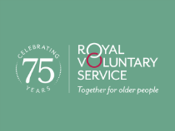

Key learning points
- Over 50 is a very broad age group. Although there is an increasing recognition of the benefits of intergenerational projects, formal projects often overlook that, even within the over 50 age bracket, there are at least two, possibly three generations and that many people closer to 50 (and many of those at the older end) are more likely to want to volunteer as a befriender of someone older than them, or in different circumstances, rather than be a recipient of befriending by a younger person.
- Strengths-based approaches require support to enable people to recognise their strengths. People who are referred into a project may require a significant amount of support to be able to identify strengths and to build the confidence to be able to share these.
- Home-based visiting is attractive to some people, but potentially counterproductive. It was felt that in some cases, where participants would be able to leave their home, the availability of someone to come to their home may actually have increased isolation as it discouraged the participant from being more active.

Introduction

Age Better in Sheffield is a partnership of organisations working to reduce loneliness and social isolation amongst people over 50 and to help them to live fulfilling lives. It is funded by the National Lottery Community Fund and is one of 14 Ageing Better pilot areas across England working to explore what works in reducing loneliness and isolation. Age Better in Sheffield services are commissioned to focus on four target wards (Burngreave, Woodhouse, Firth Park and Beauchief and Greenhill). These wards were identified as having a high percentage of the older population at risk of loneliness and isolation. The first round of Age Better in Sheffield Projects also focused on a number of hotspot areas across the city where there are particularly high numbers of people in groups at higher risk of loneliness and isolation (carers, people experiencing poor physical or mental health, people experiencing financial hardship and people from black and minority ethnic (BAME) backgrounds).

In 2015, five projects were commissioned to explore innovative ideas for tackling loneliness and isolation.

This report provides an overview of Intergenerational Skills Swap project which was delivered by the Royal Voluntary Service during the during the first three years of the Age Better in Sheffield programme, including the outcomes achieved and the lessons learned.

Methodology

The report draws on data from the National Lottery’s quantitative evaluation as well as a locally developed questionnaire tailored to the individual projects.

Participants were asked to complete questionnaires at the start of their involvement with the project, six months into the project, at the end of the project and then six months after completion.

Outcomes from the national evaluation were similar for participants on both projects and scores have been combined.

The report also draws on case studies and on a report written by, and an interview with, the project manager.

The project

The project was commissioned following a research and coproduction phase that showed the benefits and demand for intergenerational activities and projects that used the Five Ways to Wellbeing.

In particular through the coproduction, older people told us that:
- Skills that were acquired through a lifetime of employment seem to get left behind once they aren’t used regularly and this creates a sense of not feeling useful.
- They wanted to volunteer using their skills and ‘be useful’ rather than just participating in generic volunteering opportunities.
- Those who had previously held academic/teaching roles welcomed the idea of sharing the benefit of their knowledge with those undertaking similar learning. For example, one event participant (a retired Registered Nurse/Lecturer) stated she would “love” to work with those undertaking nursing/healthcare training to give the benefit of her knowledge and keep learning herself on current practice.
- A younger participant in the events told us that he was keen to learn skills around growing his own food and just ‘couldn’t get the hang of this from reading about it’.

The project sought to identify people aged over 50 (known in the project as participants) who were socially isolated or at risk of being socially isolated and to empower them by identifying skills or hobbies they have which can be passed down to a younger generation (primarily students and young people) and in return the younger generation (known as volunteers) would exchange a skill back. Skills included practical activities such as cooking, gardening, IT, sewing etc, as well as skills that someone might have developed through hobbies or work. In general, skills that younger people offered and that were sought after by older people were phone and technology based.

Once matched, volunteer and participant tended to meet approximately weekly in the beneficiary’s home, for approximately an hour and half, over an unspecified period of time. As many of the volunteers were students, relationships often continued until the volunteer moved away or found employment or had to stop for exams. In addition to the one to one support, there were also visits by schools and scout groups to supported living settings.

Participants and volunteers

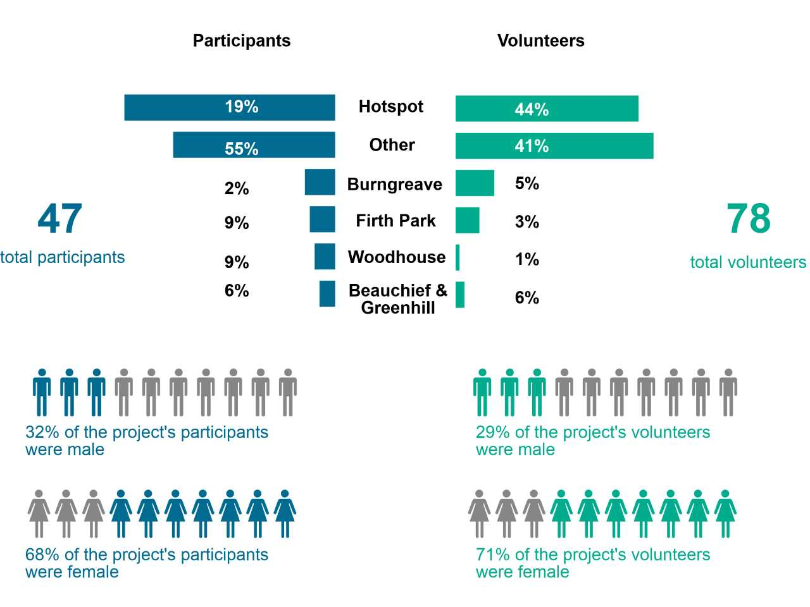
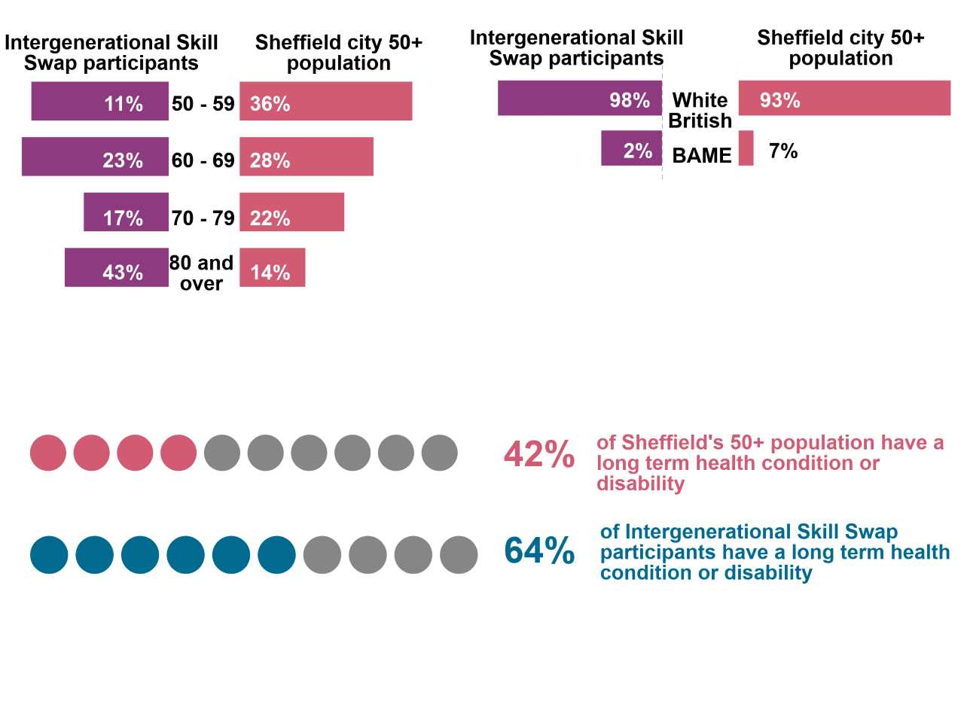

Challenges
- The project struggled to reach its participant targets as people referred through RVS often wanted a straightforward befriending service. Participants were also very reluctant to complete paperwork.
- There was a great deal of demand for student volunteer placements from the University resulting in a high number of student volunteers but it was not possible to match all of these. The high number of under 50 volunteers also reflects the involvement of a scout troop in one activity.
- The project struggled to reach older people from black and ethnic minority communities well, with only 2% not being from a White British background, but 36% of the volunteers were from BAME backgrounds, the majority of these were students.

Learning points
- Future projects should recognise that there are at least two generations within the over 50 age group and be more flexible about interpreting intergenerational work. Often people aged over 50 wanted to be volunteers and work with 80-year olds (sometimes active people in their 80s might be entirely able to visit a 50 year old experiencing high levels of isolation) but the project did not allow for this flexibility and required someone over 50 to be a participant and partner with someone under 50.

RVS found that participants tended to fall into two distinct groups:
- People who self-referred tended to already be quite active and engaged – they often self-identified as a volunteer and wanted to give back and engage with younger people, with a focus on giving rather than receiving. This group tended not to be isolated, although some used it as a ‘way back in’, a taster that led to doing more organised activities.
- People who experienced high levels of isolation – these people tended to be referred by other agencies and wanted a regular visitor who would visit weekly in the home. People in the second category tended to experience more significant issues including a lack of confidence; low self-esteem; ill health; financial issues, debt and concerns; high levels of loneliness and isolation that was often exacerbated by fragmented families and limited local communities. These participants tended to want a traditional befriending service and were less interested in the skills aspect of the programme.

Initial engagement

People often found the sign-up forms intimidating when they received them in the post so RVS completed these in a face to face meeting. This took approximately 60 minutes and provided the project worker with opportunity to get to know the individual and their skills and aspirations.

Flexibility around the location of this initial meeting really helped participants to feel engaged, going to where people were comfortable, whether this is their house, a café, a Drink Wise Age Well office space, or occasionally other groups.

A lot of the volunteers were students who were really attracted by the potential to get to know Sheffield as well as to get work experience.

Some older volunteers were out of work and looking for care work experience so volunteering with the project was valuable for them.

Challenges
- Sometimes potential participants found it difficult to identify skills that they could share. Helping people to identify their strengths can take time, especially when people have not been involved with services that work in this way. More resource focused on working with participants to identify strengths may have been beneficial.

Learning points

Brand recognition can be more important in attracting participants than the nature of a project. Although there is positive evidence about the benefits of skills based befriending, RVS found that people often wanted more traditional befriending rather than the focus on sharing skills, but had approached RVS because it was an organisation that they were familiar with and trusted. These participants were often reluctant to be referred to Age Better Champions, another Age Better in Sheffield project which would have been more suitable for their needs, because it wasn’t delivered by a name that they recognised. This demonstrates the importance of trust and brand recognition in engaging with people experiencing loneliness and isolation.

Delivery

Challenges
- The lone worker model does not work effectively. Other than a paid manager, the service was delivered entirely by volunteers, including the administration. As Age Better in Sheffield is a research programme and unusually heavy in terms of administration, this model did not work effectively and additional paid workers would have been beneficial both to manage the administration but also to allow for the flexibility to visit participants at times that were convenient for them and for someone to be on call for emergencies during the times that volunteers were visiting participants which was often weekends and evenings.

Learning points
- Short, regular visits worked well. Meeting approximately weekly for around an hour and half worked well for participants and volunteers.
- Home based befriending can encourage dependence. Participants valued the ability of volunteers to come to their home – about 90% of participants wanted to be visited at home and were not willing or able to meet volunteers outside the home. However, it was felt that in some cases where participants would be able to leave their home, the availability of someone to come to their home may actually have been more isolating as it discouraged the participant from being more active.
- Flexibility is important. RVS had timetables that they hoped to work to, but found that these often did not match those of participants and so it was necessary to be flexible to work around family commitments, medical appointments, care needs, holidays etc.
- Setting and reviewing outcomes. Setting initial outcomes for participants and then reviewing them regularly with the participant was important to ensuring that outcomes were achieved.

Exit and progression

Learning points
- Ongoing befriending can encourage dependence. The model of delivery was not time limited. This meant that some of the befriending relationships went on for a long time (over a year) and some of the participants became quite dependent on the volunteer. A time limited intervention with a plan for what would happen at the end of the project may have been helpful.

Volunteering

Learning points
- Obtaining Disclosure and Barring Service certificates can be time-consuming, but using the online service was much faster.
- Expenses should be budgeted for fully. Although some organisations may be used to volunteers not necessarily claiming expenses, for some volunteers expenses are crucial to inclusion. Travel expenses were particularly important for student volunteers for whom volunteering was otherwise not an option.
- Students were attracted by enhancing CVs and getting references.
- Volunteer management needs to be adequately resourced. Adequate support needs to be provided to allow volunteers with physical and mental health challenges, or with limited English language skills to be involved in the project.
- High quality training improves outcomes. Full training for volunteers to be completed before the role was commenced was important to the experience of both volunteer and participant.
- Volunteer supervision is important. Regular support meetings for volunteers were important for the volunteers – these were approximately monthly but for some volunteers were more frequent with regular face to face or telephone or email communication.

Coproduction

Coproduction, or involving older people in design, delivery, evaluation and governance, is key to the Age Better in Sheffield Programme and all projects were encouraged and supported to coproduce.

Learning points
- Coproduction means involving all stakeholders in developing the service. Allowing volunteers to have a voice in service development was beneficial in shaping the project.
- Person-focused services are more valued than formally coproduced services. A range of approaches was taken to coproducing the project, including co-developed (person-centred) individual support plans and having a project steering group including participants and volunteers. The project found that there was very little interest from participants and volunteers in being interested in the steering group.
- Formal coproduction can be intimidating. RVS reflected that co-production can be a daunting experience for someone who has not been used to being asked for their views and opinions and meetings can be seen as quite intimidating. Making meetings accessible, non-threatening and inclusive is vital to effective engagement.

Outcomes

RVS found it challenging to encourage participants to complete CMF data, with only approximately 1/3 of participants having follow up data. Of those who did complete, there is little evidence from the CMF that the project improved outcomes in any area, with more participants having deteriorated or stayed the same than improved across all outcome areas.

RVS found that there were distinct differences in observed outcomes between people who had self-referred and those who had been referred in to projects, with those who had self-referred appearing to achieve more positive outcomes. Those who self-referred tended to be more active in the project.

Reducing social isolation
Although positive outcomes as measured by the De Jong and UCLA scales were low (20% and 25% respectively), seven of the eight participants who responded to the bespoke questionnaire following involvement with the project said that they felt it had reduced their social isolation. However, this equates to a very small proportion of the participants.

Enabling people to share skills

Those participants who were sharing their own skills as well as receiving visits and learning from a volunteer, enjoyed the project more. They often used it as a stepping stone for other activities and particularly enjoyed giving back and sharing what they know. 100% of participants completing the bespoke follow up questionnaire felt that they had been able to share a skill.

“I used to enjoy making cards but left it for a while; the activity with the scouts gave me the inclination to do it again. Also, it gave me enthusiasm for doing something for someone else.”

Influencing internal policy
RVS is starting to move away from traditional befriending services because they have found that people who had the ongoing one to one support feel abandoned at the end of the programme because they had become dependent and couldn’t see that there were other options/social activities available, just wanted one to one home visits.

Intergenerational Skill Share contributed to RVS’s national move away from home based befriending work towards more community focused activities.

Conclusions and further recommendations

- Although some participants experienced positive outcomes, the model was not successful in attracting participants and did not work to improve outcomes.
- Both the project manager and Age Better in Sheffield agreed that future skills sharing projects should not use a befriending model and should instead be delivered in a group setting, or potentially a short time limited period of one to one home based provision with a clear plan for progressing to community based activities.

Case study

I have been volunteering now for nearly 5 months, I applied thinking it was a good thing to do and would maybe help with my job prospects and could lead to other opportunities. I have been doing the intergenerational skill swap, where I swap a skill with an older person, I have a passion for photography and so does Bill who I visit, he has a different knowledge to me as he did photography when things weren't as easy in some ways as they are now.

Bill like me did photography as a hobby and also did the odd wedding for friends and family, I have learned from him as he has taught me about photography techniques he used and it's brought things up which made me think about things. His wife also gets involved in our conversation and I help her sometimes with her iPad and recently taught her to use her mobile phone. I feel very good about myself that I do this volunteering and I feel appreciated also, they are a lovely couple and we have good chats about our hobbies and life in general.

I have sent some of my photos to him and he was so kind to print one off for me and gave me praise on my composition of the photo, which again was good to get a perspective of what someone else thought! I'd say to other volunteers if you are thinking about volunteering go for it as you benefit from it too.

Written by J.J

Volunteer at the Intergenerational Skill Swap project delivery by the Royal Voluntary Service, Sheffield. UK

Appendix 1 – Outcomes

Outcomes | Entry Average |  | Follow Up average |  | Improved |  | Stayed the same |  | Deteriorated
Social isolation and loneliness De Jong Scale | 3.9 |  | 4.3 |  | 3 |  | 9 |  | 6
Social isolation and loneliness UCLA Scale | 6.5 |  | 6.9 |  | 4 |  | 6 |  | 6
Social Contact - do the following with children / family / friends | 3.5 |  | 3.71 |  | 3 |  | 10 |  | 1
Social Contact - how often do you speak to anyone who isn't a family member | 6.25 |  | 5.5 |  | 1 |  | 5 |  | 2
Social participation - membership of clubs / organisations / societies | 0.6 |  | 1 |  | 6 |  | 12 |  | 1
Social Participation - compared to other people of your age, how often would you say you take part in social activities? | 1.2 |  | 1.13 |  | 6 |  | 5 |  | 4
Wellbeing - SWEMWBS | 20.3 |  | 20.5 |  | 8 |  | 4 |  | 7
Health - Quality of Life (EQ - 5D - 3L) | 0.4 |  | 0.36 |  | 7 |  | 7 |  | 5
Health - Health Score (EQ VAS) | 59.13 |  | 58.31 |  | 7 |  | 2 |  | 7
Volunteering | 0.8 |  | 0.9 |  | 8 |  | 4 |  | 5
Co-design | 2.4 |  | 2.5 |  | 5 |  | 5 |  | 3
Influencing | 2.9 |  | 2.3 |  | 3 |  | 5 |  | 11

These questionnaires included a standardised questionnaire, the Common Measurement Framework (CMF) completed for all National Lottery funded Ageing Better projects (as well as the other 13 pilot areas across the Big Lottery’s Ageing Better programme).
Another project delivered by RVS in Sheffield.
A full breakdown of outcomes from the CMF can be found at Appendix 1

