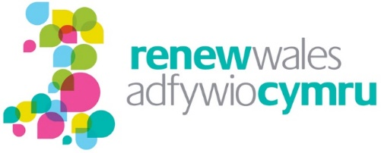
Evaluation of the Renew Wales Programme
2016-2018

November 2017

Contents

Executive Summary i
1 Introduction 1
2 Programme monitoring data 4
3 Findings of interviews with stakeholders 9
4 Findings of a survey of supported groups 17
5 Case studies of supported group 32
6 Conclusion and recommendations 44

© Wavehill Ltd. This report is subject to copyright. The authors of the report (Wavehill Ltd.) should be acknowledged in any reference that is made to its contents.

Author:
Endaf Griffiths

Any questions in relation to this report should be directed in the first instance to Endaf Griffiths (endaf.griffiths@wavehill.com)

Date of document: November 2017
Version: FINAL

Executive Summary
The programme

Set up in 2012 by a consortium of third sector organisations in Wales, Renew Wales supports community groups in tackling the causes and impacts of climate change through advice, training, mentoring and technical support services provided by experienced community practitioners. The key elements of the programme are:

- Coordinators and Mentors: the team that provides support to the community groups in developing and then implementing their plans;
- The Central Team: a small team that manages and coordinates the delivery of the programme; and
- Regional and National Events: to provide a forum wherein community groups and stakeholders can meet, network, and discuss their ideas and projects.

Importantly, Renew Wales is delivered using a model which, as well as delivering support to community groups, is designed to directly benefit those organisations involved in its delivery and, hence, the third sector in Wales more generally. The key to this is that the Central Team, Coordinators and Mentors are hosted by third sector organisations throughout Wales.

The evaluation

This is the second of two reports of an independent evaluation being undertaken alongside the implementation of the programme during 2016-2018 so that its findings can feed into delivery. The focus is on two overarching themes:

- Understanding the model: Renew Wales has a different way of working from that of many projects and programmes. The evaluation will therefore consider what the added value of the Renew Wales approach is, and how it compares to that of other projects and programmes.

- Understanding the outcomes: The evaluation is also tasked with collecting quantitative and qualitative data that will allow the impact of Renew Wales to be assessed.

For this report, semi-structured evaluation interviews were undertaken during April and May 2017 with stakeholders involved with Renew Wales in a range of different capacities. These included Renew Wales central staff, Coordinators, Mentors and Steering Group members (some of whom were also Mentors). Interviews were also undertaken with representatives of the Wales Co-operative Centre and the Wales Council for Voluntary Action (WCVA) as organisations also working with community groups in Wales. A total of 31 interviews were undertaken.

A survey of groups supported by Renew Wales was also undertaken during May 2017. In total, 72 individuals representing groups supported by the programme participated, 70 via a telephone interview and two by completing an online version of the questionnaire. This is a response rate of 65% working from a database of 110 groups supported provided by the Renew Wales team. The survey was followed up by more in-depth interviews with a small sample of eight community groups, with the information collected used to produce the case studies within this report.

Key findings and recommendations

Understanding the Model

Renew Wales was not set up solely to deliver a service (which is usually the primary focus when models of delivery are being designed); it was also set up to have a direct positive impact on the third/voluntary sector in Wales. Facets of the Renew Wales model are therefore designed to add value to the basic ‘peer-to-peer’ model which is arguably seen across a range of sectors and areas of work, ranging from business support to social services. The most obvious is that the delivery of the service is embedded into the local community/area, since both Coordinators and Mentors must be hosted by a local third sector organisation. This generates additionality in several ways:

- Renew Wales’ support is integrated into the other support delivered to communities in each area (although not necessarily in the same way due to the range of host organisations and the variance in what they do). The potential for duplication is therefore less and supported groups can be directed towards other, complementary or more appropriate support; and

- Renew Wales directly supports the host organisations of the Coordinators, Mentors and Central Team by contracting with them for the delivery of services, thereby helping to diversify their income streams and, in some instances, directly setting up and/or sustaining those organisations. It also provides training and development support to the staff of those organisations (i.e. Coordinators and Mentors), which will be beneficial to the other roles that they have within the organisation.

The second of the points above was identified during stakeholder interviews as being particularly important and a significant ‘unique selling point’ for the Renew Wales model.

It is argued that contracting with Coordinators on a part-time basis also means that the funding available can be spread far wider and that the team can be far more spread geographically throughout Wales than could a model wherein a smaller number of full-time Coordinators are employed.

The model is, however, not perfect (no model is), which is important to recognise. Factors that need to be considered include the following:

- As with any contractor-based model, programme managers have limited influence over ‘staff’ engaged to deliver Renew Wales services, as they spend only a proportion of their time delivering Renew;
- Training and development costs for staff will be relatively high due to the numbers involved; and
- The approach is relatively administratively heavy for the Central Team due to the number of organisations and individuals involved.

The general view of stakeholders is, however, that the positives of the model outweigh these factors; as an evaluation team we would agree. Maximising the benefit to the organisations participating is, however, important.

Recommendation 1: Potential actions that could further enhance the model being used to implement Renew Wales should be explored. These could include:

- Enhancing the support provided to host organisations with a view to increasing the (non-financial) benefit that they gain from being part of the ‘Renew Wales network’. Options could include: (i) the provision of ‘pro-bono’ support from within the network, (ii) collective purchasing of products/services, (iii) developing the Renew Wales brand into a ‘quality assurance’ mark useful when tendering for services, etc.
- Identifying or developing additional programmes or projects that could be delivered via the same network (increasing the income to groups, reducing training costs [and other economies of scale], etc.).
- The provision of organisation-wide training support.

Feedback collected by the survey of community groups on the support that they received was positive in the vast majority of cases. Key reasons for this would seem to be:

Maintaining these key ‘characteristics’ (or ‘critical success factors’) of the support provided as the programme progresses will be important.

Recommendation 2: The provision of ‘knowledge and expertise’ has been identified as a critical success factor for Renew Wales and, therefore, needs to be maintained and developed. The pool of experts available via Renew Wales should be mapped and assessed on an ongoing basis to ensure that it reflects the ongoing and developing needs of community groups (i.e. ensuring that the correct knowledge and expertise can be provided). If necessary (e.g. if gaps in the expertise available are identified), the potential to develop and increase the expertise of Mentors via the provision of training and development support should be considered. The potential to have a pool of funding that can be used to pay for additional expertise, to supplement that available from within the Renew Wales network, should also be considered.

It would seem clear that the Coordinators have perhaps the most critical role to play in the successful implementation of the Renew Wales programme. From a programme management perspective, understanding this is critical. Most important perhaps is being aware of the need for Coordinators to maintain (or develop) a range of different skills. For example, alongside knowledge and understanding of climate change and potential actions to mitigate its impact, the Coordinator also needs to be an excellent communicator able to work effectively (and quickly) with community groups as well as other stakeholders. They also need to be able to effectively promote the programme within their local area.

Recommendation 3: Recruitment of new Coordinators should consider the wide range of skills and expertise that the role requires, including communication, promotion and marketing skills as well as knowledge and experience of climate change issues and actions. Where appropriate, training and professional development support should be provided to develop the necessary range of skills and experiences.

This recommendation is linked to Recommendation 1, which proposes the development of additional support for host organisations — training (perhaps not only for the individual who is the Coordinator) could be one of those ‘non-financial’ benefits.

Not all Renew Wales support needs to be delivered via the Coordinators and Mentors or on a local basis. There is already an example of a project being delivered on a national level (working with the WRU) and discussions with stakeholders suggest the potential for further developments of this nature. It was also suggested that some national issues could be explored or tackled centrally to avoid the potential for duplication at a local level.

Recommendation 4: The potential for the development of more ‘national’ projects should be considered. This would not necessarily mean an expansion of the Central Team or their role; it could, for example, be that individual Coordinators or Mentors from within the Renew Wales network are given ‘national’ roles when projects are developed, or opportunities arise which match their areas of expertise. The potential to ‘scale up’ ideas and actions developed at a local level should also be explored on an ongoing basis.

The feedback on the Renew Wales website via the survey of community groups was positive. It is our view, however, that the use of the website could be enhanced substantially and that this could potentially expand the number and range of groups that Renew Wales is able to engage and support online. Such support could also effectively complement the face-to-face support provided by Mentors and Coordinators, which it should not be replacing.

Recommendation 5: Options to further develop the online presence of Renew Wales should be explored. These should include the potential to set up and host online discussion forums for accessing advice from Renew Wales Mentors, online networking forums for community groups, video tutorials, video case studies, and so on.

Turning our attention briefly to the Steering Group, the evaluation found that it continues to provide valued support to the programme, particularly to the Central Team. However, the need to ‘refresh’ the group was apparent.

Recommendation 6: Options for refreshing the membership of the Steering Group, potentially on an ongoing basis, should be explored. Options could include an annual general meeting of a more formally constituted Renew Wales as an organisation to elect members to the Steering Group or rotating a proportion of the membership of the group between the host organisations on an annual basis alongside ‘core’ members of the Steering Group.

Understanding the Outcomes

The principal outcome of Renew Wales is that it improves and enables projects and community groups to progress and deliver their services/activities to the benefit of the local community.

The outcome most frequently identified in the survey of the community groups is the provision of knowledge and expertise which the community group does not have which they needed to be able to progress with their ‘project’, whatever that may be. The provision of that knowledge and expertise via Renew Wales allows their project to progress.

Renew Wales is providing support to groups that are undertaking activities that support their local community. Whilst the outcomes of those activities cannot be attributed to Renew Wales, the support provided is supporting (and often enhancing) their delivery.

Sometimes the projects or groups supported by Renew Wales are directly related to tackling or mitigating the impact of climate change. Other projects and groups supported have another principal objective (e.g. providing space for youth services), with Renew Wales helping them to achieve that objective in a way which contributes to the mitigation of climate change.

Assessing deadweight — which would have happened anyway — is an important element when evaluating the outcomes of an intervention. In the case of Renew Wales, responses to the survey suggest low levels of deadweight within the programme, which is clearly positive. Whilst a proportion of respondents did anticipate that the outcome that they identified would have happened anyway, even in those instances, it was noted that the outcome took place sooner or was greater because of the support that they received. It is worth noting that the key reason for this is that the groups supported did not have the knowledge or expertise necessary to achieve the outcome. Again, this underlines the provision of ‘knowledge and expertise’ as being the unique selling point or critical success factor for Renew Wales.

The evaluation also explored the outcomes of the support provided by Renew Wales in respects of awareness and behaviour relating to climate change, as illustrated by the graphic below.

The findings of the survey suggest the support provided by Renew Wales as having had a positive impact on groups: (a) ‘awareness, knowledge and understanding’ of climate change as an issue; (b) ‘knowledge and understanding of potential actions’ relating to climate change; and (c) ability to take actions relating to climate change. Impact, however, seems clearest in respects of (b) knowledge and understanding of potential actions.

To conclude, the findings of this evaluation have been very positive. The feedback from stakeholders has almost exclusively been positive, as it has from the majority of groups participating in the survey. Positive outcomes have also been identified. Renew Wales is clearly a highly regarded programme due to the support that it provides but also because of the way in which that support is provided.

Introduction

Overview of the programme
Renew Wales was established in 2012 by a consortium of third sector organisations to help community groups tackle the causes and impacts of climate change through advice, training, mentoring and technical support services provided by experienced community practitioners. Importantly, Renew Wales was also set up to pilot a different model for delivering support to community groups. This is a model which, as well as delivering the support to community groups, would benefit those organisations involved in its delivery and, hence, the third sector more generally.

Hosted by the Development Trusts Association Wales (DTA Wales), Renew Wales is managed by a small Central Team and overseen by a Steering Group representing the consortium of third sector organisations that identified the need for this type of support and established the programme.

The programme is funded through the Big Lottery Fund’s Sustainable Steps Programme, which is financed by money from dormant bank accounts. Funding was first received in the summer of 2012; this, including an extension, ran until December 2015 (referred to in this report as Phase 1). Funding for what we refer to in this report as Phase 2 (the subject of this evaluation) started on the 1st January 2016 and takes Renew Wales through to the end of March 2018.

The support is delivered by Coordinators and Mentors, ‘hosted’ by third sector organisations, and geographically spread throughout Wales. A key aspect of the project is that the support is ‘peer-to-peer’, provided by individuals who have already delivered similar projects and actions within their own communities.

Coordinators’ involvement in a project can be over a few weeks or many months depending on the size of the group or the scope of the project being developed. The amount of support that can be provided is, however, restricted; they are able to provide up to three days of support to groups, with up to two days of support being available from Mentors, although some further support is potentially available if considered necessary and appropriate.

Figure 1.1: Illustration of the basic Renew Wales process

The final strand of the Renew model comprises hosting and developing regional and national events designed to provide a forum wherein groups and stakeholders can meet, network, and discuss issues, ideas and projects.

Click on the graphic below to watch a brief video introduction to the programme.

Purpose of the evaluation
This independent evaluation, which is being undertaken alongside the implementation of the programme so that its findings can feed into delivery, is focused on two overarching themes:

- Understanding the model: Renew Wales has a different way of working from that of many projects and programmes. The evaluation will therefore consider what the added value of the Renew Wales approach is, and how it compares to that of other projects and programmes.

- Understanding the outcomes: The evaluation is also tasked with collecting quantitative and qualitative data that will allow the impact of Renew Wales to be assessed.

This report
This is the second report of the evaluation. Report 1, completed in June 2016, focused on reviewing and understanding the support provided by Renew Wales and the ‘theory of change’ that underpins the programme (summarised for ease of reference in the Appendices of this document). It also set out the framework being used to undertake the evaluation. This report sets out the findings of the evaluation in respects of both the process (the delivery of the programme) and outcomes (achievements of the programme). It is structured as follows:

- Chapter 2 analyses the key monitoring data for the programme;
- Chapter 3 discusses the findings of interviews undertaken with a range of stakeholders, with a focus on assessing the management and delivery of the programme;
- Chapter 4 then sets out the findings of a survey of individuals representing groups supported by Renew Wales;
- Chapter 5 includes a series of case studies which provide examples of the groups and projects supported by Renew Wales;
- Finally, Chapter 6 considers the conclusions of the evaluation and the recommendations that are being made.

Programme monitoring data
Key points

- The programme period under review runs until March 2018, so the data reviewed in this chapter are incomplete at this time.
- Renew Wales has, however, already exceeded several of the targets set.
- The sum of Coordinator days spent on the programme to date is 664.75, distributed amongst 31 Coordinators.
- The sum of Mentor days allocated to date is 390, distributed amongst 26 Mentors.

Progress against targets
A number of targets were set for the 2016 to 2018 phase of funding based on an overall objective that communities engaged by Renew Wales should develop better knowledge, skills and abilities to allow them to work together to build more resilient communities and tackle and adapt to the impacts and causes of climate change.

Table 2.1: Renew Wales performance indicators; targets and those achieved to date (as of 31st October 2017)

Indicator | Target | Achieved to date | % achieved
Number of new community groups met | 180 | 248 | 138%
Number of new community groups registering for advice | 117 | 142 | 121%
Number of new groups receiving support via action plan | 117 | 105 | 90%
Number of groups receiving peer mentor support and developing a delivery plan (referral form) | 117 | 85 | 73%
Number of new groups considering adaptation as per action plans | 40 | 51 | 128%
Number of new groups completing projects | 60 | 6 | 10%
Source: analysis of data provided by Renew Wales

It is important to note that the table above shows the performance of the project against the performance indicators five months ahead of the completion of the programme (in March 2018). There are therefore gaps in the availability of data and there is still time for some activity to be undertaken.

Even so, the data show that the programme has overachieved against a number of the indicators, including the number of new community groups met.

It is interesting to assess achievement to date as a percentage of the number of new community groups met and supported, as shown by Table 2.2. This analysis (comparing column B with E) finds that whilst the number of community groups registering for advice is higher than the target, a slightly lower proportion of those met have subsequently registered for advice than had been anticipated when the target was set (57% compared to 65%). A potential explanation for this is that the Renew team has met with a broader range of new groups than had been expected, leading to a lower-than-expected proportion of those met subsequently registering for support. This has a knock-on effect on the proportions of new groups met subsequently receiving peer mentor support (34% compared to an expected 65%).

The analysis (comparing column C with G) finds that the proportion of the new groups supported that subsequently received peer mentoring support is currently at 81%, which is lower than the 100% that had been anticipated. These new groups could, of course, access mentor support in the remaining lifetime of the project, but it could (if the difference remains) suggest that not all groups supported have needed mentor-level support.

The proportion of new groups considering adaptation as per their action plans is higher than had been anticipated (49% compared to 34%).

Table 2.2: Renew Wales performance indicators; targets and those achieved to date in percentage terms (as of 31st October 2017)

 | A | B | C | D | E | F
Indicator | Target | Target as a % of groups met | Target as a % of target for groups receiving support | Achieved to date | Achieved to date as a % of groups met | Achieved to date as a % of groups receiving support
Number of new community groups met | 180 | - | - | 248 | - | -
Number of new community groups registering for advice | 117 | 65% | - | 142 | 57% | -
Number of new groups receiving support (via action plan) | 117 | 65% | - | 105 | 42% | -
Number of groups receiving peer mentor support and developing a delivery plan (referral form) | 117 | 65% | 100% | 85 | 34% | 81%
Number of new groups considering adaptation as per action plans | 40 | 22% | 34% | 51 | 21% | 49%
Source: analysis of data provided by Renew Wales

Other monitoring data

Coordinator days
The sum of Coordinator days spent on the programme to date is 664.8, distributed amongst 31 Coordinators, a mean of 21.4 per Coordinator. This represents 4.4 days per new group receiving support. Whilst this analysis ignores the fact that Coordinators are undertaking a range of other activities, it does provide a useful indication of how much support is being provided per one of the key performance indicators.

The graph below shows the distribution of days amongst the 31 Coordinators, which ranges from a high of 48 days to a low of four days, a mean of 21.4 each. In financial terms, this represents an expenditure of £182,806 to date, a mean of £5,897 per Coordinator. Looking again at this figure per new group supported to provide a rough indication of the distribution of the investment being made, this represents just over £1,200 per group.

Figure 2.1: Distribution of days spent on the programme per Coordinator as of 31st October 2017

Source: analysis of data provided by Renew Wales

Mentors
The sum of Mentor days allocated to date is 390, distributed amongst 26 Mentors, a mean of 11 days per mentor. The average per mentor is, however, somewhat misleading, with 22% of the total number of days (and hence expenditure) having been allocated to two Mentors, demonstrating a high demand for their expertise and some dependence on the part of the programme on their expertise (Figure 2.2).

A total of 117 groups have received Mentor support to date, meaning an average (mean) of just over three days per group supported. In financial terms, there has been a total expenditure of £107,250 on Mentors to date, an average of just over £915 per group.
Figure 2.2: Distribution of days spent on the programme per Mentor as of 31st October 2017

Source: analysis of data provided by Renew Wales

Findings of interviews with stakeholders
Key points

- Renew Wales provides additionality in the type of support provided (bespoke to the needs of the individual project) and the ‘peer-to-peer’ model employed.
- Renew Wales Coordinators (and, to a lesser extent, Mentors) are both deliverers and beneficiaries of the Renew Wales programme, an important USP of the model used to deliver the programme.
- Coordinators have perhaps the most key role in the delivery of the Renew Wales programme. As such, recruiting and developing effective Coordinators is critical to the success of the programme.
- The programme needs to maintain a pool of Mentors that are genuine experts/specialists in their field of work and continue to reflect the needs of community groups throughout Wales.
- Networking events and activities — including both regional and national events — are generally recognised by stakeholders as being an important part of the Renew Wales model, especially for the opportunity that they provide for the Coordinators to network with each other.
- The potential to make greater use of the website and other online platforms to promote networking and sharing of expertise amongst participants in the Renew Wales programme should be recognised.
- The limit on the amount of support that can be provided to groups (a total of five days) and the need for half of the groups supported to have no previous experience of taking action relating to climate change is a frustration to some stakeholders. However, those limitations ensure that the limited resources available are used to support a wide range of groups.
- Whilst operating on a ‘shoestring’, the Central Team has a critical ‘support role’ in the implementation of the Renew Wales programme.
- The programme Steering Group continues to play an important supporting role, although the need for ‘new blood’ in the group is apparent.

Introduction
Semi-structured evaluation interviews were undertaken during April and May 2017 with stakeholders involved with Renew Wales in a range of different capacities. These included Renew Wales central staff, Coordinators, Mentors and Steering Group members (some of whom were also Mentors). Interviews were also undertaken with representatives of the Wales Cooperative Centre (WCC) and the Wales Council for Voluntary Action (WCVA) as organisations also working with community groups in Wales. A total of 31 interviews were undertaken.

Added value
Understanding how a project or programme adds value to other support and interventions alongside which it operates is an important element of any evaluation process.

Stakeholders were very positive when discussing the added value of Renew Wales, describing how the programme adds value (and avoids duplication) due to the flexibility within the model. The support provided was often described as being ‘bespoke’, based on the need(s) of the group being supported. Because of that approach (assuming that it is effective), there was no duplication. Renew Wales was also described as being able to ‘fill the gaps’ left by the other support that community groups had available to them and, hence, add value to the other support available.

The fact that the support provided by Renew Wales is ‘peer-to-peer’ — provided by practitioners with experience of delivering similar projects within their own communities — was also frequently identified as a point of additionality. This differentiates Renew Wales from support provided by other projects and programmes which are often delivered by employed officers. Essentially, the suggestion is that supported provided on a ‘peer-to-peer’ basis is better than (or at least different from) that provided by ‘project officers’ who may not be able to offer such experience or the same insight into the development or implementation of a project. Regardless of whether the above is true or not, there is still additionality because, as discussed further later in the report, the evaluation has found that Renew Wales is focused on providing support that other interventions cannot (or do not) provide.

Role of the Coordinators and Mentors
Renew Wales is dependent to a significant extent on the Coordinators and their effectiveness in undertaking their role. In other words, if the Coordinator provides a good service and is effective in delivering their role, the Renew Wales service is good and effective, and vice versa. Recognising this is important. Whilst the evaluation has not identified any Coordinators as performing badly, several stakeholders did (without naming any individuals) highlight that (for a range of different reasons) the quality of Coordinators did vary.

Figure 2.1: Roles of the Renew Wales Coordinator

It is important to recognise that the role of a Coordinator is challenging to deliver; they are required to have a wide range of knowledge and skills, including knowledge and understanding of community groups operating in their area, the support available in their local area and the ‘offer’ from within the Renew Wales pool of Mentors. They are also the ‘face’ of Renew Wales in the local area responsible for promoting and marketing the service to community groups as well as delivering the service. This is a very broad range of knowledge and skills that a Coordinator needs to have. Coordinators also work for Renew Wales on a part-time basis, usually alongside the main role which they are employed to deliver. This means that the time that they can commit to their Renew Wales role is limited, although this is no different from any service which is delivered on a contractual basis.

The key finding here is that appointing Coordinators within the correct skills and knowledge base and then having in place an effective CPD programme for Coordinators needs to be a priority for Renew Wales; essentially, the programme needs to ensure that it finds, develops and generally looks after its Coordinators.

Turning our attention to the role of the Mentors, one of the key findings of the survey of supported groups discussed in the following chapter is that groups engage with Renew Wales to access ‘expert’ advice and guidance, usually provided by a Mentor. It is therefore important that Renew Wales Mentors are genuinely experts in their fields to complement the more general role of the Coordinator, as described above.

It is important to note that the evaluation has not found any suggestion that this is not the case; the feedback collected from groups has been positive. The point is that it is important to ensure that this remains the case, as it is critical to the effective delivery of the programme. Furthermore, it will be important to ensure that the pool of Mentors available evolves as necessary to ensure that it continues to meet the need/demand from community groups. As such, again, the pool of Mentors needs to be continually reviewed and ‘updated’ as necessary.
One of the few concerns raised by any stakeholders related to the ‘boundary’ between the support provided by Renew Wales Mentors and what was described as ‘professional consultancy’ provided via other schemes, services which usually required the provider to have professional indemnity insurance. This issue was only raised by a minority of stakeholders, but they were of the view that there was a difference between ‘mentor support’ and ‘professional consultancy’, the latter of which could not be provided by Renew Wales.

Networking activities
Networking events and activities — including both regional and national events — were generally recognised by stakeholders as being an important part of the Renew Wales model, with references being made to the value of face-to-face contact and the opportunity to discuss ideas with like-minded individuals. Interestingly, they were considered particularly important for the Coordinators, more so than for the community groups that the programme is seeking to support, although a benefit in that respect was also identified. The reason for this was that they were considered to provide an important opportunity for the Coordinators to meet, discuss ideas, share experiences and so on in their capacity not only as programme Coordinators but also as representatives of third sector groups themselves. This is an example of how Renew Wales Coordinators (and, to a lesser extent, Mentors) are both deliverers and beneficiaries of the Renew Wales programme, an important USP of the model used to deliver the programme and another point of ‘additionality’.

Websites and other online platforms can potentially play a substantial role in networking and sharing of knowledge amongst participants. There was, however, relatively little comment from stakeholders on the Renew Wales website. Where there was comment, it was generally positive, with the substantial amount of information provided being noted.

A few stakeholders did, however, highlight the potential to make further use of the website as a more proactive tool for promoting networking amongst participating community groups (including those for which Coordinators and Mentors work), something with which we as the evaluators would agree. Reference was also made in some instances to making more and better use of platforms such as Facebook to promote learning and sharing of experiences.

The amount of support provided to groups
One of the features of the support provided by Renew Wales to community groups is that there is a limit on the number of days of support that can be provided. Coordinators’ involvement with a group can be over a few weeks or many months depending on the size of the group or the scope of the project being developed. The amount of support that can be provided is, however, restricted. Coordinators can provide up to three days of support to groups, with up to two days of support being available from Mentors. It should be noted that there is the potential to provide further support in some circumstances, but the basic rule is that support is restricted to a combination between the Coordinator and Mentor of only five days.

Feedback on this approach from stakeholders was mixed, with some identifying the need to provide (and demand) additional support to many groups, given the complexity of many of the projects being developed. Some also highlighted the need to provide more ongoing support to groups to truly be a ‘mentor’ to a group. To paraphrase: ‘You can’t be a mentor to a group if you can only work with them for two days.’ The alternative view was that the restriction on the amount of support that groups can receive is important to ensure that the support available is as widely available as possible.

We recognise both of these arguments. Any programme operating with limited resources, however, needs to control how those limited resources are utilised. Restricting the number of days of support that can be provided to each individual group is an effective way of doing that and, therefore, something that we would support. Maintaining the flexibility to be able to go beyond those boundaries where the circumstances justify that is, however, also important. It is also worth noting that a limit on the amount of support available is also likely to generate a focus on the part of the coordinator/mentor and beneficiary of the support, thereby improving efficiency within the programme. Working with limited resources can also lead to innovation, as both the provider and the beneficiary seek to make the best possible use of the resources available to them.

Targeting of ‘new’ groups
Another feature of the way in which Renew Wales is managed is that half of the groups supported are required to be groups who have no previous experience of taking action relating to climate change. The rationale for this is that the programme should be seeking to increase the number of groups acting on climate change. It also encourages Coordinators to work outside of their existing networks and contacts. These objectives are positive. The downside, however, is that Coordinators are restricted in the groups with which they are able to work and are unable to support groups that they have previously supported but know would like support to progress new projects.

Stakeholders again expressed mixed views on this issue, recognising both the positives and the negatives of the approach. The key aspect to this debate is to understand what is the main priority for Renew Wales as a programme. Is the priority to increase the number of community groups taking action to address climate change? If it is, this approach is an effective means by which to achieve that objective. If the priority is to allow groups to continue with (or enhance) the actions that they are taking to address climate change, the approach is potentially counterproductive.

Our interpretation of the programme priorities (based on stakeholder interviews and a review of programme literature) is that the former outweighs the latter in terms of prioritisation. As such, our conclusion is that the target is appropriate, although there may be a case for reconsidering the percentage of ‘new’ groups required as the number of groups engaged in the project increases.

Benefit to the ‘host organisations’
Another important feature of the model used to deliver Renew Wales is that Coordinators, Mentors and the Central Team are all employed by ‘host organisations’ from within the third sector in Wales. Individuals cannot become Coordinators or Mentors within the Renew Wales programme unless they are part of a third sector organisation. Essentially, this means that a range of organisations (of which there were 60 at the time of writing) from within the voluntary sector in Wales are contracted to deliver different elements of Renew Wales.

Those organisations benefit from this arrangement, being paid to undertake their role on a commercial basis. Discussions with stakeholders, however, suggest that benefit to the organisation is, in fact, wider than the obvious financial benefit. For example, stakeholders from host organisations reference the contacts and networks that they have developed via Renew Wales (suggesting that the benefit to Coordinators and host organisations is transferred to the host organisation itself). Indeed, interviews with those managing some host organisations suggest that their organisation would not exist unless this arrangement with Renew Wales was in place.

This wider impact on the third sector in Wales — which will contribute to sustaining and developing the substantial economic and social benefits of the sector — is a substantial spillover benefit of the Renew Wales model.

Role of the Central Team
Interviews with stakeholders suggest that the Central Team has a vital ‘support’ role to play in the delivery of Renew Wales. The labelling of their role as ‘support’ should not be seen as downgrading the value of the role played by the Central Team. Indeed, it is clear that the programme could not operate without an effective Central Team in place to undertake the following activities (amongst others), all of which are critical to the functioning of the programme:

- Recruitment and development of Coordinators and Mentors
- Information and knowledge dissemination to the Renew Wales structure
- Organisation of national networking events
- Administrating Steering Group meetings
- General marketing and promotion
- Online presence
- Administration and monitoring

Discussions with stakeholders acknowledge that, as would seem to be the case throughout the programme, the Central Team is operating on a ‘shoestring’ basis. Whilst this is positive in respect of the value for money being provided, the risk is that it inevitably has consequences in terms of the resources that the Central Team is able to commit to the activities noted above.

The feedback on the operation of the Central Team was very positive, suggesting that they are able to effectively operate within the limited resources available. The concern is, however, whether the current high level of performance can be sustained going forward, especially if and when additional activities are added to the role of the Central Team.

There was some discussion with stakeholders surrounding the potential to enhance the role of the Central Team, partly to reduce some of the burden on Coordinators but also to seek to address some issues and opportunities on a national level. Several stakeholders referred to the potential for the Central Team to take on responsibility for a greater proportion of the monitoring and evaluation activities currently part of the remit of the Coordinators, e.g. the collection of feedback from groups once the support had come to an end. The logic of this would seem clear, as it would increase the perceived ‘independence’ of the monitoring and evaluation process if feedback were not collected by the Coordinators who had provided the support. It would also reduce some of the administrative burden on Coordinators. The capacity of the Central Team to take on this role would, however, need to be considered.

There is already an example of a project which is being run by the Central Team, which is the rollout of support to rugby clubs throughout Wales via the Welsh Rugby Union (WRU). The suggestion from some stakeholders was that the potential for further projects of this nature should be explored. It was also suggested that some national issues could be explored or tackled centrally to avoid the potential for duplication at a local level. An example given was the potential development (and then rollout throughout the ‘Renew Wales network’) of an approach to overcoming the challenges to community energy projects as a result of changes to the Feed-in Tariffs (FIT) scheme. Again, the logic of this would seem clear. It is important to note that this would not necessarily mean an expansion of the Central Team; it could, for example, be that individual Coordinators or Mentors from within the Renew Wales network are given ‘national’ roles if and when projects are developed, or opportunities arise which match their areas of expertise. Another suggestion was that the Central Team should be given a ‘consultancy budget’ which they could use on an ‘as and when’ basis to provide additional expertise to projects which were not available within the Renew Wales network.

Role of the Steering Group
As noted in the introduction, Renew Wales is overseen by a small Steering Group representing the consortium of third sector organisations that set up the programme. Their role as a group has evolved over the years, but it is clear that they continue to play an important role, especially in respect of providing support to the Central Team.

Several references were, however, made during the course of discussions with stakeholders (usually by Steering Group members) to the need and to ‘attract new blood’ to the Steering Group due to the enthusiasm and new ideas that new members would be likely to generate. It is difficult to argue against this suggestion, given the continuing value of the Steering Group and the role that they play within the programme. However, the value that the ‘original’ members offer in respects of their knowledge and experience also needs to be acknowledged, meaning that any changes must not be drastic.

One option could be to more formally set up ‘Renew Wales’ as a group or organisation with host organisations as its members, with an annual general meeting (AGM) to elect members to the Steering Group (or board depending on how the group was set up). Another option could be to rotate an element of the membership of the Steering Group between the host organisations, potentially with a time limit on the membership, which would make it clear that the organisation (or the individual) is not committing to something for an extended period of time, which can be a barrier in some instances.

Findings of a survey of supported groups
Key points

Perceived outcomes

- The most common outcome identified by respondents related to energy efficiency, which was also the most common motivation for engaging with the project.
- Responses suggest low levels of deadweight within the programme — in most instances the benefit identified by the respondent would not have happened anyway, regardless of the support that they received.
- The key reason for this seems to be that the groups supported did not have the expertise necessary to achieve the outcome without the support of Renew Wales.
- Respondents perceived the support provided to have had a positive impact on their groups: (a) ‘awareness, knowledge and understanding’ of climate change as an issue; (b) ‘knowledge and understanding of potential actions’ relating to climate change; and (c) ability to take actions relating to climate change.
- Impact, however, seems clearest in respects of (b) knowledge and understanding of potential actions.
- A wide range of other outcomes were identified by the survey, including increasing the number of people attending community group meetings, updates to group environment policies and additional funding being secured. These outcomes were not, however, seemingly common throughout the programme (i.e. they were only identified by a minority of respondents).
- Only one in four (17/69) respondents identified the project supported by Renew Wales as being ‘completed’, an indication of the long-term nature of many of the projects supported by Renew Wales. Indicators relevant to completed projects are not therefore generally useful in respect of Renew Wales.

Feedback on the support provided

- Feedback on the support provided was very positive, with ‘expertise and knowledge’ being identified as a key reason for the positive response.
- Two main reasons were apparent when respondents were asked to describe what was different about the support provided by Renew Wales: (a) the support provided was specific to their project, and (b) more personal contact.
- There was a strong view that there was an ongoing need for the type of support provided by Renew Wales.

Introduction
The survey of groups supported by Renew Wales was undertaken during May 2017. In total, 72 individuals representing groups supported by the programme participated, 70 via a telephone interview and two by completing an online version of the questionnaire. This is a response rate of 65% working from a database of 110 groups supported provided by the Renew Wales team.

Motivation
Table 3.1: Why did your group get involved with Renew Wales? What was your main objective?
Answer (coded) | Count
To save money | 24
Unknown | 1
Other | 1
To gain knowledge and advice | 27
To improve energy efficiency | 42
Were directed towards Renew Wales/Have worked with Renew Wales previously | 8
To encourage participation | 4
To establish a new development/green space | 26

Understanding the motivation of community groups supported by Renew Wales is important for a number of reasons. For example, it can help programme managers to understand why groups chose to engage with the programme and how potential future beneficiaries can be attracted to the scheme.

The survey found that the most common cited reason for getting involved with Renew Wales was to improve the energy efficiency of a building (n=42, 58%). This typically coincided with a project wanting to save money and/or because the project was established in an old building and the interviewee was not sure how best to approach energy utilities. The desire of groups to ‘save money’ is interesting because it is an example of how motivations that have nothing to do with climate change can be a motivation for groups to engage with Renew Wales and the need to look beyond ‘help to tackle climate change’ when marketing the support available to groups.

The other common motivation was to gain ‘knowledge and expertise’ on a new development, such as a community garden or green space. Other reasons included needing to have an independent assessment to secure grant funding and either having been directed to Renew Wales by someone else or having been involved with Renew Wales previously.

‘We needed help getting a community garden off the ground, get the momentum going. We're a community gardening group, so we have started one community gardening space and we're having our first hands-on session this Friday at a property that's gone through an asset transfer through RCT Council. We got in touch with Renew Wales for a bit of everything, to see if we could get some funding, for help with planning and just general advice on how to start the project.’

‘About 2.5 years ago we undertook an energy efficiency review of our building and that was funded through Renew Wales — that's how we initially got involved. We're in an historic listed building and it had been 15 years since we'd reopened the building as a gallery space and our new Chair at the time wanted to look at some aspects of the building, one of which was our energy efficiency and I was made aware of this project by someone else and I thought it was a good tie-in.’

Perceived outcomes
The questioning on the outcomes of the support provided by Renew Wales began with an open question asking the respondent to describe what, if anything, had happened because of the support that their group had received. This question was intentionally open to allow the respondent to identify any outcome that they perceived.

Table 3.2: What, if anything, has happened as a result of the support you received from Renew Wales? We’re particularly interested in anything you think happened as a direct result of the support you received from Renew Wales. (coded)
Answer | Count
Consultation on energy efficiency and cost savings | 35
Supported in project or application development | 15
Advice and support on the mechanisms of the project | 12
Received information or reports through Renew Wales | 11
Developed green space | 7
Other | 6
Installed or constructed a system of green energy, e.g. solar panels | 5
Unknown | 3
Directed to other organisations who could further support | 3

By some distance, the most common outcome identified was that a consultation on the energy efficiency of a project or building had taken place tied into how this could cut energy costs. From the responses, it seems clear that for some, having this independent assessment was necessary so that they could apply for funding (e.g. for heating and boiler systems).

The second most common outcome identified was that a project could move forward in its plans, or go in a particular direction, based on the advice and expertise that they had received from Renew Wales. This was commonly articulated in two different ways. For some, this was through assisting in grant applications or planning permission; for others, it was assistance in a technical area, such as advice on a drainage system for a community garden or on how to construct sheep fencing.

‘Renew Wales conducted an audit of the energy efficiency of the building. They helped us with a grant application to install more efficient lighting. Also helped us develop a green space with an orchard and community garden. Renew Wales also helped us make a grant application to change the heating system.’

‘They carried out an economical survey of the building, looking at energy-saving lighting and solar power. They also attended and hosted a Renew Wales event at the theatre to promote renewable energy and raise awareness for the group and for the wider community. We're still in the discussion stage about what to do to help improve energy efficiency in the building, so we've not done anything as of yet.’

‘The advice and support has been brilliant. First of all, we had some guidance about the drainage of the garden because the regeneration community that has the building had put down a membrane which has affected the drainage in the garden, so when it's rainy it gets quite muddy. They advised us on which plants would be suitable to put into the garden and what materials can be used to do that. They've given us ideas about using wooden pallets and other recyclable materials for planting. We were going to build a greenhouse using empty plastic 2-litre bottles, but they said that wouldn't be a great idea, as there would be lots of adults and children drinking pop, so we will probably use a polytunnel instead.’

Table 3.3: How likely is it that what you’ve just described would have happened anyway, regardless of the support you received from Renew Wales? On a scale of 1 (not at all likely) to 5 (extremely likely)
Answer | % | Count
1 (not at all likely) | 40% | 24
2 | 30% | 18
3 | 20% | 12
4 | 5% | 3
5 (extremely likely) | 5% | 3

Mean: 2.0

Respondents were subsequently asked how likely it was that the outcome that they had just described would have happened anyway, regardless of the support provided by Renew Wales. This is an important question, as an evaluation needs to assess the level of ‘deadweight’ within any intervention — the likelihood that the benefit generated would have happened anyway.

As shown in the table above, 70% of those who responded said that the outcome that they identified was not at all likely or very unlikely to have happened. Only 5% said that it was extremely likely to have happened anyway. This is a positive indication of the additionality of the support provided by Renew Wales.

When respondents were asked to explain their response the most common answer (with 37 respondents claiming so) was that the group themselves did not have the expertise necessary to complete the outcome that had been identified without the support of Renew Wales. There was also a clear indication in responses that, even if it were likely to have happened without support, it would have taken much longer to do so.

Indeed, all respondents who claim that it would have happened regardless of the support received identified negative consequences had they not been supported. These fell into two main categories: the first is that it would have taken more time and the second is that it would not have been such an effective process, as it was with the support of Renew Wales:

‘Renew Wales' support was very important to getting to this stage, as they provided the technical expertise to get us through a successful planning application.’

‘Wouldn't have had the expertise or knowledge to set up the garden properly. They have helped us plan how to build the grow space, irrigate it and what to plant and when.’

‘When [the coordinator] talked us through the options, we were more encouraged to carry out an AGM, as he saw it as a good opportunity to bring the volunteers back in. We would have done it anyway, but [the coordinator] made sure that we did it in the right way and the matters that needed to be discussed were discussed. With regards to funding for water sustainability, we're all very aware of climate change as an issue, but without [the coordinator] pointing out there was a potential to do something with the water, we wouldn’t have looked into it. We have been looking for arts funding specific to what we do, but we wouldn't have thought about looking for renewable energy funding, which is what [the coordinator] has suggested.’

Awareness, knowledge and understanding of climate change
Respondents were then asked whether they had identified any of a series of potential outcomes anticipated as a result of Renew Wales’ support identified via a Theory of Change exercise as discussed in Report 1. Firstly, respondents were asked whether they perceived that there had been an impact on their group’s awareness, knowledge and understanding of climate change as an issue.

Table 3.4: How much of an impact, if any, did the support from Renew Wales have on your group’s awareness, knowledge and understanding of climate change as an issue? On a scale of 1 (no impact at all) to 5 (substantial impact)
Answer | % | Count
1 (no impact at all) | 29% | 17
2 | 28% | 16
3 | 10% | 6
4 | 22% | 13
5 (substantial impact) | 10% | 6
Total | 100% | 58
Mean: 2.6

Seventy-one per cent of those who responded identified at least some impact in this respect (any response over ‘1’), with 32% identifying an impact at the top two levels of the scale (i.e. substantial). The average response (mean) was 2.6 out of 5, just below 3, which is the halfway point on the scale, suggesting that in most cases the impact in this respect was not substantial.

When asked to explain their response, most respondents (n=44) stated that there was already some level of awareness of climate change within their group prior to their involvement with Renew Wales. Impact here has, however, been articulated through the consolidation or supplementation of existing awareness and knowledge, as illustrated by the quotes below:

‘Around the garden there are lots of trees. I am very aware of the seasonal changes that have occurred over the years. What we're trying to do is use the trees for shade, to bring back birds and wildlife, but there has been a decline in the wildlife, butterflies, insects and bees over the years, so having those trees there will hopefully bring back wildlife as much as possible. We're already aware of climate change as an issue and most of the families that use the garden have noticed the seasonal changes as well. Our winters have not been as harsh as they have been in the past, which has enabled us to grow more plants and plant more trees. This, in turn, will reduce our carbon footprints. The advice we were given has just reinforced what we knew already about climate change.’

‘We're all conscious of the environment and climate change. We knew about it to start with but the advice from [the coordinator] was more to do with the practicalities of everything we could do about it.’

‘It's altered the way that we do everything here. We all have an understanding of energy, about where it comes from, from a very basic level, especially from my perspective with no science background at all to actually implementing it, because we're a cooperative of craft makers from all over Wales as well, so it's impacted through them because a number of them work now with minimising their climate impact and the energy consumption that they use. We also run a number of different projects and community work, so it's gone through the whole organisation in a number of different ways which you wouldn't have otherwise have thought of.’

Knowledge and understanding of potential actions
Table 3.5: How much of an impact, if any, did the support received from Renew Wales have on your group’s knowledge and understanding of the actions you can potentially take to help tackle and mitigate the impact of climate change?

Answer | % | Count
1 (no impact at all) | 21% | 13
2 | 6% | 4
3 | 11% | 7
4 | 40% | 25
5 (substantial impact) | 21% | 13
Total | 100% | 62

Mean: 3.3

When respondents were asked to identify the impact, if any, on the group’s knowledge and understanding of the actions that you can potentially take to help tackle and mitigate the impact of climate change, 79% of those who responded identified some kind of impact (slightly higher than the response to the previous question), with 61% identifying the impact as being at the two highest levels of the scale, which is substantially higher than was the case for the previous question. The mean response is also higher at 3.3, suggesting a greater impact in this instance.

When asked to explain their answer, respondents most commonly claimed that the advice given by Renew Wales impacted upon ‘the process’ of the project. This answer includes the use of energy-efficient light bulbs and using recyclable materials based on the advice provided by Renew Wales. The other common answer was that through the support and consultation of Renew Wales, projects could be more energy-efficient, e.g. through changing heating supplies. The following are included as examples of the comments made.

‘We are using recyclable materials for the garden, in particular tyres to plant in. We know that by using tyres we're cutting down the impact on waste. We’re using them as plant pots and as part of the seating project for the garden, too. We're also using empty milk bottles as plant containers. All of this was advised by Renew Wales — they gave us those ideas and we wouldn’t have known to do that otherwise.’

‘Renew Wales showed us how little things could have a big impact, e.g. we have installed a thermostat that can only be controlled by staff, so that we do not waste energy, and have installed more energy-efficient light bulbs.’

‘Had knowledge already about what we could do to tackle climate change, but we were given much better information about how to improve the environment and to encourage biodiversity.’

Taking action
The next question concerned whether the group had taken any action since they had been supported because of their group’s increased awareness, knowledge and understanding of climate change, other than the project/action directly supported by Renew Wales. The purpose of this question was to explore the ‘knock-on’ impact of the support provided into the other actions being taken by the group. The response was fairly evenly split, with 47% (26/55) providing a positive response, the most common actions identified being:

- Constructed energy-efficient structures, e.g. solar panels
- New green infrastructure, e.g. trees, beehives
- More recycling
- Reduced energy usage

Twenty respondents said that they had plans to take action as a result of the support that they had received from Renew Wales in the foreseeable future, usually in the form of plans to implement cost-efficient and energy-efficient solutions. It appears that this is still in the planning stages, as respondents are still in the discussion stage, or they are still awaiting results of surveys or funding applications, which illustrates that the ‘outcome’ that Renew Wales supports is often reliant on the ability of the group to access other support.

‘Once survey is completed, our plan is to look at the recommendations and we're hoping that some of those recommendations will point us in the direction of making us more efficient, to implement better insulation, and so on. We may also change the heating system again, but it all depends on what comes back in survey — we want to respond to that. We have glass framed windows, and so we're losing a lot of heat through them, and what we want is some advice on the best way to contain the heat, so possibly double-glazing windows to be put in, which would make a quite substantial impact — it's probably one of the main things we're looking for advice on.’

‘We're waiting for the outcome of the application to enable us to fit the new lights in. We're also still looking at the option of PV panels and solar lighting, but that's dependent on funding, which we haven't applied for yet, but we plan to do so.’

Other perceived outcomes
Several other positive outcomes were identified by respondents, although these outcomes were always apparent to only a minority of groups (i.e. they are not common throughout the programme):

- Thirteen respondents said that they had updated their environment policy (or similar)
- Five said that they had made changes to the constitution of their group
- Eight said that changes had been made to how the group was being run
- Sixteen said that there had been an increase in the number of members of their group / numbers attending meetings (sometimes a substantial number) (usually due to more community engagement since the support was provided)
- Eight said that a more diverse group of people were attending meetings
- Twenty-one said that they had applied for further funding
- Sixteen said that they had secured additional funding

The following are examples of comments made by respondents:

‘We met with our mentor. We didn't have a constitution to begin with, so we created a constitution with her. All we had was a draft constitution for the Incredible Edible network. She set her eyes on it and gave us a little interview to find out what our needs were, what we were looking for, and then she went through all the different legal structures with us and then gave us some advice as to which type of organisation we should be. She was able to help us navigate through those issues and answer any questions we had. She helped us to develop out constitution, so we were able to adopt it.’

‘It will [have an impact on how the group is run] because finance has been affected so indirectly in terms of the amount of money we're saving through the feeding tariff and through the LED lighting our energy bills have dropped by. We're looking at probably over 50%. It's huge last month — we produced over 50% of what we use. And with the LED lighting, because we're a gallery space, we had 50 150-watt metal daylight bulbs lighting the space and now got 30 26-watt lights, so it's reduced by 75% and that's our major consumption. Our Chair said it's almost like having a new grant every year. It's amazing and it's going to ensure our sustainability and future. We've been going since 1984 but it's always been on a shoestring and this could be a real game changer for us. It's transformational, as we're able to spend the money we'd be paying out to British Gas on our charitable aims.’

‘We are changing our approach in trying to be a more self-sustaining social enterprise, so it's at least partly due to the support because we'd just got stuck in that mindset of just applying for grant after grant and not really looking up from what we were doing to look at the wider picture and have a more forward-thinking approach really.’

‘Renew Wales helped get the whole community involved in the project by organising community meetings and sending out community surveys.’

‘Obtaining the grant funding has meant we've already started the project. We've had public meetings and generally that's increased people's awareness, which has translated into increased membership.’

‘Renew Wales helped make sure the bicycle scheme was up and running smoothly and that we had everything that we needed so that it could work properly from day one.’

‘The Renew Wales mentor developed links with the local schools and community centres, so we have had a lot more younger people involved.’

‘The garden was so well set up that it has attracted more students from different backgrounds to join us.’

Only one in four (17/69) respondents identified the project supported by Renew Wales as being ‘completed’. Again, this is an indication of the long-term nature of many of the projects supported by Renew Wales and of the type of role that the programme provides — it contributes rather than being a ‘task and finish’ support mechanism. The survey was also undertaken with almost a year left to run on the Renew Wales programme. This is important when considering what the outcome of the programme has been (or will be).

Because of this, the number of respondents that could identify any of a range of measurable impacts suggested by the questionnaire was limited, as shown by the table below.

Table 3.6: Response to the following question: did any of the following happen as a result of the project supported by Renew Wales?
Answer | Count
Change in the capacity (in megawatts) of renewable energy equipment installed | 5
Increased or safeguarded the number and type of services/facilities available to the local community | 4
Jobs have been safeguarded or created | 3
Change in the number of homes/dwellings with better (adequate) energy performance | 3
Increased area of healthy ecosystem (e.g. community gardens, orchards, allotments, etc.) | 3
Reduction in the emission of greenhouse gases | 2
Safeguarded or increased local economic activity in another way | 1
Income generated by the group has increased | 1
Change in total amount (kg) of residual waste (i.e. waste that is not reused, recycled or composted) [or increases the amount of recycling] | 1
Reduction in emission of nitrogen dioxide (NO2) | 1

When respondents were asked whether they were able to quantify these impacts, the response was usually that it was not possible to do so:

‘Installed new boilers and made the building more insulated and energy-efficient.’

‘Heating bills have been reduced but I don’t know by how much.’

‘DK, it can be calculated but we don’t have the instrument to measure it.’

‘We held a Fuel Poverty event where people got advice how to make their homes more energy-efficient by insulating and having more efficient boilers and where they could get financial help to do this.’

‘The solar panels installed will reduce greenhouse gases.’

‘Planted the community garden, which was 3 metres by 10 metres.’

‘We have increased the amount of land in the community garden to five times the original amount.’

‘Area was cleared and then we planted, put in raised beds and used recycled materials to make a sitting area.’

‘Renew Wales designed the garden and we have built it. This is now a very pleasant place which has improved the environment of our community.’

‘The community garden was such a success that we have been given more land to grow on.’

‘I'm answering on behalf of the individual members. I know that members have started to recycle or use compost in their homes because of talks we've had. More people in their homes are using energy-saving light bulbs and they're saving electricity where possible by turning off the TV at the wall and not leaving it on standby, etc.’

Overarchingly, there were no clear measurable indicators which respondents have been able to provide. Whilst there have been obvious changes such as installing new boilers and new insulation, respondents have suggested either that they do not have the tools with which to measure any change or that this has been more on a case-by-case basis.

Feedback on the support provided

Meeting expectations
All respondents (n=72) agreed that Renew Wales had provided them with the support that they had anticipated when they first got in touch with the programme, with 85% (n=61) saying that their expectation had been completely met and 15% (n=11) saying that it had been partially met. This is clearly very positive.

Of the minority who said that their expectation had been partially met, the key reasons for this were (coded):

- The limited capacity of the mentor to provide support (n=6)
- The group required more than just the advice that could be provided (n=5)

Where limited capacity of a mentor was noted, respondents typically claim that the solutions suggested by Mentors were above the project’s funding capacity or that the consultant or mentor had not been suitable.

‘The support came in two stages. We had a discussion with the coordinator and that was okay. She came to meet the group and she learnt a bit more about our hopes for the chapel. She put us in touch with a mentor and we met with the architect, who put various ideas forward which we were able to consider. But, in many ways, it didn't change much because our mentor was suggesting a form of heating that we couldn't afford. It wasn't really his fault but the solution he was giving was outside the scope of our budget; £5,000 had been allowed for the heating but a lot of the other solutions were more expensive.’

‘Partially because I think we misunderstood their purpose, and one of the things that we wanted to achieve was access to specific funding and I guess we wanted something for nothing rather than loans. They were signposting us towards loans and signposting us towards some grant aid, but it wasn't at the scale that we need for the project that we're involved with. The odd five or ten thousand pounds would be a drop in a bucket and we really need the bucket full.’

Overall satisfaction
Satisfaction with the support provided was high amongst the clear majority of respondents, with more than half identifying themselves as being very satisfied.

Figure 3.7: Respondents’ satisfaction with the support provided by Renew Wales

Mean = 4.3 | Base = 67

Key reasons given for this positive response included the ‘expertise and knowledge’ that they were able to obtain through this assistance (n=31) and also the support provided by the Mentors (n=24).

Only a minority of respondents suggested that they were not satisfied with the support that they had received. The reasons for this included the lack of an appropriate mentor and/or a lack of clarity as to what the respondent was expecting of the mentor versus what the mentor was providing.
There were some respondents who identified both positive and negative elements to their support, wherein the helpfulness of support is identified but then followed by the limited scope/time or the lack of a mentor.

‘The support from Renew Wales was very professional. We received advice and information about actions we could take very quickly. The Renew Wales mentor listened to our questions and concerns and always tried his best to explain things at a level we could understand.’

‘Renew Wales made the support very clear and comprehensive. Renew Wales gave very simple hints and tips to improve energy efficiency and had a positive impact on our group and helped us save money, which means we can do more community activities.’

‘The mentor was very likable and listened to our needs and problems and tailored the support to exactly what we needed, but we would have liked a Welsh speaker.’

‘The support and advice has been excellent. My only frustration is that we haven't met a mentor yet.’

Only seven respondents said that they had attended any of the Renew Wales regional learning events, with three of those unable to identify the actual event that they had attended (from a list provided). There is therefore no feedback on those events here other than a suggestion that there is minimal overlap between the provision of support by a coordinator/mentor and attendance at an event.

Forty-eight respondents, however, said that they had visited the Renew Wales website, identifying the following as the reasons for their visit:

- Just general browsing (n=46)
- To find out more about the programme (n=23)
- Looking for ideas or inspiration (n=13)
- To get information about a coordinator or a mentor (n=8)
- Looking for specific advice/guidance (n=6)

Those who had visited the site were asked to comment on it in respects of its look, usability and contents, with the feedback being generally positive, although not very positive, thus suggesting some room for improvement.

Figure 3.8: How would you rate the website in respect of the following? For each element, on a scale of 0 (very poor) to 5 (very good)

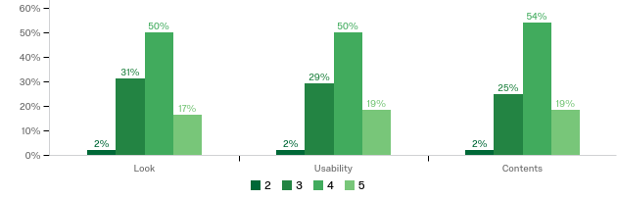
Base = 48 | Mean for ‘look’ = 3.8 | Mean for ‘usability’ = 3.9 | Mean for ‘contents’ = 3.9

When respondents were asked to explain their response, the two most common reasons given (coded) were that the site was easy to navigate (n=17) and that the information provided was clear (n=11).

What’s different about Renew Wales support?
Two issues stood out when respondents were asked to identify what, if anything, was different from the support provided by Renew Wales compared to other support available to groups such as theirs:

- The support was specific to their project (n=23)
- More personal contact (n=20)

A range of other issues were identified by respondents but the numbers identifying those issues were small compared to the above, suggesting that these are key USPs for Renew Wales. The other issues identified included:

- Knowledgeable on the environment (n=10)
- Free support (n=7)
- More flexible (n=4)
- Independent (n=3)

Perceived ongoing need for this type of support
Table 3.9: Is there ongoing need and demand for the type of support being provided? Please explain your answer
Answer | % | Count
Yes, definitely | 84% | 57
Yes, to some extent | 10% | 7
Not sure | 4% | 3
No | 1% | 1
Total | 100% | 68

Respondents were overwhelmingly positive when asked to comment on the ongoing need for the type of support provided by Renew Wales, with 94% identifying at least some need and 84% being certain that there was a need.

The most common reason for this was that the environmental expertise and knowledge provided by Renew Wales are important and something of which many people are not aware. Another key reason as to why there appears to be an ongoing need and demand is that Renew Wales is providing essential support for community groups, social enterprises and charities in areas in which they would otherwise struggle. It is suggested by 28 respondents that there are very limited resources available for these types of projects, which makes Renew Wales’ support invaluable.

There are four respondents who suggest that there is not an ongoing need for this type of support. The reasons for this include the lack of general funding, the need for a more coordinated type of support and, for two respondents, that the support they did receive through Renew Wales did not develop into what they had expected.

‘Definitely, if they were to offer more support like I've had already, then I would snap it up. It's easy to fall back into procrastination about a project where you have no guidance on it, so it's really good to have their support. I think others could really benefit from the support they provide as well because it's much more difficult when you're out there on your own without any guidance or expertise.’

‘I think awareness raising is huge. It's about keeping on top of that and continuing to drip-feed information about climate change to children. They are the next generation, so they need to be completely aware of it to look after our planet. I can't stress to them enough that the little things we choose to do every day are the things that have a big impact on our environment.’

‘I think that with the cuts in public value community schemes need support and expertise from elsewhere. These schemes delivering incredible value to their community and need the support that Renew Wales offers.’

‘We did not benefit, as the support was not carried through and we were left without a mentor.’

Case studies of supported groups
Section summary

- This chapter includes case studies which provide real examples of how Renew Wales has supported community groups and the benefits of that support.
- The case studies illustrate the range of groups supported and the range of work that they undertake, which is often enhanced as a result of the support that they have received from Renew Wales (a further positive spillover benefit).

Egni Co-operative
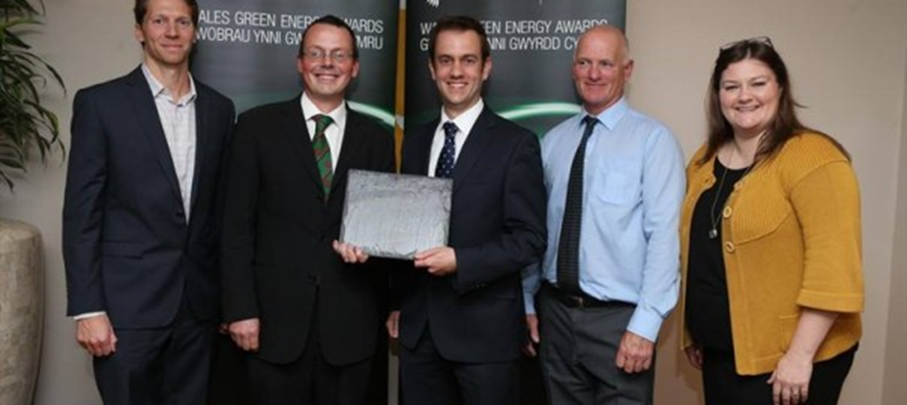
Egni Co-operative receiving the Renewable UK Cymru Green Energy Start Up Award, 2015

Established in March 2013, Egni Co-operative aims to develop solar PV projects and help others to put their money towards a more sustainable future. The co-operative does this by developing solar energy on community buildings in Wales, in turn generating clean energy whilst enabling the host buildings to be more financially stable.

As a result of the Egni share offer and further loan finance from Robert Owen Community Banking, £230,000 was raised for the co-operative in 2013. Through this and Renew Wales support, Egni Co-operative has installed solar panels on seven public buildings used by community groups. These include the DOVE Workshops in Banwen; Glynneath Training Centre; Phoenix Centre in Townhill, Swansea; Trimsaran Leisure Centre; Ysgol y Bedol Garnant primary school; Seven Sisters Community Centre; and Awel Aman Tawe.
Installation of rails for solar panels on Ysgol y Bedol

The solar panels provide free electricity to the seven sites, totalling 179kw. This means that the sites are saving an estimated £10,000 a year in electricity bills and will save 150,000 tonnes of carbon over the 20-year project lifetime.

The positive impact of the project extends to the community benefits that it provides. Members of the co-operative are drawn from the local area, which has enhanced social links within communities and educated local people about the issues surrounding climate change. The free electricity for the buildings has also meant that community organisations, including crèches, cafes and educational and training projects, have become more stable through the saving of £6–8,000 a year.

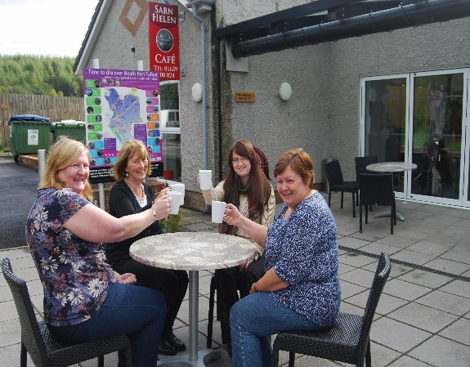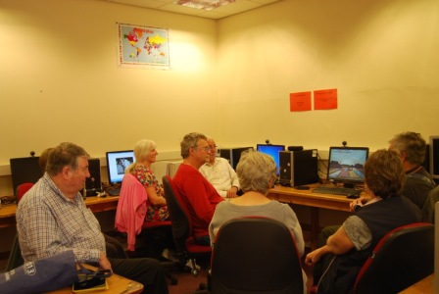
DOVE Community Café Computer course at Glynneath

When asked about Renew Wales’ support for the project, an Egni Co-operative representative said:

The project would not have happened without Renew. Renew was a very flexible source of support. It paid for development time via our Coordinator post within Awel Aman Tawe and also paid for specific expertise via Mentor time. We are very satisfied, as Renew Wales have the support package to help make projects like ours happen.

The mentor time provided by Renew Wales allowed for Energy Performance Certificates (EPCs) for each site as well as assistance with website development, grant applications, financial modelling, marketing, and the share offer. The representative stated:

The main point of difference [between Renew Wales and other support available] is the flexibility of the support and the amount of personal contact time you get with the local Mentors.

Looking forward, Egni Co-operative is planning another share offer in 2018, with the intention to carry on building, and helping others to put their money towards, a more sustainable future.

The Beaufort Theatre
The Beaufort Theatre is a lively and active community theatre managed by FFIN DANCE. In June 2017, the theatre and not-for-profit organisation FFIN DANCE engaged with Renew Wales with the aim of reviewing the energy efficiency of the building so that utility costs could be reduced, and the saved money could go into community activities.

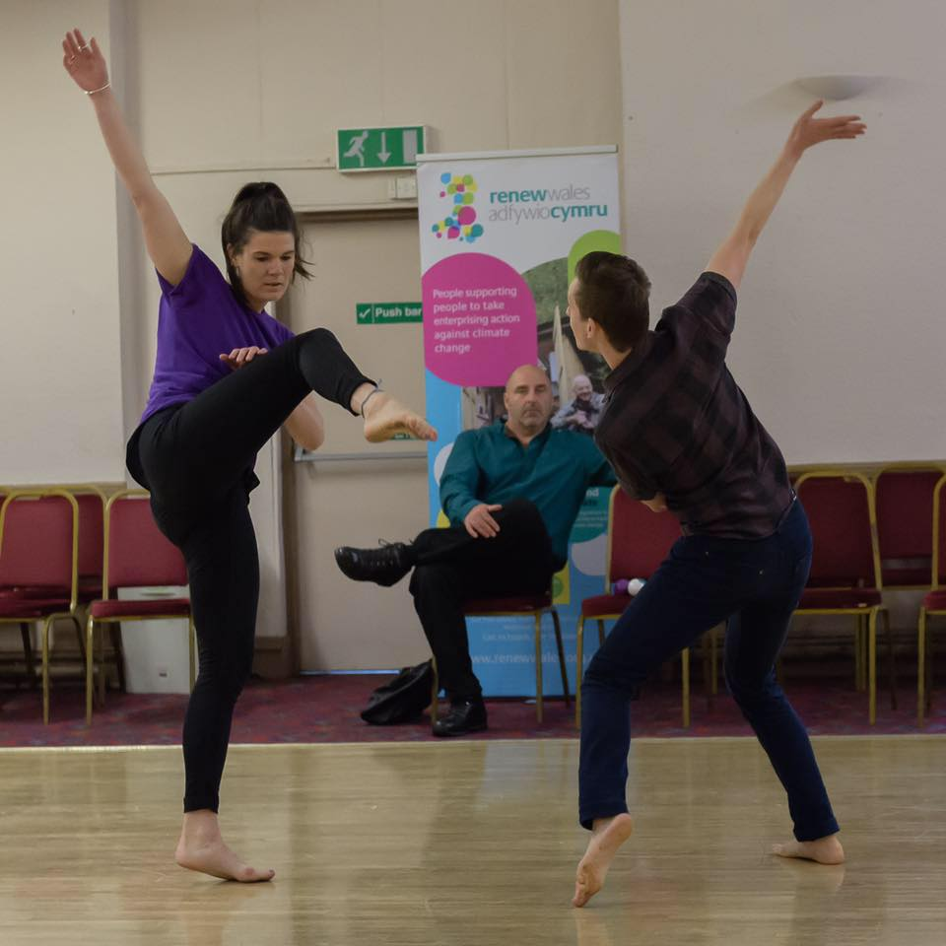
Image Paul Trask Copyright FFIN DANCE

The Beaufort Theatre hosts a wide range of performances and events throughout the year as well as arts activities, dance classes, and workshops. When asked about the theatre’s impact on the community, it was understood to be the number one theatre venue in Blaenau Gwent for dance, live music, musical theatre, and children's events:

We provide classes for local people from all age ranges, from babies to old people. We are planning to put on a Parkinson’s and dementia movement class, and also a baby yoga class. A large number of local community groups use our premises, including a male voice choir, an operatic society, local schools, and a theatre academy.

Those involved with the project suggest that Renew Wales’ role has been invaluable, as the support has been ‘very clear and comprehensive’ and has included ‘simple hints and tips to improve energy efficiency’, providing knowledge regarding light sensors and retrofitting, organising community meetings, and assisting in website development and grant applications. When asked about the wider community impact, a representative said:

It is very important to keep community buildings open and Renew Wales play an important role in doing this by helping to reduce energy costs. Community regeneration can't happen without these community hubs.

As a result of Renew Wales’ expertise and support, the theatre has updated its environment policy and has been updated on measures that they can take to save energy. Through these actions the theatre and FFIN DANCE anticipate that they will continue to benefit through the reduction of energy use and the lowering of carbon levels.

Ferryside Social Enterprise Group
In 2014, the Ferryside Social Enterprise Group (FSEG) was established so that the former Ferryside Residential Education Centre could be acquired and developed for the benefit of the local community. The project itself is complex and extensive. The centre includes old 1940s and 1960s buildings which require major refurbishments and sits on drainage and scrubland. In September 2016, the FSEG began engaging with Renew Wales for their assistance and support in respect of the project.

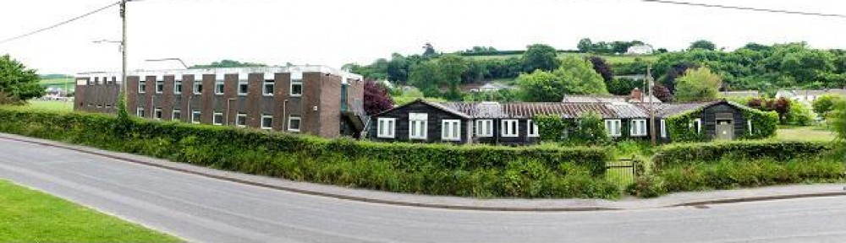
The former Residential Education Centre buildings

Renew Wales has been involved in a wide range of activities with the FSEG, including technical knowledge on sourcing materials, external cladding and the community energy scheme as well as signposting to funding sources and other soft support throughout the process:

I'm impressed by the ability of Neil (coordinator) to listen to what it is we're talking about and then identify who is going to be the most useful person for us to speak to at this phase.

Currently, grant applications of £110,000 are being drafted for the energy efficiency improvements, windows and cladding. Although the FSEG were already environmentally conscious, the following was stated:

Our sustainability policy is probably more stretching than it would have been had we not had the contact with Renew Wales. We've managed to get clauses in there that look at not just recycling of waste on site but looks at including sustainability as part of purchase policies and looks at doing more work with our potential tenants to ensure that they are all also more environmentally aware.

With Renew Wales’ support, the FSEG is hoping that a structurally sound, sustainably managed and eco-powered building will be created which will be ‘a warm, friendly place that feels safe to all’.

Abertillery Youth Centre
The Abertillery Youth Centre, situated in Blaenau Gwent, is one of two youth centre hubs in the region. The centre runs a Referral Group and an exclusion scheme which works with children who are at risk of being excluded from school. In June 2016, the centre began a project, with the assistance of Renew Wales, to build a garden within the centre using recycled materials.

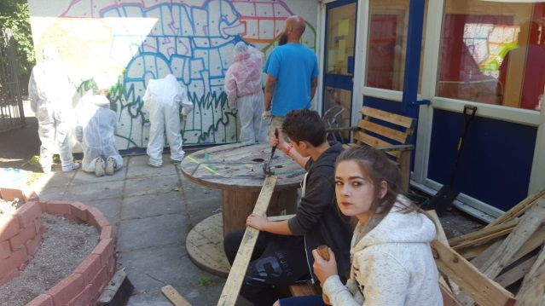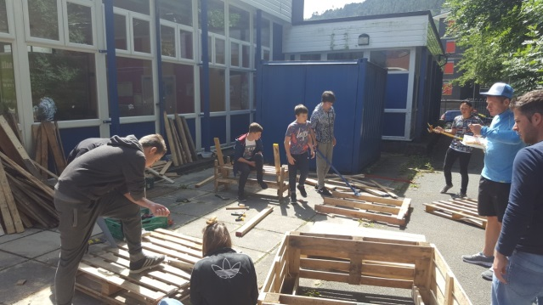
Building the Abertillery Youth Centre garden

The aim of this project was to transform an unused and overgrown space into a garden in which recycled materials were used to create raised beds and a sitting area, whilst also engaging young people and educating them on environmental awareness and recycling. The project has resulted in a thriving community garden space, increased by 10 metres squared and 40 more participants in the group. A youth centre representative stated:

The project has encouraged environmental awareness amongst the whole group. Considering a lot of the young people involved were very disengaged at the beginning, the enthusiasm of the mentor meant that environmental awareness was raised by the end of the project.

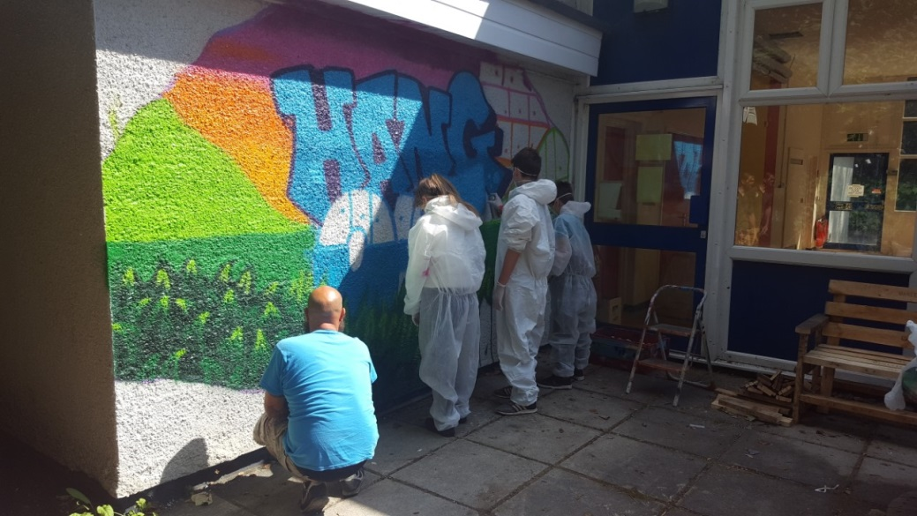
Building the Abertillery Youth Centre garden

It was suggested that the Abertillery Youth Centre’s garden project was made possible through the unique type of support offered by Renew Wales:

Most of the support out there is financial, which is good, but Renew Wales makes these projects successful by providing a mentor who has the expertise and knowledge to make it successful. We work with hard-to-engage young people and this type of project makes a huge difference to them and their lives and would not be possible without the help that Renew Wales provides.

Now that this particular project is complete, the centre is continuing to develop services for young people and has started a scheme in which young people are trained to recycle and repair old bicycles.

Oasis Cardiff
Opened in September 2008, Oasis Cardiff is an organisation that aims to help and support asylum seekers and refugees in integrating into their local community. The organisation provides a wide variety of activities, from cookery sessions, craft sessions and language classes to a range of women-only sessions. Oasis Cardiff’s Renew Wales project, launched in August 2016, is a cycle maintenance project for refugees and asylum seekers attending the centre. The aim of the project is to disseminate and educate centre attendees on bicycle maintenance and repairs so that they have a safe and free mode of transport.

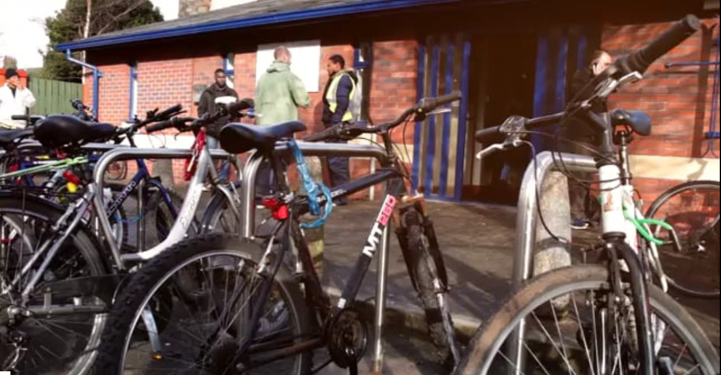
Oasis Cardiff

To run this project, Oasis Cardiff received support from Renew Wales in developing a business plan alongside expertise in bicycle maintenance and advice on training, staff and volunteers. Alongside this, Oasis Cardiff has continued to have a close relationship with its mentor:

Renew Wales was different [from other available help], as the relationship with the mentor was informal and friendly and there was less bureaucracy and the support was very flexible. Maz, our mentor, has sort of stayed with us, providing some extra time.

This project is understood to be particularly successful, as it supports the refugees who have been moved to the outskirts of Cardiff. The project has been able to ensure that these individuals have the resources and knowledge with which to get around the city safely. It is understood that with the advice and guidance of Renew Wales, this project will continue:

Renew Wales helped make sure the bicycle scheme was up and running smoothly and that we had everything that we needed so that it could work properly from day one. The scheme is continuing to grow, people are donating bikes, and we are making more storage room for them. We are also looking into making energy efficiency improvements.

Arts Factory Futures
The Arts Factory is an independent development trust established in 1990 and based in Ferndale at the top of the Rhondda Valleys. The trust aims to build a stronger and more inclusive community by creating opportunities for people who feel marginalised and excluded to develop skills, supportive social networks, self-confidence and self-esteem by contributing to team-based projects.

The Arts Factory first engaged with Renew Wales through an information meeting, as they were looking for advice on renovating their community building. A representative from the trust suggested that they had not known the extent to which Renew Wales could help:

I think loads of people still don't know about it. There's lots of community groups in buildings similar to ours and they don't realise what can be done to make them more energy-efficient and that Renew Wales can give advice to guide them in the right direction.

The development trust began working with Renew Wales in July 2016 with the aim of improving the lighting efficiency re-rendering schemes in the building. As part of the support, Renew Wales provided extensive, expert information on the building itself, alongside advice on ventilation systems, retrofit lighting, repointing, and funding application assistance.

When asked whether this support would benefit the community, it was suggested that ‘in challenging financial times’ the savings and improvements made to the building would enable the trust to keep going. In other words:

We provide job and training opportunities for vulnerable and marginalised adults, including adults with learning disabilities, with age ranges between 16–70, people who have been socially isolated. Everything that we can do to keep the building going enables us to keep providing this service.

As part of this project, two jobs have been safeguarded through the cost savings of the new lighting scheme. The Arts Factory has now completed this project and is continuing to make additional improvements with this newfound knowledge.

Friends of Mayhill Washing Lake and Community Food Garden
Friends of Mayhill Washing Lake and Community Garden is a group of local volunteers based in Swansea who maintain the historic pond area for the community whilst also providing and maintaining space for members to grow their own food.

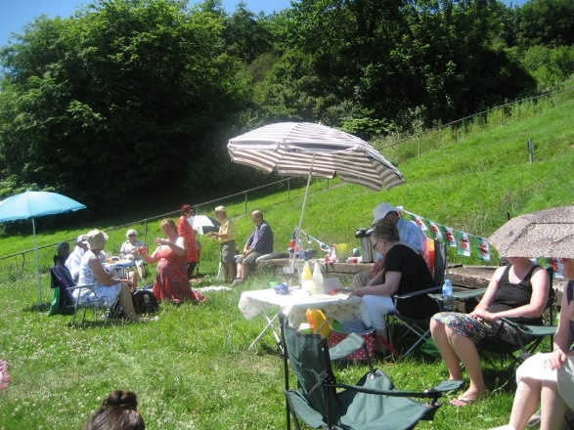
Big Lunch Community Day, June 2017

The group began working with Renew Wales in March 2017 because they needed help and advice in setting up their community growing space. As part of the support provided by Renew Wales, Friends of Mayhill Washing Lake and Community Food Garden have had their site assessed and received a report on garden planning and irrigation, as well as being provided with other practical advice on what to grow and when.

When asked about the support provided by Renew Wales, Friends of Mayhill Washing Lake and Community Garden said that the support had been ‘invaluable’, as they did not know ‘anyone else who provides this type of help’. Continuing on from this, they said:

The support from Renew Wales was different [from other available support], as the coordinator and mentor have excellent knowledge and connections in the locality about these types of projects and they are very willing to help. You feel like they have a lot of time to help you with any problems you have.

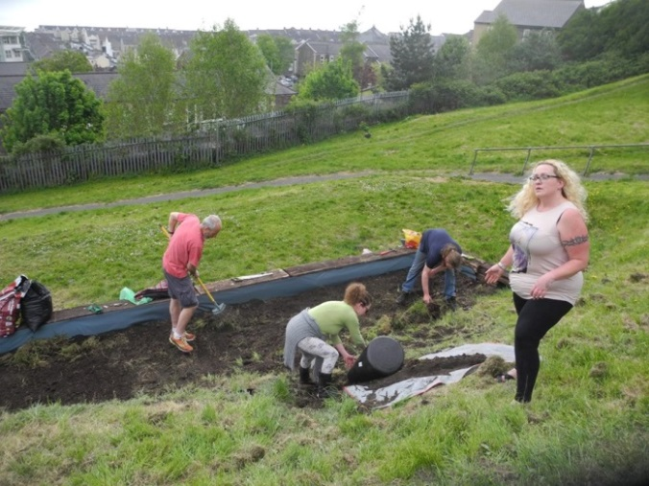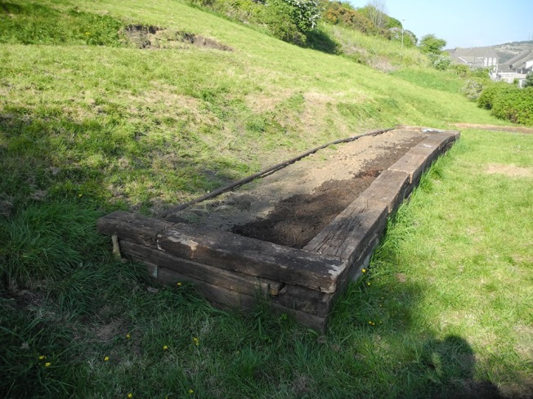Volunteers creating raised beds on the Mayhill site

As a result, the volunteer group has been able to improve ecology and biodiversity on the site through the planting of trees and additional plant species. The group has also been able to work with the local council to clean Mayhill Washing Lake and increase the number of members, with 10 extra volunteers in the local area.
Looking forward, the project will continue to plant and maintain the site with advice and guidance from Renew Wales. Having recently run community outreach events, such as the Big Lunch Community Day in June 2017, Friends of Mayhill Washing Lake plan to increase the accessibility of the site whilst also involving local people more.

Nantyffyllon Miners’ Institute
The Nantyffllon Miners’ Institute, established in Maesteg in 1954, is one of the 38 Miners’ Welfare Schemes operating in South Wales. Now operating as a local charitable organisation, the Nantyffllon Miners’ Institute is supported by the Coal Industry Social Welfare Organisation (CISWO) and is a community asset, not only for members of the mining industry but also for the community as a whole.

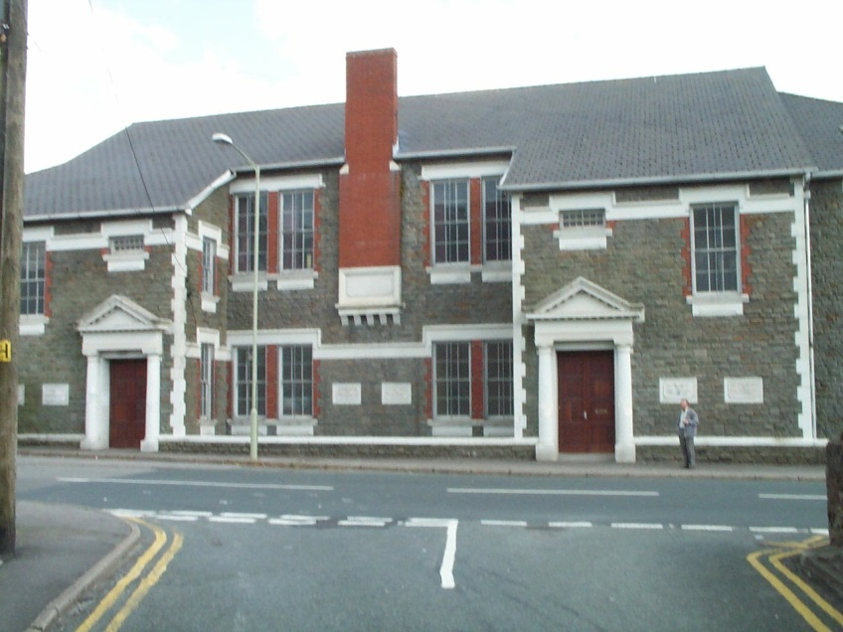
The Nantyffllon Miners’ Institute, Maesteg

In May 2016, the institute began working with Renew Wales because they had reached out for advice on how they could improve the energy efficiency of the listed building in which they are situated. When asked about the advice provided, the institute claimed:

It was free, quality advice. It's good to know that [RW] are there for those who are interested in helping the environment and being more energy-efficient.

Renew Wales provided the institute with technical advice on how to conserve energy, as well as advice on funding and options for energy-saving equipment. As a result, the Nantyffllon Miners’ Institute have installed solar panels on their building, providing them with free electricity during daylight hours of up to 3.8 megawatts. This has enabled them to reduce their energy bills by £500–600 a year, meaning that they are able to direct more funding to community activities and groups. The institute stated that they have:

Increased or safeguarded the number and type of services/facilities available to the local community. We've got about eight different groups using the premises, which have all been safeguarded because we're able to maintain the facilities, the building and the hire fees. Groups using the building include Slimming World and a Parkinson Therapy Group.

Overall, the improvements in energy efficiency supported by Renew Wales have enabled the Nantyffllon Miners’ Institute to reduce their energy bills whilst also enhancing knowledge and awareness of climate change issues.

Corwen Electricity Co-operative
The Corwen Electricity Co-operative was established in 2009 through a meeting, organised by Cadwyn Clwyd and Renew Wales, in the Corwen Sports Pavilion in Denbighshire, North Wales. The purpose of the co-operative was to build a 55kW high-head hydro scheme in Corwen to generate renewable energy for the local area for at least the next 40 years.

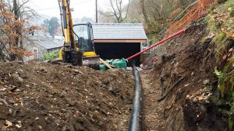
Construction of the Corwen pipework for the turbine and generator, December 2016

Renew Wales’ support for this project has been apparent since its inception. Director Joel Scott, when asked about mentor support, suggested that Renew Wales’ support had been invaluable, as they had outlined to the members where resources could come from and advised on how the co-operative would be able to put this scheme together. Scott said that Renew Wales provided:

All the information needed at the initial stage to start this project. They helped to bring together all of these other agencies, so it made sense and we had a picture of where we wanted to go.

The group noted that they had previously had no experience of renewable energy, climate change projects, or setting up a co-operative or managing capital projects. With support, the co-operative describe themselves as having ‘galvanised’ their community. From this, the Corwen Electricity Co-operative were able to complete their share offer and completed construction of the hydro scheme in December 2016.

The hydro scheme has enabled local people to access green and renewable energy, as well as increasing the co-operative revenues, which will allow it to create a larger community fund. Currently, the scheme is generating approximately 135,000kWh of renewable electricity every year, equating to 56,862kgCO2e per annum. With this successful track record, the Corwen Electricity Co-operative have confidence to take on new projects, such as the Bonwm Community Hydro scheme and an extension of the Energy Local Trial currently being trialled in Bethesda.

Conclusion and recommendations
The Headline:

The feedback from stakeholders interviewed for this evaluation and the vast majority of supported groups participating in the survey was largely positive. Renew Wales is clearly a highly regarded programme due to the support that it provides but also because of the way in which that support is provided.

This final chapter presents the conclusion of the evaluation together with several recommendations that are being made based on that conclusion. The discussion is split according to the two primary objectives of the evaluation: firstly, the review of the model being used to deliver the Renew Wales programme followed by a review of the outcomes of the programme as identified by the evaluation.
Evaluations always look for ‘additionality’:

The extent to which activity takes place at all, earlier or within a specific area or target group as a result of the intervention.

An impact or outcome that would not have occurred in the absence of the intervention.

The model
The Renew Wales “model” is often described by stakeholders as being a ‘different’ way of managing and delivering this type of programme, usually with an implicit comparison to projects and programmes that employ full-time Coordinators.

The basic model is, however, arguably seen across a range of sectors and areas of work, ranging from business support to social services. This is shown by the initial review of comparable projects undertaken for this evaluation (see Report 1).

Renew Wales was, however, not set up solely to deliver a service (which is usually the primary focus when models of delivery are being designed); it was also set up to have a direct positive impact on the third/voluntary sector in Wales. Facets of the Renew Wales model are therefore designed to add value to the ‘basic approach’. The most obvious is that the delivery of the service is embedded (or integrated) into the local community/area, since both Coordinators and Mentors must be hosted by a local third sector organisation.

This generates ‘additionality’ in several ways:

- Renew Wales’ support is integrated into the other support delivered to communities in each area (although not necessarily in the same way due to the range of host organisations and the variance in what they do). The potential for duplication is therefore less and supported groups can be directed towards other, complementary or more appropriate support; and
- Renew Wales directly ‘supports’ the host organisations of the Coordinators, Mentors and Central Team by contracting with them for the delivery of services, thereby helping to diversify their income streams and, in some instances, directly setting up and/or sustaining those organisations. It also provides training and development support to the staff of those organisations (i.e. Coordinators and Mentors), which will be beneficial to the other roles that they have within the organisation.

The second of the points above was identified during stakeholder interviews as being particularly important and a significant USP for the Renew Wales model. Indeed, there are many projects and programmes that have been set up specifically to achieve those outcomes. The ability to achieve the same outcome as a ‘by-product’ (or spillover benefit) of the principal objective of the programme (the provision of support to community groups) is therefore clearly positive.

Contracting with Coordinators on a ‘part-time’ basis also means that the funding available can be spread far wider and that the team can be far more spread geographically throughout Wales than could a model wherein a smaller number of full-time Coordinators are employed.

The model is, however, not perfect (no model is), which is important to recognise. Factors that need to be considered include the following:

- As with any contractor-based model, programme managers have limited influence over ‘staff’ engaged to deliver Renew Wales services, as they spend only a proportion of their time delivering Renew;
- Training and development costs for staff will be relatively high due to the numbers involved; and
- The approach is relatively administratively heavy for the Central Team due to the number of organisations and individuals involved.

The general view of stakeholders is, however, that the positives of the model outweigh these factors; as an evaluation team we would agree. Maximising the benefit to the organisations participating is, however, important.

Recommendation 1: Potential actions that could further enhance the model being used to implement Renew Wales should be explored. These could include:

- Enhancing the support provided to host organisations with a view to increasing the (non-financial) benefit that they gain from being part of the ‘Renew Wales network’. Options could include: (i) the provision of ‘pro-bono’ support from within the network, (ii) collective purchasing of products/services, (iii) developing the Renew Wales brand into a ‘quality assurance’ mark useful when tendering for services, etc.
- Identifying or developing additional programmes or projects that could be delivered via the same network (increasing the income to groups, reducing training costs [and other economies of scale], etc.).
- The provision of organisation-wide training support.

Feedback collected by the survey of community groups on the support that they received was positive in the vast majority of cases. Key reasons for this would seem to be:

- The ‘expertise and knowledge’ provided;
- The support provided was specific to the community’s project; and
- The level of ‘personal contact’ provided.

Maintaining these key ‘characteristics’ of the support provided as the programme progresses will be important. Perhaps most important from the list above is the ‘expertise and knowledge’ that Renew Wales was recognised as providing and it will be critical to maintain this. This is likely to mean an ongoing process of renewing and refreshing the pool of expertise available from the Renew Wales Mentors to ensure that the standard remains high, but also relevant to that is likely to be the developing and changing needs of community groups.

Recommendation 2: The provision of ‘knowledge and expertise’ has been identified as a critical success factor for Renew Wales and, therefore, needs to be maintained and developed. The pool of experts available via Renew Wales should be mapped and assessed on an ongoing basis to ensure that it reflects the ongoing and developing needs of community groups (i.e. ensuring that the correct knowledge and expertise can be provided). If necessary (e.g. if gaps in the expertise available are identified), the potential to develop and increase the expertise of Mentors via the provision of training and development support should be considered. The potential to have a pool of funding that can be used to pay for additional expertise, to supplement that available from within the Renew Wales network, should also be considered.

It would seem clear, however, that the Coordinators have perhaps the most critical role to play in the successful implementation of the Renew Wales programme. It is, however, a challenging role to deliver, requiring a range of knowledge and skills, all maintained and delivered on a part-time basis.

From a programme management perspective, understanding this is critical. Most important perhaps is being aware of the need for Coordinators to maintain (or develop) a range of different skills. For example, alongside knowledge and understanding of climate change and potential actions to mitigate its impact, the Coordinator also needs to be an excellent communicator able to work effectively (and quickly) with community groups as well as other stakeholders. They also need to be able to effectively promote the programme within their local area.

Recommendation 3: Recruitment of new Coordinators should consider the wide range of skills and expertise that the role requires, including communication, promotion and marketing skills as well as knowledge and experience of climate change issues and actions. Where appropriate, training and professional development support should be provided to develop the necessary range of skills and experiences.

Recommendation 3 is linked to Recommendation 1, which proposes the development of additional support for host organisations — training (perhaps not only for the individual who is the coordinator) could be one of those ‘non-financial’ benefits.

There was some discussion surrounding the amount of support (number of days) that Renew Wales could provide as well as the target that half of the groups supported should have no previous experience of taking action relating to climate change. Whilst these features of the programme frustrated some, our conclusion is that they are effective methods for maintaining the focus of the programme and making the best possible use of the limited resources available.
o
Not all Renew Wales support needs to be delivered via the Coordinators and Mentors or on a local basis. There is already an example of a project being delivered on a national level (working with the WRU) and discussions with stakeholders suggest the potential for further developments of this nature. It was also suggested that some national issues could be explored or tackled centrally to avoid the potential for duplication at a local level.

Recommendation 4: The potential for the development of more ‘national’ projects should be considered. This would not necessarily mean an expansion of the Central Team or their role; it could, for example, be that individual Coordinators or Mentors from within the Renew Wales network are given ‘national’ roles when projects are developed, or opportunities arise which match their areas of expertise. The potential to ‘scale up’ ideas and actions developed at a local level should also be explored on an ongoing basis.

The feedback on the Renew Wales website via the survey of community groups was positive. It is our view, however, that the use of the website could be enhanced substantially and that this could potentially expand the number and range of groups that Renew Wales is able to engage and support online. Such support could also effectively complement the face-to-face support provided by Mentors and Coordinators, which it should not be replacing.

Recommendation 5: Options to further develop the online presence of Renew Wales should be explored. These should include the potential to set up and host online discussion forums for accessing advice from Renew Wales Mentors, online networking forums for community groups, video tutorials, video case studies, and so on.

Turning our attention briefly to the Steering Group, the evaluation found that it continues to provide valued support to the programme, particularly to the Central Team. However, the need to ‘refresh’ the group was apparent.

Recommendation 6: Options for refreshing the membership of the Steering Group, potentially on an ongoing basis, should be explored. Options could include an annual general meeting of a more formally constituted Renew Wales as an organisation to elect members to the Steering Group or rotating a proportion of the membership of the group between the host organisations on an annual basis alongside ‘core’ members of the Steering Group.

To conclude this section, several further suggestions for the development of the model or the service provided by Renew Wales were suggested during the course of discussions with stakeholders or prompted in the minds of the evaluators as a result of the discussions. These are noted below:

- Broaden the programme from an initiative to help community groups to take action relating to climate change to the provision of support that addresses the objectives of the Well-being of Future Generations (Wales) Act.
- Set up some type of membership scheme (potentially at a small cost to the group) for supported groups — formalise the network and potentially generate an additional income stream.
- A greater focus on ‘education’ outreach services — working with schools and young people in particular.

Outcomes
Understanding the type of activity or project being supported is important when considering the outcomes of a programme, as is the scale of the support being provided. It is interesting to note that for most respondents to the survey, the ‘project’ supported by Renew Wales was still ongoing. This reflects the fact that Renew Wales is, in the main, an information, advice and guidance (IAG) service contributing to the delivery of a project. The support that can be provided is also limited (five days in total), which inevitably limits the likely impact.

Renew Wales usually makes a contribution to a ‘project’ as opposed to supporting it from start to finish. This means that the amount of data that groups can provide relating to what some would describe as ‘hard’ outcomes of the support provided by Renew Wales is limited. Few groups can, for example, provide data on the reduction in CO₂ emissions or the number of jobs created because of the support provided. Assessing Renew Wales against those types of outcome indicators would, however, we would argue, be inappropriate due to the type and scale of support provided.

Discussing the support provided by Renew Wales in relation to ‘projects’ is, in fact, probably inappropriate; the provision of support to groups to progress and develop their activities is probably a better description.

The outcome most frequently identified in the survey is the provision of knowledge and expertise which the community group does not have which they needed to be able to progress with their ‘project’, whatever that may be. The provision of that knowledge and expertise via Renew Wales allows their project to progress.

The principal outcome of Renew Wales is that it improves and enables projects and community groups to progress and deliver their services/activities to the benefit of the local community.

The second half of the sentence above is important, as it reflects the fact that Renew Wales is providing support to groups that are undertaking activities that support their local community. Whilst the outcomes of those activities cannot be attributed to Renew Wales, the support provided is supporting (and often enhancing) their delivery.

Sometimes the projects or groups supported by Renew Wales are directly related to tackling or mitigating the impact of climate change. Other projects and groups supported have another principal objective (e.g. providing space for youth services), with Renew Wales helping them to achieve that objective in a way which contributes to the mitigation of climate change.

Assessing deadweight — which would have happened anyway — is an important element when evaluating the outcomes of an intervention. In the case of Renew Wales, responses to the survey suggest low levels of deadweight within the programme. Whilst a proportion of respondents did anticipate that the outcome that they identified would have happened anyway, even in those instances, it was noted that the outcome took place sooner or was greater because of the support that they received. It is worth noting that the key reason for this is that the groups supported did not have the knowledge or expertise necessary to achieve the outcome. Again, this underlines the provision of ‘knowledge and expertise’ as being the USP/critical success factor for Renew Wales.

The evaluation also explored the outcomes of the support provided by Renew Wales in respects of awareness and behaviour relating to climate change, as illustrated by the graphic below, taken from Report 1 of the evaluation.

Figure 5.1: Steps from awareness to impact

The findings of the survey suggest the support provided by Renew Wales as having had a positive impact on groups: (a) ‘awareness, knowledge and understanding’ of climate change as an issue; (b) ‘knowledge and understanding of potential actions’ relating to climate change; and (c) ability to take actions relating to climate change. Impact, however, seems clearest in respects of (b) knowledge and understanding of potential actions. There are probably two reasons for this. Firstly, many of the groups supported already had an awareness of climate change issues, meaning that there was less scope to achieve a positive impact in that area. Secondly, the restrictions on the support available (IAG only, limited to five days) limited the scope of the project to have an impact on a group’s ability to take actions.

To conclude, the findings of this evaluation have been very positive. The feedback from stakeholders has almost exclusively been positive, as it has from the majority of groups participating in the survey. Positive outcomes have also been identified. Renew Wales is clearly a highly regarded programme due to the support that it provides but also because of the way in which that support is provided.

The extent to which activity takes place at all, earlier or within a specific area or target group as a result of the intervention and/or an impact or outcome that would not have occurred in the absence of the intervention.
This is an issue that could be usefully evaluated in subsequent research.
You can find more information about this programme here: https://www.biglotteryfund.org.uk/global-content/programmes/wales/sustainable-steps
If the link is not working, you can view the video by copying or typing the following into your browser URL bar: https://www.youtube.com/watch?v=l_6SxWFwNdo&t=119s
This is defined as any exchange between the Coordinator and a group to discuss a potential project or the support that is available. This includes meetings, an exchange of emails, etc.
Continuous professional development
https://www.ofgem.gov.uk/environmental-programmes/fit/about-fit-scheme/changes-fit-scheme
‘Renew Wales’ is currently not constituted as an organisation in any way.
It was noted within the question that we understood that the level of impact was likely to vary within a group. If this was the case, the respondent was asked to note what they considered to be the level of impact ‘on average’ within the group.
Respondents would provide multiple reasons.
Unique Selling Points
Further information is available here: http://gov.wales/topics/people-and-communities/people/future-generations-act/?lang=en

