GARDEN MANAGEMENT PLAN FOR TREDEGAR HOUSE LAUNDRY GARDEN 2018-2020

Version: Year 1 - September 2018: Replaces Version: 0000

Operations Manager (Growing space)
Vocational Training Officer (Woodland Routes to Well-being)
Head Gardener (National Trust)
Visitor Experience Officer (National Trust)
Community Engagement Officer (National Trust)

Contents

- Background
- Introduction
- Vision
- Primary character areas
- Identified priority project work in the Laundry garden 2018-2019 (Table format detailing works for next 2 years)
- Garden standards
- Future aspirations (Potential works that will not be picked up in time period of plan)
- Projects suitable for donation funding
- Funding
- Interpretation and Visual Language
- Conclusion
- Appendix
- Bibliography

1. Background
Tredegar House and Parkland

Tredegar House was the historic center of an estate built up by the Morgan family between C15th – C20th. It was sold in 1951 to St Joseph’s Convent and High School and in 1962 the last Lord Tredegar died childless in Monaco. Tredegar House was purchased by Newport Borough Council in 1974 and leased to the National Trust in 2012 on a 50 year lease. It has been open to the public since 1974, but has only recently been opened up on a much bigger scale as previously the only way to view the house was through pre-booked tours for only part of the week.

Tredegar House and Parkland has been managed by the NT since 2012, opening up more access for people and with a big aim to engage with the local community and the people of South East Wales. This grade 1 listed mansion, gardens and parkland, is positioned right in the heart of the Duffryn community, with the Duffryn estate being built on the previous Tredegar Estate land.

There is great opportunity to build on Tredegar’s relationship with the community, opening up more opportunities for local people to benefit from all that the Tredegar estate has to offer, especially in the area of learning, personal development, gaining new skills through volunteering, and also from the tranquil sanctuary of the beautiful surroundings.

Working very closely with the local community, the NT has ambitious plans for Tredegar over the next 10 years to conserve and develop the estate for people. The wider vision will bring a wealth of opportunities for local people to help us shape plans and thinking; offer diverse volunteering opportunities to help people gain work experience; and see us transform some of the spaces/buildings at Tredegar for the benefit of the local community.

In 2012 NT developed an area of Tredegar House as a community food growing area. This project was developed in partnership with the local Communities First Cluster; managed by Duffryn Community Link and mental health charity Growing Space. The project contributed directly to Oxfam’s ‘Sustainable Livelihoods Approach’ to tackling poverty on the ground within Newport’s Communities First West Cluster. This successful project saw fantastic engagement with the community, and it came to a point where in order to progress further more space, particularly indoor space, was needed for the community to undertake training and development in a place of sanctuary.

2. Introduction

Where is Tredegar House Laundry Gardens in 2018…?

The Laundry building and Laundry gardens have recently been renovated with the help of grants funding from the Welsh Assembly Government, Community Facilities programme and The Big Lottery, Create Your Space fund. This funding has enabled the National Trust to develop the Laundry building for community use and it has transformed the old Laundry Yard into the Laundry gardens. The Laundry gardens have three growing areas which are designed to appeal to individuals and groups with a range of disabilities and social issues. The Laundry garden consists of; 1. A sensory garden for those with visual impairment, this area has been carefully planted with scented and tactile plants. 2. An area of raised beds which make it easy for wheel chair users to enjoy the benefits of being outdoors and cultivating plants. 3. An area of tranquility that appeal to those with low level mental health issues, a quiet area for reflection and contemplation.

Method

To note work has been planned around the nesting bird season which requires conservation work such as cutting back to be undertaken between September and early March. Typically we undertake our heavier work, project work in the Autumn and Winter months and this allows for the later months of spring and summer to be given over to the routine maintenance of mowing, edging and weeding to showcase the gardens at this time. Timings will be affected by specific seasonal weather conditions experienced at the time and so we will need to respond to this and take a flexible approach to our work. Consideration has also been given to optimum planting times so at its very basic, water lilies respond best when planted in May and trees and shrubs do best when planted in the autumn months on the lead up to Christmas.

3. Vision

For the Laundry building and gardens to become a green community hub - a unique environment inspiring learning, social engagement and well-being

“I really want the Laundry to be a beautiful and inspirational place where local people can offer their time to help. It will have full disability access and the work will be gentle so that everyone can contribute to making it a place Duffryn can be proud of."
Person X (December 2017)

4. Primary identified areas of Laundry Garden

There are three distinct areas to the Laundry Gardens, consisting of community growing beds, sensory garden and garden of tranquility. These areas are cared for by Growing Space as part of the Woodland Routes to Well-being project which funds one gardener to manage the gardens three days per week, supported by referred clients and community volunteers.

Primary identified areas of Laundry Garden 2018

2. Sensory garden
Laundry Building
Tredegar house

1. Community
growing beds

3. Garden of Tranquility

Character area | Work | Priority | Timescale | Costing | Comments
2018
Community growing beds | Identify Crop rotation Grouping (Appendix 2) | 1 | March 2018 | N/A
Community growing beds | Develop Four year rotation plan (Appendix 2) | 1 | March 2018 | N/A
Community growing beds | Deliver Companion planting plan (Appendix 2) | 1 | March 2018 | N/A
Community growing beds | 1st Seeding of beds | 1 | July 2018 |  | Big lottery create your space funding
Sensory Garden | Community Groups to help plant new beds | 1 | June 2018 |  | Big lottery create your space funding
Garden of Tranquility | Community Groups to help plant new beds | 1 | June 2018 |  | Big lottery create your space funding
All Areas | Interpretation Officer to work alongside partners to deliver interpretation and help consult on visual language | 1 | June 2018 | N/A
All Areas | Visitor access to be trialed and monitored | 1 | September 2018 | N/A
5. Identified Priority Work in Community Gardens 2018-2019

Key

Priority of works

1 .High Priority

2. Medium Priority

3. After 1-2 completed

Note- There may be adjustments to timings and dates as
garden conditions and property requirements evolve.

Character area | Work | Priority | Timescale | Costing | Comments
2019
Community growing beds | Develop composting area | 2 | Jan-Fab 2019 |  | Re using wood from old allotment gardens
Community growing beds | Annual planting plans delivered | 1 | Jan 2019
Community growing beds
Sensory Garden | Consult with local bee keeping association and NT staff on Bee hives being located in Garden | 2 |  |  | B to lead and consult with local bee association and NT Department heads
Raised beds | Example Phase 3 reduce outside path edge of Beech hedges. This will complete the 3 year restoration of this hedge.  Review and replace any underperforming roses | 3
Sensory Garden | Example butterfly border areas.  To support longevity team to prune subsequent replants in April and after flowering in early August. An inch of fresh growth removed at each cut back to keep plants tight and fresh. | 2
All Areas | Review original planting scheme and identify future changes | 2
All Areas | Develop cyclical annual works planner |  |  |  | Excel spread sheet
All Areas | Continue testing visitor access
All Areas | Continue working alongside VE team to ensure visual language meets SoP

Cyclical annual works garden planner to follow, due autumn 2019
6. Gardening standards
- Staff managing the gardens to have or be working towards a RHS level 2 qualification in horticulture.
- Although the gardens have a welcoming, informal community feeling this should not compromise standards. Examples being, that no pernicious weeds should be allowed to establish in the gardens, soil should be kept in good condition and no plastic planting containers to be used within the gardens.
- Any changes in planting or garden design should be agreed and planned through this garden management plan, an example of changes that would need to be agreed include planting of more hardy woody plants.
- Where ever possible standards of garden management should be informed by the National Trusts, Environmental Standards for Gardens & Parks. All works in the garden should aim to reach gold standards as set out within this document.
- The garden will seek to attain the Green Flag Award for community spaces, in accordance with standards set out in 2016 Keep Britain Tidy guidance manual ( Ellicott, 2016).
- Use of herbicides and pesticides to be agreed by Tredegar House, Head Gardener, with accurate records being kept of usage.
- All new planting to be peat free.

7. Future Aspirations

Area | Aim | Importance
All Areas | Laundry gardens to attain soil association accreditation so produce can be used in Tearooms | 2
All Areas | Will meet gold level of NT environmental standards | 1
All Areas | The gardens will be awarded The Green Flag Award Status | 1

8. Projects Suitable For Donation Funding

Area | Need | Cost | Possible funder
All areas | Tools and Seeds | TBC | GoCompare
All areas | Small project items | TBC | Friends of Tredegar House
All areas | Small project items | TBC | Gwent National Trust Association

9. Funding

- The annual cyclical work is currently funded by a Big Lottery “Create Your Space” fund as part of the Woodland Routes to Well-being project and this will enable B to manage garden works three day per week until 2025.
- National Trust community budget will allocated a sum each year to be spent on planting.
- Tredegar House visitor experience team will be consulted regarding, funds available for ongoing changes to interpretation and visitor experience.
- Any compliance improvements to gardens will be referred to the National Trust Facilities or Gardening Departments in the first instance and external funding may be sourced.

2018 Small project funding

Name of organisation | Amount donated | Allocated to
Organisation 1 | £1000 | Gardens Gift Fund

10. Interpretation and Visual Language

The Laundry and Dairy building are part of the wider Home Farm area. A visual language is being developed for this area, to include colour schemes and materials. This is to ensure that each part of the Home Farm, as it develops, fits within the whole and is line with the Spirit of Place for Tredegar House, the Home Farm, and the Laundry/Dairy. This may include things like garden containers, plant labels, benches etc.

This work will be carried out with the Visitor Experience team, in particular the Interpretation Officer. This will be collaborative with the Garden Team, Community Officer and partners including Growing Space and the Woodland Routes to Wellbeing. This is to ensure that any interpretation or suggestions that fit with the visual language are practical for use in the space.

The Tredegar House ‘Story’

The story of Tredegar House for the next 5-10 years has been agreed as ‘The Morgans and their Influence’. This will help to guide the visitor experience and interpretation across the whole site. This includes the Home Farm area and the Laundry/Dairy building as historically being part of the self-sustaining estate.

It is the intention for Tredegar House to participate in the NT National Public Programming Plans for the next 3 years. 2019’s theme is ‘Radical Landscapes’ and we will be looking at land use across the wider estate, both historically and today, with a focus on the Chartist uprising of the 19th century. 2020 looks at ‘Mental Health and Wellbeing’ and offers an opportunity to widely share the work taking place on site, encouraging our visitors and community to take part. The Laundry development will be included in these plans. This should have a positive impact on the use of the Garden, and would be worked out in conjunction with all partners.

Visitor Access

Access to the gardens to visitors and park users will be trialled and monitored across some days. Appropriate signage would be in place, particularly highlighting the tranquillity garden and sensory garden, as well as promoting the work that is being done by partners and the local community.

11. Conclusions

We hope this document will provide a focus and a settled long term plan for the management of Laundry gardens, it is also hoped this plan will help to support future funding opportunities. This document will be a working plan for the Tredegar House garden team, wider property team and Growing Space/ Woodland Routes to Well-being; it will be the go to document for future works. The plan is flexible and it may evolve but the core conservation targets are now set in a stronger time frame for the future. Now Gardeners’… let’s dig…!

12. Appendix

List of appendices

Appendix 1…………….. List of Documents consulted

Appendix 2…………….. Crop rotation groupings
Appendix 3…………….. Example of Table of completed works following version 2018
Appendix 4……………...Laundry garden plants list Sept 2018
Appendix 5…………….. garden design and planting plan 2017

Appendix 1

Documents consulted to inform this Garden Management Plan and of value for reference alongside this document:

- Welsh Government, Community Facilities Programme Application Form 2016
- Big Lottery, Create your Space: Woodland Routes to Wellbeing Application Form 2016
- Garden Management Plan for Chartwell Garden 2016-2021
Appendix 2
(Example) Crop rotation groupings (Foster 2008)
Brassicas
Roots
Alliums
Others
Legumes

Onions
Shallots
Garlic

Potatoes
Carrots
Jerusalem
Artichokes
Parsnips
Beetroot
Cabbage
Cauliflower
Brussels
Sprouts
Broccoli
Swede
Turnip
Radishes
Ornamental
vegetables

Lettice
Sweetcorn
Courgettes
Pumpkins
Squash
Aborigines
Cucumbers
Chicory
Endive
Fennel
Tomatoes
Spinach
Chard
Celery
Celeriac

Peas
French beans
Broad beans
Runner beans

Four year crop rotation
Year 1 Year 2 Year 3 Year 4
Roots
Brassicas
Legumes
Alliums

Alliums
Roots
Legumes
Brassicas

Alliums
Legumes
Legumes
Brassicas
Roots
Alliums
Roots
Brassicas

(Example) Four year crop rotation Community growing beds
Brassicas
Roots
Alliums
Roots
Alliums
Legumes

Brassicas
Roots
Legumes
Brassicas
Alliums
Legumes

Year 2019
Legumes | Alliums | Roots | Brassicas | Legumes | Alliums
Alliums | Legumes | Brassicas | Roots | Brassicas | Roots

Year 2020
Brassicas | Legumes | Alliums | Roots | Brassicas | Legumes
Legumes | Brassicas | Roots | Alliums | Roots | Alliums

Year 2021
Roots | Brassicas | Legumes | Alliums | Roots | Brassicas
Brassicas | Roots | Alliums | Legumes | Alliums | Legumes

The Laundry at Tredegar House - Crop Rotation and Companion Planting - 2019 Season
Nutrient Accumulators | Nettles/Comfrey/Plantain | Horseradish/Dandelion/Dock
Potato | Earlies, second earlies | Maincrop
Fruit | Courgettes & Nasturtium | Pumpkin & Sweetcorn
Roots & onions | Beetroot & Onions  Parsnip & Garlic | Carrots & Chives/Parsley  Leeks & Celery  Rosemary
Brassicas | Cabbage & Borage/Dill  Broccoli & Chamomile/Pak Choi  Kale & Sage  Cauliflower & Marjoram | Chard & Coriander  Spinach & Radish  Brussels & Thyme
Beans | Runner, Broad & Marigolds | French, Borlotti & Summer Savory  Peas & Turnips  Sugar Snap & Swede
Nutrient accumulators provide constant ‘cut and come again’ greens for composting and fertiliser. They stay in the same bed but each year vegetables move down one row.

Appendix 3
Example of Table of completed works following version 2018

2018
Character area | Work | Priority | Cost | By | Status
Community Growing Beds | EXAMPLE Rose Garden Wall restoration phase 1 and subsequent border replanting and re tying to new wire supports. Borders on outer wall to receive refreshed shrub planting. | 1 | Funded Via Wall Restoration Project | Brian Hanlon / NT Garden team | Completed July 2018
Sensory Garden |  |  | N/A
Raised beds |  |  | N/A
Garden of tranquility |  |  | £400

Appendix 4

Laundry garden plants list Sept 2018

Common Name | Latin Name | Height x Spread | Planting Plan Spacing | Soil | Light | Hardiness
Bamboo | Arundinaria auricoma | 1.5-2.5m x  1.5-2.5m | 4/m2 | Humus rich | Full sun | H5 (-15)
Great masterwort | Astrantia major ‘Hadspen Blood’ | 50-100cm x  10-50cm | 5/m2 | Humus rich | Full/partial sun | H7 (-20+)
Japanese laurel | Aucuba japonica ‘Rozannie’ | 50-100cm x  50-100cm | 4/m2 | All but not waterlogged | Full/partial shade | H5 (-15)
Japanese maple | Acer palmatum  (cultivar?) | 1.2-8m | Tree | Moist but well drained | Full/partial sun | H6 (-20)
Common box | Buxus sempervirens | 70cm diameter ball | Spec | well drained | Full/partial shade | H6 (-20)
Elephant’s ears | Bergenia ‘Silberlicht’ | 10-50cm x  10-50cm | 5/m2 | Moist but well drained/  Humus rich | Full/partial sun | H6 (-20)
Californian lilac | Ceanothus ‘Blue Mound’ | 1-1.5m x  1.5-2.5m | 4/m2 | well drained | Full sun | H4 (-10)
Bearberry cotoneaster | Cotoneaster dammeri | 10-50cm x  1.5-2.5m (mat) | 4/m2 | well drained/dry | Full/partial sun | H6 (-20)
Californian lilac | Ceanothus ‘Italian Skies’ | 1-1.5m x  1.5-2.5m | Climber | well drained | Full sun | H4 (-10)
Clematis | Clematis montana ‘Rubens’ | 4-8m x  1.5-2.5m | Climber | Moisture retentive, well drained/  sheltered | Full/partial sun/keep roots cool | H5 (-15)
Filbert | Corylus maxima ‘Purpurea’ | 4-8m x  2.5-4m | 2/m2 | chalky/keep clear 60cm around trunk | Full/partial sun | H6 (-20)
Mexican orange | Choisya dewitteana ‘White Dazzler’ | 50-100cm x  50-100cm | 3/m2 | well drained/  sheltered | Full sun | H4 (-10)
Escallonia | Escallonia ‘Apple Blossom’ | 1.5-2.5m x  1.5-2.5m | 2.5/linm | well drained/  sheltered | Full/partial sun | H4 (-10)
Oleaster | Elaeagnus ‘Quicksilver’ | 2.5-4m x  2.5-4m | 4/m2 | well drained | Full sun | H5 (-15)
Geranium | Geranium ‘Patricia’ | 50-100cm x  1.5-2.5m | 4/m2 | Moderately fertile/not waterlogged | Full/partial sun | H7 (-20+)
Alum root | Heuchera ‘Chocolate Ruffles’ | 50-100cm x  50-100cm | 5/m2 | Fertile, moist but well drained/mulch | Full/partial sun | H6 (-20)
Alum root | Heuchera ‘Licorice’ | 30-40cm x  30-40cm | 5/m2 | Well drained | Full/partial sun | H6 (-20)
Hebe | Hebe ‘Midsummer Beauty’ | 1.5-2.5m x  1-1.5m | 4/m2 | Moist but well drained | Full/partial sun | H4 (-10)
Hebe | Hebe ‘Wiri Mist’ | 60cm x 80cm | 3/m2 | Fertile, well drained | Full/partial sun | H4 (-10)
Irish ivy | Hedera helix ‘Hibernica’ | 8-12m x  4-8m | Climber | Fertile, humus rich, alkaline/neutral soil | Full/partial sun | H5 (-15)
Lenten Rose | Helleborus x hybridus | 10-50cm x  10-50cm | 4/m2 | Fertile, humus rich, alkaline/neutral soil | Full/partial sun | H7 (-20+)
Hydrangea | Hydrangea paniculata ‘Ammarin’ | 2.5-4m x  1.5-2.5m | 2/m2 | Fertile, humus rich, well drained/shelter | Full/partial sun | H5 (-15)
Hydrangea | Hydrangea paniculata ‘Pink Diamond’ | 1.5-2.5m x  1.5-2.5m | 3/m2 | Moist but well drained | Full/partial sun | H5 (-15)
Oak-leaved hydrangea | Hydrangea quercifolia | 1-1.5m x  1.5-2.5m | 3/m2 | Moist but well drained | Full/partial sun | H5 (-15)
Daylily | Hemerocallis ‘Stella d’Oro’ | 10-50cm x  10-50cm | 4/m2 | Moist, fertile but well drained | Full sun | H6 (-20)
Silver-margined holly | Ilex aquifolium ‘Argentea Marginata’ | 12m+ x  4-8m | 1/m2 | Well drained | Full/partial sun | H6 (-20)
Lavender | Lavendula ‘Grappenhall’ | 80 x 60cm | 4/m2 | Well drained, alkaline/neutral soil | Full sun | H5 (-15)
Common Lavender | Lavendula angustifolia ‘Alba’ | 50-100cm x  1-1.5m | 2.5/linm | Well drained, alkaline/neutral soil | Full sun | H5 (-15)
Honeysuckle | Lonicera periclymenum | 4-8m x 1-1.5m | 1/m2 | Moist but well drained | Full/partial sun | H6 (-20)
Oregon grape | Mahonia aquifolium ‘Apollo’ | 50-100cm x  1-1.5m | 4/m2 | Moist but well drained | Full/partial shade | H5 (-15)
Oregon grape | Mahonia japonica | 1-1.5m x  1.5-2.5m | 4/m2 | Moist but well drained | Full/partial shade | H5 (-15)
Tree celandine | Macleaya cordata | 2.5m x 1m | 4/m2 | All types | Full/partial sun | H4 (-10)
Eulalia | Miscanthus sinensis ‘Morning Light’ | 1-1.5m x  50-100cm | 4/m2 | Moist, moderately fertile but well drained/avoid excessive winter wet | Full sun | H6 (-20)
Sacred bamboo | Nandina domestica | 1-1.5m x  1-1.5m | 2/m2 | Moist but well drained/  sheltered | Full sun | H5 (-15)
Peony | Paeonia ‘Bowl of Beauty’ | 50-100cm x  50-100cm | 4/m2 | Deep, fertile, humus rich, well drained/  shelter/support | Full/partial sun | H6 (-20)
Peony | Paeonia ‘Duchesse de Nemours’ | 50-100cm x  50-100cm | 4/m2 | Deep, fertile, humus rich, well drained/  shelter/support | Full/partial sun | H6 (-20)
Peony | Paeonia ‘White Wings’ | 50-100cm x  50-100cm | 4/m2 | Deep, fertile, humus rich, well drained/  shelter | Full/partial sun | H6 (-20)
Flax Lily | Phormium ‘Bronze Surfer’ | 70cm x 40cm | 4/m2 | All but not waterlogged | Full/partial sun | H3 (-5)
New Zealand Flax | Phormium tenax ‘Maori Queen’ | 1m x 1.5m | 4/m2 | Fertile, moist but well drained/mulch | Full/partial sun | H3 (-5)
Shrubby cinquefoil | Potentilla davurica ‘Elizabeth’ | 50-100cm x  50-100cm | 4/m2 | All but flowers fade more rapidly in full sun and last longer in moister soils | Full/partial sun | H7 (-20+)
Christmas berry | Photinia x fraseri ‘Red Robin’ | 2.5-4m x  2.5-4m | 2.5/linm | Fertile, humus rich | Full/partial sun | H5 (-15)
Poppy | Papaver orientale ‘Beauty of Livermere’ | 50-100cm x  50-100cm | 4/m2 | Well drained/well rotted manure prior to planting/avoid overfeeding | Full sun | H7 (-20+)
Winter flowering cherry | Prunus subhirtella ‘Autumnalis Rosea’ | 4-8m x  2.5-4m | Tree | Moist but well drained | Full sun | H6 (-20)
Tawhiwi | Pittosporum tenuifolium ‘Silver Queen’ | 2.5-4m x  1.5-2.5m | 4/m2 | Fertile, moist but well drained/best leaf effect in full sun | Full/partial sun | H4 (-10)
Kohuhu | Pittosporum tenuifolium ‘Purpureum’ | 3m x 2m | 3/m2 | Fertile, moist but well drained/best leaf effect in full sun | Full/partial sun | H3 (-5)
Mock orange | Philadelphus x virginalis | 105-165cm x  105-180cm | 2/linm | All types | Full/partial sun | H5 (-15)
Rosemary | Rosmarinus officinalis ‘Severn Sea’ | 50-100cm x  50-100cm | 4/m2 | Poor, well drained soil | Full sun | H4 (-10)
Rhubarb | Rheum x hybridum ‘Timperly Early’ | 1-1.5m x  1.5-2.5m | 6/m2 | Moist but well drained | Full sun | H5 (-15)
Rhubarb | Rheum x hybridum ‘Victoria’ | 1.4m x 1.4m | 6/m2 | Moist but well drained | Full/partial sun | H5 (-15)
Ice plant | Sedum/  Hylotelephium  matrona | 60-100cm x 10-50cm | 4/m2 | Moderately fertile, well drained, neutral to slightly alkaline | Full sun | H7 (-20+)
Balkan clary | Salvia nemorosa ‘Caradonna’ | 10-50cm x  10-50cm | 4/m2 | Moderately fertile, light, humus-rich, well drained/mulch in spring | Full/partial sun | H7 (-20+)
Purple sage | Salvia officinalis ‘Purpurascens’ | 10-50cm x  10-50cm | 4/m2 | Moderately fertile, light, humus-rich, well drained | Full sun | H5 (-15)
Argentinian vervain | Verbena bonariensis | 1.5-2.5m x  10-50cm | 4/m2 | Moist but well drained | Full sun | H4 (-10)
Chinese wisteria | Wisteria sinensis | 12m x 8m | Climber | Moist but well drained | Full/partial sun | H6 (-20)

Appendix 5
Catherine Etchel garden design and planting plan 2017

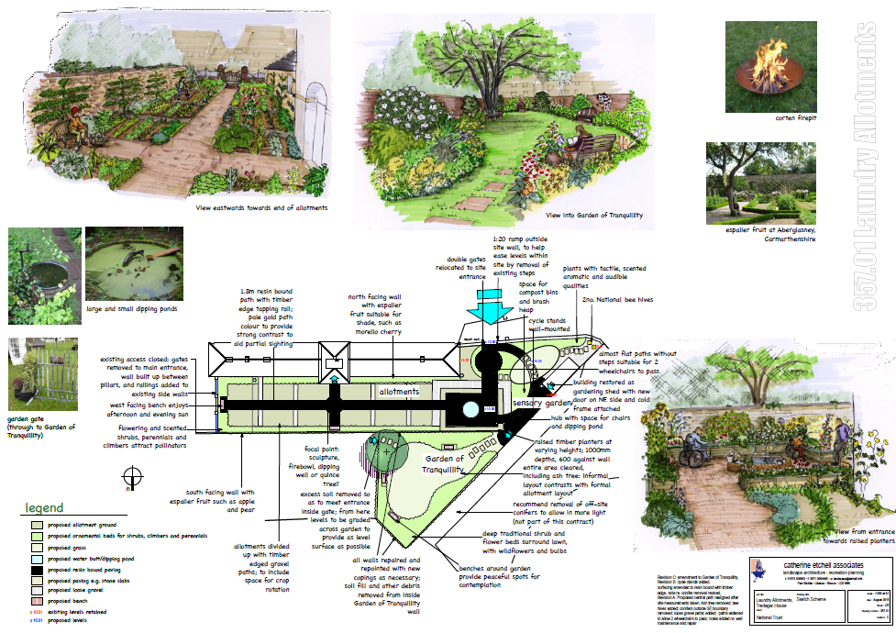

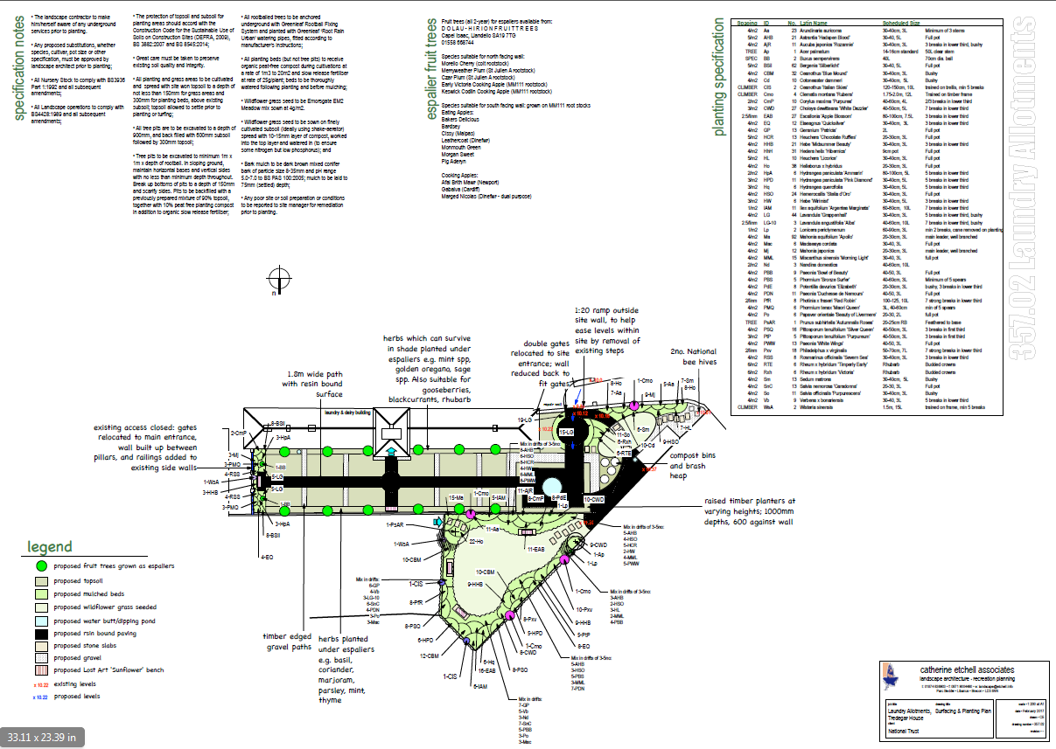

13. Bibliography

Foster, C. (2008). your allotment. London: Index Books Ltd, p.49.
Mike Calnan and EGS team (2018). Heelis, Swindon: Environmental Standards for Gardens & Parks: National Trust,
Katharine Ellicott (2016.) The Green Flag Award guidance manual, Raising the standard, Keep Britain Tidy, Wigan.

National Trust internal document

