#iwill Fund Impact evaluation and Learning contract

Interim Report II
November 2025

This report presents the second interim summary of the #iwill Fund impact evaluation and learning contract.

Prepared by the Dartington Service Design Lab, Renaisi-TSIP and Ipsos MORI
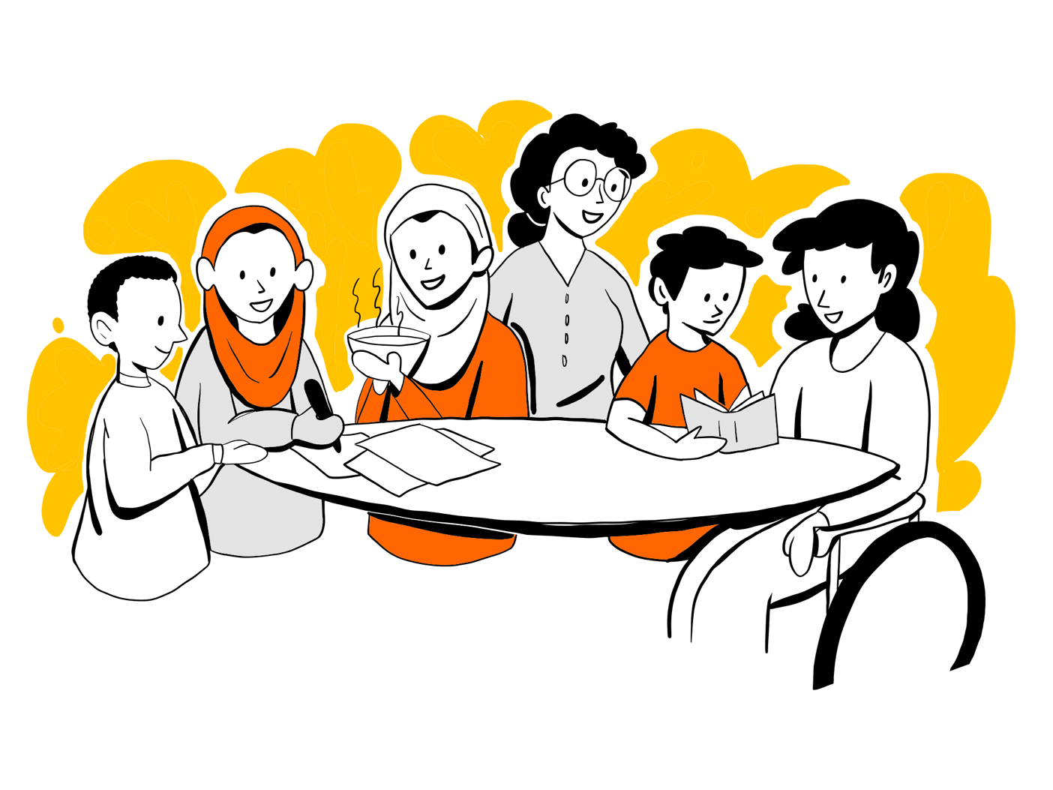

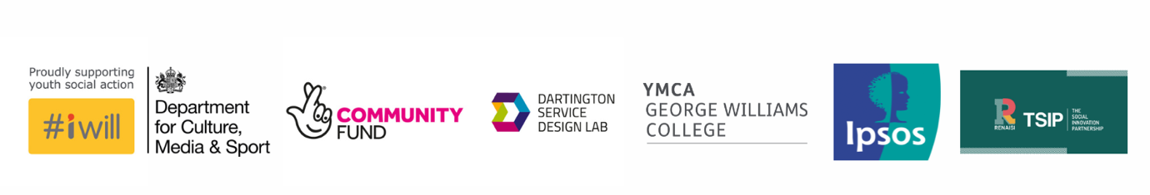

Table of Contents
Executive summary 3
Introduction 8
Evaluation methodology 13
Evaluation methods 22
Results and synthesis 27
Revised Contribution Claims 34
Discussion 38
Conclusions 40
References 41
Appendices 43

Executive summary
The #iwill Fund is an England-wide joint investment of £69 million from the Department for Culture, Media and Sport (DCMS) and The National Lottery Community Fund. This is matched at least equally by Match Funders to encourage collaborative working and to increase targeted investment in high-quality nation-wide Youth Social Action (YSA) programmes for 10–25-year-olds from all backgrounds, including those who have not previously taken part in regular YSA.

Beyond funding, one of the key purposes of the #iwill Fund is to create a learning environment which develops a collective understanding of YSA, quality provision and ways to optimise impact. It also aims to build an organisation’s capability and capacity to use evidence to inform their delivery. This is seen as key to supporting the delivery of high-quality provision and facilitating the sustainability of YSA in the longer term.

The evaluation component gathers and appraises evidence for the impact of the #iwill Fund and associated YSA activities on young people taking part, communities who benefit from YSA activities, and organisations who support young people to undertake YSA. The evaluation is guided by the following questions:
- What were the different types of YSA opportunities young people engaged in during the programme period? What was the profile of the young people involved (e.g., age, background, geographical area), how many took part and with how much intensity?
- What was the socio-emotional, employment, educational, civic-societal impact of #iwill Fund projects on young people and their communities?
- What was the impact and added value for Match Funders and delivery partners from the #iwill Fund’s convening and other support?
- What was the overall value for money of the #iwill Fund?
These questions are being addressed through the triangulation of evidence from:
- The impact data portal: captures organisational monitoring information and survey data on young people’s outcomes (Research Questions #1 and 2).
- Case studies: collect data at different levels of the Match Funder ecosystem, to deepen understanding about the impact of YSA on young people, communities and other local actors as well as how and why, and in what contexts these outcomes arise (Research Questions #2 and 3).
- Cost effectiveness analyses: explore the measurement of community outcomes and possibilities for future economic analysis of these, as well as evidence for the current cost-effectiveness of different types of YSA (Research Question #4). We do not report on this aspect of the evaluation during this phase as this analysis will be progressed at a later phase.
These work strands are underpinned by the Young Evaluators Network (YEN, led by Renaisi-TSIP) — a panel of young people who are involved in all elements of the impact evaluation.

Research Questions 2 and 3 are being addressed through Contribution Analysis, a theory-led approach to evaluation which appraises whether a particular initiative has contributed to a set of outcomes, how it has done that, and for whom or in what circumstances.

The evaluation is taking place over three phases. This report is the second interim report of the #iwill Fund impact evaluation which runs from 2022 to 2027. This and the previous interim report build on a one-year set up phase underpinning the #iwill Fund impact evaluation which detailed the initial project set up, methodological details and timelines. This report reflects the findings from the first two phases of the evaluation and will outline the following in more detail:

- Part 1: The overall evaluative approach
- Part 2: The strands of the evaluation
- Part 3: The results and findings so far
- Part 4: Next steps to further refine the evaluative approach

What we know so far
A summary of emerging findings as at September 2025 is provided below.

What are the different types of YSA opportunities young people have engaged in and what was the profile of the young people involved, and how many have taken part?
- Of the 483 total registered YSA opportunities approx. 2,600 young people have been reported as directly reached, with over 65,000 estimated to have been indirectly reached (e.g. young people who were not involved in leading the activity but were engaged by those projects).
- Campaigning (30%) and helping to improve the local area (22%) were the most reported types of YSA activities, with tutoring (1%) and fundraising (0.4%) being the least common type of YSA activities.
- The opportunities are spread across areas with varying levels of deprivation, with a concentration towards more deprived areas.
Demographic information about young people involved in #iwill Funded YSA has been derived from surveys. So far 1,147 surveys have been completed at baseline and 416 at follow up by young people aged 9-17 years old, of which over half identified as ‘female/girl’, and 64% identified as any White ethnic group.

What was the socio-emotional, employment, educational, civic-societal impact of #iwill Fund projects on young people and their communities?

Survey data evidence
Attitudes towards social action. After taking part in YSA, young people overall more commonly agreed that their ideas are listened to. However, they were less inclined to take action to make a positive difference in the lives of others in future. There were differences when we looked at particular sub-groups of young people, with improvements in specific attitudes towards YSA observed for 15-17-year-olds, those identifying as non-binary, were unsure or preferred not to say about their gender, for Asian/Asian British young people and for those identifying with the ‘mixed, multiple’ or ‘other’ ethnic groups.

Socio-emotional skills. In the overall sample, and when looking by age group, there was little evidence of change in socio-emotional skills before and after taking part in a YSA activity. There were, however, improvements observed in some skills for particular groups of young people (those identifying as non-binary, were unsure or preferred not to say about their gender and those identifying as ‘mixed, multiple’ or ‘other’ ethnic groups). There was a decline in self-reported empathic skills among those identifying as ‘male or boy’.

Belonging and life satisfaction. Having taken part in YSA there was an improvement in neighbourhood belonging for the sample overall, and also within certain sub-groups. This includes 15-17-year-olds, those identifying as ‘female / girl’, those who identified as non-binary or unsure or preferred not to say, and those identifying as White, and ‘mixed or multiple’ or ‘any other’ ethnic groups. Life-satisfaction only improved for those identifying as ‘female / girl’ and those who identified as non-binary, unsure or preferred not to say about their gender.

Case study findings on benefits to young people and communities
Match Funder and delivery organisation interviewees identified several benefits of taking part in YSA for young people and communities, including:
- Greater influence on policy and decision-making processes.
- Strengthened community cohesion and collaboration.
- Increased awareness of social and environmental issues.
- Tangible improvements within schools and local environments.
- Expanded youth participation in climate action.
Their accounts suggested that some of the YSA quality principles relate to the mechanisms through which YSA generates both young person and societal outcomes. In particular, the quality principles of “being reflective,”, “youth-led”, “challenging”, and “progressive” were thought to influence outcomes. For example, by enhancing young people’s self-awareness and confidence; supporting buy-in from peers and adults and creating conditions for self-directed action; helping to achieve socially impactful outcomes; building socio-emotional resilience and critical thinking; and, by enhancing civic participation skills.

There was some evidence that YSA providers perceived that outcomes may be stronger for more marginalised groups such as young people not in education, employment, or training. Also, that the nature and scale of benefits vary depending on the type of initiative, the focus of the social action, and the wider socio-economic and environmental context. While some benefits accrue directly to young people others may be mediated through community changes as a result of YSA activities.

Several factors were commonly identified as supporting young people’s sustained involvement in YSA.
- Enhancing accessibility and lowering barriers to entry.
- Helping young people feel supported, recognised, and connected.
- Skill development and confidence-building.
- Weaving opportunities into education, community life, or civic platforms
Conversely, unmet expectations, particularly when YSA activities do not result in immediate or long-lasting impact, can act as a barrier to continued engagement.

Some interviewees questioned whether it is realistic or even desirable to expect youth-specific activities to persist across the life course. Instead, they argued that the more enduring legacy of YSA lies in the cultivation of active citizenship and transferable life skills.

What was the impact and added value for Match Funders and delivery partners from the #iwill Fund’s convening and other support?

Match Funder and delivery organisation interviewees indicated that the #iwill Fund’s convening and support has enabled them to access greater resources and increase the scale of their YSA activities. This scaling effect was seen not only as increasing reach but also as fostering more equitable relationships between funders and funded organisations.

There was also evidence of learning and capacity-building resulting from engagement with the #iwill Fund. For instance, helping them refine grant-making processes and operational approaches. The Fund’s support offer (resources, guidance, and convening opportunities) was seen as valuable and potentially transferable to wider organisational practice.

More constructive feedback was also offered. For example, about how to optimise the Match Funder meetings led by The National Lottery Community Fund. Several referred to unintended impacts of the funding model on Match Funders and Delivery Organisations. In particular, how administrative challenges such as managing multiple funding streams with different reporting requirements could detract from the quality of YSA delivery by diverting attention and resources.

‘Embedding youth voice’ was a key investment driver for the #iwill Fund, and one of the priority criteria for allocating funds to Match Funders. The YEN analysed case study data pertaining to youth voice as a feature of YSA that they were most interested in. Their findings suggested that while the #iwill Fund itself did not necessarily create the conditions to embed youth voice but that the #iwill Fund helped reinforce, and in some cases, evolve these practices. For instance, by providing additional support and validation for embedding youth voice at a range of levels.

Summary and next steps
We are using a theory-led approach to capture insights about the extent to which the #iwill Fund is impacting young people, communities, Match Funders and Delivery Organisations based on data collected through case studies and the #iwill Data Portal. Importantly, we also report on insights about how and why this happens, as well as under what circumstances.

Phase 2 of the #iwill Fund Impact Evaluation and Learning project adds iteratively to phase 1 findings and has contributed more nuanced insights about the evaluation research questions and our capacity to evidence key aspects of the #iwill Fund’s Theory of Change. This has also helped to identify specific areas to target further data collection in the final phase of the evaluation.

Further work in phase 3 will aim to address some of the identified evidence gaps; it will also include cost effectiveness analyses and estimations of the social value linked to community benefits of YSA.

Introduction
The #iwill Fund is an England-wide joint investment of £69 million from the Department for Culture, Media and Sport (DCMS) and The National Lottery Community Fund. This is matched at least equally by Match Funders to encourage collaborative working and to increase targeted investment in high-quality nation-wide Youth Social Action (YSA) programmes for 10–25-year-olds from all backgrounds, including those not previously taken part in regular YSA.

Beyond funding, one of the key purposes of the #iwill Fund is to create a learning environment which develops a collective understanding of YSA, quality provision and impact. The aim is also to build an organisation’s capability and capacity to use evidence to inform their delivery. This is seen as key to supporting the delivery of high-quality provision and facilitating the sustainability of YSA in the longer term.

The #iwill Fund impact evaluation is an evaluation established by The National Lottery Community Fund and the Department for Culture, Media and Sport (DCMS), spanning six years from 2022 until 2027. The aim of this interim report is to provide an update having completed the second phase of the evaluation.

The evaluation gathers and appraises evidence for the influence of the #iwill Fund and associated Youth Social Action (YSA) activities on outcomes for young people, organisations and communities. The #iwill Fund impact evaluation is being conducted by a consortium including Dartington Service Design Lab, Ipsos MORI, Renaisi-TSIP (and previously also YMCA George Williams College). It is supported by a Young Evaluators Network, a steering group comprised of Match Funders, The National Lottery Community Fund and DCMS staff, sector experts, and a Leadership Board which additionally includes young person representatives.

The current #iwill Fund impact evaluation follows a previous #iwill Fund Learning Hub project. The Learning Hub project included the development of a shared definition of “Youth Social Action” (YSA) and clarity around the essential components of YSA activities. It also collated evidence on types of outcomes of YSA activities, including outcomes for young people, organisations, community and wider society (see Table 1), as well as the core mechanisms through which YSA activities influence those outcomes. Lastly, it identified ways to enhance the accessibility of YSA, as well as a set of six “Quality Principles” underpinning and defining what ‘high quality’ YSA looks like. This offered examples of what the quality principles may look like in practice and identified the need for greater understanding about how the quality principles could be implemented in different contexts and settings. Based on findings from the #iwill Fund Learning Hub, an iteration of a high-level Theory of Change was developed. This was to be used as the basis for a theory-led approach (detailed below) to evaluating the influence of YSA opportunities for young people, organisations and communities. During the feasibility phase, the consortium initially set out a proposed methodological approach to the evaluation.

The evaluation specifically addresses the following initial questions:
- What were the different types of YSA opportunities young people engaged in during the programme period? What was the profile of the young people involved (e.g., age, background, geographical area), how many took part and with how much intensity?
- What was the socio-emotional, employment, educational, civic-societal impact of #iwill Fund projects on young people and their communities?
- What was the impact and added value for Match Funders and delivery partners from the #iwill Fund’s convening and other support?
- What was the overall value for money of the #iwill Fund?

There are five workstreams that feed into addressing these evaluation questions, three of which have been designed to generate and appraise research evidence:

Impact Data Portal - the data portal captures organisational monitoring data and information on young people’s outcomes for the #iwill Fund. It enables Delivery Organisations and Match Funders to upload YSA opportunities monitoring data and send out surveys to young people to capture outcome data. Following the closure of YMCA George Williams College, the hosting of the data portal was transferred to YMCA England and Wales, with ongoing support for technical maintenance and responsibilities for data governance. Dartington Service Design Lab took over responsibility for providing data reviews including analysis of opportunities and survey data. This report summarises data input to the Portal to date (over the phase 1 and 2 periods).

Case studies (led by Renaisi-TSIP) – 15 qualitative case studies in total will be undertaken over three study phases. The case studies collect data at different levels of the Match Funder ecosystem, to deepen understanding about the impact of YSA on young people, communities and other local actors as well as how and why, and in what contexts these outcomes arise or do not. This report focuses on findings from phase 2, integrating insights from phase 1 in the Results and synthesis section.

Value for Money (led by Ipsos MORI) - this strand explores the measurement of community outcomes and possibilities for future economic analysis of these, as well as evidence for the current cost-effectiveness of different types of YSA.​ This report does not provide an update on this aspect of the evaluation.
​
These are underpinned by two further work strands:

Young Evaluators Network (led by Renaisi-TSIP) - the Young Evaluators Network (YEN) is a panel of young people who are involved in all elements of the impact evaluation. The YEN aims to keep young people at the core of the evaluation so that it is informed by young people with lived experience to enhance youth voice.

Learning Strand (led by Dartington Service Design Lab) - the Learning Strand enhances the overall #iwill Fund impact evaluation by creating shared spaces where the quality principles can be explored and refined over time. It also supports the learning needs of Match Funders and broader stakeholders working toward systemic change. Details of the Learning Strand and findings from the first phase are provided in a separate report.

Young Evaluators Network involvement
Eleven young people were originally recruited to the YEN, led by YMCA George Williams College. Engagement was maintained through monthly online meetings, regular one-to-ones, and two “residentials”. However, there were challenges in upholding engagement with changes to the initial project timelines and competing demands in the young people’s lives. Despite several mitigations to address these, at the start of phase 2 of the evaluation, only three original YEN members remained. Therefore, YMCA George Williams College recruited three new YEN members, creating a network of six young people. By September 2025, YEN members had joined online introductions to the evaluation, participated in online interviews, provided written reflections on these interviews, come together for a two-night in-person residential event, contributed towards co-analysis of the qualitative data collected as part of the case studies, designed and delivered an in-person celebration event for Match Funders and written reflections to be included in this interim report, also reviewed by several YEN members.

The two-day “residential” event was an opportunity for the new YEN members to meet and build relationships with the remaining original members, discuss the progress of the evaluation and develop their research and evaluation skills. The YEN co-analysed case study data, focusing on data relating to how YSA activities help embed habit for life (relevant to Research Question #2) and how the #iwill Fund has created the conditions for Match Funders and Delivery Organisations to embed youth voice into their delivery and governance (relevant to Research Question #3). Their analysis has been incorporated into the overall case study write-up in the results and section of this report.

Additionally, the YEN discussed one of the Contribution Claims, that ‘YSA activities create benefits to communities and society’, as well as some of the challenges in evidencing this claim. They were then introduced to a range of creative research methods, including community mapping, photo voice, and film ethnography, and asked to consider how they might incorporate some of these methods to support data collection during the third phase of the evaluation.

One YEN member, who joined four online interviews, provided the following reflection on their experience:

“I was really impressed by the dedication of both Match Funders and Delivery Organisations in embedding the #iwill [Fund] youth social action principles and the truly youth led nature of projects. It was really positive hearing how most projects involved young people new to youth social action and the impact it has been having on them. During many interviews we discussed the value of the #iwill habit for life, as well as how this extends to transferable skills relevant for both youth social action and future employment.” – Young Evaluator

During this second phase of the evaluation the YEN have also been involved in supporting the Learning Strand through collaborative workshops to help bring their voice into session design as well as to help shape the Learning Strand offer itself (see below). This has also opened opportunities for the Young Evaluators to gain skills in co-design and co-facilitation, as well as offering them a platform for their ideas to feed into the evaluation that go beyond the original offer.

Learning Strand
This phase of the learning strand retained the focus on the priority areas from the previous year (see the first Learning Strand interim report), with an emphasis on the role of youth voice and the creation of actionable insights. At the beginning of 2025, the priority areas were refined with the YEN members and a series of action-learning workshops were developed for young people, Match Funders and Delivery Organisations to attend during April-May 2025 (Equity of access and youth voice; Mental health and youth voice; Anti-racism and youth voice; Bringing it all together). These sessions were planned to focus on the following reflective questions (see Appendix) building on the findings of the first phase of the Learning Strand, to support deeper thinking around quality practice for more inclusive and accessible YSA. However, the sessions were cancelled due to lack of attendance by Match Funders or Delivery Organisation representatives. Recruitment for the planned Learning Strand sessions was challenging for a number of reasons (e.g., the timing — after school / college to support young people to attend — and feedback that reflective practice is already happening within organisations, so the added value of action learning within the #iwill Fund evaluation was less clear).

Pivoting the Learning Strand workshops to better platform youth voice
To help us to better understand the barriers to engagement, we sent out a survey to Match Funders and Delivery Organisations through the #iwill Fund network, as well as seeking advice from our National Lottery Community Fund colleagues on how best to progress the Learning Strand offer.

At the same time, the new cohort of YEN members was keen to have a platform for their voice to share their views as young evaluators with lived experience of YSA with the #iwill Match Funders and Delivery Organisations. Involvement in the Learning Strand also opened opportunities for further skills development in facilitation and event planning and created a more continuous offer for their ongoing engagement.

Following discussions with the YEN (including at the YEN residential in August 2025), the group have proposed that they would like to take more of a role in creating opportunities for shared learning within the #iwill Fund, drawing on their own lived experience and their research and analysis within the evaluation. For example, the YEN developed a workshop for the planned interim celebration event with the aim of sharing their voice on the insights from their case study analysis, and what they think will help support quality and access for YSA. The YEN group believes that sharing learning about what works well and less well across the #iwill Fund network will help to strengthen YSA, especially through centring the potential mechanisms that support access and inclusion for the most underserved. The YEN feel that they have much to offer in this space and are keen to share their views on what can be changed and improved from their perspectives. The group also recognised the systemic challenges and barriers to access that may also require more collective action, which they also believe could be further explored and navigated through the Learning Strand of the #iwill Fund in particular.

Part 1: The overall evaluative approach

Evaluation methodology

Theory-led approach: Contribution Analysis
As outlined in the #iwill Fund Impact and Evaluation feasibility phase, the #iwill Fund impact evaluation (in particular, Research Questions 2-3) is being undertaken using Contribution Analysis; an established theory-based evaluation method used to consider whether a particular initiative has contributed to a set of outcomes (as opposed to attribution-focused approaches such as quasi-experimental or experimental methods). Contribution Analysis focuses on building a credible and robust theory for how activities lead to desired outcomes and focuses on gathering and appraising best available evidence. This helps to assess the extent to which those narratives hold true. The ‘theory’ aspect of Contribution Analysis is based upon mapping how and why outcomes may happen using literature and robust research on the specific outcome. By using evidence of ‘what works’ the factors leading to outcomes can be mapped backwards through incremented stages, forming a plan of action, or a theory for what might work, depicted in a ‘Theory of Change’ (ToC). Contribution Analysis therefore relies on the development of a robust ToC so that the proposed causal links between activities and outcomes, as well as the assumptions underpinning these links, are clearly articulated. The presentation of barriers and enablers to change, help define the contextual environment of YSA activities and can offer further evidence for contribution (if there is evidence that barriers were overcome to achieve impact).

The #iwill Fund impact evaluation and learning contract allows for multiple different sources of information to be collated and synthesised to appraise the contribution claims and assumptions and clearly communicate findings through the development of plausible causal narratives. These narratives are generated based on drawing together multiple sources of evidence for change in the outcomes of interest, as well as how and why change occurred (or otherwise), and for whom.

Contribution Analysis does not generally aim to quantify the share of/amount by which an outcome can be attributed to a particular programme (e.g., an ‘effect size’). Approaches to quantifying the size of contribution have been suggested but deemed unsuitable for this project. This is because the causal relationships underpinning the #iwill Fund Theory of Change are complex, with multiple factors operating in combination to influence outcomes rather than alone. Relative importance can be appraised qualitatively in terms of stakeholder perceived importance, how the causal factors operate (their role in influencing change) or the capacity for those factors to effect change (e.g., considering the barriers affecting any causal factors’ likelihood of influencing change)^{1,2}. These factors can be assessed through examining qualitative data, for example, about how a specific activity triggered change from the perspective of those benefitting from outcomes, or how an organisation is delivering support rather than the type of support they offer.

However, in developing evaluation questions based on a ToC, it can simplify what is highly complex, emergent and non-linear in practice by imposing a degree of linearity between ‘cause and effect’. Also, where relationships between outcomes and drivers are complex or distant, data collection can be time consuming and resource intensive, requiring prioritisation. To mitigate against these factors and enhance the utility of the evaluation, we draw on Apgar and Ton’s (2021) approach which recasts the six-steps of Contribution Analysis into an iterative cycle (Figure 1). In line with the approach to learning in this contract, this describes a ToC as a ‘facilitated reflexive process’ and learning tool for adaptation, rather than as a static definitional representation of the #iwill Fund initiative.

Also, we draw on Mayne’s approach to identifying and focusing on ‘causal hotspots’ rather than to try and evaluate each and every component of the ToC. Apgar and Ton (2021) define causal hotspots as “where there is most value in undertaking evaluation to contribute to theory and practice….where there is simply an obvious gap in evidence…..[and] the area in the ToC that is emphasized by one or more stakeholders in the evaluation.”⁴ They recommend that approximately three hotspots allows for diverse stakeholder interests, with additional evidence being collected to check key challenges and assumptions. These challenges and assumptions are captured in the nested ToCs while remaining pragmatic to resource constraints. This approach also helps evaluators to avoid ‘getting lost’ in the multi-level ‘jungle of causality’ in evaluations of complex initiatives and helps ensure that the ToC being evaluated is robust and detailed enough but also feasible /amenable to evaluation.

This approach also serves to ensure that the evaluation focuses on aspects of the ToC which are least well evidenced currently and of most interest to stakeholders, within the resource and time available. Thus, gathering preliminary data and identifying and prioritising hotspots are key goals of phase 1. The #iwill Fund impact evaluation has developed steps to be conducted at each phase of the evaluation. The evaluation thus far has completed step 1 and completed one round of work through steps 2-5. Steps 2-5 will be ongoing to exemplify the iterative nature of the Contribution Analysis, ensuring that crucial findings can update the evaluation process. See Box 1 for an outline of the Contribution Analysis steps against the three #iwill Fund impact evaluation and learning phases.

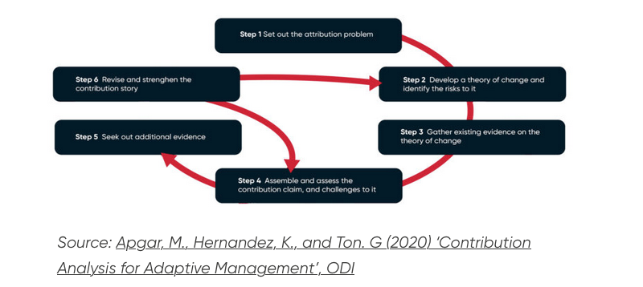
Figure 1. Contribution Analysis as an iterative process
Source: Apgar, M., Hernandez, K, and Ton. G (2020). Contribution Analysis for Adaptive Management, ODI.

Box 1 Contribution Analysis steps for the #iwill Fund evaluation
#iwill Fund IELC Phase 0
- Step 1: Define attribution problem
- Completed through the feasibility phase.
- The updated version of the ToC was developed during this stage.
#iwill Fund IELC Phase 1
- Steps 2-5 are ongoing.
Step 2: Develop ToC and identify risks to it
- Refining the earlier version of the ToC/splitting into four nested pathways, updating the assumptions.
Step 3: Gather existing evidence on the ToC
- Identifying existing evidence for ToC pathways/assumptions from ToC developed after the #iwill Fund Learning Hub, initial Portal and Case Study data, and Learning Strand initial findings.
Step 4: Assemble and assess the contribution claim and challenges to it
- Re-look at initial contribution claims and revise them.
- Decide what part of the causal pathway holds the claims we will examine in more detail through additional more focused data collection in phase 2 and 3 based on identification of ‘causal hotspots’.
- Prioritise approx. 3 causal hotspots to take forward to phase 2 and 3.
#iwill Fund IELC Phase 2
- Step 5: Seek out additional evidence
- Revise and tailor case study materials to focus on causal hotspots.
- Analysis of evidence for refined ToC links, assumptions, barriers and enablers including external factors influencing what is in the programme’s direct control/influence and indirect influence.
- Step 6: Revise and strengthen contribution story then return to step 2 or 4.
#iwill Fund IELC Phase 3
- Steps 2-4, and 6: Repeat as necessary/appropriate

Theory of Change
The feasibility phase developed an updated ToC (Figure 1), using learning from the previous #iwill Fund Learning Hub activities. This brought together information reported by the previous cohort of Match Funders and the existing evidence base. It focuses, in line with the requirements of the impact evaluation and learning contract, on exploring the relationship between #iwill Fund activities and the hypothesised outcomes.

This version aligned with the revised definition of YSA, and it included the #iwill Fund’s key investment drivers. Importantly, it was also an initial attempt to address some gaps in the previous ToC iteration. These included: (i) a need for clear mechanisms of change to show ‘how’ activities lead to outcomes (ii) inclusion of the quality principles for YSA (iii) clarification of the activities that Match Funders and Delivery Organisations undertake to support outcomes, as well as any quality principles that might be identified from the #iwill Fund Learning Hub’s outputs, and finally (iv) a clearer sense of the reflexive relationship between the benefits for young people and organisations, and wider society. ‘Reflexive’ refers to the idea that benefits accrue not just directly from taking part in YSA (e.g., taking part in campaigning), but that the YSA activities themselves lead to changes that in turn benefit young people, organisations and society (e.g., changes in public awareness of an issue as a result of a campaign). The table below summarises the types of outcomes referred to in the ToC.

Table 1 Types of outcomes linked to Youth Social Action (YSA)

Outcome | Specific outcomes include
Direct community benefit | These include outcomes to the ‘beneficiaries’ of volunteering, mentoring, local environmental work or campaigning.
Societal benefit | Benefit to society as a result of young people taking part in YSA – e.g., more civic engagement in the population.
Reflexive benefit | Benefit to young people as a result of changes brought about by YSA e.g., changes brought about by campaigning, or by improved public spaces.
Organisational benefit | Benefit to social purpose organisations which enable youth social action – e.g., YSA helps them create more impact on their goals and strengthens the organisation.
Young person benefit | Benefits to young people as a result of taking part in YSA – e.g., improved well-being, confidence or change agency.
The feasibility phase detailed the initial assumptions underpinning the updated ToC (Figure 1), as a result of the Learning Hub project. This version reflects a high-level depiction of cause-and-effect relationships found during the #iwill Learning Hub between the #iwill Fund and the various outcome domains. This is necessary for communication purposes and for building shared understanding about how key concepts such as quality principles and triple benefit relate together. The ‘quality principles’ refer to the agreed upon criteria for what good quality youth social action looks like, and the concept of ‘triple benefit’ refers to the benefits of YSA which accrue to young people, the community influenced by YSA activities, and the organisations supporting the delivery of YSA activities. This ToC formed the basis for the initial contribution claims, as well as the contextual barriers and enablers to those assumptions.

ToCs are meant to be iterative, they are refined as relevant, new, practice-based and research/evaluation evidence is generated. High level ToCs can be broken down and each process within the ToC can be presented independently. For meaningful Contribution Analysis aligned with the steps outlined in Box 1, there was a need to create more detailed ToCs, or ‘sub-theories’ for particular components of the causal pathway that are nested within the overarching ToC (see Appendix). This supports the collection and analysis of data for the appraisal of contribution around the identified causal hotspots. These “nested” theories of change (see Appendix) and refined assumptions have been developed, comprising four causal pathways at each level of the YSA ecosystem:

Match Funder: The influence of #iwill Fund investment, funding and learning environment on the availability of quality youth social action activities which reach young people at a younger age and groups who are under-represented in YSA (e.g., in socio-economically deprived areas).

Delivery organisation: As above, plus, the reciprocal influence of youth voice and leadership on the Delivery Organisations themselves (a small number of Match Funders also deliver activities themselves).

Young people: The influence of access to quality YSA activities and youth leadership opportunities on young people’s socio-emotional, education and employment outcomes, and on developing a habit for life.

Communities: The influence of YSA activities for the communities they serve, and the reciprocal benefit to young people from changes to communities.

These were supplemented by the development of an outcomes map to understand how the different types of outcomes, mechanisms and quality principles are related to one another with an indication of the evidence base linked to each. This is detailed in Appendix 1 Mapping outcomes, mechanisms and quality principles against the evidence base.

Causal hotspots
Eight contribution claims were set out in the feasibility phase. However, some of these were better (or less well) evidenced through the #iwill Learning Hub and wider literature. Moreover, several of the claims spanned multiple causal steps across different levels of the ecosystem (#iwill Fund, Match Funder, delivery organisation, young person, community). Therefore, the current impact evaluation aimed to focus on and refine those claims that required further evidence gathering, and/or where multiple causal mechanisms may be at play. Using the nested ToCs (see Appendix 2 Sub (or ‘nested’) theories of change) as a guide, we carried out a process of mapping the evidence base against each component of the ToC (see Appendix 1 Mapping outcomes, mechanisms and quality principles against the evidence base) and building on the summary reports and evaluation from the previous #iwill Fund Learning Hub, to identify the following evidence gaps:
- Limited understanding /’testing’ of links between quality principles, mechanisms and outcomes, and the context/circumstances influencing them.
- Limited understanding of how to create the conditions for quality YSA (especially ‘being embedded’ and ‘allowing progression’).
- Limited understanding of how/under what conditions a ‘habit for life’ can be influenced, or for whom.
- Mixed evidence for the mechanism around ‘self-directed action’.
- Community and societal outcomes less well evidenced.
- Education and employment outcomes for young people linked to the YSA participation less well evidenced.
- Reflexive benefits (benefits to young people as a result of — changes brought about by YSA e.g., changes brought about by campaigning, or by improved public spaces) less well evidenced.
- Limited understanding of whether/how the #iwill Fund and how it’s convened influences MFs, DOs, and the quality of YSA activities.
Based on feedback from the Steering Group, The National Lottery Community Fund and the YEN, we identified the following causal hotspots:
- Understanding how, and to what extent, the quality of YSA activities influences outcomes for young people, Delivery Organisations and communities (including reflexive benefits), and how the quality of YSA links to each of the proposed and additional mechanisms of change.
- Understanding how, and to what extent, the #iwill Fund creates the conditions for quality YSA, and how this could be enhanced.
- Further understanding of and evidence for the reflexive and community benefits of YSA, as well as the underpinning mechanisms and contextual contingencies.
- Getting a deeper understanding about the contexts in which, and for whom, YSA activities become a habit for life.

Contribution Claims
In line with the approach to Contribution Analysis detailed in Box 1 (steps 3-4), we refined the following contribution claims to be explored and elaborated upon through the analysis of successive data collection phases. Specifically, in this further exploration and refinement, there is a need to examine evidence about 1) the assumptions underpinning these causal links, 2) the mechanisms linking activities to outcomes and, 3) the contextual factors which may influence whether and how YSA activities influence the outcomes of interest:

1. The quality of YSA activities influences outcomes for young people, Delivery Organisations and communities. This is because YSA activities that are aligned with the six quality principles are more likely to influence the core mechanisms linking YSA to outcomes. The core mechanisms are: ‘providing a safe yet challenging space’, ‘encouraging young people to take self-directed action’, and ‘allowing them to engage with others’.

2. The YSA activities that young people engage in create various benefits to communities and society. In turn, young people reflexively benefit from these community outcomes. This depends on the quality of the YSA activities.

3. The YSA activities that young people engage in encourage them to develop a habit for life. This is being achieved through a range of causal factors, including investment in activities which reach young people at a younger age and focus on transition points, involvement in youth leadership activities, signposting to other opportunities in their community, as a result of civic societal outcomes of YSA for young people (e.g., change agency, civic skills, social cohesion, habit of service), aligning YSA activities with the six quality principles.

4. The #iwill Fund is contributing to high quality youth social action opportunities. This is being achieved through a range of causal factors, including: a robust funding model underpinned by relevant investment drivers, evaluation requirements, the creation of a learning environment, and embedding youth voice.

Part 2: The strands of the evaluation

Evaluation methods

Data Portal
The data portal was built by YMCA George Williams College, in close collaboration with Match Funders, evaluation consortium partners, and The National Lottery Community Fund. The process included developing a shared set of measures, testing the survey and the portal with young people and Match Funders, and then onboarding Match Funders onto the portal. Delivery partners and Match Funders are able to share links to young people’s surveys with the results recorded on the portal. Regular communication with Match Funders has kept them (and delivery partners) informed about the Data Portal. Bespoke dashboard views for The National Lottery Community Fund, the evaluation consortium, Match Funders, and delivery partners, allow these organisations to track their progress with data collection.

The surveys
The ‘opportunity survey’, completed by Match Funders on behalf of Delivery Organisations, records the following data:
- Data about the opportunity (project name, start and end dates, location). Location is reported in terms of Index of Multiple Deprivation (IMD 2015) decile, with 1 reflecting the most deprived, and 10 the least deprived areas.
- Type and setting, captured using several typologies to categorise and describe opportunities (e.g., fundraising in schools on crisis and poverty causes).
- Extent of participant engagement (e.g., time spent on the opportunity, whether and how the opportunity is youth led, how many young people have engaged). Numbers of young people reached include those directly reached and estimates of how many were indirectly reached (e.g., who were not involved in leading the activity but were engaged by those leading YSA projects in the process).
The ‘young person survey’ records the following data:
- Demographic information (age, gender, and ethnicity). Ethnic groups were defined using the Office of National Statistics guidance on ethnicity categories.
- Attitudes toward social action to understand whether taking part in the #iwill Fund has given participants the platform to make positive change to help others, whilst also feeling listened to and to have a sense of belonging.
- Socio-emotional skills that underpin education, employment and other longer-term outcomes (based on six questions from the Young People's Survey (YPS) to cover the domains of emotion management, empathy, problem solving, initiative, teamwork, and responsibility).
- Perceived neighbourhood belonging.
- Life satisfaction (based on question 1 from the ONS Well-being measures).
Match Funders have also been allowed to add a few of their own questions to the ‘young people’ survey; seven of ten Match Funders have done so.

The ‘young person’ survey is to be administered at the beginning and end of any opportunity which is at least 12 weeks long, to capture change in the participants’ outcomes over time. A challenge arose in relation to the capacity to send surveys to individual young people due to the nature of some of the Match Funders’ opportunities. For example, where Match Funders are working in schools where young people cannot access digital surveys, or there is inadequate internal infrastructure to add all individuals to the portal where very large numbers of young people are involved. Following discussions, YMCA George Williams College implemented a system whereby group data could be submitted. This allows Match Funders to submit data that has been aggregated across different opportunities and points of time. With the added use of a quasi-identifier (participant initials) in this group, it was hoped that pre- and post-intervention survey results will be matched. To allow for longitudinal analysis based on changes in individual scores.

Data Portal data analysis
Full technical details of the approach to data analysis are included in the Data Portal data analysis section of the Appendix.
We compared young people’s responses to surveys before taking part in a YSA opportunity and after taking part. This allowed us to examine whether there were statistically significant changes in their attitudes towards social action, socio-emotional skills, neighbourhood belonging and life satisfaction. Due to limitations to the data, we could not match individual young people. Therefore, we examined differences in mean responses — this is less sensitive but still a robust way to explore change over time.

We looked at differences for the sample overall (all those who completed baseline and follow-up surveys). We also looked at differences for sub-groups of young people, based on age group (9–11, 12–14, 15–17 years old), gender (female / girl, male / boy, or non-binary/unsure or prefer not to say), and high-level ethnic group (Asian or British Asian, Black, Black British, Caribbean or African, White, other responses).

Case Studies
Renaisi-TSIP co-designed research materials with the YEN through two co-design activities during phase 1. Overall, the aim of the case studies is to capture organisational, young person and community perspectives to contribute to answering the evaluation questions and elaborate upon the initial Contribution Claims, through:
- Scoping interviews with all Match Funders to support the choice of Match Funders to base case studies on.
- Site visits to Delivery Organisations to observe activities.
- In-person interviews with young people conducted on site visits.
- In-person interviews with staff conducted on site visits.
- Online interviews with young people and/or staff where site visits were not possible.
- Interviews with community members (such as community leaders).
In this second phase, Renaisi-TSIP sampled three Match Funders, along with their Delivery Organisations, young people, and communities, as well as two cohorts of young people to explore their Youth Social Action (YSA) journey. The selection of Match Funders was based on criteria including not having been involved in Phase 1, being further along in their delivery process, and ensuring a diverse representation of YSA activities. Renaisi-TSIP successfully conducted online interviews with the Match Funders but faced challenges in connecting with some Delivery Organisations, young people, and communities due to lack of response, delays in replying, or YSA programmes not running at the time planned for interviews and site visits.

The organisations that participated in phase 2 were: SOS UK; the Coop Foundation and their delivery partner, Restless Development; Sovereign Housing Association; and the Youth Endowment Fund with their delivery partner, NE Youth. For the latter, Renaisi-TSIP had originally planned to engage a cohort of young people, but since this was not feasible, they were included in the Match Funder sample instead. Finally, Renaisi-TSIP held a focus group with a group of young ambassadors from the #iwill movement. Renaisi-TSIP (alongside the YEN) had engaged seven staff members and three young ambassadors. Table 2 summarises the case study data collected during phase 1 and phase 2.
Table 2 Case study data collection in evaluation phase 1 and 2
Phase 1: 2024
Match Funder /Delivery Org | Fieldwork conducted
#iwill Movement | 1x online interview with Match Funder
BiteBack | 1x online interview with Match Funder  2x online focus groups
Clarion Futures | 2x online interviews with Match Funder  2x in-person site visits & follow-up interviews with delivery staff
Diana Award | 1x online interview with Match Funder  1x in-person site visit plus follow-up interviews with delivery staff
Global Action Plan | 2x online interviews with Match Funder
Phase 2: January 2025 – August 2025
SOS UK | 1x online interview with Match Funder
Coop Foundation | 1x online interview with Match Funder
Restless Development | 1x online interview with Delivery Organisation
Sovereign Housing Association | 1x online interview with Match Funder
Youth Endowment Fund | 1x online interview with Match Funder
Ne Youth | 1x online interview with Delivery Organisation
#iwill ambassadors | 1x online focus group

Value for Money
Detailed methods are included in the Appendix 4 Value for Money work strand methods as we do not report on this aspect of the evaluation during this phase.

Part 3: Results and findings so far

Results and synthesis
The following results for phase 2 are based on Data Portal data (collected accumulatively over phases 1 and 2) and case study data. Where case study data are reported, we present findings from phase 2 but integrate applicable insights from phase 1 to support interpretation. The results are structured by Research Question and the Contribution Claims that are relevant to those questions. Question 1 is addressed using Data Portal data, Question 2 (Contribution Claims 1-3) is addressed using both Data Portal survey and case study findings. Question 3 (Contribution Claim 4) is addressed using case study findings only. After presenting findings, we next provide Revised Contribution Claims based on the analysis, followed by Evidence gaps to be addressed through the remaining iteration of the Contribution Analysis in phase 3, as well as through further research.

Research question 1
What are the different types of YSA opportunities young people have engaged in and what was the profile of the young people involved, and how many have taken part?

To understand the reach of YSA opportunities amongst young people, demographic data was collected from young people who took part in the surveys.
Table 1 Demographic characteristics of young people completing surveys at baseline
Demographic characteristic | n | %
Age (years) (n=1,058)
9 | 70 | 6.6
10 | 120 | 11.3
11 | 122 | 11.5
12 | 182 | 17.2
13 | 166 | 15.7
14 | 175 | 16.5
15-17 | 223 | 21.1
Gender (n=1,147)
Female / girl | 623 | 54.3
Male / boy | 442 | 38.5
Non-binary | 23 | 2.0
Prefer not to say | 50 | 4.4
Unsure how to describe myself | 9 | 0.8
Ethnicity* (n=1,116)
Asian or Asian British | 122 | 10.9
Black, Black British, Caribbean or African | 116 | 10.4
Mixed or multiple ethnic groups | 63 | 5.7
Other ethnic group | 19 | 1.7
Prefer not to say | 86 | 7.7
White | 710 | 63.6
*Grouped due to small numbers to preserve anonymity

A total of 1058 young people took part in the survey. The demographic data showed an even spread of young people aged 10-14 (72.2%) with individual ages showing a relatively consistent representation (11.3%-17.2%). Those aged 15-17 made up the majority representation (20%), while 9-year-olds made up the lease (6.6%). There were far more girls (54.3%) than boys (38.5%), and non-binary, uncertainty around self-identifying or preferring not to self-identify made up 7.2% of genders. Finally, the group was largely comprised of white young people (63.6%), with Asian, Asian British, Black, Black British, Caribbean or African made up 10% respectively. Mixed, multiple ethnic groups and other ethnic groups were represented the least at 7.4% collectively.

Match Funders uploaded data to the Portal about their related YSA opportunities. Of the 483 total registered YSA opportunities that have been marked as ‘finished’ (n=155) and which also have data provided on numbers directly reached (n=135), approximately 2,600 young people have been reported as directly reached.

Table 2 The number of opportunities by Match Funder and opportunity typology
Match Funder | Campaigning | Coaching or mentoring | Fundraising/ Sponsored event | Helping to improve local area | Not Known | Other | Tutoring | Volunteering | Grand total
#iwill Movement |  |  |  |  |  | 2 |  |  | 2
Bite Back | 103 |  |  |  |  |  |  |  | 103
Clarion Housing Group |  |  |  | 2 | 18 | 26 |  |  | 46
Co-operative Community Investment Foundation | 3 | 3 | 1 | 7 |  | 9 |  | 5 | 28
Global Action Plan | 4 |  |  | 28 |  |  |  |  | 32
SNG #iwill Fund | 6 | 9 | 1 | 7 |  | 13 |  | 1 | 37
Student Organising for Sustainability (SOS-UK) | 1 |  |  |  |  |  |  | 38 | 39
The Diana Award |  | 42 |  |  |  |  |  |  | 42
The Ernest Cook Trust | 19 | 12 |  | 62 | 6 | 11 | 2 | 4 | 116
Young Manchester | 1 | 12 |  | 1 |  | 2 | 2 |  | 18
Youth Endowment Fund | 10 |  |  | 1 |  | 7 | 1 | 1 | 20
Grand total (n) | 147 | 78 | 2 | 108 | 24 | 70 | 5 | 49 | 483
Proportion of opportunities (%) | 30.4 | 16.1 | 0.4 | 22.4 | 5.0 | 14.5 | 1.0 | 10.1 | 100.0

The number of young people Match Funders estimated to be indirectly reached by activities rose to over 65,000. Campaigning (30%) and helping to improve the local area (22%) were the most commonly reported types of YSA activities (see Appendix Table 13). The opportunities are spread across areas with varying levels of deprivation, with a concentration towards more deprived areas (see Appendix Figure 2).

Research question 2
What was the socio-emotional, employment, educational, civic-societal impact of #iwill Fund projects on young people and their communities?

This question is relevant to the following Contribution Claims (#1-3):

The quality of YSA activities influences outcomes for young people, Delivery Organisations and communities. This is because YSA activities that are aligned with the six quality principles are more likely to influence the core mechanisms linking YSA to outcomes. The core mechanisms are: ‘providing a safe yet challenging space’, ‘encouraging young people to take self-directed action’, and ‘allowing them to engage with others’.

The YSA activities that young people engage in create various benefits to communities and society. In turn, young people reflexively benefit from these community outcomes. This depends on the quality of the YSA activities.

The YSA activities that young people engage in encourage them to develop a habit for life. This is being achieved through a range of causal factors, including investment in activities which reach young people at a younger age and focus on transition points, involvement in youth leadership activities, signposting to other opportunities in their community, as a result of civic societal outcomes of YSA for young people (e.g., change agency, civic skills, social cohesion, habit of service), aligning YSA activities with the six quality principles.

Survey findings
Survey data indicates some improvements to young people’s outcomes before and after taking part in YSA across specific items related to several outcomes, with evidence for sub-group differences in the impact of involvement in YSA. See Appendix 3 Data Portal data analysis technical detail for full details of changes in mean scores and summary statistics for the sample overall and by sub-groups. Percentages represent the percentage improvement or reduction in the mean response to the respective question.

Attitudes towards social action: overall, young people were more likely to feel their ideas were listened to (+2.8%), but less likely to report wanting to take future action to help others (-2.4%). Subgroup analyses showed significant improvements in attitudes among:
- 15–17-year-olds: feeling they can make a difference to people in their community (+7.6%) and that they are working with other people who want to make the world a better place (+8.8%).
- Non-binary/unsure/prefer not to say: believing they can make a difference in the world (+5.4%), that their ideas were listened to (+10.8%) and that they could change things that are unfair (+7.0%).
- Asian/Asian British groups: that they are working with other people who want to make the world a better place (+7.6%).
- Mixed/multiple/other ethnic groups: that their ideas being listened to (+6.6%) and in believing that they can change things that are unfair (+4.6%).
However, participants identifying as ‘female/girl’ were less likely to agree that in future they wanted to make a positive difference to other people's lives (-3.6%), after taking part in an opportunity.

Socio-emotional skills: while no changes were observed in the sample overall, several subgroup differences arose:
- Male participants: significant decline in empathic skills from baseline to follow up (-5.4%).
- Non-binary/unsure/prefer not to say: improvements across all socio-emotional skills (emotion management: +8.2%, empathy: +10.2%, initiative: +12.0%, teamwork: +10.4%, problem solving: +7.4%, responsibility: +16.2%).
- Mixed/multiple/other ethnic groups: improvements across several socio-emotional skills (emotion management: +6.2%, initiative: +5.4%, problem solving: +4.4%, responsibility: +8.6%).
Neighbourhood belonging and life satisfaction: neighbourhood belonging significantly improved overall (+2.6%), and within-subgroup analyses indicated significant improvements for 15-17-year-olds (+10.4%), participants identifying as female/girl (+3.0%), or non-binary, unsure or preferred not to say (+8.2%), as well as those identifying as White (+3.8%) or mixed/multiple or other ethnic groups (+3.4%). Life satisfaction improved only among participants identifying as a female/girl (+5.4%) and those who were non-binary, unsure or preferred not to say (+7.9%).

Case study findings
Interviews with Match Funders, delivery partners and young ambassadors indicated broad agreement that YSA is delivering impact for young people and communities, though the nature and scale of that impact varied considerably depending on the initiative. Reported benefits included:
- Greater influence on policy and decision-making processes.
- Strengthened community cohesion and collaboration.
- Increased awareness of social and environmental issues.
- Tangible improvements within schools and local environments.
- Expanded youth participation in climate action (among those who’d taken part in climate related YSA activities).
This builds on findings from phase 1 which included interviews and focus groups with young people. There, young people identified feeling enabled to make a positive difference, and as though they had a sense of purpose or achievement through the project; developing new skills; enhanced confidence; teamwork skills; and enhanced ability to take self-directed action by leading their YSA projects.

Despite these positive outcomes, it remained difficult to appraise the full extent of community and societal benefits generated by YSA. This is because such outcomes were described as complex and context-dependent, influenced by: the type of social action undertaken, the nature of the benefits (e.g., social, environmental, educational) and broader socio-economic and environmental conditions.

The Theory of Change for the #iwill Fund indicates that young people benefit from taking part in YSA opportunities but also receive a reciprocal benefit from the changes in the community that their activities create. This was supported by case study evidence, with participants indicating that some benefits appear to accrue directly to young people (e.g., skills, confidence), while others are mediated through community change; however, that disentangling these pathways is difficult.

Case study accounts indicated that while the surveys have been designed to track carefully selected outcomes that were agreed to be most applicable to YSA across contexts, these may not be sensitive or nuanced enough to capture impact from specific projects in context. For example, phase 1 case study findings indicated that some Delivery Organisation staff experienced challenges in measuring “soft” skills such as confidence and public speaking, which they recognise as nonetheless important changes in young people’s lives, enabling longer term and larger scale impact.

Despite the limited sample in the second phase of case study data collection, the evidence across phases 1 and 2 pointed to a relationship between the quality principles and the mechanisms underpinning YSA outcomes for young people. The principles of being “reflective,” (e.g., by enhancing young people’s self-awareness and confidence) “challenging,” (e.g., by developing critical thinking, socio-emotional resilience and civic participation skills) and “youth-led” (e.g., by fostering engagement, buy-in, and the capacity for self-directed action) appeared particularly influential in activating the core mechanisms of safe challenge, self-directed action, and engagement with others.

These insights point to a potential pathway where quality principles shape the experience of YSA in ways that align with the core mechanisms outlined in the Theory of Change — providing safe yet challenging environments, encouraging self-direction, and enabling engagement with others.

Some providers perceived that outcomes may be stronger for more marginalised groups (e.g., young people not in education, employment, or training), with gains in skills, networks, and employability. Furthermore, that contextual factors — such as the characteristics of participants, the duration of engagement, and scaffolding through support networks — can influence how quality principles translate into outcomes. The nature and scale of benefits were also seen to vary considerably depending on the type of initiative, the focus of the social action, and the wider socio-economic and environmental context. This suggests that the impact is not only dependent on the quality of activities, but also on their scope, scale, and context.

In terms of building a YSA ‘habit for life’ specifically, several factors emerged as supporting sustained involvement such as:
- enhancing accessibility and lowering barriers to entry through inclusive design, flexible funding, or diverse pathways;
- supporting young people’s activity through relationships and networks (e.g., through schools, community organisations, or peer groups) so that they feel supported, recognised, listened to, and connected;
- supporting skills development, confidence-building and a sense of agency — helping YSA to become embedded not just as an activity but as part of young people’s identity and future trajectory;
- being able to see tangibly the value and fruits of their YSA activities;
- participants felt that weaving opportunities for social action into education, community life, or civic platforms means they are more likely to reach a diverse group of young people and to be sustained over time.
The YEN also identified skill development as a key enabler in supporting YSA to become a habit for life. They emphasised the importance of young people feeling listened to and ‘like they have a voice’. Reflecting on the data, they noted that when young people perceive their voices as being heard and their actions as impactful, they are more likely to engage in YSA consistently over time. Conversely, unmet expectations — particularly when YSA activities do not result in immediate or long-lasting impact — may deter continued engagement. This was supported by phase 1 case study findings in which the achievement of tangible and accessible changes appears to support young people to believe in their ability to make a difference.

There was an argument raised by interview participants that the more enduring legacy of YSA lies in the cultivation of active citizenship and transferable life skills, rather than in sustained engagement in YSA activities per se. This was supported by findings from phase 1 of the case studies, in that participants recognised that young people “drop in and out” of YSA, and that these skills are important for whatever they may engage in next. Together, these findings suggest that the long-term value of YSA may not rest on continuous participation into adulthood, but rather on creating accessible, meaningful, and supportive opportunities that equip young people with the attitudes, skills, and networks needed for civic contribution at different life stages. In this way, YSA functions as both a formative experience and a foundation for broader patterns of community engagement and social responsibility.

Case study interviewee accounts also suggested that it is important to consider the feasibility of appraising community outcomes in the short term and at the level of a single project, compared with the sustained community/societal impact of a programme (or mix of programmes) operating over several years. This potential tension between the importance to young people of seeing the impact of their activities in the short term, and the potentially longer term / accumulative nature of some benefits to communities may therefore be important to address in order to optimise the extent to which YSA contributes to sustained social action / civic engagement. Findings from phase 1 case studies also suggested that some projects are more amenable to evidencing immediate term tangible change than others, for instance, adding a water fountain to their school canteen was not only a bonus to the young people — who felt a sense of achievement — but also a change that is relatively easy to measure as a result of YSA.

Research question 3
What was the impact and added value for Match Funders and delivery partners from the #iwill Fund’s convening and other support?

This question is relevant to the following Contribution Claim (#4):
The #iwill Fund is contributing to high quality youth social action opportunities. This is being achieved through a range of causal factors, including: a robust funding model underpinned by relevant investment drivers, evaluation requirements, the creation of a learning environment, and embedding youth voice.

Case study findings
Case study data suggests that greater financial resources from #iwill Fund funding means Match Funders and delivery partners can increase the scale and reach of their YSA activities, though there was limited evidence that the increased funding directly leads to greater quality YSA (in terms of the quality principles). Pooling resources through the Match Funding model also allows organisations to do more and creates more equitable relationships between funders and funded organisations. These mirror findings from phase 1 of the case studies (reported on in the first interim report) that there was a perception from some Match Funders (also shared by some Delivery Organisations) that the Match Funding model enabled them to expand their reach in new ways, providing connections with new partners and unlocking additional investments. Phase 1 findings also indicated that Delivery Organisations external to Match Funders often had no prior relationship to #iwill which meant more time was needed to familiarise delivery partners with the #iwill Fund and core YSA principles. This may therefore influence the extent to which the #iwill Fund is perceived to contribute to quality delivery at this stage.

There was also evidence that Match Funders and delivery partners had benefited through learning and capacity-building (e.g., experience in managing multiple grants). The #iwill Fund’s support offer — in terms of resources, guidance, and convening opportunities — was also seen as valuable and potentially transferable to wider organisational practice. However, there was some concern about the extent to which the learning environment supports the quality principle of delivering socially impactful YSA beyond supporting the development of individual young people taking part in YSA alone. Findings from phase 1 of the case studies indicated that some Match Funders felt that more opportunities to collaborate, share learning and create a sense of collective movement, could be beneficial to the programme. Nonetheless, our experience from the Learning Strand indicates that engagement with activities offered is limited, suggesting further work is needed to understand how to provide this environment in a way that fits capacity, availability and organisational priorities. This is supported by phase 1 findings suggesting that organisations may have difficulties in finding the resources and capacity to engage with learning resources and to use learning to adapt practice.

Challenges were also identified in terms of increased administrative complexity and burden, particularly for Match Funders in managing multiple funding streams with different reporting requirements and data systems. This created a trade-off for some between the benefits of scale (and any potential benefits to quality), and the operational burden of coordinating across funders. There was also a lack of consensus about the extent to which the #iwill Fund was experienced as flexible or overly bureaucratic and constraining. Further work may consider how the context and resources of organisations may shape how the #iwill Funding model is experienced.

While there was some support amongst interviewees for the idea that the #iwill Fund supports YSA that is ‘youth-led’. This was an aspect of the findings that the YEN prioritised to focus on in their August residential, as summarised in Box 1 below. This builds on phase 1 case study findings which suggested that giving young people clear opportunities for leadership experience within the framework of their programme, such as leaders and co-leaders, appeared to support Delivery Organisations to implement a youth-led approach. However, also that some smaller organisations may face financial barriers to meaningfully embedding youth voice. There was also limited case study data to link the funding driver of ‘being youth led’ to the quality of YSA delivered. This may depend heavily on organisational context and how the fund’s mechanisms are applied and is an avenue for further exploration.
Box 1 YEN perspectives on embedding youth voice
Young Evaluator Network reflections on embedding youth voice
The YEN felt that whilst the #iwill Fund supports and enables Match Funders and Delivery Organisations to embed youth voice into their programme delivery and governance, it did not necessarily create the conditions to do so, as ‘youth voice was already embedded in these organisations’. Nonetheless, they agreed that the Fund helped reinforce, and in some cases, evolve these practices.

Case study evidence that the #iwill Fund helped further embed youth voice:
- Match Funders and Delivery Organisations reported that youth voice was already central to their ethos, but that the Fund provided additional support and validation.
- Delivery Organisations noted changes in programme design and delivery following feedback from young people.
- There was evidence of a desire for youth-led funding decisions. However, the YEN highlighted that limitations in governance structures, e.g., final decisions having to be made at board-level, acted as a barrier to this being enacted.

How youth voice was embedded:
- Youth-led governance structures (e.g., young trustees, student staff)
- Co-productions of workshops and resources with young people
- Ongoing consultation and feedback loops throughout programme delivery
- Youth voice audits
- Decision-making power handed over to young people

YEN reflections and challenges:
- Ensuring diversity of youth voice is a challenge, more clarity is needed on how this is achieved
- Some ambiguity remains around how youth voice is embedded in grant-making processes
- Delivery Organisations’ voices are underrepresented in the evidence base
- Ultimate decision-making power often remains with adults, limiting full youth leadership
- There is a need for more shared learning across the sector on what works

Part 4: Next steps to further refine the evaluative approach

Revised Contribution Claims
Based on the findings above, we provide updates to the prioritised Contribution Claims which in turn indicate evidence gaps which inform the focus for of the final round of data collection as well as further research. Revisions are indicated in bold and italic text.

- There is moderate evidence across survey and case study findings that YSA directly and indirectly positively influences outcomes for young people (in terms of attitudes toward social action and awareness of social and environmental issues, socio-emotional skills, neighbourhood belonging and life satisfaction). There is also emerging evidence that the quality of YSA activities influences outcomes for young people. This is because YSA activities that are aligned with the six quality principles (in particular, being “reflective,” “challenging,” and “youth-led”) are more likely to influence the core mechanisms linking YSA to outcomes (‘providing a safe yet challenging space’, ‘encouraging young people to take self-directed action’, and ‘allowing them to engage with others’). This depends on the nature, scope, scale and socio-economic and environmental context in which YSA activities are delivered, and the characteristics of young people taking part. For example, young people experiencing marginalisation (e.g., those who are not in education, employment and training [NEET], marginalised gender groups and some minoritised ethnic groups) may experience greater benefits from taking part in YSA. Activities which are longer in duration and/or offer greater scaffolding through support networks may also be more impactful for young people.

- There is some qualitative evidence that YSA activities that young people engage in create various benefits to communities and society (e.g., greater involvement in climate action, improvements to school and local environments, strengthened community cohesion, and input into policy and decision-making). There is also weaker qualitative evidence that, in turn, young people reflexively benefit from these community outcomes. This depends on the quality of the YSA activities, as well as the nature, scope, scale and socio-economic and environmental context of YSA activities.

- The YSA activities that young people engage in foster the conditions for them to develop a habit for life in terms of various forms of sustained active engagement in civic and community life. As yet, there is currently limited evidence about whether or not this is being achieved through a range of causal factors including investment in activities which reach young people at a younger age and focus on transition points, involvement in youth leadership activities, signposting to other opportunities in their community, as a result of civic societal outcomes of YSA for young people (e.g., change agency, civic skills, social cohesion, habit of service), aligning YSA activities with the six quality principles. However, there is evidence that sustained engagement depends on the accessibility of YSA activities, the extent to which young people feel supported, connected, listened to and recognised in their YSA, the extent to which they have the opportunities to develop transferrable skills, and the extent to which opportunities are woven into existing structures. It also depends on the extent to which young people’s expectations about the impact of their YSA are met.

- There is currently limited evidence that the #iwill Fund is contributing to high quality youth social action opportunities. As such, there is currently limited evidence about whether this is being achieved through a range of causal factors, including: a robust funding model underpinned by relevant investment drivers, evaluation requirements, or the creation of a learning environment. However, there is some evidence that the #iwill Fund is helping to enhance the scale and reach of YSA activities, promoting equity of relationships between funders and funded organisations and supporting the role of youth voice among #iwill Fund funded organisations. There is some case study evidence that embedding youth voice can enhance the quality of YSA activities, though the contribution of the #iwill Fund to this is unclear. There is weak evidence that the learning environment is experienced as supportive. Benefits to Match Funders and Delivery Organisations depends on the extent to which they experience the funding model as adding administrative complexity and burden, which in turn may compromise capacity to deliver quality YSA.

Evidence gaps
The following list of evidence gaps responds to the extent to which we can evidence each Contribution Claim as outlined above, and identifies areas where more evidence is needed to either fill a gap or strengthen particular aspects of the causal narrative. Some of these can be at least partially addressed through further data collected during phase 3 of this impact evaluation. Other gaps may be more realistically or appropriately filled through further targeted research as well as collation of existing evaluation data.

Gaps in evidence on the impact of YSA on outcomes for young people and communities
- Further qualitative case study data and from further surveys uploaded to the Data Portal to appraise the strength of evidence about whether young people from marginalised groups experience greater benefit from YSA, and if so, why and in what circumstances.
- Further qualitative case study data from and, where possible, through sub-group analysis of further baseline and follow-up surveys uploaded to the Data Portal providing evidence for whether/how the type and context in which YSA activities take part influence outcomes.
- Further exploration through case studies into the balance between the direct community benefits generated by individual projects and the wider benefits that emerge from cohorts of young people engaging in YSA.
- Exploration with Match Funders through case study data and discussions as part of the Learning Strand about the capacity to, and feasibility of, appraising community outcomes in the short term and at the level of a single project, compared with the sustained community/societal impact of a programme (or mix of programmes) operating over several years.
- Gathering richer insights directly from young people who have historically taken part in YSA to understand whether they perceive the support received through the #iwill Fund as fostering lasting engagement, and how this relates to putative causal factors. This may be partially possible through further case study data but would be limited within the current study design. Further qualitative research specifically sampling young people who have sustained engagement in YSA would support this gap.
- Though not possible in the current study, longitudinal research would be desirable to track whether YSA involvement leads to enduring patterns of civic participation or whether its impact is better understood through transferable skills, values, and confidence that manifest in different ways across the life course.

Gaps in evidence on the impact of the #iwill Fund on Match Funders and Delivery Organisations
- Further qualitative case study data collection to probe more deeply about how particular components of the #iwill Fund funding model and convening benefits Match Funders and Delivery Organisations, and in what circumstances. Also, about what impact, if any, it has on quality of delivery.
- Exploration with Match Funders through case study data and discussions as part of the Learning Strand to understand more specifically how the learning environment supports — or could better support — the quality of YSA delivery.
- Exploration with Match Funders through case study data and discussions as part of the Learning Strand to understand the extent to which, and in what circumstances, the #iwill Fund’s support to embed youth voice enhances the quality of YSA delivery, and any actions that might enhance this.
- Exploration with Match Funders through case study data and discussions as part of the Learning Strand to understand how to enhance the diversity of youth voice within the #iwill Fund, and actions to support this.
- Exploration as part of the Learning Strand about how youth voice is embedded in #iwill Fund related grant-making processes, the barriers to this, and actions to address these barriers.

Discussion

Summary
This interim report synthesises key findings from data collected so far as part of the impact evaluation of the #iwill Fund. We use a theory-led approach to capture insights about the extent to which the #iwill Fund is impacting young people, communities, Match Funders and Delivery Organisations based on data collected through case studies and the #iwill Data Portal. Importantly, we also report on insights about how, why this happens and under what circumstances. We focussed on four prioritised aspects of the Theory of Change based on evidence gaps in the YSA literature and the interests of key stakeholders to the #iwill Fund, including young people. For each aspect, we have synthesised the data collected to elaborate upon existing (partial) narratives (creating revised ‘Contribution Claims’) about the causal influence of the #iwill Fund. We identified remaining evidence gaps linked to each claim, indicating which of these may be targeted through a further round of qualitative data collection and ongoing insights from data being uploaded to the Data Portal.

In the remainder of the discussion, we summarise strengths and limitations of the impact evaluation and offer some wider reflections before the concluding statement.

Strengths and Limitations

Data Portal data
- The demographic data only reflects that of young people completing baseline surveys and therefore not representative of all young people directly involved in #iwill Fund funded YSA activities. It is not possible to determine how representative the sample is as we do not have data on ‘non-responders’, however, some of those directly reached young people would have been too young to have completed surveys (e.g., Clarion HQ’s work with under 10-year olds), hence the overall picture of age profile may be impacted. Nonetheless, over 1,100 baseline surveys represent a sizeable proportion of the estimated 2,600 directly reached, and will therefore be a notable contribution to existing quantitative evidence base which includes predominantly small sample sizes.
- While numbers of follow up surveys are lower, this can be expected to increase as opportunities are closed. However, at present there will be selection bias affecting who responds to both baseline and follow up. We will be able to contrast demographic characteristics of the baseline and follow-up sample to deepen our understanding about this bias in future analyses.
- Other limitations to the analysis include the grouping of certain demographic groups for analysis due to sample size (e.g., grouping different Black ethnic groups). We acknowledge this does not match the varied lived experience of those groups and differences based on intersectional experiences. Future qualitative work may more usefully explore the nuances of within and between-group experiences without assuming homogeneity.
- Last, the data currently collected by the Data Portal does not allow for matching of baseline and follow-up survey responses. The data fields consistently collected are opportunity name, age, gender and ethnicity which is not sufficient to distinguish between individuals. The initials column is inconsistently completed between baseline and follow-up. One Match Funder (who collect their data on a separate system) have implemented the use of a unique participant identifier and have historically used initial and birth year/month code as a way to match baseline and follow-up surveys. It is recommended that future evaluations / data collection portals implement a similar system to be explored to enable survey matching for individual respondents.

Case studies
In this phase the sample of case studies interviewees was small. Feedback suggested that limited capacity to engage and mismatches between timing of data collection and delivery constrained involvement of delivery organisation young people and the incorporation of community voices. Nonetheless, the phased approach to case study data collection is a strength, allowing iterative evidence building and the capacity to shift focus given emerging insights. The final phase will be targeted to meet the identified evidence gaps where possible, and to strengthen evidence for each contribution claim. In phase 3 we will also incorporate evidence collected as part of the Match Funder routine monitoring reporting to The National Lottery Community Fund as an additional source of triangulation evidence.

Learning Strand activities
As with case studies, and for similar reasons, engagement with Learning Strand activities has been limited, makes it difficult to build momentum. Reasons for this include a lack of capacity, unclarity about how it overlaps with or adds value to other sources of learning and networking within and beyond the Fund, and other factors (such as staff turnover at participating organisations). This is valuable learning for future work of this nature though as we finish phase 2 and move into phase 3, our hope is that the celebration and learning event led by the YEN, and timely feeding back of interim report findings will help create opportunities for meaningful learning engagement.

Wider reflections
YSA activities are not simple, linear ‘interventions’, they operate in different, complex and emergent environments, and even similar ‘types’ of YSA activities look different in each context and community. The theory-based approach to the current work is appropriate in such case. However, there is an inevitable limitation in trying to identify measurable outcomes that are meaningful in each case/place, to each group of young people, and over time. It may be useful to take a multi-level approach to conceptualising and understanding how YSA shifts systemic conditions influencing young people, communities and society — in terms of individual projects as well a mix of programmes, and in terms of a ‘way of operating’ for young people and organisations. For example, considering shifts in mindsets about young people within society, communities and organisations, and in young people’s mindsets about such issues as a critical condition/foundation or mechanism of change.

Conclusions
Informed and strengthened by the ongoing engagement of the Young Evaluators Network, phase 2 of the #iwill Fund Impact Evaluation and Learning project adds iteratively to phase 1 findings and has contributed more nuanced insights about the evaluation Research Questions. The Contribution Claims, based on the current Theories of Change (overall and nested) have been revised and more fully delineated. This has also helped to identify specific areas to target further data collection in the final phase of the evaluation. Nonetheless, some key insights have been gleaned already. For example, we find evidence indicating those experiencing gender-based and racialised marginalisation are particularly likely to benefit from taking part in YSA. Further work in phase 3 will aim to address some of the identified evidence gaps; it will also include cost effectiveness analyses and estimations of the social value linked to community benefits of YSA.

References
- Apgar, M., Hernandez, K. & Ton, G. (2020). Contribution Analysis for adaptive management. Briefing Note.
- Apgar M. & Ton, G. (2021). Learning through and about Contribution Analysis for impact evaluation. Available: https://www.ids.ac.uk/opinions/learning-through-and-about-contribution-analysis-for-impact-evaluation/
- Arthur, J., Harrison, T., Taylor-Collins, E. & Moller, F. (2017). A Habit of Service: The factors the sustain service in young people: Research report. University of Birmingham. Available:
https://www.jubileecentre.ac.uk/wp-content/uploads/2023/07/A_Habit_of_Service.pdf
- Department for Environment Food & Rural Affairs (2020). Amenity Value Benefits of a Deposit Return Scheme for Drinks Containers - EQ0126. Available:
https://randd.defra.gov.uk/ProjectDetails?ProjectID=20652&FromSearch=Y&Publisher=1&SearchText=eq0126&SortString=ProjectCode&SortOrder=Asc&Paging=10#Description
- Fujiwara, D., Kudrna, L., Dolan, P. (2014). Quantifying the Social Impacts of Culture and Sport. Department for Culture Media and Sport, April. Available: https://assets.publishing.service.gov.uk/media/5a7e463640f0b62305b81ef6/Quantifying_the_Social_Impacts_of_Culture_and_Sport.pdf
- HM Treasury (2021). Wellbeing discussion paper: monetisation of life satisfaction effect sizes: A review of approaches and proposed approach. Available: https://assets.publishing.service.gov.uk/government/uploads/system/uploads/attachment_data/file/1005389/Wellbeing_guidance_for_appraisal_background_paper_reviewing_methods_and_approaches.pdf
- HM Treasury (2022). The Green Book: Guidance. Available: https://www.gov.uk/government/publications/the-green-book-appraisal-and-evaluation-in-central-government/the-green-book-2020
- Homes & Communities Agency (2014). Additionality Guide. Available:
https://assets.publishing.service.gov.uk/media/5a7ec4b9e5274a2e87db1c92/additionality_guide_2014_full.pdf
- Magenta Book 2020. Supplementary Guide: Handling Complexity in Policy Evaluation. Available: https://assets.publishing.service.gov.uk/media/5e96c98ed3bf7f412d7f7bb0/Magenta_Book_supplementary_guide._Handling_Complexity_in_policy_evaluation.pdf
- Mayne, J. (2011). Contribution Analysis: Addressing cause and effect. In R. Schwartz, K. Forss, & M. Marra (Eds.), Evaluating the complex (pp. 53–96). New Brunswick, NJ: Transaction Publishers.
- Mayne, J. (2012). Contribution Analysis: Coming of age? Evaluation, 18(3), 270–280. Available: https://doi.org/10.1177/1356389012451663
- Mayne, J. (2019). Revisiting Contribution Analysis. Canadian Journal of Program Evaluation 34(2): 171-191
- National Health Service (NHS). Physical Activity Guidelines for Adults Aged 19-64. Available:
https://www.nhs.uk/live-well/exercise/physical-activity-guidelines-for-adults-aged-19-to-64/
- Simetra Jacobs (2020). Loneliness monetisation report: Analysis for the Department for Digital, Culture, Media & Sport, June 2017. Available: https://assets.publishing.service.gov.uk/media/602fcb91d3bf7f72154fabc3/Loneliness_monetisation_report_V2.pdf
- Ton, G.; Mayne, J., Delahais, T., Morell, J., Befani, B., Apgar, M. & O'Flynn, P. (2019). Contribution Analysis and Estimating the Size of Effects: Can We Reconcile the Possible with the Impossible?, CDI Practice Paper 20, Brighton: IDS
- YMCA George Williams College. Young People’s Survey. Available: https://www.ymcageorgewilliams.uk/socio-emotional-skills-measurement-hub/measures/young-peoples-survey

Appendices

Appendix 1 Mapping outcomes, mechanisms and quality principles against the evidence base
Table 3 Evidence base for young people's outcomes from Youth Social Action (YSA)
Outcomes | Examples | Evidence | Top reported improvements
Civic-Societal | Change agency, civic skills,  social cohesion, habit of  service | Moderate- Strong Evidence  (n= 42)  Mixed Methods | Social cohesion  Change agency  Civic Participation
Socio-emotional | Wellbeing, self-concept,  interpersonal skills, pro-social  attitudes | Strong Evidence  (n=132)  Mixed methods data (mix of validated measures and non-validated) | Wellbeing  Interpersonal skills  Self-concept
Employment | Skills development, career  choices, work readiness*  Achievement of accreditations  Shaping career aspirations  *Employment outcomes may have not been relevant to YP participating in YSA under the age of 14 | Low-moderate evidence  (n=13)  Qualitative data | Changes in employability skills
Education | Attitude to education,  attendance, progress*  *Some educational outcomes arguably extended from socio-emotional outcomes. For example, Ormiston Academies  Trust (n=14,000) reported that, at the endpoint, participating pupils reported statistically higher average scores across all three social-emotional learning domains than pupils who hadn’t participated in #iwill-funded activities. | Low evidence  (n=5)  Mixed Methods (Teacher reports) | Behaviour in school  Improved academic performance

Table 4 Evidence base for organisational, community, societal and reflexive benefits of Youth Social Action (YSA)
Outcomes | Examples/description | Evidence | Top outcomes
Organisational Benefit | Benefit to social purpose organisations which enable youth social action – e.g., youth social action helps them create more impact on their goals and strengthens the organisation. | Strong Evidence  Mixed Methods | Young people contributing skills, capacity and time to organisations.  Allowed for a better understanding of young people more broadly.  Benefit of embedding youth voice in organisations and shaping organisational activity and strategy.
Direct Community Benefit | These include outcomes to the ‘beneficiaries’ of volunteering, mentoring, local environmental work or campaigning | Low-moderate evidence  Mixed methods (Case studies, reported measures) | Influenced support, services, or spaces in their community.  Resident of the community reported being happier after YSA
Societal Benefit | Benefit to society as a result of young people taking part in social action – e.g., more  civic engagement in the population | No evidence
Reflexive Benefit | Benefit to young people as a result of changes brought about by youth social action e.g., changes brought about by campaigning, or by improved public spaces | Low evidence (more research needed)  (n=1 study) | Interviews with school and care home leads  highlighted that youth social action opportunities not only  offered intergenerational linking and added to the care  home residents’ happiness, but in turn, residents shared  skills, knowledge and stories with the young people

Table 5 Evidence base for mechanisms and links to outcomes
Mechanisms | Evidence base | Types of Outcomes | Mechanism interactions
Habit for Life | Promising evidence of effectiveness | Civic-societal benefit | Quality principles
Young people have a safe yet challenging space in which to develop practical, vocational, and socio-emotional skills | Promising evidence of effectiveness | Reflexive benefit  Civic-Societal benefit  Socio-emotional benefit | Unknown
Young people take self-directed action which gives them a sense of purpose that contributes to their well-being, self-concept, or self-efficacy | Evidence of effectiveness still emerging | Civic-societal benefit  Socio-emotional benefit | Unknown
Young people have the opportunity to engage with different communities, increasing their knowledge of others and their sense of belonging | Promising evidence of effectiveness | Civic-societal benefit  Socio-emotional benefit | Unknown

Appendix 2 Overall theory of change and Sub (or ‘nested’) theories of change

Figure 1#iwill Fund high level Theory of Change

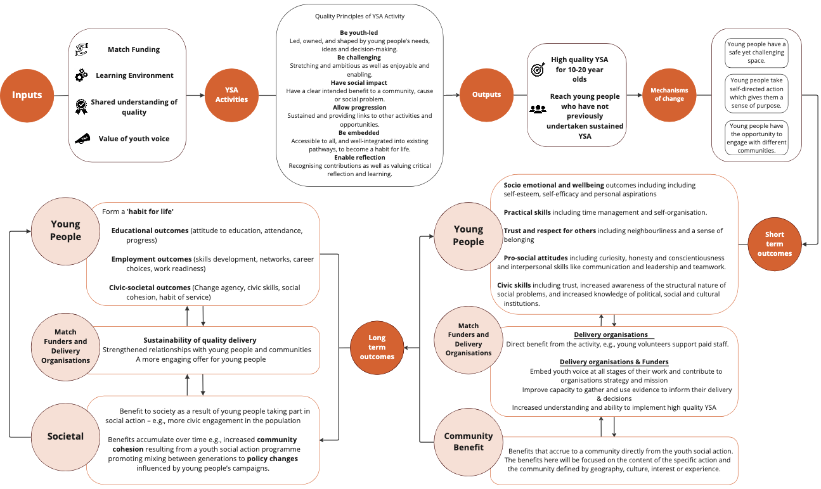

Figure 2 Sub-theory of change - Match Funder pathway

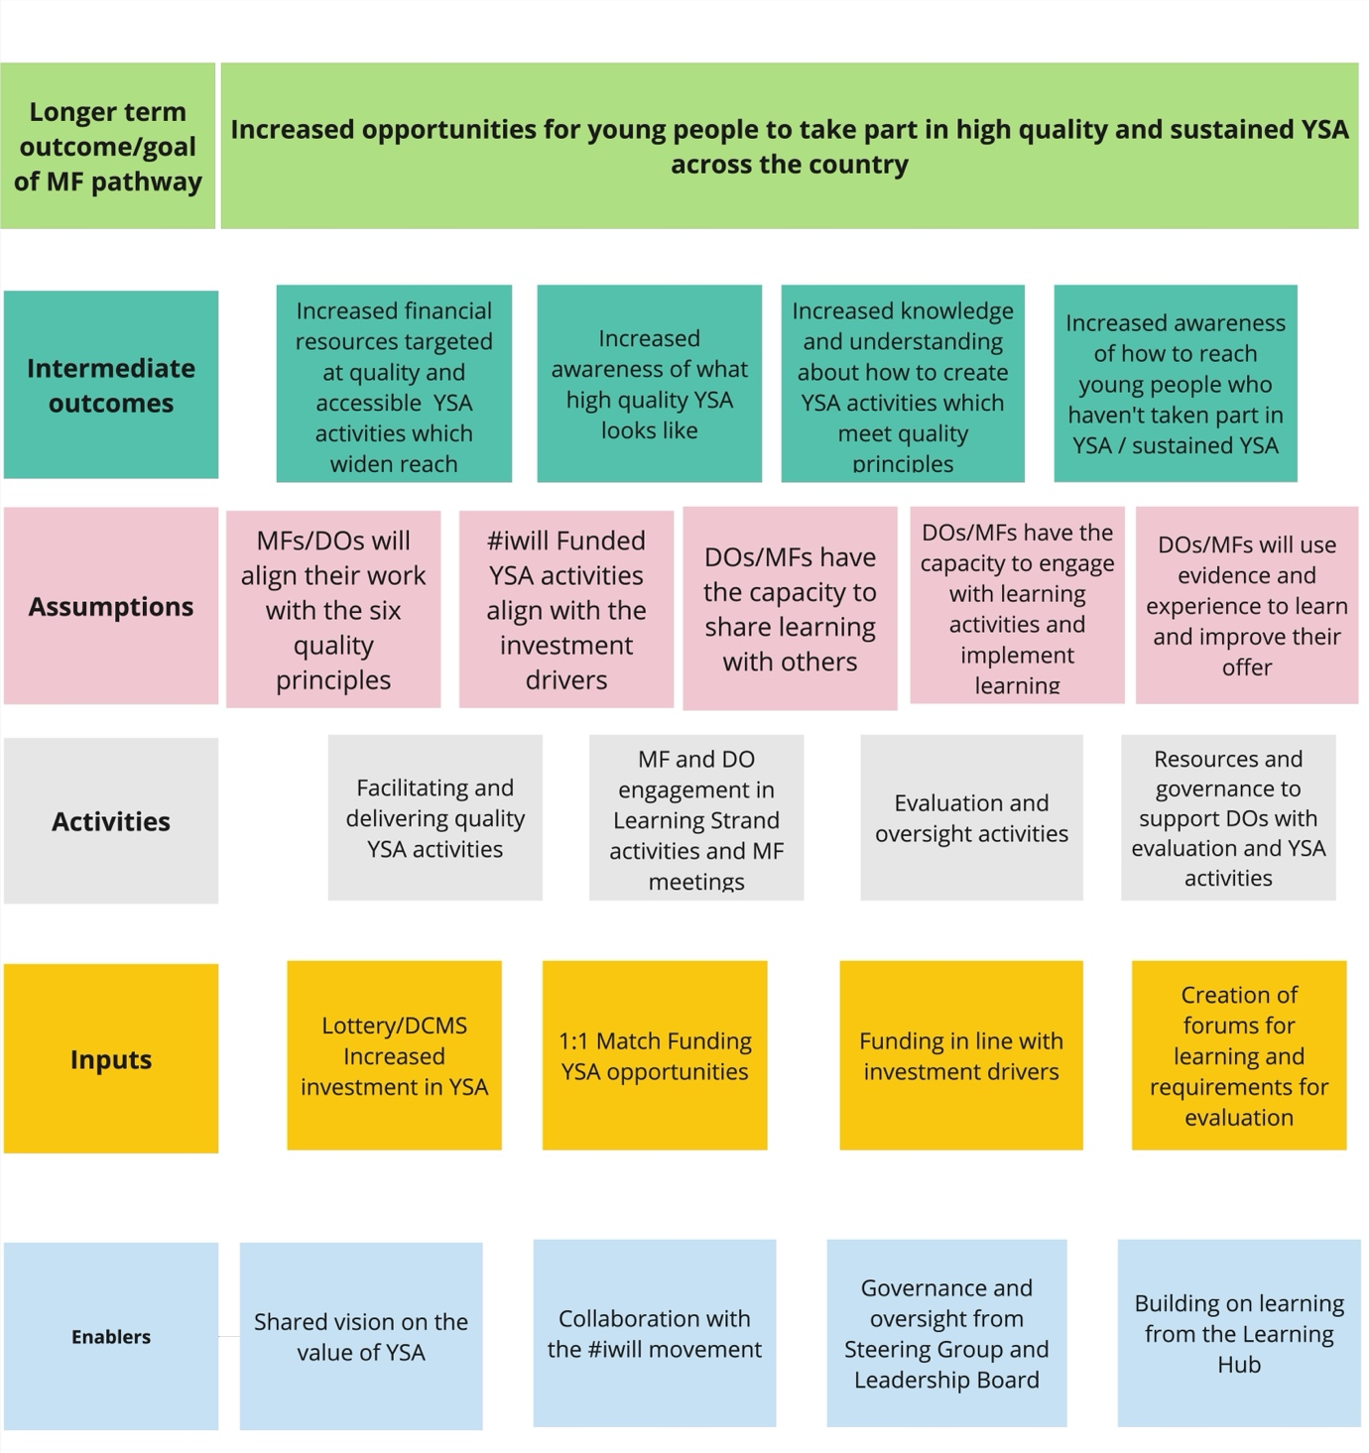
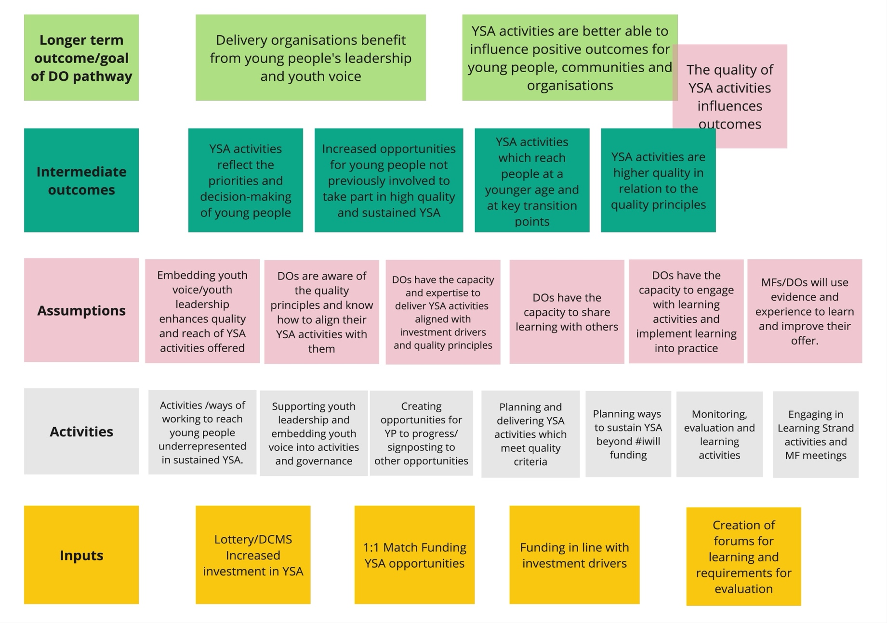
Figure 3 Sub-theory of change - delivery organisation pathway

Figure 4 Sub-theory of change - Young person pathway

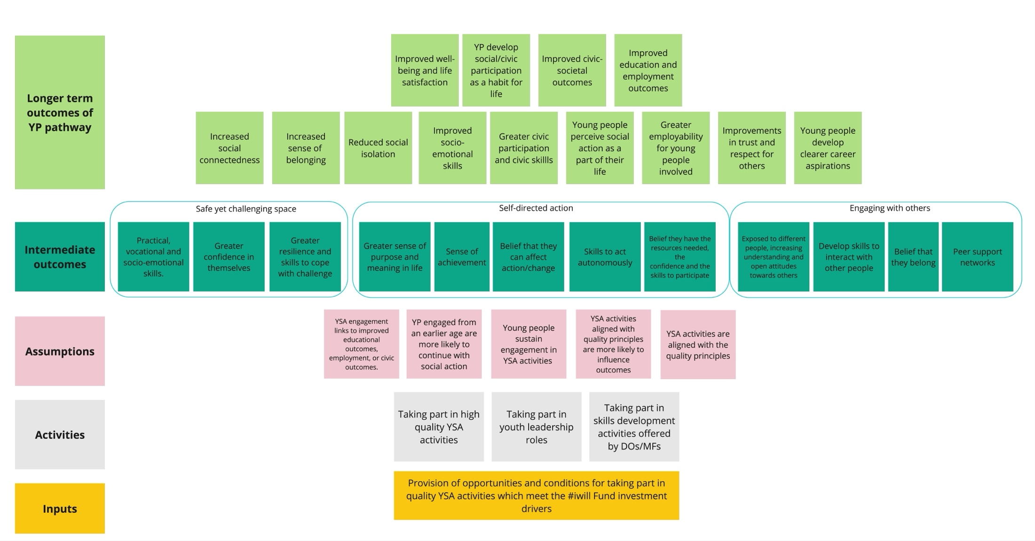
Figure 5 Sub-theory of change - community pathway
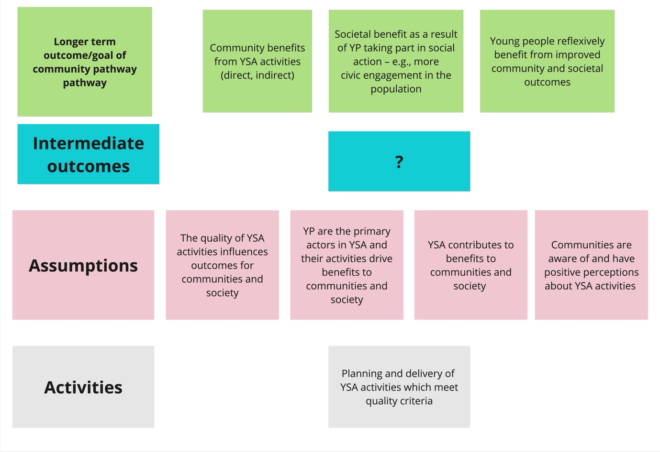

Appendix 3 Data Portal data analysis technical detail

Descriptive statistics
Opportunity data: We report the numbers and percentages of the types of YSA activity opportunities uploaded to the Portal, as well as numbers of young people engaged directly, and the estimated numbers engaged indirectly. The geographic distribution of YSA is reported in terms of Index of Multiple Deprivation (IMD 2015) decile, with 1 reflecting the most deprived, and 10 the least deprived areas.

Before and after comparison
We undertook pre-post comparative analysis of survey responses. The aim of this analysis is to see if there is a statistically significant difference between young people’s responses before taking part in an opportunity and after they take part. This is how we judge whether young people’s attitudes, beliefs or behaviours have changed in the time that they participated in an opportunity. This analysis uses an independent samples T-test which compares the mean values between two groups (the ‘before’ and ‘after’ groups). The data currently collected by the portal does not allow for matching of baseline and follow-up survey responses.
Our analyses therefore treat baseline and follow-up responses as if they were independent samples. An independent samples T-test is less sensitive to differences between the means but does still provide a reasonable estimate of significant difference between the means Levene’s test for equality of variance was applied to the baseline and follow-up survey responses prior to each independent samples T-test and the T-test was conducted accordingly where similarity of variance between the pre and post samples was and was not present. The detailed results from this analysis process can be made available on request.

Pre-post analyses were conducted for each survey question overall and within age groups (9–11, 12–14, 15–17 years old), gender (Female / girl, Male / boy, other responses) and high-level ethnic group (Asian or British Asian, Black, Black British, Caribbean or African, White, other responses). Ethnic groups were defined using the Office of National Statistics guidance on ethnicity categories. All analyses are independent samples T-tests with Levene’s equality of variance assumption tested and accounted for. Sample sizes, mean, standard deviation, T statistic and P-value are reported (see below for explanation).

Statistical significance
Statistical significance tells us the probability that the result observed is not due to chance. We report the statistical significance of the observed difference between the means at baseline compared to follow-up at the 5% (probability = 0.05), 1% (probability = 0.01) and 0.1% (probability = 0.001) levels. These are the levels of probability (‘p-values’) that are commonly deemed to mean that we can be reasonably sure that the change is meaningful (“statistically significant”) and not just a random fluctuation or something that happens by chance. The lower the p-value, the less likely the change is due to chance. We use asterisks to indicate how confident we can be – no asterisk means that the change is not statistically significant, we cannot be sure it is not due to chance. Statistically significant findings are indicated by * meaning there is less than 5% probability, ** less than 1% probability, and *** less than 0.1% probability that the change is due to chance.

Appendix 4 Value for Money work strand methods
The Value for Money (VfM) assessment aims to demonstrate the return on investment of the #iwill Fund across a range of outcomes that cover all age groups of participants. This requires an assessment of the indirect benefits of the #iwill Fund to the beneficiaries of social action in social value terms. The UK government defines social value as the additional economic, social, and environmental benefits generated by public spending beyond the goods or services being procured. It is about ensuring that procurement positively impacts people and communities. Social value analysis involves measuring and demonstrating social impact by quantifying the effects of an organisation's actions on stakeholders and communities, moving beyond simply recognising social value to quantifying it. This measurement enables organisations to demonstrate the value they create to funders, partners, and beneficiaries, strengthening their business case and attracting investment. It also helps organisations understand their impact and make better decisions to improve well-being. To deliver this social value assessment and support future assessments, Ipsos has proposed to produce two products:
- Undertaking cost-effectiveness analysis (CEA) to help understand which projects/interventions are more cost-effective – in other words, by determining the cost per unit, CEA will be used to compare projects.
- Developing a bespoke tool to capture community benefits using social value analysis that could be used for economic evaluation. A community benefits tool which can be used to estimate the monetary value produced by #iwill Fund-funded social action. This includes differentiating the relative social value created by different types of activities, to provide more evidence of the activities which provide most social return on investment.
The two products will provide important evidence of the social value produced by different strands of the programme, relative to the costs allocated to deliver them. This can be used for internal planning, programme optimisation and policy design and can provide an indicative social return on investment (SROI) figure for reporting. However, given the lack of counterfactual we cannot be sure of the additional value that the volunteer activities are making. For example, we do not know what other services are operating in the areas where #iwill Fund volunteer YSA activities are happening which could be providing similar benefits. Similarly, we do not know if volunteers would have identified other volunteer opportunities without the #iwill Fund. This should be made clear when interpreting any analysis using these estimates.

Cost effectiveness analysis
The cost effectiveness analysis will explore key outcomes from the #iwill Fund against their associated costs to compare the cost effectiveness of different Fund investments. This analysis will provide a cost-per-unit for specific outcomes so they can be compared across activities to see where cost effectiveness is maximised. Initial outcomes identified are:
- Number of young people who have been ‘directly reached’ by the opportunity (directly reached defined as those who are engaged in delivery, decision making, evaluation and research as part of the YSA activities).
- Number of young people who have been ‘indirectly reached’ by the opportunity (indirectly reached defined as those who haven't been directly involved in the above activities but have benefitted from them).
- Total number of young people who partook in the opportunity, and for whom it was their first meaningful engagement in a YSA opportunity.
- Opportunities where participation encouraged sustained participation (captured through the length and frequency of participation).
The costs associated with the #iwill Fund are being collected from the National Lottery Community Fund monitoring form which captures data from Match Funders on their activities to date, risks and targets as well as their spending. Specific information is shared on the spend to date, including details of any underspend, grant remaining and forecast expenditure for the next six months. A data cleaning and consolidation exercise will be undertaken to create a database of spending which can then be matched with the survey data containing the outcomes set out above.

The cost-effectiveness analysis has been progressed in this phase by identifying and beginning to consolidate spending data to assess the cost of #iwill Fund funded activities. This will provide the necessary information to estimate cost effective metrics for the number of young people directly and indirectly reached by the opportunity and those activities which support consistent and maintained engagement with young people, by analysing the frequency and length of participation using the primary data collected through the data portal.

Social value of community benefits from YSA
We are developing a bespoke tool to enable the estimation of community benefit of volunteering in monetary terms. The tool uses findings from the existing literature to calculate a per person value for those supported by volunteering (e.g., communities visited by volunteers, local households benefitting from YSA in the environment etc) which can then be aggregated to a total social value. This tool will be designed to be used to support Leadership Board decision making and inform programme design in future projects, to ensure optimal use of #iwill Funds on those volunteering activities which provide the most benefits to communities as well as enabling ongoing monitoring and assessment. The tool will include a range of unit values which can be applied to data collected by volunteer programmes to measure social value in monetary terms.

Logic chain
The following diagram outlines the logic chain as to how the value of volunteer activities can be monetised using existing literature. The first step is to identify how a volunteering activity benefits people e.g., volunteers who spend time with people feeling isolated can reduce loneliness in those communities. The next step is identifying literature which relates the benefits to individuals into a quantifiable outcome. For example, we can equate levels of loneliness to wellbeing outcomes. The third step is applying monetary values. In our example we use the monetary values associated with an increase in wellbeing known as WELLBYs. The outcomes from combining the assumptions from steps 2 and 3 provide unit values which will become the key source of information in the tool. Step 4 aggregates the unit values across the population of beneficiaries i.e., the people benefitting from the actions of the volunteer activities. This step is reliant on data specific to the example which the use of the tool will need to collect. We will provide advice within the tool on how to aggregate these tools in line with HM Treasury Green Book principles (see section “Further guidance on application of methods” for more details).

Diagram 1: Logic chain of social value calculations

Challenges
The #iwill Fund supports volunteers to do an enormous range of activities which improve the lives of a variety of people in different ways. It is therefore not possible for the tool to include a bank of values for every type of activity, outcome and community group. The tool will therefore attempt to include a variety of outcomes to cover as much of the range of volunteer activities as possible. The number of unit values included in the value bank will be dependent on identifying relevant and accurate assumptions from the existing literature (see steps 2 and 3 of Diagram 1).

To show how monetary values can be estimated and aggregated, we have set out some of our progress in identifying relevant social action activities and estimating monetary values using three ‘Illustrative examples of community benefits social value calculations’, detailed in the Appendix.

Further guidance on application of methods
As part of the tool, we will include guidance to help practitioners use the unit values to aggregate to a total value for a YSA activity. We suggest that any calculations follow the principles set out in the HM Treasury Green Book. Some of the key points to follow to ensure consistency with the HM Treasury Green Book are included below:

Avoid double counting - Although some volunteer activities are likely to meet multiple objectives it is important to choose one method only. This is because some methods will capture value from other outcomes. For example, organising a trip to the local theatre could reduce loneliness and improve health of individuals. However, because the benefits of reducing loneliness are calculated through improved subjective wellbeing, it is likely that health benefits would be at least partially captured in the wellbeing valuation. Therefore, adding the values from reduced loneliness and improved health are likely to produce an overestimate.

Account for deadweight – because the methods set out above do not include a counterfactual there is no way of knowing whether some of these outcomes would have happened anyway (leading to ‘deadweight’ loss). For instance, in our hypothetical example, there may have been alternative activities in place at the Age UK centre had the volunteers not visited which could have also reduced loneliness. Following guidance produced by the Homes & Communities Agency (2014), that identifies key areas of an intervention to assess against the current economic, social and environmental context, we suggest applying a deadweight of 19% to all estimates.

Discounting - allows costs and benefits with different time spans to be compared on a common “present value” basis. The public sector discount rate adjusts for social time preference, defined as the value which society attaches to present as opposed to future consumption. It is based on comparisons of utility (as termed in economic analysis or defined as wellbeing more broadly and in social value analysis) across different points in time or different generations. The discount rate of 3.5% (suggested within HM Treasury Green Book guidance) should be applied to any analysis over multiple years to account for the preference for utility now over utility in the future (in other words, the fact that people would prefer a £1 benefit now to a £1 benefit in a year’s time; a time preference factor which should be accounted for to be consistent with HMT Green Book methods).

Illustrative examples of community benefits social value calculations
To show how monetary values can be estimated and aggregated, we have set out some of our progress in identifying relevant social action activities and estimating monetary values using three illustrative examples. The examples have been chosen to align with one of the five broad types of social action which can be appropriately measured as part of a HM Treasury Green Book consistent methodology:

(1) Supporting people/ groups in the community: reducing loneliness
(2) Improving the local environment: litter picking
(3) Tutoring, coaching and mentoring: Encouraging participation in sport and cultural activities.
(4) Campaigning for a (non-political) cause: Deemed not appropriate for VfM given breadth of possible causes
(5) Fundraising/ sponsored activity: Not appropriate for VfM as economic transfers should not be included in social value measurement.

The examples use hypothetical scenarios with fictional assumptions made on the numbers of people supported by the volunteering activities, the period of time over which the volunteering took place and communities benefitting from the volunteer activities. These assumptions are not based on any real examples and therefore when applying to a real-world example this information will need to be collected. The three outcomes are designed to provide transparency on the type of methods that can be used to estimate social value in the context of the #iwill Fund, however, we would look to expand this list to cover a wider range of activities during the evaluation.
Outcome 1: #iwill Fund volunteers help reduce loneliness in their communities
Young people taking part in social action often spend time with communities at risk of loneliness. For example, the #iwill funded Intergenerational Linking project linked together young people aged 5-14 years from schools and youth organisations with older people living in care homes across England.

There is a range of research showing the positive impact that reducing loneliness can have on people’s health and wellbeing. In particular, research commissioned by DCMS and produced by Simetrica-Jacobs estimates the change in life satisfaction when people reduce their feelings of loneliness. For example, moving from “Severe Loneliness” to “Moderate Loneliness” was associated with a 0.7-point improvement in life satisfaction score on a scale of 0-10. We can take these findings and apply the latest monetary value estimates for a 1-point increase in subjective wellbeing for one year, known as a WELLBY (Wellbeing-adjusted Life Year). The use of WELLBYs in appraisal is suggested as part of the HM Treasury Green Book and is commonplace in economic appraisal. The central estimate of a WELLBY is £13,000 (lower bound £10,000 and upper bound £16,000). Uprated to 2023-24 financial year prices using the GDP deflator (following HMT best practice), this equates to £14,641. The calculations set out above are included in the table below and can be used to estimate the benefits of #iwill funded activities. The unit values included in the table will be included in the tool.

Table 6 Estimating social value example 1: #iwill Fund volunteers help reduce loneliness in their communities
 | Moving from “Mild loneliness” to “lack of Loneliness” | Moving from “Moderate loneliness” to “Mild loneliness”
Impact on life satisfaction on a scale of 0-10, where 0 is not at all satisfied with life and 10 is extremely satisfied with life | 0.44-point improvement in life satisfaction on scale from 0-10 | Between 0.58 and 0.7-point improvement in life satisfaction on scale from 0-10
Unit Value: Annual wellbeing benefit per person from improving life satisfaction | 0.44 x £14,641  = £6,442 | 0.58 x £14,641  = £8,491  0.7 x £14,641  = £10,248

As the unit values are annual, we can divide by 365 to estimate a daily unit value for each level of loneliness improvement:
 | Moving from “Mild loneliness” to “lack of Loneliness” | Moving from “Moderate loneliness” to “Mild loneliness” | Moving from “Severe loneliness” to “Moderate loneliness”
Day wellbeing cost from loneliness per person | £6,442/365 = £17.64 | £8,491/365 = £23.26  £10,248/365 = £28.07 | £10,248/365 = £28.07

Example of aggregation using a hypothetical example
Now we have the per person unit values (which will be provided as part of the tool) we can use a hypothetical example to show how the unit values could be used to estimate the total value of a particular YSA activity. In our hypothetical example, a group of volunteers make visits to local care homes to spend time with 150 elderly individuals. We need to make an assumption on the level of loneliness – we therefore assume they have moved on average from moderate to mild loneliness for the day. The calculations are included in the table below which estimate that the social value of the volunteering activity is between £3,489 and £4,211.

Table 7 Estimating social value example 1:example of aggregation
Number of participants | Change in Loneliness | Value
150 | Moderate to mild | 150 x (£23.26 to £28.07) = £3,489 to £4,211

Outcome 2: #iwill Fund volunteers improve the local environment
YSA to improve the environment is a key pillar of the #iwill movement (receiving #iwill Fund investment). This includes taking part in environmental volunteering such as litter picking or planting pollinator-friendly flowers, fundraising to maintain or enhance green spaces or campaigning for the zero plastic waste agenda - amongst other activities.

It is therefore important that we provide values which can capture the value volunteers make towards improving the quality of people’s local environment. A range of evidence shows that people who are proud of their local area are happier. This research often refers to "Amenity" which is a term used to refer to a bundle of services including aesthetic and visual benefits, tranquillity, and recreational opportunities. Litter and fly-tipping are common examples of "disamenity" where amenity is negatively affected by the condition of the local area. Interventions that address disamenities can generate benefits to local people by removing negative effects. Research commissioned by Department for Environment, Food and Rural Affairs (Defra) and conducted by eftec finds that local households are willing to pay to avoid accumulation of litter in their local area:

Table 8 Estimating social value example 2: #iwill Fund volunteers improve the local environment
Type of disamenity | Value willing to pay per local household to improve local area (2020) | Unit Value: Value willing to pay per Household to improve local area (uprated to 2023 prices)
Remove litter in residential areas | £75 per year | £84 per year
Improve water environment | £65 per year | £72 per year
Remove litter in recreational areas | £55 per year | £61 per year
Improve business areas | £20 per year | £22.45 per year

Example of aggregation using a hypothetical example
We now use an example to illustrate how these values could be applied to value the benefits of volunteering. A group of volunteers might identify a local park with significant build-up of litter which they work to remove. Anecdotally, it takes one week for litter to accumulate again in the park. The park has around 200 houses in the immediate local area.

Table 9 Estimating social value example 2: Example of aggregation
Steps | Calculation
Per household value of their local park being free of significant levels of litter for a week | £61 / 52 weeks = £1.17
Value for 200 households | £1.17 x 200 = £234

Outcome 3: #iwill Fund volunteers help communities participate in sport, culture and heritage
Engaging people in sports and culture is a key part of the tutoring, coaching and mentoring broad category of YSA. Engaging people in sports and cultural activities, both as an audience member and participating, has been shown to improve health outcomes for individuals. To estimate the value linked to these types of activities, we use findings from research commissioned by DCMS which estimated the social impact of engaging with culture and sport. The research found that those who participate in sport are 14.1% more likely to report good health than non-participants while arts audience members are 5.4% more likely to report good health than non-audience members.

Research, conducted by Simetrica in 2014, uses the findings from the research commissioned by DCMS to estimate an association between self-reported health scores and medical service usage rates in the UK alongside. These usage rates were combined with average GP costs to estimate the cost savings from engaging with sport and culture.

Table 10 Estimating social value example 3: #iwill Fund volunteers help communities participate in sport, culture and heritage
 | Probability of reporting good health per person | NHS cost savings per person annually (based on 2014 data) | Unit Value: NHS Savings per person annually (updated to 2023 prices)
All sports | 14.1% | £97.71 | £125.68
All audience arts | 5.4% | £37.42 | £48.13

We can use these estimates to work out how much a singular session of participation is worth in social value terms. In the sports participation context, the definition of “regular” sports participation is playing sport three times a week, divided into three 45-60 min sessions). For simplicity, we assume the same holds for cultural activities.

Table 11 Estimating social value example 3: #iwill Fund volunteers help communities participate in sport, culture and heritage, value per session
 | Value per person per week of regular sports participation | Value per person per session of regular sports participation
All sports | £125.68/ 52 = £2.41 | £2.41/3 = £0.80
All audience arts | £48.13/ 52 = £0.93 | £0.93/3 = £0.31

Example of aggregation
We can now apply a hypothetical example to show how these unit values (which will be part of the tool) can be used to estimate the social value of YSA activity. In our hypothetical example, a group of volunteers organise an hour of sports activities for a group of 30 individuals. The calculation in the table below shows that the estimate for the social value produced by the session was £24.00.

Table 12 Estimating social value example 3: example of aggregation
Steps | Calculation
Value sports activity with 30 people | £0.80 x 30 = £24.00

Appendix 5 Data Portal Analysis Tables and Figures

Figure 2 Bar chart of YSA opportunities by Index of Multiple Deprivation decile (n=356 opportunities)
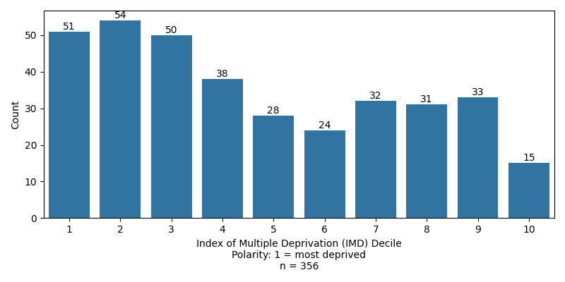
Figure illustrates the distribution of YSA opportunities by area level measure of deprivation, where 1 refers to most deprived and 10 least deprived. Numbers of opportunities at each decile are reported.

Table 16 Demographic characteristics of young people completing surveys at baseline
Demographic characteristic | n | %
Age (years) (n=1,058)
9 | 70 | 6.6
10 | 120 | 11.3
11 | 122 | 11.5
12 | 182 | 17.2
13 | 166 | 15.7
14 | 175 | 16.5
15-17 | 223 | 21.1
Gender (n=1,147)
Female / girl | 623 | 54.3
Male / boy | 442 | 38.5
Non-binary | 23 | 2.0
Prefer not to say | 50 | 4.4
Unsure how to describe myself | 9 | 0.8
Ethnicity* (n=1,116)
Asian or Asian British | 122 | 10.9
Black, Black British, Caribbean or African | 116 | 10.4
Mixed or multiple ethnic groups | 63 | 5.7
Other ethnic group | 19 | 1.7
Prefer not to say | 86 | 7.7
White | 710 | 63.6
*Grouped due to small numbers to preserve anonymity

Table 17 Descriptive statistics (number of responses, mean and standard deviation) and statistical comparison of baseline and follow up social action responses.
 | Baseline |  |  | Follow-up |  |  | Comparative T-test
Survey question | N | Mean | SD | N | Mean | SD | T statistic | P-value | Sig.
Q1. I can make a difference in the world | 1147 | 3.39 | 1.03 | 411 | 3.43 | 1.05 | -0.652 | 0.514
Q2. I have a voice in decisions that affect  me and my community | 1144 | 3.37 | 0.95 | 415 | 3.38 | 1.06 | -0.164 | 0.870
Q3. My ideas are listened to | 1145 | 3.49 | 0.94 | 413 | 3.63 | 0.92 | -2.568 | 0.010 | *
Q4. I can make a difference to people in  my community | 1147 | 3.51 | 0.93 | 413 | 3.51 | 0.97 | 0.009 | 0.993
Q5. It is important to help others | 1147 | 4.47 | 0.72 | 412 | 4.43 | 0.80 | 0.827 | 0.409
Q6. I can change things that are unfair | 1143 | 3.57 | 0.92 | 411 | 3.57 | 0.99 | -0.022 | 0.983
Q7. I am working with other people who want to  make the world a better place | 1147 | 3.79 | 0.98 | 413 | 3.80 | 0.99 | -0.197 | 0.844
Q8. In future, I would like to do more to make  positive difference to other people's lives | 1146 | 4.07 | 0.84 | 413 | 3.95 | 0.92 | 2.383 | 0.017 | *
SD = Standard Deviation; Sig. = Statistical significance P-value less than: * 0.05, ** 0.01, *** 0.001

Table 18 Descriptive statistics (number of responses, mean and standard deviation) and statistical comparison of baseline and follow up socio-emotional skills responses.
 | Baseline |  |  | Follow-up |  |  | Comparative T-test
Survey question | N | Mean | SD | N | Mean | SD | T statistic | P-value | Sig.
Emotion management: I easily stop myself from doing things that might be bad for me | 1106 | 3.51 | 1.00 | 393 | 3.60 | 1.04 | -1.4974 | 0.135
Empathy: It is easy for me to feel what other people are feeling | 1109 | 3.53 | 1.05 | 405 | 3.56 | 1.11 | -0.4046 | 0.686
Initiative: I work as long and as hard as necessary to get a job done | 1117 | 3.86 | 1.01 | 406 | 3.87 | 1.05 | -0.1203 | 0.904
Teamwork: I respect other points of view, even if I disagree | 1118 | 4.05 | 1.00 | 398 | 4.06 | 1.02 | -0.2015 | 0.840
Problem solving: I start a new task by thinking about different options for doing it | 1105 | 3.48 | 1.10 | 396 | 3.58 | 1.14 | -1.5561 | 0.120
Responsibility: I take responsibility for my actions, even if I make a mistake | 1120 | 3.91 | 0.99 | 400 | 3.98 | 1.01 | -1.2884 | 0.198
SD = Standard Deviation; Sig. = Statistical significance P-value less than: * 0.05, ** 0.01, *** 0.001

 | Baseline |  |  | Follow-up |  |  | Comparative T-test
Survey question | N | Mean | SD | N | Mean | SD | T statistic | P-value | Sig.
Neighbourhood belonging | 1140 | 2.72 | 0.78 | 407 | 2.85 | 0.73 | -3.0134 | 0.003 | **
Life satisfaction | 1136 | 6.65 | 2.22 | 406 | 6.88 | 2.18 | -1.8186 | 0.069
Table 19 Descriptive statistics (number of responses, mean and standard deviation) and statistical comparison of baseline and follow up belonging and life-satisfaction responses.

SD = Standard Deviation; Sig. = Statistical significance P-value less than: * 0.05, ** 0.01, *** 0.001

Table 20 Descriptive statistics (number of responses, mean and standard deviation) at baseline and follow-up and independent samples T-test results for social action questions by age group.
 |  | Baseline |  |  | Follow-up |  |  | Comparative T-test
Age group (years) | Survey question | N | Mean | SD | N | Mean | SD | T statistic | P-value | Sig.
9 - 11 | Q1. I can make a difference in the world | 312 | 3.52 | 1.08 | 136 | 3.66 | 1.12 | -1.2459 | 0.214
9 - 11 | Q2. I have a voice in decisions that affect me and my community | 312 | 3.43 | 0.96 | 136 | 3.29 | 1.07 | 1.3948 | 0.164
9 - 11 | Q3. My ideas are listened to | 312 | 3.65 | 0.92 | 136 | 3.51 | 1.07 | 1.2842 | 0.200
9 - 11 | Q4. I can make a difference to people in my community | 312 | 3.62 | 0.91 | 136 | 3.53 | 1.05 | 0.9386 | 0.349
9 - 11 | Q5. It is important to help others | 312 | 4.51 | 0.69 | 136 | 4.51 | 0.83 | -0.0249 | 0.980
9 - 11 | Q6. I can change things that are unfair | 312 | 3.68 | 0.95 | 136 | 3.55 | 1.11 | 1.1952 | 0.233
9 - 11 | Q7. I am working with other people who want to make the world a better place | 312 | 3.91 | 0.93 | 136 | 3.81 | 1.11 | 0.9978 | 0.319
9 - 11 | Q8. In future, I would like to do more to make positive difference to other people's lives | 312 | 4.00 | 0.87 | 136 | 3.94 | 1.01 | 0.6239 | 0.533
12 - 14 | Q1. I can make a difference in the world | 523 | 3.33 | 1.04 | 92 | 3.21 | 1.07 | 1.0332 | 0.302
12 - 14 | Q2. I have a voice in decisions that affect me and my community | 522 | 3.34 | 0.94 | 92 | 3.45 | 0.98 | -0.9799 | 0.328
12 - 14 | Q3. My ideas are listened to | 522 | 3.43 | 0.97 | 92 | 3.66 | 0.75 | -2.5997 | 0.010 | *
12 - 14 | Q4. I can make a difference to people in my community | 523 | 3.49 | 0.95 | 92 | 3.38 | 1.03 | 0.9649 | 0.335
12 - 14 | Q5. It is important to help others | 523 | 4.47 | 0.72 | 92 | 4.40 | 0.74 | 0.8109 | 0.418
12 - 14 | Q6. I can change things that are unfair | 523 | 3.57 | 0.93 | 92 | 3.49 | 0.97 | 0.7788 | 0.436
12 - 14 | Q7. I am working with other people who want to  make the world a better place | 523 | 3.77 | 1.00 | 92 | 3.90 | 0.83 | -1.1606 | 0.246
12 - 14 | Q8. In future, I would like to do more to make positive difference to other people's lives | 523 | 4.08 | 0.83 | 92 | 3.90 | 0.76 | 1.9341 | 0.054
15 - 17 | Q1. I can make a difference in the world | 223 | 3.31 | 0.91 | 12 | 3.83 | 0.58 | -1.9634 | 0.051
15 - 17 | Q2. I have a voice in decisions that affect me and my community | 222 | 3.29 | 0.91 | 12 | 3.17 | 1.03 | 0.4497 | 0.653
15 - 17 | Q3. My ideas are listened to | 222 | 3.39 | 0.85 | 12 | 3.50 | 0.80 | -0.4496 | 0.653
15 - 17 | Q4. I can make a difference to people in my community | 223 | 3.37 | 0.87 | 12 | 3.75 | 0.45 | -2.6451 | 0.018 | *
15 - 17 | Q5. It is important to help others | 223 | 4.43 | 0.70 | 12 | 4.58 | 0.67 | -0.7387 | 0.461
15 - 17 | Q6. I can change things that are unfair | 219 | 3.41 | 0.78 | 12 | 3.33 | 0.89 | 0.3329 | 0.740
15 - 17 | Q7. I am working with other people who want to make the world a better place | 223 | 3.56 | 0.95 | 12 | 4.00 | 0.60 | -2.3963 | 0.031 | *
15 - 17 | Q8. In future, I would like to do more to make positive difference to other people's lives | 222 | 4.08 | 0.82 | 12 | 4.33 | 0.65 | -1.0474 | 0.296
SD = Standard Deviation; Sig = statistical significance P-value less than: * 0.05, **0.01 ***0.001

Table 21 Descriptive statistics (number of responses, mean and standard deviation) at baseline and follow-up and independent samples T-test results for social action questions by gender.
 |  | Baseline |  |  | Follow-up |  |  | Comparative T-test
Gender | Survey question | N | Mean | SD | N | Mean | SD | T statistic | P-value | Sig.
Female / girl | Q1. I can make a difference in the world | 623 | 3.49 | 0.93 | 135 | 3.57 | 1.03 | -0.8956 | 0.371
Female / girl | Q2. I have a voice in decisions that affect  me and my community | 621 | 3.42 | 0.95 | 135 | 3.39 | 1.04 | 0.2852 | 0.776
Female / girl | Q3. My ideas are listened to | 621 | 3.57 | 0.88 | 135 | 3.62 | 0.95 | -0.5752 | 0.565
Female / girl | Q4. I can make a difference to people in  my community | 623 | 3.56 | 0.86 | 135 | 3.56 | 0.94 | -0.014 | 0.989
Female / girl | Q5. It is important to help others | 623 | 4.55 | 0.67 | 135 | 4.52 | 0.75 | 0.419 | 0.675
Female / girl | Q6. I can change things that are unfair | 619 | 3.65 | 0.87 | 135 | 3.50 | 0.97 | 1.7114 | 0.087
Female / girl | Q7. I am working with other people who want to  make the world a better place | 623 | 3.87 | 0.93 | 135 | 3.93 | 0.92 | -0.6856 | 0.493
Female / girl | Q8. In future, I would like to do more to make  positive difference to other people's lives | 623 | 4.19 | 0.75 | 135 | 4.01 | 0.86 | 2.4776 | 0.013 | *
Male / boy | Q1. I can make a difference in the world | 442 | 3.29 | 1.14 | 100 | 3.32 | 1.21 | -0.2028 | 0.840
Male / boy | Q2. I have a voice in decisions that affect  me and my community | 441 | 3.28 | 0.97 | 100 | 3.27 | 1.08 | 0.0605 | 0.952
Male / boy | Q3. My ideas are listened to | 442 | 3.45 | 1.02 | 100 | 3.59 | 0.93 | -1.299 | 0.195
Male / boy | Q4. I can make a difference to people in  my community | 442 | 3.44 | 1.04 | 100 | 3.36 | 1.14 | 0.6535 | 0.514
Male / boy | Q5. It is important to help others | 442 | 4.38 | 0.80 | 100 | 4.36 | 0.85 | 0.2739 | 0.784
Male / boy | Q6. I can change things that are unfair | 442 | 3.51 | 0.97 | 100 | 3.49 | 1.14 | 0.2122 | 0.832
Male / boy | Q7. I am working with other people who want to  make the world a better place | 442 | 3.64 | 1.04 | 100 | 3.73 | 1.08 | -0.7536 | 0.451
Male / boy | Q8. In future, I would like to do more to make  positive difference to other people's lives | 441 | 3.91 | 0.94 | 100 | 3.83 | 1.02 | 0.749 | 0.454
Non-binary, unsure or prefer not to say | Q1. I can make a difference in the world | 82 | 3.11 | 0.97 | 176 | 3.38 | 0.95 | -2.0694 | 0.034 | *
Non-binary, unsure or prefer not to say | Q2. I have a voice in decisions that affect  me and my community | 82 | 3.45 | 0.77 | 180 | 3.42 | 1.06 | 0.2498 | 0.803
Non-binary, unsure or prefer not to say | Q3. My ideas are listened to | 82 | 3.12 | 0.84 | 178 | 3.66 | 0.88 | -4.6153 | <0.001 | ***
Non-binary, unsure or prefer not to say | Q4. I can make a difference to people in  my community | 82 | 3.46 | 0.74 | 178 | 3.54 | 0.87 | -0.7343 | 0.463
Non-binary, unsure or prefer not to say | Q5. It is important to help others | 82 | 4.32 | 0.54 | 177 | 4.41 | 0.81 | -1.0529 | 0.294
Non-binary, unsure or prefer not to say | Q6. I can change things that are unfair | 82 | 3.33 | 0.93 | 176 | 3.68 | 0.91 | -2.8332 | 0.005 | **
Non-binary, unsure or prefer not to say | Q7. I am working with other people who want to  make the world a better place | 82 | 3.89 | 0.92 | 178 | 3.73 | 0.98 | 1.2446 | 0.214
Non-binary, unsure or prefer not to say | Q8. In future, I would like to do more to make  positive difference to other people's lives | 82 | 3.99 | 0.75 | 178 | 3.97 | 0.91 | 0.1381 | 0.890
SD = Standard Deviation; Sig = statistical significance P-value less than: * 0.05, **0.01 ***0.001

Table 22 Descriptive statistics (number of responses, mean and standard deviation) at baseline and follow-up and independent samples T-test results for social action questions by high level ethnic group.
 |  | Baseline |  |  | Follow-up |  |  | Comparative T-test
Ethnicity (grouped) | Survey question | N | Mean | SD | N | Mean | SD | T statistic | P-value | Sig.
Asian or Asian British | Q1. I can make a difference in the world | 122 | 3.30 | 0.98 | 22 | 3.68 | 1.13 | -1.6311 | 0.105
Asian or Asian British | Q2. I have a voice in decisions that affect me and my community | 120 | 3.46 | 0.99 | 22 | 3.09 | 1.11 | 1.5752 | 0.118
Asian or Asian British | Q3. My ideas are listened to | 122 | 3.50 | 0.95 | 22 | 3.59 | 0.96 | -0.4137 | 0.680
Asian or Asian British | Q4. I can make a difference to people in my community | 122 | 3.48 | 0.88 | 22 | 3.32 | 1.21 | 0.7229 | 0.471
Asian or Asian British | Q5. It is important to help others | 122 | 4.60 | 0.56 | 22 | 4.77 | 0.43 | -1.3978 | 0.164
Asian or Asian British | Q6. I can change things that are unfair | 121 | 3.68 | 0.85 | 22 | 3.77 | 1.19 | -0.4515 | 0.652
Asian or Asian British | Q7. I am working with other people who want to make the world a better place | 122 | 3.76 | 1.00 | 22 | 4.14 | 0.77 | -1.6582 | 0.010 | **
Asian or Asian British | Q8. In future, I would like to do more to make positive difference to other people's lives | 122 | 4.16 | 0.84 | 22 | 4.27 | 0.63 | -0.6194 | 0.537
Black, Black British, Caribbean or African | Q1. I can make a difference in the world | 116 | 3.54 | 1.02 | 24 | 3.58 | 1.28 | -0.1684 | 0.867
Black, Black British, Caribbean or African | Q2. I have a voice in decisions that affect me and my community | 116 | 3.34 | 0.99 | 24 | 3.08 | 1.14 | 1.1494 | 0.252
Black, Black British, Caribbean or African | Q3. My ideas are listened to | 114 | 3.55 | 1.02 | 24 | 3.29 | 1.16 | 1.1096 | 0.269
Black, Black British, Caribbean or African | Q4. I can make a difference to people in my community | 116 | 3.59 | 0.95 | 24 | 3.54 | 1.10 | 0.203 | 0.839
Black, Black British, Caribbean or African | Q5. It is important to help others | 116 | 4.44 | 0.75 | 24 | 4.29 | 0.91 | 0.8482 | 0.398
Black, Black British, Caribbean or African | Q6. I can change things that are unfair | 114 | 3.65 | 0.91 | 24 | 3.58 | 1.35 | 0.2282 | 0.821
Black, Black British, Caribbean or African | Q7. I am working with other people who want to make the world a better place | 116 | 3.75 | 1.07 | 24 | 4.00 | 0.83 | -1.0774 | 0.283
Black, Black British, Caribbean or African | Q8. In future, I would like to do more to make positive difference to other people's lives | 116 | 4.09 | 0.87 | 24 | 3.92 | 1.21 | 0.8075 | 0.421
White | Q1. I can make a difference in the world | 710 | 3.41 | 1.02 | 175 | 3.49 | 1.07 | -0.9685 | 0.333
White | Q2. I have a voice in decisions that affect me and my community | 709 | 3.38 | 0.94 | 175 | 3.38 | 1.03 | -0.0776 | 0.938
White | Q3. My ideas are listened to | 710 | 3.53 | 0.92 | 175 | 3.65 | 0.88 | -1.6354 | 0.102
White | Q4. I can make a difference to people in my community | 710 | 3.50 | 0.95 | 175 | 3.54 | 1.02 | -0.4218 | 0.673
White | Q5. It is important to help others | 710 | 4.49 | 0.70 | 175 | 4.49 | 0.72 | -0.0688 | 0.945
White | Q6. I can change things that are unfair | 710 | 3.59 | 0.90 | 175 | 3.50 | 0.95 | 1.2662 | 0.206
White | Q7. I am working with other people who want to make the world a better place | 710 | 3.84 | 0.95 | 175 | 3.85 | 0.98 | -0.1668 | 0.867
White | Q8. In future, I would like to do more to make positive difference to other people's lives | 709 | 4.08 | 0.84 | 175 | 3.94 | 0.90 | 1.9528 | 0.051
Mixed, multiple or ‘any other’ group | Q1. I can make a difference in the world | 199 | 3.28 | 1.06 | 190 | 3.32 | 0.98 | -0.3799 | 0.704
Mixed, multiple or ‘any other’ group | Q2. I have a voice in decisions that affect me and my community | 199 | 3.29 | 0.92 | 194 | 3.44 | 1.06 | -1.5125 | 0.131
Mixed, multiple or ‘any other’ group | Q3. My ideas are listened to | 199 | 3.33 | 0.95 | 192 | 3.66 | 0.91 | -3.4483 | <0.001 | ***
Mixed, multiple or ‘any other’ group | Q4. I can make a difference to people in my community | 199 | 3.49 | 0.88 | 192 | 3.49 | 0.87 | -0.0264 | 0.979
Mixed, multiple or ‘any other’ group | Q5. It is important to help others | 199 | 4.33 | 0.83 | 191 | 4.36 | 0.88 | -0.2822 | 0.778
Mixed, multiple or ‘any other’ group | Q6. I can change things that are unfair | 198 | 3.39 | 1.00 | 190 | 3.62 | 0.95 | -2.342 | 0.020 | *
Mixed, multiple or ‘any other’ group | Q7. I am working with other people who want to make the world a better place | 199 | 3.63 | 1.00 | 192 | 3.68 | 1.03 | -0.479 | 0.632
Mixed, multiple or ‘any other’ group | Q8. In future, I would like to do more to make positive difference to other people's lives | 199 | 3.94 | 0.82 | 192 | 3.92 | 0.93 | 0.258 | 0.797
SD = Standard Deviation; Sig = statistical significance P-value less than: * 0.05, **0.01 ***0.001

Table 23 Descriptive statistics (number of responses, mean and standard deviation) at baseline and follow-up and independent samples T-test results for socio-emotional skills questions by age group.
 |  | Baseline |  |  | Follow-up |  |  | Comparative T-test
Age group (years) | Survey question | N | Mean | SD | N | Mean | SD | T statistic | P-value | Sig.
9 - 11 | Emotion management: I easily stop myself from doing things that might be bad for me | 299 | 3.64 | 1.03 | 129 | 3.61 | 1.09 | 0.2080 | 0.835
9 - 11 | Empathy: It is easy for me to feel what other people are feeling | 304 | 3.41 | 1.07 | 134 | 3.31 | 1.22 | 0.9083 | 0.364
9 - 11 | Initiative: I work as long and as hard as necessary to get a job done | 306 | 3.91 | 1.02 | 135 | 3.73 | 1.13 | 1.6329 | 0.103
9 - 11 | Teamwork: I respect other points of view, even if I disagree | 308 | 4.06 | 1.02 | 135 | 4.04 | 1.13 | 0.1882 | 0.851
9 - 11 | Problem solving: I start a new task by thinking about different options for doing it | 301 | 3.48 | 1.20 | 131 | 3.51 | 1.23 | -0.288 | 0.774
9 - 11 | Responsibility: I take responsibility for my actions, even if I make a mistake | 305 | 4.01 | 1.02 | 133 | 3.82 | 1.13 | 1.7087 | 0.088
12 - 14 | Emotion management: I easily stop myself from doing things that might be bad for me | 502 | 3.44 | 1.00 | 86 | 3.37 | 0.92 | 0.5538 | 0.580
12 - 14 | Empathy: It is easy for me to feel what other people are feeling | 501 | 3.55 | 1.07 | 89 | 3.55 | 0.97 | 0.0028 | 0.998
12 - 14 | Initiative: I work as long and as hard as necessary to get a job done | 506 | 3.88 | 1.00 | 90 | 3.73 | 1.06 | 1.2275 | 0.220
12 - 14 | Teamwork: I respect other points of view, even if I disagree | 508 | 4.03 | 1.01 | 87 | 3.91 | 0.91 | 1.0858 | 0.278
12 - 14 | Problem solving: I start a new task by thinking about different options for doing it | 507 | 3.50 | 1.08 | 87 | 3.57 | 1.09 | -0.62 | 0.536
12 - 14 | Responsibility: I take responsibility for my actions, even if I make a mistake | 510 | 3.85 | 1.03 | 89 | 3.89 | 0.88 | -0.3665 | 0.714
15 - 17 | Emotion management: I easily stop myself from doing things that might be bad for me | 221 | 3.46 | 0.94 | 10 | 3.30 | 1.49 | 0.5156 | 0.607
15 - 17 | Empathy: It is easy for me to feel what other people are feeling | 220 | 3.68 | 0.95 | 12 | 3.25 | 1.14 | 1.5245 | 0.129
15 - 17 | Initiative: I work as long and as hard as necessary to get a job done | 220 | 3.76 | 0.98 | 12 | 4.08 | 0.79 | -1.1309 | 0.259
15 - 17 | Teamwork: I respect other points of view, even if I disagree | 218 | 4.05 | 0.95 | 11 | 4.00 | 1.00 | 0.1721 | 0.864
15 - 17 | Problem solving: I start a new task by thinking about different options for doing it | 216 | 3.50 | 0.99 | 10 | 3.60 | 1.17 | -0.2946 | 0.769
15 - 17 | Responsibility: I take responsibility for my actions, even if I make a mistake | 218 | 3.88 | 0.83 | 11 | 3.73 | 1.42 | 0.3552 | 0.730
SD = Standard Deviation; Sig = statistical significance P-value less than: * 0.05, **0.01 ***0.001

Table 24 Descriptive statistics (number of responses, mean and standard deviation) at baseline and follow-up and independent samples T-test results for socio-emotional skills questions by gender.
 |  | Baseline |  |  | Follow-up |  |  | Comparative T-test
Gender | Survey question | N | Mean | SD | N | Mean | SD | T statistic | P-value | Sig.
Female / girl | Emotion management: I easily stop myself from doing things that might be bad for me | 605 | 3.54 | 0.97 | 125 | 3.58 | 1.06 | -0.4306 | 0.667
Female / girl | Empathy: It is easy for me to feel what other people are feeling | 607 | 3.64 | 1.04 | 130 | 3.54 | 1.14 | 0.9496 | 0.343
Female / girl | Initiative: I work as long and as hard as necessary to get a job done | 609 | 3.88 | 1.00 | 133 | 3.79 | 1.11 | 0.9481 | 0.343
Female / girl | Teamwork: I respect other points of view, even if I disagree | 610 | 4.14 | 0.97 | 130 | 4.05 | 0.96 | 0.8984 | 0.369
Female / girl | Problem solving: I start a new task by thinking about different options for doing it | 604 | 3.51 | 1.10 | 127 | 3.64 | 1.17 | -1.1316 | 0.258
Female / girl | Responsibility: I take responsibility for my actions, even if I make a mistake | 610 | 3.98 | 0.95 | 132 | 3.80 | 1.01 | 1.9174 | 0.056
Male / boy | Emotion management: I easily stop myself from doing things that might be bad for me | 424 | 3.50 | 1.05 | 96 | 3.43 | 1.04 | 0.6341 | 0.526
Male / boy | Empathy: It is easy for me to feel what other people are feeling | 424 | 3.43 | 1.08 | 99 | 3.16 | 1.11 | 2.2027 | 0.028 | *
Male / boy | Initiative: I work as long and as hard as necessary to get a job done | 428 | 3.92 | 1.05 | 98 | 3.72 | 1.05 | 1.6811 | 0.093
Male / boy | Teamwork: I respect other points of view, even if I disagree | 429 | 4.00 | 1.05 | 97 | 3.88 | 1.16 | 1.0279 | 0.305
Male / boy | Problem solving: I start a new task by thinking about different options for doing it | 422 | 3.48 | 1.13 | 95 | 3.40 | 1.18 | 0.5882 | 0.557
Male / boy | Responsibility: I take responsibility for my actions, even if I make a mistake | 431 | 3.90 | 1.00 | 96 | 3.86 | 1.10 | 0.2899 | 0.772
Non-binary, unsure or prefer not to say | Emotion management: I easily stop myself from doing things that might be bad for me | 77 | 3.29 | 0.89 | 172 | 3.70 | 1.02 | -3.2771 | 0.001 | **
Non-binary, unsure or prefer not to say | Empathy: It is easy for me to feel what other people are feeling | 78 | 3.29 | 0.84 | 176 | 3.80 | 1.03 | -4.0755 | <0.001 | ***
Non-binary, unsure or prefer not to say | Initiative: I work as long and as hard as necessary to get a job done | 80 | 3.42 | 0.73 | 175 | 4.02 | 0.98 | -5.3927 | <0.001 | ***
Non-binary, unsure or prefer not to say | Teamwork: I respect other points of view, even if I disagree | 79 | 3.66 | 0.85 | 171 | 4.18 | 0.98 | -4.0504 | <0.001 | ***
Non-binary, unsure or prefer not to say | Problem solving: I start a new task by thinking about different options for doing it | 79 | 3.27 | 0.83 | 174 | 3.64 | 1.09 | -3.0406 | 0.003 | **
Non-binary, unsure or prefer not to say | Responsibility: I take responsibility for my actions, even if I make a mistake | 79 | 3.37 | 1.06 | 172 | 4.18 | 0.92 | -6.2013 | <0.001 | ***
SD = Standard Deviation; Sig = statistical significance P-value less than: * 0.05, **0.01 ***0.001

Table 25 Descriptive statistics (number of responses, mean and standard deviation) at baseline and follow-up and independent samples T-test results for socio-emotional skills questions by high level ethnic group.
 |  | Baseline |  |  | Follow-up |  |  | Comparative T-test
Ethnicity (grouped) | Survey question | N | Mean | SD | N | Mean | SD | T statistic | P-value | Sig.
Asian or British Asian | Emotion management: I easily stop myself from doing things that might be bad for me | 120 | 3.62 | 0.94 | 22 | 3.45 | 0.86 | 0.7556 | 0.451
Asian or British Asian | Empathy: It is easy for me to feel what other people are feeling | 117 | 3.78 | 0.98 | 22 | 3.55 | 0.80 | 1.0438 | 0.298
Asian or British Asian | Initiative: I work as long and as hard as necessary to get a job done | 117 | 3.91 | 0.94 | 22 | 4.18 | 0.66 | -1.6608 | 0.105
Asian or British Asian | Teamwork: I respect other points of view, even if I disagree | 119 | 4.17 | 1.01 | 22 | 4.32 | 0.89 | -0.6506 | 0.516
Asian or British Asian | Problem solving: I start a new task by thinking about different options for doing it | 119 | 3.61 | 1.10 | 22 | 3.73 | 1.12 | -0.4779 | 0.633
Asian or British Asian | Responsibility: I take responsibility for my actions, even if I make a mistake | 120 | 4.05 | 0.87 | 22 | 4.05 | 1.05 | 0.0218 | 0.983
Black, black British, Caribbean or African | Emotion management: I easily stop myself from doing things that might be bad for me | 112 | 3.68 | 1.05 | 23 | 3.78 | 0.95 | -0.4393 | 0.661
Black, black British, Caribbean or African | Empathy: It is easy for me to feel what other people are feeling | 111 | 3.73 | 1.02 | 24 | 3.42 | 1.21 | 1.3196 | 0.189
Black, black British, Caribbean or African | Initiative: I work as long and as hard as necessary to get a job done | 111 | 4.03 | 0.99 | 24 | 3.58 | 1.25 | 1.9025 | 0.059
Black, black British, Caribbean or African | Teamwork: I respect other points of view, even if I disagree | 111 | 4.05 | 1.02 | 24 | 3.88 | 1.23 | 0.7127 | 0.477
Black, black British, Caribbean or African | Problem solving: I start a new task by thinking about different options for doing it | 109 | 3.79 | 0.88 | 24 | 3.38 | 1.31 | 1.4735 | 0.152
Black, black British, Caribbean or African | Responsibility: I take responsibility for my actions, even if I make a mistake | 112 | 3.92 | 0.94 | 23 | 3.61 | 1.34 | 1.0608 | 0.298
White | Emotion management: I easily stop myself from doing things that might be bad for me | 684 | 3.51 | 1.00 | 163 | 3.53 | 1.10 | -0.2111 | 0.833
White | Empathy: It is easy for me to feel what other people are feeling | 691 | 3.45 | 1.08 | 170 | 3.44 | 1.12 | 0.0802 | 0.936
White | Initiative: I work as long and as hard as necessary to get a job done | 697 | 3.88 | 1.02 | 172 | 3.77 | 1.08 | 1.2239 | 0.221
White | Teamwork: I respect other points of view, even if I disagree | 697 | 4.06 | 1.00 | 170 | 4.00 | 0.99 | 0.724 | 0.469
White | Problem solving: I start a new task by thinking about different options for doing it | 693 | 3.44 | 1.14 | 163 | 3.60 | 1.12 | -1.519 | 0.129
White | Responsibility: I take responsibility for my actions, even if I make a mistake | 696 | 3.94 | 0.97 | 169 | 3.89 | 1.00 | 0.6715 | 0.502
Mixed, multiple or ‘any other’ group | Emotion management: I easily stop myself from doing things that might be bad for me | 190 | 3.34 | 0.97 | 185 | 3.65 | 1.02 | -3.0298 | 0.003 | **
Mixed, multiple or ‘any other’ group | Empathy: It is easy for me to feel what other people are feeling | 190 | 3.57 | 0.99 | 189 | 3.68 | 1.12 | -1.0022 | 0.317
Mixed, multiple or ‘any other’ group | Initiative: I work as long and as hard as necessary to get a job done | 192 | 3.71 | 1.01 | 188 | 3.97 | 1.01 | -2.5135 | 0.012 | *
Mixed, multiple or ‘any other’ group | Teamwork: I respect other points of view, even if I disagree | 191 | 3.94 | 0.99 | 182 | 4.12 | 1.04 | -1.6523 | 0.099
Mixed, multiple or ‘any other’ group | Problem solving: I start a new task by thinking about different options for doing it | 184 | 3.36 | 1.00 | 187 | 3.58 | 1.13 | -1.9718 | 0.049 | *
Mixed, multiple or ‘any other’ group | Responsibility: I take responsibility for my actions, even if I make a mistake | 192 | 3.67 | 1.11 | 186 | 4.10 | 0.95 | -4.0951 | <0.001 | ***
SD = Standard Deviation; Sig = statistical significance P-value less than: * 0.05, **0.01 ***0.001

Table 26 Descriptive statistics (number of responses, mean and standard deviation) at baseline and follow-up and independent samples T-test results for belonging and life-satisfaction questions by age group.
 |  | Baseline |  |  | Follow-up |  |  | Comparative T-test
Age group (years) | Survey question | N | Mean | SD | N | Mean | SD | T statistic | P-value | Sig.
9 – 11 | How strongly do you feel you belong to your immediate neighbourhood? | 312 | 2.84 | 0.75 | 136 | 2.93 | 0.77 | -1.0759 | 0.283
9 – 11 | Overall, how satisfied are you with your life nowadays? | 312 | 7.10 | 2.26 | 136 | 7.39 | 2.34 | -1.2373 | 0.217
12 - 14 | How strongly do you feel you belong to your immediate neighbourhood? | 517 | 2.76 | 0.76 | 92 | 2.75 | 0.67 | 0.1207 | 0.904
12 - 14 | Overall, how satisfied are you with your life nowadays? | 517 | 6.59 | 2.25 | 92 | 6.57 | 2.35 | 0.1115 | 0.911
15 - 17 | How strongly do you feel you belong to your immediate neighbourhood? | 222 | 2.48 | 0.75 | 12 | 3.00 | 0.74 | -2.3428 | 0.020 | *
15 - 17 | Overall, how satisfied are you with your life nowadays? | 219 | 6.16 | 1.94 | 12 | 7.17 | 2.52 | -1.734 | 0.084
SD = Standard Deviation; Sig = statistical significance P-value less than: * 0.05, **0.01 ***0.001

Table 27 Descriptive statistics (number of responses, mean and standard deviation) at baseline and follow-up and independent samples T-test results for belonging and life-satisfaction questions by gender.
 |  | Baseline |  |  | Follow-up |  |  | Comparative T-test
Gender | Survey question | N | Mean | SD | N | Mean | SD | T statistic | P-value | Sig.
Female / girl | How strongly do you feel you belong to your immediate neighbourhood? | 617 | 2.73 | 0.75 | 135 | 2.88 | 0.69 | -2.166 | 0.031 | *
Female / girl | Overall, how satisfied are you with your life nowadays? | 615 | 6.62 | 2.15 | 135 | 7.16 | 2.37 | -2.5889 | <0.001 | **
Male / boy | How strongly do you feel you belong to your immediate neighbourhood? | 441 | 2.75 | 0.82 | 100 | 2.84 | 0.79 | -0.9663 | 0.334
Male / boy | Overall, how satisfied are you with your life nowadays? | 439 | 6.85 | 2.33 | 100 | 6.95 | 2.53 | -0.3649 | 0.715
Non-binary, unsure or prefer not to say | How strongly do you feel you belong to your immediate neighbourhood? | 82 | 2.41 | 0.68 | 172 | 2.82 | 0.73 | -4.2143 | <0.001 | ***
Non-binary, unsure or prefer not to say | Overall, how satisfied are you with your life nowadays? | 82 | 5.84 | 1.86 | 171 | 6.63 | 1.74 | -3.3099 | 0.001 | **
SD = Standard Deviation; Sig = statistical significance P-value less than: * 0.05, **0.01 ***0.001

Table 28 Descriptive statistics (number of responses, mean and standard deviation) at baseline and follow-up and independent samples T-test results for belonging and life-satisfaction questions by high level ethnic group.

 |  | Baseline |  |  | Follow-up |  |  | Comparative T-test
Ethnicity (grouped) | Survey question | N | Mean | SD | N | Mean | SD | T statistic | P-value | Sig.
Asian or British Asian | How strongly do you feel you belong to your immediate neighbourhood? | 119 | 2.71 | 0.75 | 22 | 2.59 | 0.67 | 0.7208 | 0.472
Asian or British Asian | Overall, how satisfied are you with your life nowadays? | 119 | 6.75 | 2.07 | 22 | 6.41 | 2.59 | 0.6763 | 0.500
Black, Black British, Caribbean or African | How strongly do you feel you belong to your immediate neighbourhood? | 116 | 2.71 | 0.85 | 24 | 2.88 | 0.90 | -0.8691 | 0.386
Black, Black British, Caribbean or African | Overall, how satisfied are you with your life nowadays? | 113 | 6.89 | 2.19 | 24 | 7.83 | 2.65 | -1.8383 | 0.068
White | How strongly do you feel you belong to your immediate neighbourhood? | 708 | 2.75 | 0.77 | 175 | 2.94 | 0.71 | -2.975 | 0.003 | **
White | Overall, how satisfied are you with your life nowadays? | 707 | 6.64 | 2.28 | 175 | 6.99 | 2.36 | -1.8088 | 0.071
Mixed, multiple or ‘any other’ group | How strongly do you feel you belong to your immediate neighbourhood? | 197 | 2.61 | 0.78 | 186 | 2.78 | 0.73 | -2.2869 | 0.023 | *
Mixed, multiple or ‘any other’ group | Overall, how satisfied are you with your life nowadays? | 197 | 6.49 | 2.08 | 185 | 6.71 | 1.82 | -1.1324 | 0.258
SD = Standard Deviation; Sig = statistical significance P-value less than: * 0.05, **0.01 ***0.001

Mayne, J. (2019). Revisiting Contribution Analysis. Canadian Journal of Program Evaluation 34(2): 171-191
Ton, G., Mayne, J., Delahais, T., Morell, J., Befani, B., Apgar, M. & O’Flynn, P. (2019). Contribution Analysis and estimating the size of effects: Can We reconcile the possible with the impossible?
Magenta Book 2020. Supplementary Guide: Handling Complexity in Policy Evaluation. Available: https://assets.publishing.service.gov.uk/media/5e96c98ed3bf7f412d7f7bb0/Magenta_Book_supplementary_guide._Handling_Complexity_in_policy_evaluation.pdf
Magenta Book 2020. Supplementary Guide: Handling Complexity in Policy Evaluation. Available: https://assets.publishing.service.gov.uk/media/5e96c98ed3bf7f412d7f7bb0/Magenta_Book_supplementary_guide._Handling_Complexity_in_policy_evaluation.pdf
Apgar M. & Ton, G. (2021) Learning through and about Contribution Analysis for impact evaluation. Available: https://www.ids.ac.uk/opinions/learning-through-and-about-contribution-analysis-for-impact-evaluation/
Apgar, M., Hernandez, K. and Ton, G., 2020. Contribution Analysis for adaptive management. Briefing Note.
See The English Indices of Deprivation 2019 for further information. Opportunity postcodes were removed for n = 14 non-local programmes, where the location registered is known to be a misleading indicator of the deprivation of participants’ areas. It may be possible that other programmes operate across multiple postcodes.
Office for National Statistics (ONS) ethnicity classification: https://www.ons.gov.uk/methodology/classificationsandstandards/measuringequality/ethnicgroupnationalidentityandreligion
Young People's Survey | YMCA George Williams College
Personal Well-being ONS4 measures – Evaluating wellbeing (measure-wellbeing.org)
Statistical significance tells us the probability that the result observed is not due to chance. A statistically significant result means we can be confident that any observed change is not due to chance.
https://www.jubileecentre.ac.uk/project/a-habit-of-service/
See The English Indices of Deprivation 2019 for further information. Opportunity postcodes were removed for n = 14 non-local programmes, where the location registered is known to be a misleading indicator of the deprivation of participants’ areas. It may be possible that other programmes operate across multiple postcodes.]
Office for National Statistics (ONS) ethnicity classification: https://www.ons.gov.uk/methodology/classificationsandstandards/measuringequality/ethnicgroupnationalidentityandreligion
https://www.gov.uk/government/publications/the-green-book-appraisal-and-evaluation-in-central-government/the-green-book-2020
https://assets.publishing.service.gov.uk/media/5a7ec4b9e5274a2e87db1c92/additionality_guide_2014_full.pdf
See section 5.4 of HM Treasury Green Book Guidance available at: https://www.gov.uk/government/publications/the-green-book-appraisal-and-evaluation-in-central-government/the-green-book-2020
Transfers of resources between people should be excluded from the overall estimate of Net Present Social Value (NPSV). Transfers pass purchasing power from one person to another and do not involve the consumption of resources. Transfers benefit the recipient and are a cost to the donor and therefore do not make society as a whole better or worse off. (see section 6.3 of the HM Treasury Green Book)
https://assets.publishing.service.gov.uk/media/602fcb91d3bf7f72154fabc3/Loneliness_monetisation_report_V2.pdf
Severity of loneliness is defined in the DCMS report based on responses to the loneliness question in the DCMS Community Life Survey: Mild loneliness refers to ‘hardly ever’, moderate to ‘occasionally’ or ‘some of the time’ and severe to ‘often’ or ‘always’ lonely
https://assets.publishing.service.gov.uk/government/uploads/system/uploads/attachment_data/file/1005389/Wellbeing_guidance_for_appraisal_-_background_paper_reviewing_methods_and_approaches.pdf
https://randd.defra.gov.uk/ProjectDetails?ProjectID=20652&FromSearch=Y&Publisher=1&SearchText=eq0126&SortString=ProjectCode&SortOrder=Asc&Paging=10#Description
https://assets.publishing.service.gov.uk/media/5a7e463640f0b62305b81ef6/Quantifying_the_Social_Impacts_of_Culture_and_Sport.pdf
The results below are considered conservative given they do not account for a range of other benefits which come from participating in sport and being an audience of the arts including better educational outcomes, higher earnings and greater civic participation.
(based on UK guidelines of 150 minutes of moderate activity per week. https://www.nhs.uk/live-well/exercise/physical-activity-guidelines-for-adults-aged-19-to-64/

