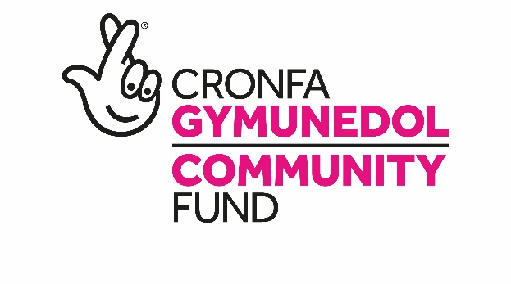

Could you help decide how National Lottery money supports communities in Wales?
Wales Committee Candidate Briefing Pack

Thank you for your interest in joining The National Lottery Community Fund’s Wales Committee. We are recruiting two new members to our Wales Committee, for an initial period of four years.

The Wales Committee currently has five members who sets the ambitions for how our funding is allocated across Wales. We are looking for someone to join the team who will add to the broad base of knowledge, skills and experience that currently exists.

The National Lottery Community Fund
The Fund is the largest community funder in the UK. Every year we distribute £600 million raised by National Lottery players. We believe that when people are in the lead communities thrive, forming relationships, developing skills and sharing ideas. This is the vision we’re working towards - a society where people can take the lead in growing happy, sustainable communities for the future.

In Wales we award over £30 million a year using money raised by National Lottery players. 90% of our grants are up to £10,000, supporting grassroots voluntary groups. We also award larger grants of up to £500,000 that can last up to five years. Information on our grant can be found at tnlcommunityfund.org.uk/funding.

In addition to our responsive funding programmes, we run strategic programmes that address specific themes or issues. In the coming two years we will develop two new funding programmes to support the mental health and resilience of young people, and to help communities to take action on climate change.

But we’re more than just a funder. We collaborate with other funders, charities and individuals, sharing knowledge and building partnerships, so we can all be as effective as possible. We like to bring our stakeholders and the groups we fund together so that they can share their learning, influence policy and practice and strengthen links between them.

Skills and Experience Required
The primary role for Committee members is to use their knowledge of the third sector and strategic thinking to help provide the direction for the National Lottery Community Fund in Wales, providing un-bias input to our grant making committees and being an ambassador for the Fund.

The Wales Committee supports the Wales Chair in representing Wales at the UK Board and supports the Senior Management Team in delivering The National Lottery Community Fund’s functions in Wales.

We want our Committee to have a broad base of knowledge, skills and experience and to reflect the diversity of modern society and indeed, the communities that we fund and serve. We particularly welcome applications from those with a disability; those from a Black, Asian or Minority Ethnic (BAME) background; LGBT+ communities; young people and Welsh speakers as they are currently under-represented in our Committee.

The following criteria are essential for the role:

- We are recruiting for two new members, one of whom must be able to speak fluently in Welsh
- An understanding of and interest in the Welsh political, social and cultural landscape and the role of the voluntary and community sector in it
- An understanding and commitment to the principles required to hold a public post of this nature (The Nolan Principles)
- An understanding of the principles under the National Lottery Community Fund’s strategic framework, People in the Lead
- The ability to understand complex and interlinked issues and make decisions taking into account competing demands
- The ability to make impartial, unbiased funding decisions
- Experience of representing an organisation and willingness to represent the Fund at public events
- A clear understanding and commitment to achieving diversity and inclusion

We are committed to enhancing diversity and inclusion in our organisation to reflect the communities within which we work and proactively encourage applications from all groups and communities.

Time Commitment
The time commitment is expected to be an average of 2 days per month. This includes:

- The Wales Committee meets every three months plus two annual planning days. Due to COVID-19 these are currently held virtually. Going forward a majority of meetings will have the option to attend virtually, but we will ask members to attend face to face meetings on an ad-hoc basis.
- There will be other Committee or Funding Panel meetings which will be identified on appointment and in discussion with the Chair of the Wales Committee.
- We expect Ad hoc attendance at project visits and meetings with other stakeholders.

The post is for an initial period of four years.

Remuneration
The successful candidate will receive an annual fixed payment of £5,232 plus expenses such as travel, and subsistence incurred on The National Lottery Community Fund business.

How to Apply
Complete the application form, equality monitoring form and provide a brief CV. Please note that CVs will not be accepted unless also accompanied by a completed application form.

All documents should be submitted to wales.committee@tnlcommunityfund.org.uk

The Fund is committed to equal opportunities. Please indicate on the monitoring form if you have any special requirements which will help you fully engage with the appointment process. This information is for monitoring purposes only and will not be seen by the selection panel.

If you have any questions on any aspect of the appointment process, need additional information or wish to have an informal discussion, please contact Awel Jones at Awel.Jones@tnlcommunityfund.org.uk before submitting your application.

All applications will be assessed against the skills and experience required for the post. Shortlisted candidates will be invited for an interview over Microsoft Teams.

The closing date for receipt of completed applications is midday, Monday 19 April 2021.

Interviews are expected to be held in May.

About the Way We Work
Our Commitment to the Welsh language
The National Lottery Community Fund is committed to providing a bilingual service to the public in Wales. Find out more about our Welsh Language Standards by visiting tnlcommunityfund.org.uk/welshlanguage.

Disability Confident committed employer
The National Lottery Community Fund is proud to be a Disability Confident committed employer. We will commit to interview an applicant with a disability if they meet the minimum criteria for selection. The National Lottery Community Fund will make any reasonable adjustment to help attendance at the interview stage of the selection process. To assist us, applicants with a disability should complete the questions on disability in the application form.

Nolan Principles - The Seven Principles of Public Life
The Committee on Standards in Public Life (originally the Nolan Committee) set out Seven Principles of Public Life: Selflessness; Integrity; Objectivity; Accountability; Openness; Honesty; Leadership. All National Lottery Community Fund Board and Committee members are expected to uphold these.

All public appointments are based on merit
This appointment will be made in accordance with the OCPA Code of Practice which requires that appointments are made on merit with independent assessment and transparency of process. Political activity will play no part in the selection process.

Candidates may come from a wide range of backgrounds and experience. The National Lottery Community Fund welcomes applications irrespective of race, colour, ethnic or national origin, sex, marital status, disability, sexual orientation, religion, religious beliefs or similar philosophical beliefs, age, gender re-assignment or community background.

Accessibility to public appointments is a fundamental requirement and the public appointments process promotes, demonstrates and upholds equality of opportunity and treatment to all applicants. If you require any of the application documentation in an alternative format, please contact us.

