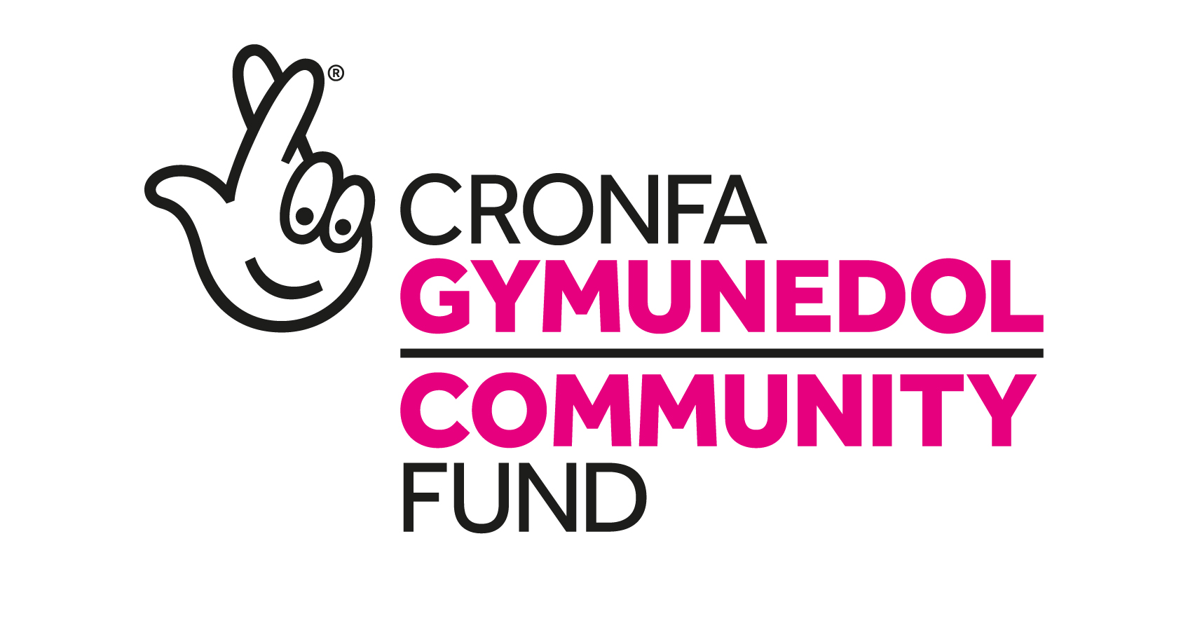

People and Places
Stage one: Guidance for land and building projects for large grants - £100,001 to £500,000

This guidance is for applicants applying to the People and Places programme for Large grants from £100,001 to £500,000, where the project includes capital costs involving land, buildings or other construction-related works (regardless of how much of this you are requesting from us).
These notes should be read alongside the guidance in the Stage one application form and the People and Places guidance notes. Please make sure you have read all sets of guidance notes before making a start on your application.
Supporting you with your capital application
We understand that you have a lot of work to do to produce your capital application. We will offer you support to help you provide the information we require. If you have already received an application form, this support can be accessed by contacting your allocated Funding Officer. Otherwise you can call our enquiries line on 0300 123 0735.
Developing your capital application
When developing the capital aspects of your application, you should follow the Royal Institute of British Architects (RIBA) ‘plan of work’. More information is available at www.architecture.com/RIBA. To complete the capital checklist you will need to have completed RIBA work stages 1 to 2.
To carry out this work you will need to appoint a design team. This team will normally comprise an architect, quantity surveyor, structural, civil and building services engineers and a principal designer to address the health and safety issues contained within the construction, design and management regulations. Your job is to give the design team a brief of what your project needs - this is like a shopping list for your building. They will then develop the designs and costs of your project based on this brief. The design team will also help you complete the capital checklist that you will submit to The National Lottery Community Fund with your Stage two application.
You should make sure that the process you use to procure the design team is publicly accountable, transparent and ensures value for money. We can provide advice on how to do this and you should make sure we have approved your process before you start.
Decision and invitation to Stage two
Your application will be considered by the People and Places Committee. If it is successful we’ll give you further guidance and support on the application process and how to work with your design team.
You will need to provide more detailed capital information including a capital delivery plan and details of the building design.
We will expect you to complete the next RIBA stages (stages 3-4), obtain tender prices from contractors and determine the final cost of the capital work. You’ll also need to submit a tender opening list form to show that you’ve used an open and transparent method of engaging a contractor and have considered value for money.
Development funding
If you are invited to stage two you will probably need the help from professionals to develop your capital project and to prepare the information that we will ask for. You may also have to commission surveys or make use of other technical support services, all of which is likely to incur costs. If you are unable to cover these costs yourself, you can apply for a capital development grant.
Capital development grants must be for no more than 10 per cent of the total cost of the capital part of your project, up to a maximum of £50,000
If you wish to apply for a capital development grant you should phone us to request a capital development grant application form. Your funding officer can give you guidance on how to complete the form.
If we offer you a capital development grant, you will have to complete the development work and send us all relevant payment claims and invoices within six months of the date of the grant offer letter.
After you have successfully completed the capital development grant, you can then apply for the full capital grant for your land and building works. If we offer you a capital development grant it does not automatically mean that we will also offer you a full capital grant.
Legal requirements
All grants for projects involving land and buildings are subject to our Terms and Conditions for Capital Grants which require you to meet specific legal requirements. You can find these on the People and Places page of our website. Please read these to make sure you will be able to accept them as they cannot be changed.
Projects are required to have a freehold or leasehold title to any land or property to be used for the project (or be able to provide evidence from your solicitor that a legally-binding contract is in place for the purchase/lease). Please see our Terms and Conditions for Capital Grants on the People and Places page of our website for details of the length of lease required.
Planning consent
If you are applying for a capital grant for a project involving land and buildings, and planning permission, listed building consent or conservation area consent is required for your project, we expect you to have obtained these consents before we can make you a grant offer, so you may need to demonstrate you’ve made some progress with this.
Statutory obligations
You will be required to meet your obligations under the legislative framework. For example: recipients should ensure that building projects do not prevent them from fulfilling the requirements of The Equality Act 2010 in relation to access for people with disabilities - www.gov.uk/guidance/equality-act-2010-guidance.
Environmental sustainability
We want to encourage projects to be environmentally sustainable and to demonstrate this in their approach to creating jobs and economic growth.
The following links give some guidance on best practice: Well-being of Future Generations (Wales) Act In general: New Economics Foundation Blue New Deal, and The National Lottery Community Fund sustainable development guide.

