**Building Better Opportunities – Quarterly Update - October 2019**

**Programme update**

**Programme Guides**

The ESF Programme Guide has moved on the MA website.  You can now find it [here](https://www.gov.uk/government/publications/european-social-fund-programme-guidance).  The National Eligibility Rules and European Social Fund data evidence requirements: eligibility and results have also moved and both can be found [here](https://www.gov.uk/government/publications/european-social-fund-eligibility-documents). Cross cutting themes guidance can now be found [here](https://www.gov.uk/government/publications/european-social-fund-programme-guidance).  All of the other key documents seem to have remained where they were previously.

**Purchase of Second-hand equipment**

A number of funding officers have been approached by grant holders about the purchasing of Second-hand equipment for use on their projects. We have approached the Managing Authority who advised that they do not allow second hand purchases in ESF for a number of reasons;

* The potential for ESF to be funding the purchase of equipment more than once (for example, one ESF project purchasing small items of equipment from another ESF project, where ESF had originally been used to fund the purchase) or where other public grants had purchased them.
* There is a value for money question in that how do you establish that the purchase cost does not exceed its current market value, taking into account its age and condition and also the need to ensure that the cost does not exceed the price of similar new equipment.
* Health and safety and duty of care are vital considerations in the decision not to fund (what guarantees are in place that the equipment is safe and fit for purpose?)

**Innovative interventions**

As part of our drive to increase learning on the Building Better Opportunities programme, we always want to hear from grant holders that are coming up with innovative ways of how they deliver their projects. Below are some examples of the fantastic work taking place on BBO projects.

**Pluss Project – Cornwall**

The Pluss project in Cornwall recently brought Konnect Cornwall into their core partnership to specifically engage ex-offenders after a growing demand emerged due to local funding cuts and lack of local provision. Konnect are now establishing their services and are seen as a key partner for offenders returning to Cornwall and have built relationships with a number of organisations aimed at supporting ex-offenders in the community.

With the Ministry of Justice currently reviewing resettlement services and recognising that current capacity for resettlement providers is not effecting change, staffing resources in the 3 regional prisons has increased. This is good news for Konnect as the Resettlement Provider Catch 22 will have more time to work with them and work out a more effective release strategy with housing and support services lined up prior to release. Konnect are now attending the “Check Out” days at Exeter Prison and can request that certain offenders attend to start building trust and confidence and begin eligibility checks prior to release. This will help reduce the start‐up process after date of release, so Konnect can work with the participant more effectively and plan activities and training as close to release date as possible.

Konnect have also been working closely with the Community Rehabilitation Company (CRC) and National Probation Service and have arranged co‐location with the CRC in Truro and St Austell where they can use interview and meeting space and build the relationship with Probation Officers. They are also very much part of the Housing Provider Community and participate on the Rough Sleepers Operational Group, which they say provides two key advantages, firstly, the promotion of Positive People and an increase in participant numbers and secondly, it provides access to inside knowledge of housing opportunities that maybe up and coming and find out about prisoner releases and whether accommodation has been allocated.

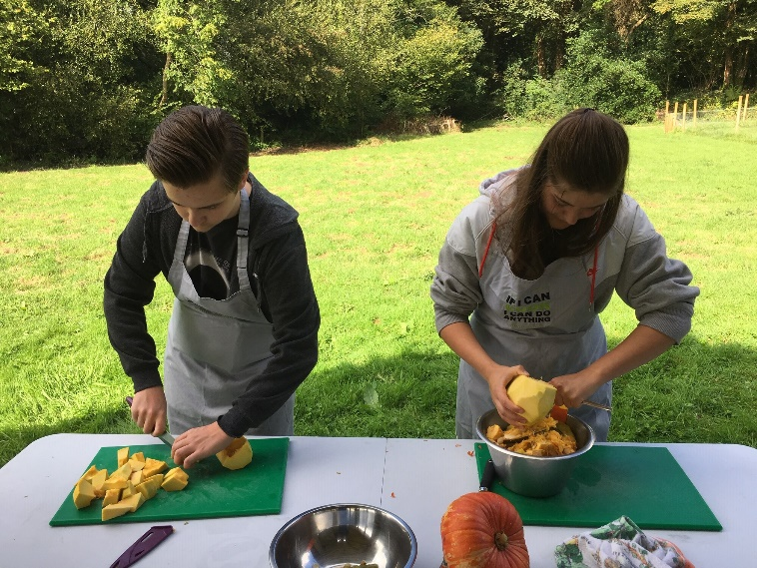**Game Changer – Training Garden at Eden**

Funding Officer Peter Foggo recently visited his Game Changer project and attended the Millennium Commissioned Eden Project.

Peter says that Cornwall’s largely rural landscape and poor transport links mean social isolation and mental health are two major challenges for the BBO Game Changer project.

Supporting young People between 15 – 24 and managed by lead partner Real Ideas Organisation Ltd, In conjunction with another partner, the Cornwall Food Foundation, the project delivered a horticultural and cooking based activity for a new group of young people who were all quite a distance away from the employment market. The session involved starting a fire with kindling and cotton wool, picking vegetables and herbs from the garden and preparing and cooking the food (a gorgeous vegetable Asian curry with sticky rice and salad).

The objectives and impact of the activity were numerous: it enabled the participants to meet new people, introduced them to cooking and the hospitality industry that is prominent in Cornwall, increased their confidence and resilience by actively taking part in a practical activity and helped create friendships that were clearly evident.

According to Peter the impact of the fantastic session he attended can be summed up by one young person. Suffering from severe OCD and anxiety issues he had withdrawn into himself and had spoken to only 4 people all year. Encouraged onto Game Changer he had, within the space of a day-and-a-half, spoken to 4 or 5 times as many people as that. Peter said that seeing this first hand gave him an excellent insight into the invaluable difference the Game Changer project (and BBO) is having.

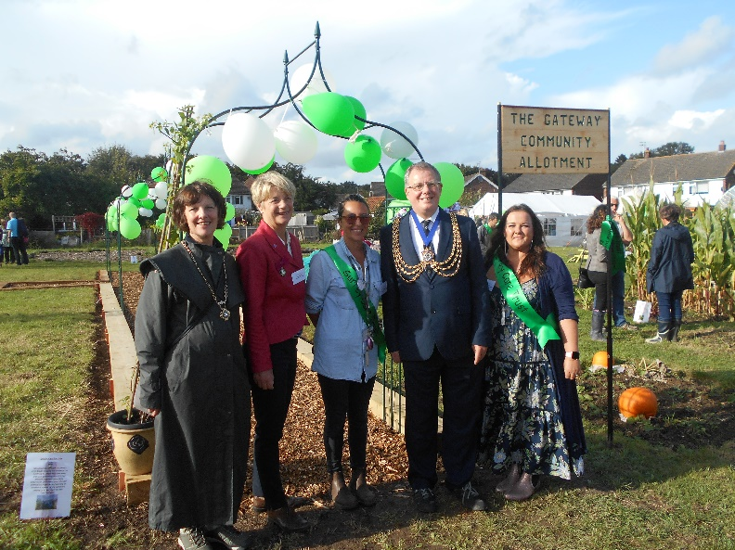**Surrey Care Trust - Gateway Community Allotment**

On 24 September funding Officer Manuela Scharf visited Surrey Care Trust as they celebrated the official launch of their Gateway Community Allotment project.

The High Sherriff of Surrey, Mrs Bridget Biddell, attended to cut the ribbon and officially opened the allotment. Surrey Care Trust is a partner in the Building Better Opportunities projects Local Learning Perspectives and working Together for Work operating in Sussex and Surrey and led by Aspire Sussex Limited. The allotment project is based in Earlswood on land provided by Reigate and Banstead Council and aims to help anyone at risk of isolation and the long-term unemployed to make positive changes by developing practical skills and to benefit from the therapeutic benefits of gardening. Participants are supported by the Trust’s trained volunteer mentors.

Sir Denis O’Connor, Chairman of Surrey Care Trust, summed up the spirit of the project: “less than a year ago we stood on the bank looking at a blank field….. now looking out to see the plants, polytunnel, raised beds, children’s play area, pond etc is truly inspiring. For me it is seeing how The Gateway has brought out smiles and confidence in the clients we work with. One of our clients 6 months ago would not leave her house, now she comes every week and is making huge progress in her journey to get back to work.  It brings the community together, young, old, skilled or unskilled, but a common theme for these people can be total isolation.  They find friends at the Gateway, people that can understand how they have been feeling and it is a ‘safe’ environment to say as little or as much as you want.”

Speaking after her visit Manuela said that the strength of the approach lies in the sheer variety of learning and development opportunities an allotment has to offer, e.g. project planning and management, teamwork, practical skills, social skills, to name but a few. There is space for participants to get involved as little or as much as they want. If participants need additional support, they are paired up with a peer mentor who can guide them on their journey. The allotment project has had some wonderful successes already and participant case studies will be published in due course.

If you would like any further details regarding the above projects or would like to share your own intervention, please contact your funding officer.

**Branding Compliance and Communications**

**Project visits**

If any projects are planning on hosting events where politicians, members of the royal family or other dignitaries will be in attendance, could you please let your funding officer know in advance so that The National Lottery Community Fund is able to support and assist in maximising the publicity and engagement opportunities.

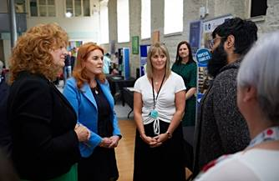**Hopeful Families – Yorkshire Children’s Centre**

Yorkshire Children’s Centre were proud to host a recent visit from the Duchess of York.  During the visit the Duchess learned about the services and support offered by Hopeful Familes and met team members along with former Hopeful Families participant Hussnain Bashir Bhatti, who recently won an award. The Duchess spoke with the Family Mentors and support staff to find out more about the programme and how the service has helped participants. Family Mentors explained how the project works with individuals to break down barriers to help support individuals in achieving their goals and aspirations.

Hussnain spoke with the Duchess about his journey with Hopeful Families, the support he received and how far he has progressed from being low with poor mental health and unemployed to now having improved confidence, new friendship groups and being employed.  The Duchess commented that “Hussnain’s family should be very proud of him and his achievements” and praised his commitment in achieving so much.

**BBO website and project overviews**

With projects now moving into a more mature phase of delivery, we thought now would be a good opportunity to review with you the project descriptions that we have on our [website](https://www.tnlcommunityfund.org.uk/funding/programmes/building-better-opportunities#section-2).

Although we have links to each individual project where further information can be accessed, we feel that the current descriptions do not best reflect the innovative and diverse ways in which projects are being delivered. As such, we would encourage you to review your current summary and provide an updated version via [BBOCommunications@tnlcommunityfund.org.uk](mailto:BBOCommunications@tnlcommunityfund.org.uk)

**Case studies**

Thanks to everyone who has so far contributed case studies. We continue to build a bank of these to show the impact of your projects and Building Better Opportunities more generally. So far, we have used this content to run information sessions across the Fund, which are being well received. Short videos are proving a particularly useful tool to show the human side of the work you are all doing. The next step is to make them all available on our website, So, please continue to send your content to [BBOCommunications@tnlcommunityfund.org.uk](mailto:BBOCommunications@tnlcommunityfund.org.uk), together with a completed consent [form](https://www.tnlcommunityfund.org.uk/media/consent-form.pdf?mtime=20190521144117).  When sending through case studies, could you please name the file as follows: Project reference, Participant name + case study, date, an example of this would be: ‘SEL.2.10 Karen’s case study DATE”.

If you would like more guidance on how to get started with compiling case studies, speak to your FO. Alternatively further details on compiling case studies can be found at: <https://www.tnlcommunityfund.org.uk/media/documents/building-betteropportunities/logos/bbo_writing_a_good_case_study.pdf?mtime=20190131144314>

**Websites**

A number of projects continue to use the old Big Lottery Fund logo on their project pages. As you will be aware, the Big Lottery Fund changed its operating name to The National Lottery Community Fund on 30 January 2019 and we requested that all grant holders update the digital logo as soon as possible.

With the above in mind, could all grant holders please review their websites and ensure that the joint BBO logo incorporates The National Lottery Community Fund logo, and is also complaint with the European Social Fund requirements. Should you have queries about this issue, please email: [bbocommunications@tnlcommunityfund.org.uk](mailto:bbocommunications@tnlcommunityfund.org.uk)

**Social Media**

As part of The National Lottery Community Fund rebranding, a new hashtag (#TNLComFundESF) was created for BBO related tweets. Can all grant holders use this hashtag when tweeting about their project, and also copy in The National Lottery Community Fund twitter feed [@TNLComFund](https://twitter.com/TNLComFund)

**Learning and Evaluation**

**Evaluation report**

Ecorys have recently published the latest national evaluation report – it is available now on the [evaluation website.](https://buildingbetteropportunities.org.uk/evaluation-findings) This report brings together evidence from various evaluation strands to present an overview of the latest developments and achievements of the programme.

**Learning papers**

Ecorys have produced another learning paper based on the evaluation evidence – on the theme of **employer engagement**. This looks at what different BBO projects have done in terms of employer engagement, what has worked well and some key tips for integrating this into project delivery. It is available to [download here.](https://buildingbetteropportunities.org.uk/sites/default/files/2019-10/Employer%20Engagement%20Learning%20Paper.pdf)

The next learning paper is on the theme of **in-work support and achieving sustainable jobs**. If your project is doing anything that is working well in this area, Ecorys would like to hear about it – please send a message to [BBO@ecorys.com](mailto:BBO@ecorys.com) and we will get in touch to find out more.

**BBO Online Network**

The online BBO network is still available, providing an opportunity to ask any questions, share tips or share experiences with other grant holders. If you are not already on the Slack network, you can [join here.](https://join.slack.com/t/bbo-network/shared_invite/enQtNDg4MjUzMjIxMDQwLWI1YWU0Y2ZjMWM2YTI0YzBiMzNlZDc4ZmNkNWQzMTZkZWJkMmU0NDU0OWY1NmNiMThjZjY0YjFiNjIwNDQwYTE)

**Learning and networking event**

The networking and learning events delivered by Ecorys to date have been positively received so we are keen to provide another opportunity for BBO projects to come together to share learning. The current thinking is that this will be a single event, bringing together all the BBO projects in a central location rather than on a regional basis. This next learning event will likely happen in early March next year.

If you have ideas of themes you would like us to cover, any preferences on location or timings please get in touch using [BBO@ecorys.com](mailto:BBO@ecorys.com) or [bbocommunications@tnlcommunityfund.or.uk](mailto:bbocommunications@tnlcommunityfund.or.uk)

**Essential Updates**

* [**Essential update July 2019**](https://www.tnlcommunityfund.org.uk/media/documents/building-better-opportunities/guidance/Essential%20updates/Essential-update-July-2019.docx?mtime=20191004113932)– Updates to Annex L and Annex T
* [**Essential update August 2019**](https://www.tnlcommunityfund.org.uk/media/documents/building-better-opportunities/guidance/Essential%20updates/Essential-update-August-2019.docx?mtime=20190830143415) – Focus on Procurement
* [**Essential update September 2019**](https://www.tnlcommunityfund.org.uk/media/documents/building-better-opportunities/guidance/Essential%20updates/Essential-update-September-2019.docx?mtime=20191016122529) - Grant closure guidance and additional direct staff costs methodology
* [**Essential update October 2019**](https://www.tnlcommunityfund.org.uk/media/documents/building-better-opportunities/guidance/Essential%20updates/Essential-update-October-2019.docx?mtime=20191011084824) -Cabinet Office Procurement Policy Note
* [**Essential update October 2019: Number 2**](https://www.tnlcommunityfund.org.uk/media/documents/building-better-opportunities/guidance/Essential%20updates/Essential-update-October-2019-part-2.docx?mtime=20191016122523) - Materials update and managing Self-Declared Adjustments and Irregularities

**GDPR**

There have been a number of data breaches reported on the BBO programme.  These mainly relate to unauthorised access to paper versions of participant records, several involving theft of records from vehicles.   There has also been some confusion around how these data breaches are reported. We advise all grant holders to review the ESF Action Note 020/18 for additional advice relating to the General Data Protection Regulation that is available [here](https://www.gov.uk/government/publications/esf-action-notes-2014-to-2020-programme).

We also advise all lead and partner organisations to review storage arrangements for both paper and electronic records and carefully consider this in relation to mobile workers, and to ensure staff understand the organisational requirements.

Data breaches must be reported to [ESFDATA.BREACH@DWP.GOV.UK](mailto:ESFDATA.BREACH@DWP.GOV.UK)

**Reporting Fraud**

To be consistent with organisational policy, we request that grant holders should in the first instance report all potential fraud concerns to The National Lottery

Community Fund’s central fraud inbox: [fraud@tnlcommunityfund.org.uk](mailto:fraud@tnlcommunityfund.org.uk)

Fraud concerns can also be reported through the fraud hotline number which is: 0800 496 9991.