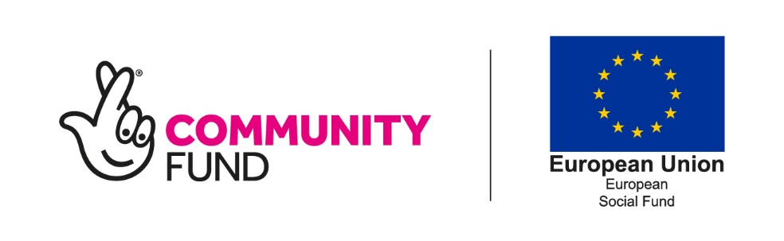
Annex R
Participant exit form – Cor/2/1 only

For participants and project staff to complete

For Investment Priority 1.2 project – Cornwall/2/1 only
This form must be completed by the participant together with a project officer.
Part one: Summary
This is completed by project staff once the participant’s eligibility has been confirmed.
Organisation:

Participant name:

National Insurance number:

Customer reference number:

Exit date from the project:
Date of the participant’s last activity on the project

Part two: Participant status on exit from the project
This information needs to reflect the participant’s status within four weeks of the exit date (last recorded activity on the project)
Your current employment situation, tick one box
I am economically inactive (not in employment and not seeking work)
I am unemployed and searching for a job (including long-term unemployed)
Please tell us the number of consecutive months you have been unemployed
Employed (including self-employed)

Please answer the following two questions,
Are you engaged in education or training?
Yes No
Have you gained basic skills (entry level or above in one or more of numeracy, literacy or ESOL*) that you did not have when you joined the project
Yes No
*The following link explains UK skills levels:
https:/www.gov.uk/what-different-qualification-levels-mean/compare-different-qualification-levels
Please briefly tell us more about what you are currently doing, complete all applicable boxes
Part three: Education or training and/or basic skills
If you are or are moving into education or training, please tell us more about this below including which college, university or learning provider you have registered with, what course or training you are undertaking, when you enrolled, what date you start and how long your course or training will last. If you have gained basic skills please tell us what skills you have gained
Part four: Employment or self-employment
If you’ve moved into employment or self-employment, please tell us who you are working or going to work for, what job you will be doing and when you will be starting. If you are self-employed please tell us what you are doing.

Part five: Job-search
If you are job-searching, please tell us what job search activity your have undertaken, what jobs you have applied for details of any job clubs or similar provision you have attended.

Part six: Data protection and privacy notice

This privacy notice explains who the Data Controller is for the personal data which is collected through the Building Better Opportunities Programme and how you are able to find out how and why the Data Controller uses this data.

Who is the Data Controller for the Building Better Opportunities Programme?
The Data Controller for the Building Better Opportunities Programme is the Department of Works and Pensions.
For more information about how and why the Data Controller uses your personal data or to exercise your data protection rights please see www.gov.uk/dwp/personal-information-charter or contact the Department of Works and Pensions using the contact details below.

Contact Details
If you have any questions, queries or complaints, and to exercise your personal data rights, please in the first instance contact the Data Protection Officer at the Department of Works and Pensions rightofaccess.requests@dwp.gsi.gov.uk .
You can contact the Information Commissioner’s Office on 0303 123 1113 or via email https://ico.org.uk/global/contact-us/email or at the Information Commissioner’s Office, Wycliffe House, Water Lane, Wilmslow, Cheshire SK9 5AF.

Please review and sign the participant and project officer declarations in sections seven and eight

Part six: Participant declaration
Tick each box to confirm:
I acknowledge that the support I have received was funded by the European Social Fund and The National Lottery Community Fund.
The information provided in this form is true and accurate

Name: | Signature:
Date:

Part seven: Project officer declaration
Tick each box to confirm:
The participant has been told that the support they have received was funded by the European Social Fund and The National Lottery Community Fund.
The information provided in the form is, to the best of my knowledge, true and accurate.
Name: | Signature:
Job title:

Organisation: | Date:

