Annex C  Project progress report – COR/2/1 only  For lead organisations to complete | 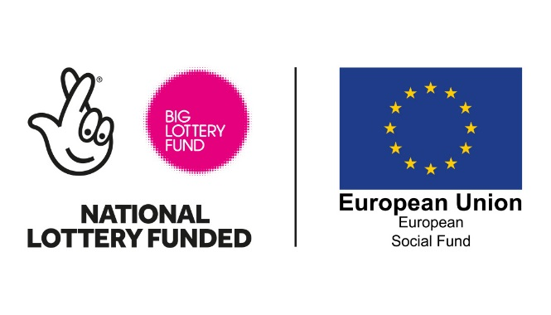
This report should only be used by COR/2/1 as this reflects that there are different targets for this project outline.
You’ll submit this report to us at the end of each quarter. It gives us a detailed picture of how the grant is being spent and how the project is performing.
Part one: Summary information
Lead organisation:

Project name:

Project ID:
Project outline: | COR/2/1

Reporting period - Tick one box: |  | 2016 – Q2 |  | 2016 – Q3 |  | 2016 – Q4
 | 2017 – Q1 | 2017 – Q2 | 2017 – Q3 |  | 2017 – Q4
 | 2018 – Q1 | 2018 – Q2 | 2018 – Q3 |  | 2018 – Q4
 | 2019 – Q1 | 2019 – Q2 | 2019 – Q3 |  | 2019 – Q4
Attachments
Tick each box to confirm that you are sending us:
your updated payment schedule (Annex A).
your target and project outcome schedule (Annex F).
your participant monitoring spreadsheet (Annex L).
your financial monitoring spreadsheet (Annex O).
A current staff list.
A current partner list.
A Project Change form if relevant (Annex D).

Part two: About your project
What progress have you made?
Describe the main activities you’ve started, continued or finished during this reporting period. Write up to 300 words including spaces.
What have you learned?
Tell us about any achievements or unexpected outcomes you’d like to share with us and any problems you’ve faced and how you’ve tackled them. Write up to 300 words including spaces.

Part three: Your costs for this quarter
Using the information you provided in Annex A, explain any major differences between what you forecasted and what you actually spent. By ‘major difference’ we mean an underspend or an overspend of at least 10%. Write up to 500 words, including spaces.

Part four: Your targets for this quarter
This provides a summary of the information on your target schedule and your participant monitoring spreadsheet. You must only report the outputs and results you have actually achieved, for which you will have retained evidence in the participant file for each individual you have engaged through the project. Remember that, because this project specifically targets young people, only participants aged under 25 (when first engaging with the project) can be counted.

Explain any major differences between the targets you forecasted and the targets you actually achieved. By ‘major difference’ we mean an underperformance or overperformance of at least 10%. Write up to 500 words including spaces.

Part five: Your project outcomes
With reference to your project outcome schedule, describe:
- your progress towards each of the project outcomes
- any milestones you’ve achieved
- any changes you may need to make and why.
Write up to 500 words including spaces.

Part six: Publicity
It is a condition of grant that you acknowledge both the Big Lottery Fund and the European Social Fund on any correspondence or materials used for the delivery of the project. This includes: job descriptions, promotional materials, event and websites.
Provide a list or description of the publicity you have carried out. Write up to 300 words including spaces.

Part seven: Cross-cutting themes
Tell us what you have done to implement the cross-cutting themes of: (1) sustainable development and (2) equal opportunities and gender equality, specifically including:
- What activity has been undertaken so far and how does this compare with your action plan objectives?
- Who champions the themes and what mechanisms exist to review progress? How often is progress reviewed?
- How have you supported your partners to develop and implement their own plans and policies, and how have these been monitored?
Write up to 300 words including spaces.

Part eight: Looking ahead
How prepared are you for the next part of your project?
Give us a sense of how well prepared you are for the challenges ahead. Please be open about sharing concerns with us, we’ll be able to help if you tell us your concerns.
 | Everything is on track and you don’t expect any problems | A problem may arise but you’re confident you can handle it | A problem is likely to arise that could seriously affect your project.
Your ability to deliver your planned project activities
Your ability to control project costs
Your ability to recruit or train staff and other resources you need for this project
Your ability to achieve your targets or outcomes
Your ability to deliver the cross-cutting themes
Your ability to monitor the participants engaged in the project
Your ability to implement the publicity guidelines across the project
External factors, like changes in legislation

Explain what challenges you’re facing and how you’re planning to manage it. Tell us if there are ways you think we can help. Write up to 300 words including spaces.

Part nine: Declaration
You confirm that:
- the information in this report is accurate and true
- the money from the Big Lottery Fund and the European Social Fund has been used exclusively for the project described in the original application, together with any changes you’ve agreed with us since then
- there haven’t been any significant changes to your project or the governance of your organisation or partnership apart from any you’ve told us about and we’ve agreed to in writing
- you haven’t received any duplicate funding for the activities, services or facilities the Big Lottery Fund and the European Social Fund are paying for
- you have sought to achieve value for money for your project by securing goods and services at reasonable prices
- your organisation keeps full and proper accounts and records, including invoices and receipts, which show how the money from the Big Lottery Fund and the European Social Fund has been used
- your organisation has implemented its equalities policy and, if working with children, young people or vulnerable adults, a safeguarding policy; these policies are carried out and regularly reviewed to ensure they adhere to current legislation and regulations
- your organisation hasn’t disposed of any funded assets without getting permission from us in writing
- your organisation is following all current statutory requirements and other laws and regulations relating to the project and its working including: adherence to employers’ liability insurance; procurement regulations; the National Living Wage; the working time directive; health and safety; safeguarding of children, young people and vulnerable adults; data protection, Freedom of Information and intellectual property rights legislation.
Name: | Signature:
Job title:

Organisation:

Date:

