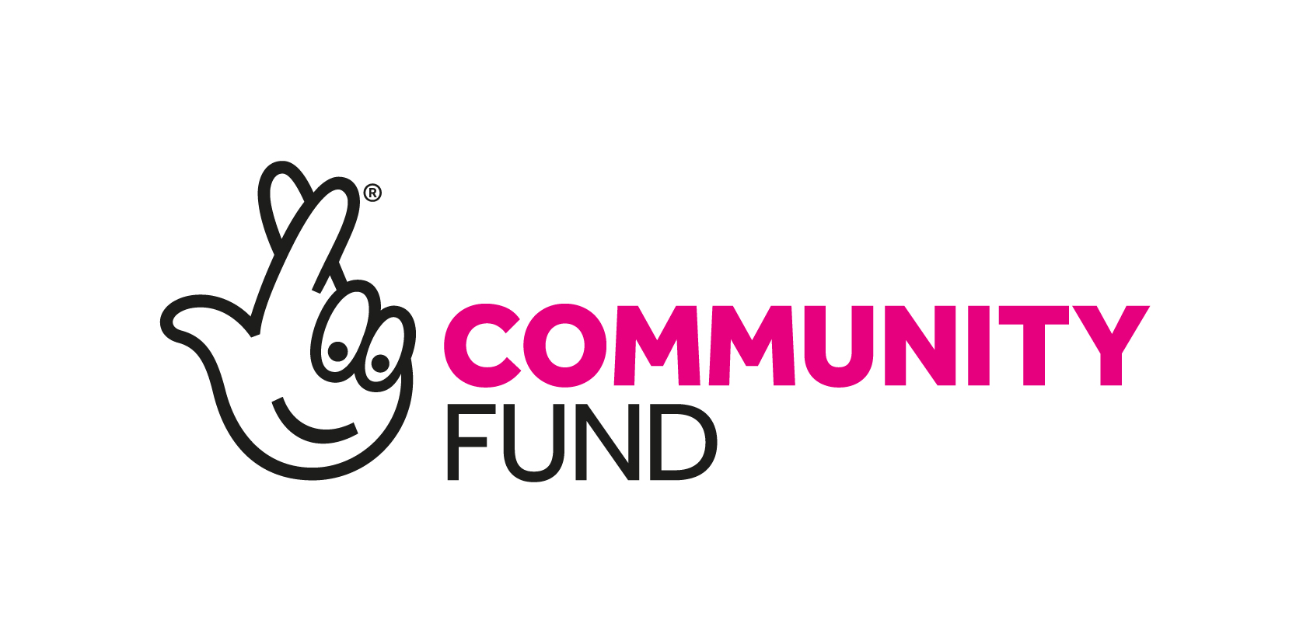

Resources from the Ageing Better Programme

Ageing Better is a seven-year, £87 million investment to improve the lives of people aged over 50 which began in 2015. It is a test and learn programme and is collecting information and insights from across 14 partnerships to identify learning that will be useful to other programmes and organisations delivering activities aimed at reducing social isolation in people aged 50+. The programme has engaged nearly 150,000 people and although it focuses on older people, many of the resources would be practical and adaptable for a range of age groups.
Key Resources:
Topic | About | Resource | Link
Co-production | The toolkit is particularly useful to community development workers, community builders, commissioners, clinical health or wellbeing leads, community volunteers or indeed anyone who is interested in co-production. The toolkit contains a wealth of resources organised into a range of folders (Resource Library) offering:  - Information, tools and resources for understanding what co-production is and how to put it into practise  - Inspiration for a specific vision or redesign of current ways of working  - Evidence of good practise  - Easily accessible actionable, practical tools and ‘how to’ guides  (Resource Library link can be found on slide 34 of the toolkit)  The Ageing Better in Leeds programme (Time to Shine) has also produced a stand alone toolkit which provides a good overview and key things to consider:  Co-Production: A time to shine toolkit | Toolkit | Stronger Together: A Co-production Toolkit from Ageing Better
Warm Welcome | Being welcomed to a community activity has a big impact on whether or not a person will return and therefore a warm welcome is considered essential when encouraging people to take part in activities. This toolkit is aimed at activity providers, and it provides information and resources to support the running of 'Warm Welcome' activity. This toolkit would work well for any community group activity. It contains a wide range of useful resources including:  - A range of checklists for staff/volunteers  - Top Tips including ‘Meeting and Greeting’ and promoting an activity correctly  - Case studies including Engaging with Men and BAME communities  - Ideas for icebreakers, seating arrangements, building in time for chatting  - Training scenarios for staff | Toolkit | The Warm Welcome Toolkit: A guide to running welcoming community activities with older people

Topic | About | Link
Involving Men | This guide gives practical advice for getting men involved in activities to address loneliness and social isolation including:  - Barriers for men getting involved  - Top tips for getting men to attend your group  - Types of activity  - Promoting activities to men | Tackling Loneliness and Social Isolation in Older People: How to get more men involved
Top Tips for a successful activity | Ageing Better in Birmingham has created two useful guides offering advice on delivering successful activities:  - The first outlines top tips and ideas to help you set up a local group or activity including: What kind of activity should you run, Practical Pointers, helping people get to your activity and promoting your group.  - The second provides examples and advice for ensuring legacy and sustainability of a local group or activity. | Tackling loneliness and social isolation in older people: Top tips for a successful activity  How to make a difference in your community and keep your activity going
Marginalised Communities | This workbook guides you in identifying and supporting seldom heard communities in your neighbourhood. It includes three main sections:  - Identification of marginalised groups  - Mapping your marginalised groups  - Approaches to working with marginalised groups  The document uses the term ‘marginalised’ to recognise that some groups are at risk of being pushed to the margins of society. Marginalising characteristics include being male, being single/living alone, identifying as LGBT+, being in poor health, identifying as a minority ethnicity or religion. | Mapping and working with marginalised communities
Friendship Groups | This toolkit was designed by Ageing Better in East Lindsey. It is designed to help other people to develop their own friendship groups, and the things to consider and ensure when doing so. The toolkit includes:  - What is a friendship group  - How to create a group  - Things to consider  - Case Studies | Friendship Groups Toolkit
Digital Skills | This toolkit was created by Ageing Better in East Lindsey. It has been designed to support you on your journey towards setting up inclusive Digital Sessions for individuals over 50. The toolkit includes:  - Case Studies  - Hints and Tips on how to set up successful training sessions  - Venue assessment checklist | Digital Skills Toolkit

Topic | About | Link
Inter-generational | This briefing explores the benefits of setting up your own intergenerational activity and provides tips on how to make your activity a success including:  - Reaching participants of different ages  - Choosing an activity | Bringing different ages together through shared activities
Age Friendly | Age Friendly has been an important aspect of the Ageing Better programme and some of the partnerships have created guides, toolkits and checklists which would be useful for anyone who is considering becoming more age-friendly.  - Bristol Ageing Better have produced a toolkit offering advice to making your neighbourhood Age-Friendly. It includes a range of considerations including improving transport access, supporting older neighbours to access community support and health services and increasing social opportunities in your community.  - Ageless Thanet has designed a toolkit aimed to be a starting point to help you assess your organisation and think about what changes you could make in the short term and in the longer term to become age friendly. It includes practical advice and case study examples.  - The Time to Shine project in Leeds has created a checklist that aims to help you look at how your organisation might become more age and dementia friendly. | Make Your Neighbourhood Age-Friendly  Age-Friendly Toolkit  Age and Dementia Friendly Checklist
Outreach | Ageing Better in Camden ran successful pop-up events in Sport and Leisure Centres to help them engage with older people. This toolkit was developed to support service providers to lead the delivery of their own regular pop-up events for older people. Although the guide is targeted at providers in Camden, many of the messages are universal and therefore can be adapted to other areas. The toolkit includes:  - Advice on the best ways to prepare for a pop-up event including street outreach  - Materials to advertise and promote a pop-up event  - Top Tips on how to run an informal event for older people | Street Outreach and Informal Pop-up Events for Older People
Social Prescribing | Ageing Better’s Brightlife project in Cheshire ran a successful social prescribing programme and created this top tips document based on their learning and experience. | Top Tips: Social Prescribing

Topic | About | Link
Food Projects | This toolkit outlines the value of ‘Shared Tables’. Although it is based on work with people aged 50+ the model could be adapted for use with groups of people who share particular interests or life experiences. It was developed by ‘Time to Shine’ (an Ageing Better project in Leeds) and includes:  - Step-by-step guide to setting up a Shared Tables project  - Top Tips | Setting up a Shared Table Project in Your Local Area
 | This guide is designed to support you through the first steps of setting up a successful social eating project. The guide explores some of the key factors required to create social eating environments and includes a range of useful information and resources including:  - Different models of social eating  - Case studies  - Marketing and Promotion  There is also a Technical Handbook offering further support and advice for organising and running a session. | Social Eating Guide  Technical Handbook
Community Groups | Created by Leicester Ageing Together, this toolkit covers a wide range of useful information about setting up a group or activity which would be particularly useful to anyone thinking of starting up a community group or activity. | A Toolkit for Community Groups
Creating a Cohesive Programme | This toolkit by Ageing Better’s ‘Time to Shine’ in Leeds aims to share practical learning points on key topics and is accompanied by a learning report 'Greater than the sum of its parts: Creating a cohesive programme'. The purpose of both the toolkit and learning report is to provide practical help to others who are interested in creating a similar programme approach within large-scale or small-scale projects. | Creating a Cohesive Programme: A Time to Shine Toolkit

You can find more of the Ageing Better resources from including local evaluations, learning reports, insight reports, factsheets and more here. There is also a collection of national learning reports covering a range of topics available in this document.

