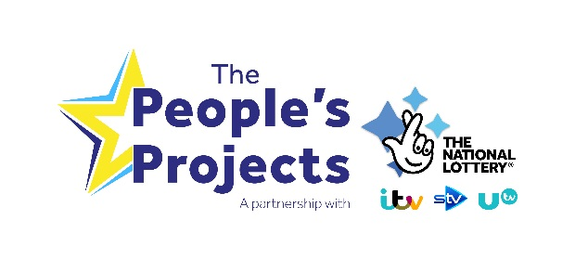
Step by step guide – voting
I’m sure you’re already thinking about how you’re going to build public support for your project. Encouraging local people who may not already know about your project to vote for you is really important!
Here’s more information on how people can vote for you.
Online voting
This year we’re focussing on the online vote, the aim of your campaign will be to drive the public to the website to vote for your project.
Voting online is even easier this year and we’ve made some changes to reflect that more and more people are using a mobile device to access things online. The way that the public can vote online is at www.thepeoplesprojects.org.uk.
People will only be able to vote between 9am on Monday 01 April to midday on Monday 15 April 2019. These are the steps that people can follow to vote for your project:
Step 1 – Find a project!
Select a region on our map or list, by entering your postcode, or allow us to use your current location.
You can vote in more than one region but you can only vote for one project per region. If you want to vote in more than one region you will have to place all your votes at the same time.
Step 2 – Click on a project in your chosen region
Watch the films to find out more about the projects and choose one to vote for within that region. The project you select will then be added to your basket. A bit like online shopping!
Step 3 –Submit your vote
Once you have chosen a project, submit your vote or browse other regions to vote for projects in a different region. Every time you select a project to vote for in a different region, it will be added to your basket. Once you have chosen one project for all the regions you wish to vote for you are ready to submit your vote.
When submitting your vote, we ask for your name, email address OR mobile phone number and postcode.
All votes must be verified by the voter and this year you can do this either by a mobile phone number or your email address.
If you wish to verify your vote(s) via a mobile phone you will be sent a text message containing a verification code. You will need to enter this code in the box specified on the voting page. You will do this whilst you are still on the website so this is the quickest way to verify and place your vote. In order for your vote to be counted, please make sure you submit the verification code before leaving the website.
If you choose to verify your vote(s) via email then you will be emailed a link that you need to click on to confirm your vote. You will not need to go back on to The People’s Projects website to do this. In order for your vote to be counted, please follow this link and remember to check your junk folder too.
Postal voting
Each project will be sent 300 readymade postcards for use by people who cannot vote for a project online.

You will be sent the readymade postcards and the prepaid envelopes as part of your The People’s Projects goody bag. You should receive this by mid-march. The prepaid envelopes will have the return address printed on them. You should place no more than 60 postcards in each A4 envelope.

We will only accept these readymade postcards and each one has a unique identifier number. You can vote for one project on each postcard. Any other postcard used to vote will not be accepted and the vote will not be counted. We are unable to provide any more than the 300 postcards.

The postcards you receive should only be filled out by the person voting as they will need to fill in their own details. We understand that some people may need some support in filling out their postcard and we understand that there may be occasions when someone else helps fill out the postcard. However, please be aware that the voting adjudicators will be checking the postcards submitted, and if we suspect fraudulent voting has occurred that has had the effect of excessively manipulating or tampering with the vote, we reserve the right to discount those votes and/or disqualify a project from The Peoples Projects.

To help ensure the postcard arrives in time, best to send it by last post Wednesday 10 April 2019.

