The People’s Projects  Your organisation details | 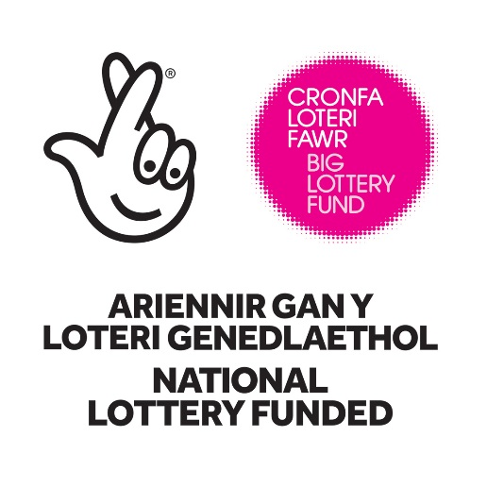

Part one: Your organisation details

- What is the full legal name of your organisation, as shown on your governing document?

- What is the main or registered address for your organisation?
If we offer you a grant, this is the address we’ll send our offer letter to, so make sure you can safely receive post at this address. We recommend this to be your organisation’s office address, but if you don’t have an office your registered address may be a home address.
Organisation name
Sub-building name/number
Building name
Building number
Street
Town or city
Postcode

Phone number one
Phone number two or text phone

- Does your organisation have a website?
 | Yes |  | No

If yes, what is its address?

- What type of organisation are you?
Select all options that are relevant to you.
Charity | Registered charity |  | Charitable unincorporated association
 | Charitable incorporated organisation |  | Charitable trust
 | Exempt charity |  | Excepted charity
 | Charity (Royal Charter or Act of Parliament)
Company or mutual society | Company limited by shares |  | Company limited by guarantee
 | Company listed publically |  | Community interest company limited by shares
 | Community interest company limited by guarantee |  | Community interest company listed publically
 | Credit Union |  | Limited liability partnership
 | Industrial and provident society |  | Co-operative
 | Friendly society
Public sector | Community council |  | Parish council
 | Town council |  | Local authority
 | NHS Trust foundation |  | NHS Trust – other
 | Health authority |  | Local health board
 | Non departmental public body |  | Police authority
 | Fire service |  | Prison service
 | Other
School | State school |  | Community school
 | Foundation or Trust school |  | Voluntary aided school
 | Voluntary controlled school |  | Academy
 | City technology college
Other | Individual |  | Sole trader
 | Further or higher education |  | University
 | Independent school |  | Non charitable unincorporated organisation
 | Faith based organisation |  | Parochial church council
 | Partnership |  | Other

Give any reference or registration numbers you have:

Charity Commission for England and Wales
Charity Commission for Northern Ireland (or HMRC number)
Office of the Scottish Charity Regulator
Companies House
Financial Conduct Authority
Health Authority number
School reference number

Other reference or registration numbers
Please give details:

- What is your organisational income?
All organisations, including schools and statutory organisations, need to provide this information.
If your organisation is less than 15 months old and has not yet produced annual accounts, please give us the date you expect your first set of annual accounts to be produced and enter the income as zero.

Accounting year ending (Please use format dd/mm/yyyy):

Total income for the year:

Part two: Your contact details
We need the date of birth and home address for all of your contacts. This includes a previous address if they’ve not lived at their current address for three years.
We use this to carry out some basic identity checks as part of our standard fraud prevention process, so please check that the information provided is correct. All organisations, including schools and statutory organisations, need to provide this.
Our identity check may appear on a credit report, but it’s not a credit check and can only be seen by the person we’re checking, so their credit rating won’t be affected. You can find out more in our Guide to risk analysis, available at www.biglotteryfund.org.uk/informationchecks and the Data Protection policy at the end of this form. Alternatively, you can contact us at customer.services@biglotteryfund.org.uk or you can call our advice team on 0345 4 10 20 30.

Main contact
6. Who should we contact if we have questions about your application?
They must be someone who runs or works for your organisation. We call this the main contact.
Title
Forenames
Surname
Date of birth (dd/mm/yyyy) | / /
Job title or position held
Daytime phone
Mobile number

Email

The email address should be one they use for your organisation. We’ll use this whenever we get in touch about your project.
Home address:
 | Flat number
 | Building name/number
 | Street
 | Town or city
 | Postcode
Have they lived at this address for the last three years? |  |  | Yes |  | No
If no, give their previous home address:
Flat number
Building name/number
Street
Town or city
Postcode

If your main contact has any of the following communication needs, please let us know here. These include things like: audiotape, Braille, a community language, hard copy letter, large print, sign language, Textphone, voice activated software, etc. Please give details:

Which address should we use for any correspondence? Select one:
Main organisation address
Home address
Other address

If another address, what is it?
Flat number
Building name/number
Street
Town or city
Postcode

Legally responsible contact
7. Who in your organisation will be legally responsible for the funding?
This cannot be the same person as the primary contact. We call this person the legally responsible contact.
The legally responsible contact must be over 18 years old and is responsible for ensuring that this application is supported by the organisation applying, any funded project is delivered as set out in the application form and that the funded organisation meets our monitoring requirements.
Title
Forenames
Surname
Date of birth (dd/mm/yyyy) | / /

What is their job title or position?
The legally responsible contact must hold one of the following positions. Tick just one box:
Company | director or  company secretary
School | head teacher
Local authority or health body | chief executive or  director
Town, Parish or Community Council | clerk to the council or  office bearer or  chair
All other types of organisations (including Registered Charity) | chair or  vice chair or  treasurer or  trustee

Tick to confirm the primary contact and legally responsible contact are different people:
Home address:
Flat number
Building name/number
Street
Town or city
Postcode
Daytime phone
Mobile number

Email

The email address should be one they use for your organisation. We’ll use this whenever we get in touch about your project.

Have they lived at this address for the last three years?
 | Yes |  | No

If no, give their previous home address:
Flat number
Building name/number
Street
Town or city
Postcode

If your legally responsible contact has any of the following communication needs, please let us know here. These include things like: audiotape, Braille, a community language, hard copy letter, large print, sign language, Textphone, voice activated software etc. Please give details:

Language preference
8. Which language should we use?
 | Welsh |  | English

Part three: Your declaration
Please read this section carefully and make sure you understand it all.

Data protection
We hold and store your information in line with the Data Protection legislation currently in force and in line with our Data Protection Policy. Please read our full policy published on our website
www.biglotteryfund.org.uk/data-protection. This policy may be updated from time to time.

There are circumstances where we will share the information you have provided to us in this application in line with the limitations of legislation. We may share information with organisations and individuals with a legitimate interest in Lottery applications and grants or specific funding programmes. We will use the information you give us during assessment and during the life of your grant (if awarded) to administer and analyse grants and for research purposes.

We will keep in contact with you throughout the life of your grant and we will send your regular email updates. These will contain useful information on a range of things including how to publicise your grant, information on other funding available and project ideas and tips from other grant holders.

Freedom of information
The Freedom of Information Act 2000 gives members of the public the right to request any information that we hold. This includes information received from third parties, such as, although not limited to grant applicants, grant holders and contractors. Please read our full policy published on our website www.biglotteryfund.org.uk/freedom-of-information. This policy may be updated from time to time.

If you think that there is information in your application that may be exempt from release if requested, then you should let us know when you apply. We will not usually release information about your project whilst it is being assessed. Otherwise we will use our judgement as to whether any exemptions may apply, which we may seek your opinion on. Personal information would be withheld subject to the requirements of the Data Protection Act 1998.

Our approach to fraud
We know the vast majority of the many thousands who seek and use our funding are genuine.
However, if you provide false or inaccurate information in your application, or at any point in the life of any funding we award you fraud is identified, we will provide details to fraud prevention agencies to prevent fraud and money laundering. If you are a company this will include the names of the Company Directors at the time of the fraud. You must undertake to inform all Directors, Trustees and Committee members of this notice.

You can obtain further details explaining how the information held by fraud prevention agencies may be used by emailing dataprotection@biglotteryfund.org.uk, by telephoning our advice line on 0345 4 10 20 30, or by writing to Customer Services, Big Lottery Fund, 2 St James’ Gate,
Newcastle upon Tyne, NE1 4BE.

By submitting this application you confirm that

(Please tick all to confirm):

All the information you have provided in your application is accurate and complete and you will notify us of any changes.
The legally responsible contact named in question 7 and the board or committee that runs the organisation, have authorised this application
You understand that we will use any personal information you have provided for the purposes described under the Data Protection Statement.
If information about this application is requested under the Freedom of Information Act, we will release it in line with our Freedom of Information Policy.

