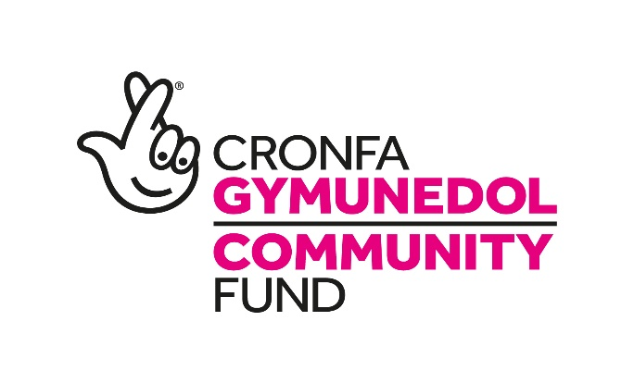

People and Places -
Cost-of-living Response Fund in Wales
As the Cost-of-living crisis unfolds, we have been looking at how we can support communities across Wales.

Our immediate priority is to support people, communities, and organisations by ensuring that we can maintain our commitments to existing grant holders.

Programme priorities
We are also looking at how we could further support communities in Wales by providing funding for projects that focus on:

- Support people with the direct impact of the cost-of-living crisis in relation to food and heating.

- Support organisations and community facilities experiencing current cash flow problems resulting from losses or short-term liquidity challenges as a direct result of the cost-of-living crisis.

Who can apply?
You can apply if you are a voluntary or community group such as a charity, co-operative, social enterprise or community benefit company, not-for-profit company limited by guarantee, or a statutory organisation such as a local authority or school. Partnerships are also welcome to apply as long as the lead applicant is a voluntary or community organisation, or social enterprise (VCSE). Your organisation must have a management committee with at least three unrelated members aged 18 or over. We cannot fund individuals or sole traders, for-profit groups or those not established in the UK.

We want to support as many organisations as possible with the funding we have available. The funding is available to support groups for up to two years.

If you think you have a project that fits in with the Cost-of-living priorities above, please contact us so we can see if we can support you with the resources you need for your community.

What can I apply for?
Grants of up to £50,000 are available. We can fund most costs such as staff salaries, training, volunteer expenses, management costs, equipment, building costs, monitoring and evaluation, and overheads. We wouldn’t expect to be funding capital costs, however if this is something you require, please speak to us direct.

How do I apply?
If you think you currently need grant funding, please let us know by responding to the questions below. We know that everyone is extremely busy and focused on essential work, so we only need short, concise answers. Please title the document Cost-of-living Response Fund. You will also need to provide a completed Organisation Details form:

- How much funding are you asking for?
- Please complete the ‘People and Places Budget Tool’ to let us know how much funding you are requesting from us.
- Please note that we cannot provide unrestricted funds, so please indicate what specific costs our money will cover.
- Please let us know if and when you anticipate receiving additional grant funding towards this new/additional activity.
- What period would the grant funding cover?
- We can support projects which last up to two years.

- Outline how the project fits with the priorities we outlined above.
- If it is a new/additional activity, describe what the activity would involve, who it will help, and why you think it will support the community at this time of crisis.

- Provide information to demonstrate what consultation and engagement you have carried out with both existing and potential beneficiaries, and how this demonstrates a need for your project.

- Tell us where the project will be delivered in Wales.

- Equity, diversity, and inclusion
- Please tell us how your project will be fully accessible to anyone who wishes to participate.
- We require all projects in Wales to provide a fully bilingual service, so please consider any additional costs you may require.

• If your organisation is facing financial uncertainty due to the crisis and needs support to
cover your core activities:
- Outline your current financial situation and how our funding can help.

- How many months of unrestricted, free reserves do you currently have, if applicable?

- Do you expect to draw on your reserves in the next 6-9 months if they become available?

- If yes, what is the income gap you need to cover?

- How many months of operating costs will this cover?

- Please tell us about other measures you have taken to reduce costs and what impact these measures will have.

- Do you receive/expect to receive any additional support from other funders to support with core costs? Please note that we cannot fund any costs incurred from other funds, including any government funding responding to the Cost-of-living crisis.

• If you have not previously received grant funding from the National Lottery Community
Fund, give a summary of how your organisation is structured and run.

When will you make the decision?
We will aim to give you a decision within three months of receiving your application.

We only have a limited amount of money available, and we anticipate that the money will be in high demand. Therefore, we would not be able to fund all the applications we receive. If you are unsuccessful, we will give you feedback on our decision.

Enquiries
If you do not yet have a designated Funding Officer, please email wales@tnlcommunityfund.org.uk or call us on 029 2168 0214.

