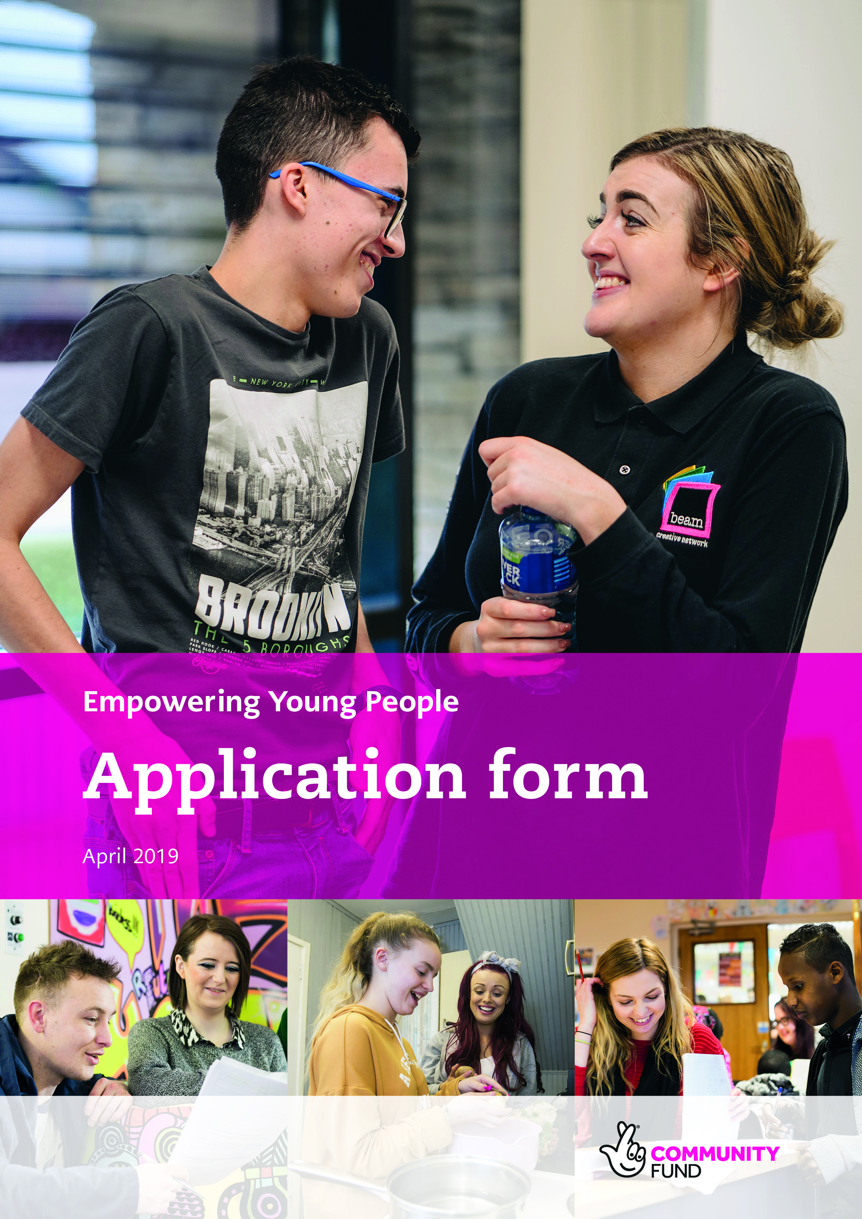

For use in Northern Ireland
If you have any questions about completing this application form, or if you need it in a different format (for example large print), please contact us by email at enquiries.ni@tnlcommunityfund.org.uk or call us on 028 9055 1455.
Our website also has further information, advice and tips to help you complete your application.

Your project
1. Project name
Give your project a short title, something we can use when we promote your project.
Write up to 70 characters (including spaces).
2. Project delivery
Where are the people or organisations who will benefit from your project based?
Select the relevant local council area/s from the table below and enter the percentage, for example:
- If the people or organisations are in one area only, select the appropriate council area and put 100 percent in the space provided.
- If the people or organisations are in more than one area, select the area and estimate a percentage for each one selected. The total percentage must add up to 100 per cent.
- If your project is Northern Ireland wide you can select this option and put 100 per cent in the space provided.
Local council area | Tick as required | % per area
Antrim and Newtownabbey
Armagh, Banbridge and Craigavon
Belfast City
Causeway Coast and Glens
Derry City and Strabane
Fermanagh and Omagh
Lisburn and Castlereagh
Mid and East Antrim
Mid Ulster
Newry, Mourne and Down
North Down and Ards
Northern Ireland wide

3. Project summary
- Summarise the purpose of the project.
- Tell us who will benefit, where they live, their age range and the numbers involved.
- Summarise the main activities.
You can write up to 600 words.

4. Young people and how they’re involved
- What are the challenges young people have identified in their lives? How were you made aware of this?
- Tell us how young people were involved in planning the project and how they will be involved in delivering and managing it.
- How will young people’s support networks also be involved? (Support networks could include young people’s peers, their wider family, educators, youth workers, social workers and mentors).
- Briefly tell us about other consultations/research/evaluations that support the project.
You can write up to 1,000 words.

5. Your organisation and local services
- Why is your organisation the best to deliver the project?
- What other services are available in the area for young people?
- How will your project fill a gap or link to and enhance these other services?
You can write up to 600 words.

6. The difference your project makes
- Tell us about the changes or benefits you expect the project to bring to young people.
- How will your project help young people overcome the challenges they face?
You can write up to 600 words.

7. Project costs
Some organisations may be registered with HM Revenue and Customs to recover VAT. If you are registered, then we cannot fund any VAT on your project.
If you are not registered, you can include VAT within your project.
 | Total cost (£) | Amount from us (£) | How many years is this funding for?
Revenue
Capital
Total
Write a list of what our funding will cover.
You can write up to 300 words.

Your organisation details
8. What is the full legal name of your organisation, as shown on your governing document?
Please check this – if the full legal name is incorrect it may delay your application.
9. What is the main or registered address for your organisation?
Enter your organisation’s address including full postcode.
Organisation website (if applicable)
Twitter address (if applicable)
Facebook address (if applicable)

10. What type of organisation are you?
Select all options that are relevant to you
Organisation Type | Tick as required | Reference number
Registered with Charity Commission for Northern Ireland
Recognised by HM Revenue and Customs in Northern Ireland as charitable for tax purposes
Registered with Charity Commission for England and Wales
Registered with Companies House as a Company Limited by Guarantee
Unregistered community organisation/club/society |  | N/A
Other (please specify)

Your contact details
We need the date of birth and home address for all of your contacts. This includes a previous address if they’ve not lived at their current address for three years.
We use this to carry out some basic identity checks as part of our standard fraud prevention process, so please check that the information provided is correct. Our identity check may appear on a credit report, but it’s not a credit check and can only be seen by the person we’re checking, so their credit rating won’t be affected. You can find out more in our Guide to risk analysis, available at www.tnlcommunityfund.org.uk/informationchecks and in the Data Protection policy at the end of this form.
11. Main contact
Who should we contact if we have questions about your application? They must be someone who runs or works for your organisation.
Title |  | Mr |  | Mrs |  | Ms |  | Miss
Forenames
Surname
Date of birth |  | Day |  |  | Month |  | Year
Job title or position
Daytime telephone
Mobile telephone
Email
If you have any particular communication needs, tell us what they are
Main contact home address and full postcode
Have they lived at this address for the last three years?
 | Yes |  | No – you must give previous home address
Main contact previous home address and full postcode

12. Legally responsible contact
This cannot be the same person as the main contact.
The legally responsible contact must be over 18 years old and is responsible for ensuring that this application is supported by the organisation applying, any funded project is delivered as set out in the application form, and that the funded organisation meets our monitoring requirements.
The legally responsible contact must hold one of the following positions, which is dependent on your organisation type:
- Company/Incorporated Charity – Director or Company Secretary
- School – Head Teacher
- Statutory body – Chief Executive or Director
- All other types of organisations (including Registered Charity) – Chair, Vice Chair, Treasurer or Trustee
Title |  |  |  |  | Mr | Mrs |  | Ms |  | Miss
Forenames
Surname
Date of birth |  |  |  |  | Day |  | Month |  | Year
Position in organisation
Legally Responsible Contact’s home address and full postcode
Have they lived at this address for the last three years?
 | Yes |  | No - you must give previous home address
Legally Responsible Contact’s previous home address and full postcode
Contact telephone number
Email
If you have any particular communication needs, tell us what they are

Equality monitoring
Your answers help us understand who benefits from our funding but we don’t use them to decide if we will fund your project.
13.1 Will your project mostly benefit people from a particular ethnic background?
 | Yes |  | No
If yes, which ethnic background? You can select up to three.
White
English / Scottish / Welsh / Northern Irish / UK | Gypsy or Irish Traveller
Irish | Any other white background
Mixed / Multiple ethnic groups
Mixed ethnic background (this refers to people whose parents are of a different ethnic background to each other).
Asian / Asian UK
Indian | Chinese
Pakistani | Any other Asian background
Bangladeshi
Black / African / Caribbean / Black UK
African
Caribbean
Any other Black/African/Caribbean background
Other ethnic group
Arab
Any other

13.2 Will your project mostly benefit people of a particular gender?
 | Yes |  | No
If yes, which gender?
 | Male |  | Female

13.3 Will your project mostly benefit people from a particular age group?
 | Yes |  | No
If yes, which age group? You can select up to two.
0 – 24 years
25 – 64 years
65 + years

13.4 Will your project mostly benefit disabled people?
We use the definition from the Equality Act 2010, which defines a disabled person as someone who has a mental or physical impairment that has a substantial and long-term adverse effect on their ability to carry out normal day to day activity.
 | Yes |  | No

13.5 Will your project mostly benefit people of a particular religion or belief?
 | Yes |  | No
If yes, which religion or belief? You can select one.
No religion | Jewish
Christian | Muslim
Buddhist | Sikh
Hindu | Other

13.6 Will your project mostly benefit lesbians, gay men or bisexual people?
 | Yes |  | No

13.7 Which community do the people who will benefit from your project belong to?
Both Catholic and Protestant | Mainly Protestant (more than 60 per cent)
Mainly Catholic (more than 60 per cent) | Neither Catholic nor Protestant

13.8 Will your project mostly benefit people with caring responsibilities?
 | Yes |  | No
Data Protection and Freedom of Information Act
Data protection
The National Lottery Community Fund is a public body with a duty to distribute National Lottery and other money in grants for good causes. We use the personal data you provide, such as contact details for individuals at your organisation, to help you apply for a grant and to assess your application. We may also carry out checks on the individuals as described below. If a grant is awarded, we will use the personal data to manage and monitor the grant, carry out evaluations and research, and to check the money is being used appropriately.
We may share your personal data with organisations which help us with our grant making activities or others which have a legitimate interest in our work or have funded your grant. We will only share personal data which they need to carry out their work and subject to appropriate safety measures.
We may keep in contact with you throughout the life of your grant and send you advice about your grant by email. This will contain useful information on a range of things including how to publicise your grant, information on other funding available and project ideas and tips from other grant holders.
Our Data Protection and Privacy Notice gives more information about how we store and use personal data and the lawful basis for this. Please read the full Notice which is published on our website at www.tnlcommunityfund.org.uk/data-protection or contact us to request a hard copy. The Notice may be updated from time to time.
Freedom of information
The Freedom of Information Act 2000 gives members of the public the right to request any information that we hold. This includes information received from third parties, such as, although not limited to grant applicants, grant holders and contractors. Please read our full policy published on our website www.tnlcommunityfund.org.uk/freedom-of-information. This policy may be updated from time to time.
If you think that there is information in your application that may be exempt from release if requested, then you should let us know when you apply. We will not usually release information about your project whilst it is being assessed. Otherwise we will use our judgement as to whether any exemptions may apply, which we may seek your opinion on. Personal information would be withheld subject to the requirements of data protection laws.
Our approach to fraud
We know the vast majority of the many thousands who seek and use our funding are genuine. However, we sometimes receive fraudulent applications and so we have a duty to carry out checks on individuals at organisations which apply for grants.
The personal information we have collected from you will therefore be shared with fraud prevention agencies who will use it to prevent fraud and money-laundering and to verify your identity. If fraud is detected, you could be refused certain services, finance or employment.

Further details of how your information will be used by us and these fraud prevention agencies, your data protection rights and how to contact us, can be found in our full Data Protection and Privacy Notice which is published on our website www.tnlcommunityfund.org.uk/data-protection. Contact us to request a hard copy.

