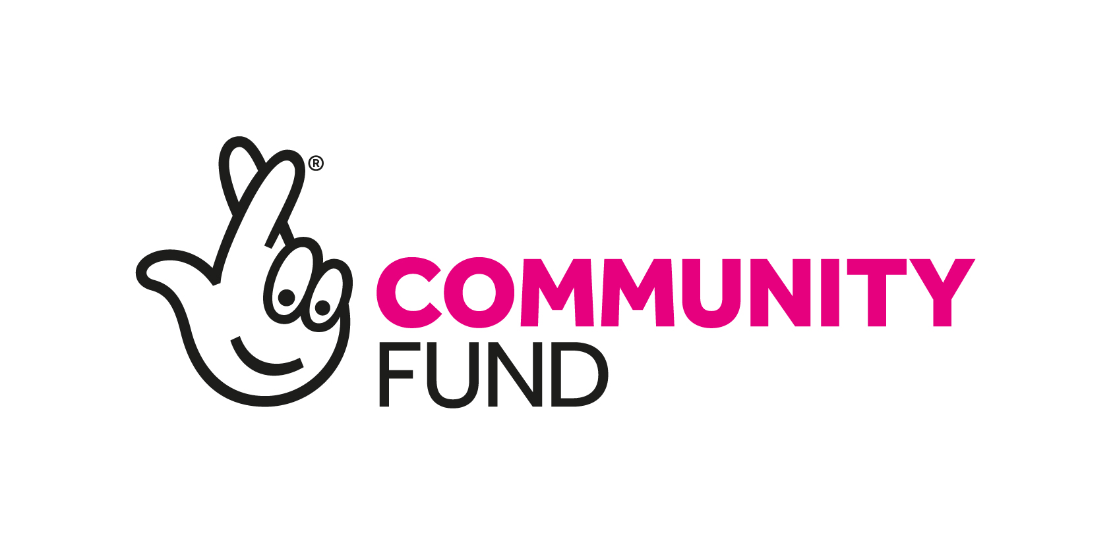
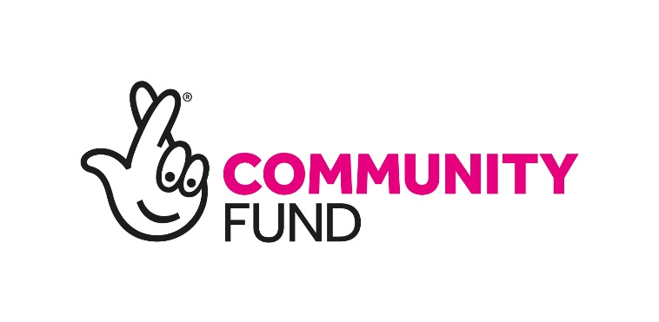

Community Assets

Sep 2019

In Scotland, we believe that the following three approaches are vital to help us deliver National Lottery funding that empowers communities and reduces inequality and we will fund activity that embraces these.
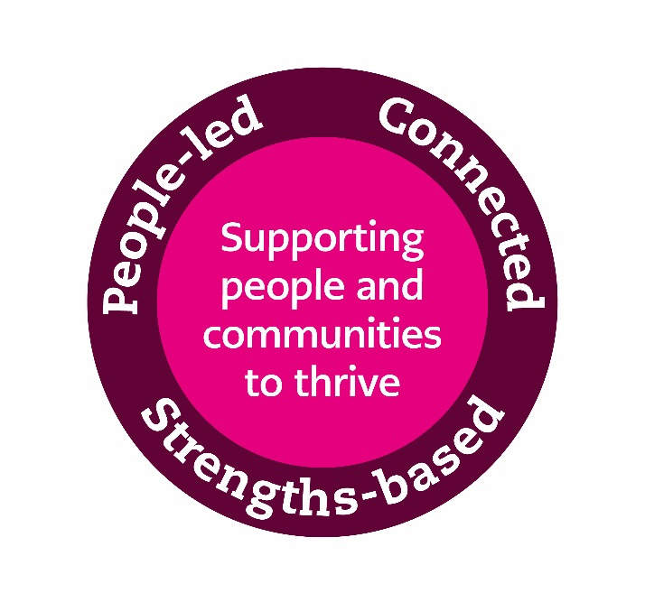

- People-led – meaningfully involving the people you’re working with in the development, design and delivery of your activity.

- Strengths-based – making the most of, and building on, the skills and experiences of people and assets within communities.

- Connected – having a good understanding of what others are doing locally, developing good working relationships and complementing and adding value to other relevant activity in your area.

We will look at how you embrace the three approaches in your activity. This will be important when we consider your submission.

Further information about these and examples of how organisations have taken these approaches in their work can be found on our website https://www.tnlcommunityfund.org.uk/threeapproaches

- What’s it about?

Through Community Assets we aim to empower people to create strong, resilient communities by helping them to acquire and/or develop assets in their area. These could be physical assets such as buildings or pieces of land but may also include other types of asset such as renewable energy opportunities. Whatever your idea is, you should be able to show that this has been developed by, and has the support of, your community.

We want to focus our funding where it will have the most impact so we will prioritise applications that address disadvantage and inequality. We are looking for strong applications that support communities to build on their strengths and develop opportunities to improve their community. These will:

- be rooted in the community, genuinely community-led, and give the community a stake in local decision making
- be connected to other organisations and services in the community
- show clearly the changes that will take place, and why this is the best way to deliver these change
- show that developments will be economically sustainable once our grant has ended.

If your application involves land or buildings, we would normally expect you to own these or be looking to acquire these as part of the application. Our experience in funding asset development tells us that ownership provides communities with the power to make the changes that will benefit their community in the long term. In exceptional cases we may be able to consider a lease as an alternative to ownership.

- Who can apply?

Your organisation should be able to meet some basic good practice features in order to apply for Community Assets funding.

Your organisation must have a governing body (e.g. committee or board) with at least three unrelated people on it and a written governing document (e.g. constitution). The governing document should be clear that the organisation has:

- A social purpose – The organisation must have a clearly stated purpose which benefits your local area in some way
- Open membership – Everyone living in your area should be able to get involved in your organisation and the work that it does
- Community control – The majority of people serving on your governing body should be from the local area and should make the decisions
We expect any activity we fund to be largely based in, and developed by, defined local geographic communities. For example this might be a recognised neighbourhood, school catchment area, local authority ward or parliamentary constituency. However we can consider applications from communities of interest or more dispersed communities where there is:

- A clear link between the proposed use of the asset and reduction in inequality for the community of interest
- A clear commitment to include and engage with the wider community
- An appropriate local geographic definition that the community of interest functions in.
Examples of the types of activity we want to fund under Community Assets can be found on our blog: https://bigblogscotland.org.uk/category/hints-and-tips-2/community-asset/

Existing National Lottery Community Fund grantholders can apply but you can only have one Community Assets grant at a time.

- How do you apply?

Talk to us

The first step is to talk to us about your idea so we can give you advice on whether or not this funding is right for what you want to do. We’ve found that talking with applicants earlier in the process can lead to stronger applications. Contact us on 0300 123 7110 or at advicescotland@tnlcommunityfund.org.uk to discuss your idea.

If, after speaking to you, we think your application is a potential fit with Community Assets we will then normally arrange to visit you. This visit will involve looking at the intended aims of your activity and, where these form part of the application, consideration of the building or land you have identified to achieve these aims.

If, following the visit, your application is considered a good fit with Community Assets we will ask you to submit the following documents:

- A strategic plan – this should provide information on your organisation, your plans for the community use of the asset and high level financial costs and projections. We’ll give you more detailed guidance on the strategic plan after we visit you.

- A completed capital checklist – this checklist and its enclosures provide information on the design and costs of the capital work. You can find more information in the Community Assets capital guidance on our website.

If you are only requesting revenue funding, such as salaries and running costs, you will only need to submit a strategic plan. If your activity involves capital work then we will also require a completed capital checklist and enclosures, but we will provide guidance on what this involves during the application process.

Development Funding

You can apply for development funding to develop your application. Development funding can be used to cover costs such as community consultation and strategic plan development as well as costs to engage a design team to take forward the technical aspects of your application. We will give you a development funding application form after the initial visit and can provide advice on what costs should be included in your application.
Capital mentor

You may also be able to get access to specialist capital support through a ‘capital mentor’ to guide you through the technical process. Capital mentors are experienced in developing capital projects. They will be available to provide support and advice for the duration of the capital phase including appointing and managing the design team, carrying out the tender process and completing the construction phase. We can provide more information on this at the visit.

Decision and grant offer

Once you have submitted your strategic plan and capital checklist we will assess these within four months and let you know whether you have been offered a grant. If we offer you a grant this will be dependent on you meeting the following two conditions within 12 months:

- That you submit a full business plan and have this approved by The National Lottery Community Fund
- That you submit a tender return form and have this approved by the The National Lottery Community Fund.

This is to ensure you have a deliverable application that represents good value for money.

- How much can you ask for?
Grants made under Community Assets will be a minimum of £10,000 up to a maximum of £1 million.

- What can you apply for?
We want to provide longer term funding that offers community-led organisations stability to deliver great work. You can therefore apply for capital and/or revenue funding for up to five years to acquire or develop an asset.
Although we encourage match funding in applications, we may fund up to 100 per cent of activity costs including staff, training, volunteer expenses, equipment, premises costs, evaluation and overheads.

There are some things we can’t pay for such as anything you spend money on before we confirm our funding, activities that actively promote religion and items that only benefit one person.

- How will we make our decision?
The information you provide in your strategic plan and capital checklist is a starting point and we’ll contact you to discuss these further during our assessment. As well as considering how your activity fits with what we want to fund, we’ll look at:
- How your activity demonstrates people-led, strengths-based and connected approaches
- The capacity of your organisation to deliver your activity
- The longer term sustainability of your application
- The likely impact on disadvantage and inequality of your application

Process for applying

This diagram lays out the application processes for revenue projects (those primarily involving running costs) and capital projects (those also involving significant building work, purchase, or groundworks). In practice these processes may vary depending on your circumstances.

You apply for development funding and may get access to a capital mentor
You appoint a design team and develop your application
You have 6 months to submit a strategic plan and capital checklist
We assess information in your strategic plan and capital checklist
We tell you if you have been offered a grant within 4 months
You undertake a tender process. You submit a business plan and the tender return form within 12 months
We review and approve your business plan and tender return form
You appoint contractors and start the capital work
You can access some of your grant to help meet these conditions
We tell you if you have been offered a grant within 4 months
You develop a business plan and submit it within 6 months
You have 6 months to submit a strategic plan
We assess information in your strategic plan
You apply for development funding if required
We review and approve your business plan
You start your funded activities
You can access some of your grant to help meet this condition
Visit
Funding and capital staff meet with you and advise whether you should continue to develop your application. If yes…
Contact
You contact our advice team to discuss your idea and we consider if it fits with the aim of Community Assets.
If yes…
Revenue
Capital
Submit
Decision
Develop
Start

